ABSTRACT
Since sickle cell disease (SCD) is caused by a single point mutation in the hemoglobin (Hb) gene, gene therapy has long been considered as a viable treatment. Genomic sequencing advances have improved our understanding of Hb control, and the development of molecular tools for hematopoietic stem cell genome alteration has opened the door to gene therapy for sickle cell disease. In order to improve SCD, gene-addition techniques utilizing gene transfer vectors have been refined over the last few decades to boost the expression of normal or antisickling globins. Obtaining enough stem cells for gene modification, boosting the expression of transferred genes to a therapeutic level, and safely preparing patients to allow for sufficient engraftment of gene-modified cells were just a few of the challenges that needed to be overcome before clinical translation. The safety and effectiveness of gene therapy have been further enhanced by the development of genome editors that make precise edits, and the lessons learnt from improving gene-addition procedures have surely aided in the quick transition to clinical trials. Given that gene-modification occurs ex vivo in specialized facilities and that cells must be extracted from patients who frequently have severe organ dysfunction in order to administer chemotherapy, the current gene therapies being tested in clinical trials demand a substantial amount of infrastructure and expertise. These treatments would need to be effective, safe, and portable in order to reach their full potential and make an in vivo-based strategy appealing. In addition, adequate resources for SCD screening and access to standardized care are critically important for gene therapy to be a viable treatment option for SCD.
INTRODUCTION
DNA, the genetic code that governs a large portion of the body's shape and function (phenotype), is what makes up genes. DNA governs how cells divide, proliferate, and carry out their respective tasks. Mutating genes result in either a malfunction or a change in the way cells function. A mutation is a change in an organism's or person's genome's gene sequence. The goal of gene therapy is to correct these mutations, swap them out with a healthy gene, or strengthen the immune system to combat illnesses. It has potential as a treatment for illnesses like AIDS, cancer, sickle cell disease, diabetes, heart disease, hemophilia, and cystic fibrosis. The genetic hereditary form of anemia known as sickle cell disease (SCD) is caused by a mutation in the B-globin gene (HBB) where the hydrophobic valine at the 6th codon replaces the hydrophilic glutamic acid. As a result, the red blood cell takes on a crescent or sickle form. Through the red blood cells (erythrocytes), hemoglobin transports oxygen to the different areas of the body. The polymerized hemoglobin in sickle cell disease patients takes on the shape of a sickle. Because of their shortened lifespan and ability to obstruct small capillaries, these crescent-shaped red blood cells (RBC) can cause a number of symptoms and characteristics, including strokes, organ damage, and, most often, early mortality in those who are afflicted.
Gene therapy using a lentiviral vector has demonstrated promising preclinical and clinical outcomes over the past few decades. A certain DNA or RNA sequence is included as part of the gene therapy procedures. This implies that the therapy's effects and results are limited to the patient and will not have an impact on their children. Compared to germline gene therapy, the foundation of somatic gene therapy is less fraught with ethical issues. Incorporating the new gene into the genome is the first successful outcome of somatic gene therapy.
Ex-vivo gene therapy involves transferring genes to cultured cells, selecting, multiplying, and introducing the altered cells into a patient. By using autologous cells, the immune system is prevented from rejecting the imported cells. Before being reintroduced into the same person, the cells are first taken from the patient to be treated and cultured. This method is applicable to tissues such as skin and hematopoietic cells, which can be extracted from the body, genetically altered outside the body, and then reintroduced into the patient's body, where they engraft and live for a long time. A certain DNA or RNA sequence is included as part of the gene therapy procedures. Instead of prescribing medications or doing surgeries, researchers hope that gene therapy will eventually allow patients to receive treatment by introducing genes into their cells. To adequately investigate the safety and efficacy of these methods, more research is still necessary. Germline therapy and somatic gene therapy are the two fundamental forms of gene therapy. In germline therapy, the genes within germ or gamete cells (sex cells), such as sperm or ova, are altered. Therefore, germline treatment should be used during reproduction, when the altered gamete cells unite to create a zygote or fetus. After fusing together, the zygote divides and transfers the altered gene to every other bodily part as the fetus grows. Although germline treatment may theoretically be able to treat inherited illnesses, some nations have laws that forbid its usage because of the therapy's unknown hazards and potential long-term repercussions on future generations. The cost of germline treatment restricts its practical application. Inserting therapeutic DNA into bodily cells other than gametes is known as somatic gene therapy. This implies that the therapy's effects and results are limited to the patient and will not have an impact on their children.
Compared to germline gene therapy, the foundation of somatic gene therapy is less fraught with ethical issues. Incorporating the new gene into the genome is the first successful outcome of somatic gene therapy. Additionally, introducing a changed gene into the wrong place in the DNA can cause illness rather than prevent it.

DEVELOPMENT OF SICKLE CELL DISEASE (SCD)
Sickle cell disease (SCD) is an inherited blood disorder. This means it is passed down from parent’s genes to offspring. Having a family history of SCD increases the risk for the disease. SCD mainly affects people whose families came from Africa, Central America, South America, the Middle East, Asia, India, the Mediterranean, or Southern Europe. One in 365 Black babies in the U.S. is born with SCD. One in 13 Black babies in the U.S. carries the sickle cell gene. Symptoms of the disease varies may be mild or severe. Symptoms include Anemia. This symptom is the most common one. Having fewer red blood cells causes anemia. Severe anemia can make you feel dizzy, short of breath, Yellowing of the skin, eyes, and mouth (jaundice). This is a common symptom: sickle cells are not as long-lived as normal red blood cells; they die more quickly than the liver can filter them out; the yellow color is due to a substance called bilirubin, which is released when the red blood cells die; sickle crisis, also known as pain crisis, is a sudden pain that can occur anywhere because sickle cells can become stuck in small blood vessels, obstructing blood flow.

GENE THERAPY
The in vivo method of gene transfer involves transferring cloned genes directly into the patient's tissues, which is done in cases where the patient's cultured cells cannot be re-implanted in an efficient manner or where the individual cells cannot be cultured in vitro in sufficient numbers, such as brain cells.
Gene therapy is a novel treatment technique that uses genes or short oligonucleotide sequences as therapeutic molecules instead of conventional drug compounds. In other words, gene therapy involves introducing one or more foreign genes into an organism to cure hereditary or acquired genetic defects.
It is particularly difficult to detect off-target effects, and it gets harder the smaller the edits are, like base edits. Although DNA sequencing technology has advanced greatly and is now able to identify changes in sequence at the genome level, there is still much disagreement about the most effective assays for measuring off-target effects because of issues with sensitivity and specificity. 66 Further, off-target effects detected by in vitro assays may not be representative of in vivo models, and human studies are needed to determine the clinical impact of potential off-target edits.
TREATMENT OF SICKLE DISEASE WITH GENE THERPY
Over the years, gene therapy has demonstrated its capacity to treat sickle disease, a hereditary condition that impairs hemoglobin (RBS). As previously mentioned, sickle makes the RBS stiff and sickle-shaped, which results in blood flow obstructions, excruciating pain, and organ damage.
Previous developments in gene therapy technology have produced therapies that may be able to cure sickle cell disease.
This involves modifying the patient's hematopoietic stem cells using the genome editing technique CRISPR/CAS9. Following transplantation, the patient receives healthy red blood cells from the altered cells.
In 2023, the US Food and Drug Administration (FDA) approved the gene treatments Lyfgenia and Casgevy to cure sickle disease in patients aged 12 and up.
For those who have struggled with the crippling effects of sickle cell disease, gene therapy has provided a curable option. To guarantee long-term success, it is crucial to keep enhancing these treatments' efficiency, durability, and safety.

HOW CRISPR/CAS9 ARE USED IN TREATING SICKLE CELL
Clustered Regularly Interspaced Short Palindromic Repeats is what the acronym CRISPR stands for.
It is an effective technique for gene editing that aids in genetic therapy and research.
The bacterial genome contains a brief repetitive DNA sequence called CRISPR. They serve as a memory system that aids in bacterial recognition and virus defense.
The CAS9 protein is an enzyme that cuts DNA at a specific spot by acting as molecular scissors.
CRISPR/CS9 is revolutionary gene editing technology that treat sickle cell disease by targeting the root cause of the disease by the following ways;
- IDENTIFICATION OF TARGET GENE: Scientist finds out the specific mutation in HB gene responsible for the sickle cell disease

- DESDIGNING GUIDE RNA (gRNA): A guide RNA is made to complement the sequence of the mutant HB gene. This gRNA then shows the cas9 enzyme the precise location in the DNA.

- COLLECTING STEM CELLS:Blood stem cells are collected from the affected individual. Stem cells are responsible for producing all types bloods which also include red blood cell.

- GENE EDITING : The stem cell are treated with CRISPR/CAS9 complex. The guide RNA directs the cas9 enzyme to the faulty HB gene where cas9 makes the cut in the DNA. It does so in two ways;

- BASE EDITING: This convert AT to GC without DSBs which is the correct way for nucleotide correction
- PRIME EDITORS: Use CAS9 reverse transcriptase fusion to find and replace DNA sequence reducing high target risks.

- CORRECTION OF GENE:The template with the correct DNA sequence above with the cell natural repair mechanism repair the cut. This process corrects the mutation in the HB gene.

- TRANSPLANTATION: The edited stem cells and the corrected HB gene are infused back into the patient. The cell engrafts in the bone marrow and start producing the healthy red blood cells.

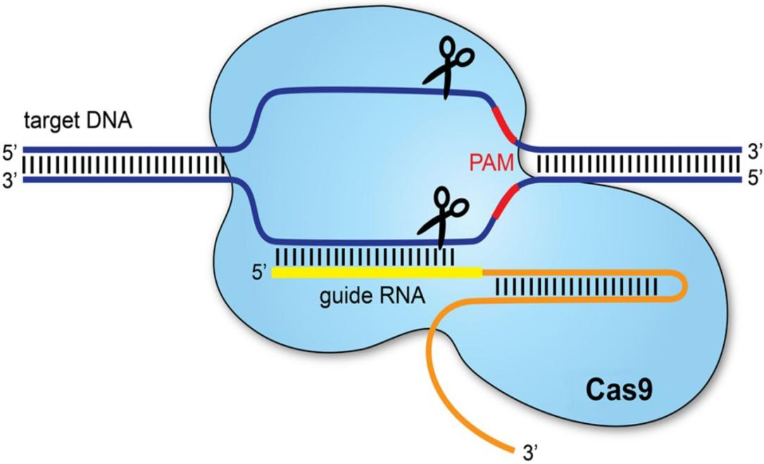

BASIS OF GENE THERAPY
Adeno-associated viruses, baculovirus, retroviruses (γ- retroviruses and lentiviruses), poxvirus, adeno-associated viruses, and herpes simplex viruses are among the viruses that can be used to deliver transgenes; the use of a particular virus for clinical application depends on its toxicity, transgene expression efficiency, ease of production, and stability. Non-viral vectors, on the other hand, rely on physical or chemical methods to convey genetic material into a cell. Chemical nonviral vectors use synthetic or natural compounds as a delivery medium to cells, such as liposomes, polymers like polyethylene glycol and polyethyleneimine, nanoparticles, alginate, and cationic lipids. Chemical nonviral vectors are more convenient and effective than physical nonviral vectors. The physical method includes electroporation (application of electric field to create pores for DNA or RNA to enter), gene gun (use of high-pressure gas to shoot DNA-coated particles into cells), and sonoporation (use of ultrasound to create opening in cells). The drawbacks of nonviral vector mechanisms include lower efficiency, temporary or transient gene expression, and instability.

Most ethical concerns of genome editing are related to genome editing around human germline because changes made to germline would be passed to future generations or offspring (Smithies et al., 1985). It is being investigated in research and clinical trials for a wide range of diseases, including single-gene disorders like hemophilia, sickle cell disease, and cystic fibrosis. It also holds promise for the treatment and prevention of more complex diseases like cancer, heart disease, mental illness, and HIV infection.

CONCLUSION
Gene-editing techniques have been made possible by the substantial advancements in gene-addition technologies over the past few decades, including their successful translation to clinical application. Many gene therapies are expected to be approved in the upcoming years. However, as the majority of SCD patients globally live in low-resource environments, there is still a pressing need to increase access to standard care (screening, drugs, vaccinations, and clinical infrastructure) in order to make gene therapy for the disease more widely available. To maximize effectiveness, assess long-term safety, and enhance gene therapy's viability and portability, more study is required. The creation of a successful in vivo strategy for SCD will depend heavily on these initiatives. One thing is certain: gene therapy is developing as a potentially effective treatment for sickle cell disease (SCD) following decades of research.

REFERENCES
- 1.Yawn BP, Buchanan GR, Afenyi-Annan AN, et al. Management of sickle cell disease: summary of the 2014 evidence-based report by expert panel members. JAMA. 2014; 312(10):1033-1048.
- 2.Niihara Y, Miller ST, Kanter J, et al. ; Investigators of the Phase 3 Trial of l-Glutamine in Sickle Cell Disease. A phase 3 trial of l-glutamine in sickle cell disease. N Engl J Med. 2018;379(3):226-235]
- 3.Ataga KI, Kutlar A, Kanter J, et al. Crizanlizumab for the prevention of pain crises in sickle cell disease. N Engl J Med. 2017;376(5): 429-439.
- 4.Vichinsky E, Hoppe CC, Ataga KI, et al. ; HOPE Trial Investigators. A phase 3 randomized trial of voxelotor in sickle cell disease. N Engl J Med. 2019;381(6):509-519. ]
- 5.Johnson FL, Look AT, Gockerman J, Ruggiero MR, Dalla-Pozza L, Billings FT III. Bone-marrow transplantation in a patient with sickle-cell anemia. N Engl J Med. 1984; 311(12):780-783.
- 6.Gluckman E, Cappelli B, Bernaudin F, et al. ; Eurocord, the Pediatric Working Party of the European Society for Blood and Marrow Transplantation, and the Center for International Blood and Marrow Transplant Research. Sickle cell disease: an international survey of results of HLA-identical sibling hematopoietic stem cell transplantation. Blood. 2017;129(11): 1548-1556
- 7.Walters MC, De Castro LM, Sullivan KM, et al. Indications and results of hla-identical sibling hematopoietic cell transplantation for sickle cell disease. Biol Blood Marrow Transplant. 2016;22(2):207-211.
- 8.Hsieh MM, Kang EM, Fitzhugh CD, et al. Allogeneic hematopoietic stem-cell transplantation for sickle cell disease. N Engl J Med. 2009;361(24):2309-2317. ]
- 9.Hsieh MM, Fitzhugh CD, Weitzel RP, et al. Nonmyeloablative HLA-matched sibling allogeneic hematopoietic stem cell transplantation for severe sickle cell phenotype. JAMA. 2014;312(1):48-56.
- 10.Bernaudin F, Dalle JH, Bories D, et al. ; Société Française de Greffe de Moelle et de Thérapie Cellulaire. Long-term event-free survival, chimerism and fertility outcomes in 234 patients with sickle-cell anemia younger than 30 years after myeloablative conditioning and matched-sibling transplantation in France. Haematologica. 2020;105(1):91-101.
- 11.Kamani NR, Walters MC, Carter S, et al. Unrelated donor cord blood transplantation for children with severe sickle cell disease: results of one cohort from the phase II study from the Blood and Marrow Transplant Clinical Trials Network (BMT CTN). Biol Blood Marrow Transplant. 2012;18(8):1265-1272. ]
- 12.Shenoy S, Eapen M, Panepinto JA, et al. A trial of unrelated donor marrow transplantation for children with severe sickle cell disease. Blood. 2016;128(21):2561-2567.
- 13.Abraham A, Cluster A, Jacobsohn D, et al. Unrelated umbilical cord blood transplantation for sickle cell disease following reduced-intensity conditioning: results of a phase I trial. Biol Blood Marrow Transplant. 2017;23(9):1587-1592.
- 14.Joseph JJ, Abraham AA, Fitzhugh CD.. When there is no match, the game is not over: Alternative donor options for hematopoietic stem cell transplantation in sickle cell disease. Semin Hematol. 2018;55(2):94-101.
- 15.Saraf SL, Oh AL, Patel PR, et al. Haploidentical peripheral blood stem cell transplantation demonstrates stable engraftment in adults with sickle cell disease. Biol Blood Marrow Transplant. 2018;24(8):1759-1765.
- 16.Bolaños-Meade J, Cooke KR, Gamper CJ, et al. Effect of increased dose of total body irradiation on graft failure associated with HLA-haploidentical transplantation in patients with severe haemoglobinopathies: a prospective clinical trial. Lancet Haematol. 2019;6(4):e183-e193.
- 17.de la Fuente J, Dhedin N, Koyama T, et al. Haploidentical bone marrow transplantation with post-transplantation cyclophosphamide plus thiotepa improves donor engraftment in patients with sickle cell anemia: results of an international learning collaborative. Biol Blood Marrow Transplant. 2019;25(6):1197-1209. ]
- 18.Genetics Home Reference US National Library of Medicine . HBB gene; 2020. Available at: https://www.ncbi.nlm.nih.gov/pubmed/. Accessed 19 June 2020.
- 19.Pawliuk R, Westerman KA, Fabry ME, et al. Correction of sickle cell disease in transgenic mouse models by gene therapy. Science. 2001;294(5550):2368-2371. [
- 20.Levasseur DN, Ryan TM, Reilly MP, McCune SL, Asakura T, Townes TM.. A recombinant human hemoglobin with anti-sickling properties greater than fetal hemoglobin. J Biol Chem. 2004;279(26):27518-27524.

