KWAME NKRUMAH UNIVERSITY OF
SCIENCE AND TECHNOLOGY



BSC.BIOCHEMISTRY
BCHEM 365

AGYENIM BOATENG PHILIP
3163522

ELUCIDATING MOLECULAR GENETICS OF GENE THERAPY AND HOW IT TECHNOLOGY HAS HELP WITH THE TREATMENT OF SICKLE CELL DISEASE
INTRODUCTION

Gene therapy is a technique that uses a gene(s) to treat, prevent or cure a disease or medical disorder. Often, gene therapy works by adding new copies of a gene that is broken, or by replacing a defective or missing gene in a patient’s cells with a healthy version of that gene. Both inherited genetic diseases (e.g., hemophilia and sickle cell disease) and acquired disorders (e.g., leukemia) have been treated with gene therapy.[1]
The concept of gene therapy began in the 1960s when scientist realized they can chnge the DNA sequence human to cure genetic diseases.
In 1990 a 4 year old girl name Ashanthi de Silva suffering from a severe combined immunodeficiency (SCID), received a healthy ADA gene from scientist delivered into her blood using a disabled virus.
Gene therapy has evoled significantly over years after the completion of the Human Genome Project in 2003. this has provide the complete blue print of our DNA, which has have an advance in this field. Over the years gene therapy has become the solution to many diseases especially those caused by mutations in a single gene.
Gene therapy has been group into two types; Ex-vivo and In-vivo
Ex-vivo gene therapy deals in removing cells from patients introducing new genetic material and then returning the cells to the patient.
In-vivo gene therapy does direct infusion of the vector into yhe bloodstream of the target organ.
Gene therapy has made significant change and continues draw interest from the biopharmaceutical industry. Today it has become the standard of care for genetic disease mainly sickel cell disease which will be focusing on.
Sickle cell disease is a genetic disorder characterized by abnormally shaped red blood cell (RBC). The cells become rigid,sticky,and sickle shaped due to mutation in hemoglobi, the oxygen carrying protein. This causes RBS to block blood flow, leading to tissue damage and complications.
This is caused by genetic mutation,inheriatnce pattern and triggers for sickling
Genetic mutaion is caused by mutation in the HBA gene wchich provides instrution for beta globin. The mutation replace glutamic acid with valine in HB protein which causess the abnormal shape RBS
Inheritance pattern; causes when an individual inherit two defectives gene from parebt
Sickle cell diseases can be treated by disease modifying therapy and curative treament
Curative treament include;
- BONE MARROW CELL TRANSPLANT
- GENE THERAPY: Using exagamglogene autotemcel, CRISPR-based treatment which corrects the HBB gene
We will now look at how the technology of gene therapy and has help with the treatment of sickle cell disease.

TREATMENT OF SICKLE DISEASE WITH GENE THERPY
Gene therapy over the years has proven it ability to cure this genetic disease known as sickle disease which affects the hemoglobin (RBS). Sickle as stated above causess the RBS to become rigid and sickle shape, leading to blockages in blood flow, severe pain and organ damage.
Earlier advancement in technology of gene therapy have led to development of treatments that can potentially cure sickle cell disease.
This inloves the use of CRISPR/CAS9 a genome editing techonolgy that modify the patients hematopoietic stem cells. The modified cells are then transplanted back into the patient, where the produce healthy red blood cell.
The US Food and Drug Administrion (FDA) in 2023 aproved two gene therapies casgevy and lyfgenia, for treating sickle disease in patience 12 years and above.
Gene therapy has offered a curative option for sickle patients, providing hope for those who have struggle with the debilitating effect of the disease. However , it is essential to continue improving the efficacy,durability and safety of these therapies to ensure long term success.

HOW CRISPR/CAS9 ARE USED IN TREATING SICKLE CELL
The term CRISPR stands for Clustered Regularly Interspaced Short Palindromic Repeats.
Is a powerful tool for editing genes and has help in the field of genetic research and therapy.
CRISPR is a short repetitive DNA sequence found in the the genome of bacteria. They act as a memory system that helps bacteria to recongnise and defend against virus.
CAS9 Protein is an enzyme that act as molecular scissors that cut DNA at at specified location.

CRISPR/CS9 is revolutionary gene editing technology that treat sickle cell disease by targeting the root cause of the disease by the following ways;
- IDENTIFICATION OF TARGET GENE: Scientist finds out the specific mutation in HB gene responsible for the sickle cell disease

- DESDIGNING GUIDE RNA (gRNA): A guide RNA is made to complement the sequence of the mutant HB gene. This gRNA then shows the cas9 enzyme the precise location in the DNA.

- COLLECTING STEM CELLS:Blood stem cells are collected from the affected individual. Stem cells are responsible for producing all types bloods which also include red blood cell.

- GENE EDITING : The stem cell are treated with CRISPR/CAS9 complex. The guide RNA directs the cas9 enzyme to the faulty HB gene where cas9 makes the cut in the DNA. It does so in two ways;

- BASE EDITING: This convert AT to GC without DSBs which is the correct way for nucleotide correction
- PRIME EDITORS: Use CAS9 reverse transcriptase fusion to find and replace DNA sequence reducing high target risks.

- CORRECTION OF GENE:The template with the correct DNA sequence above with the cell natural repair mechanism repair the cut. This process corrects the mutation in the HB gene.

- TRANSPLANTATION: The edited stem cells and the corrected HB gene are infused back into the patient. The cell engraft in the bone marrow and start producing the healthy red blood cells.

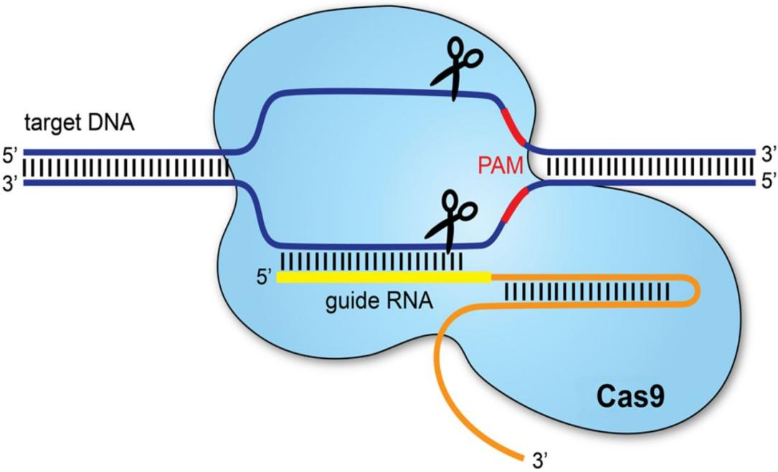

CASGEVY AND LYFGENIA
Casgevy and lyfgenia are another gene therapy approved by FDA for treatment of sickle cell disease in patients 12 years and above.

CASGEVY, was developed by Vertex Pharmaceutical which utilise CRISPR/CAS9 technology
STEAM CELL COLLECTION: blood sample of patient stem cell are taken
GENE EDITING: CRISPR/CAS9 is used to edit the BCL11A gene in the stem cells.this reduce the activity of the gene, leading to incraese production of dead HbF preventing the sickling of the red blood cells.
TRANSPLANTATION: Cells are then return back into the patients after their existing bone is removed. These cells generate new bone marrow and start proucing new healthy ones.

LYFGEENIA, was developed by Bluebird Bio. Similarly to Casgevy, Lyfgenia uses same approach but in their GENE MODIFICATION process a lentiviral vector is used to add functional copies of beta-globin gene to the patients stem cells. This produces anti-sickling Hb which prevent vaso- occlusive event (VOCs).

3. Key Differences Between Casgevy and Lyfgenia*
Feature | Casgevy (CRISPR) | Lyfgenia (Lentiviral)
Mechanism | Gene editing (BCL11A  disruption) | Gene addition (HbAT87Q
Hb Type Produced | Fetal hemoglobin (HbF) | Modified adult hemoglobin(HbAT87Q)
Editing Tool | CRISPR-Cas9 | Lentiviral vector
Target | Endogenous gene regulation | Exogenous gene delivery
Therapeutic Durability | Lifelong (if HSCs engraft | Lifelong (if HSCs engraft)
Primary Risk | Off-target edits | Insertional mutagenesis

APPLICATION OF GENETHERAPY TO SICKLE CELL DISEASE

CLINICAL TRIALS AND OUTCOMES
LentiGLOBIN trial (BluebirdBIO)
Method; Autologus HSCs transduced with a lentivirus carrying HBG
Results: Median HbF levels of 40%, with 85% of patients free from vaso-occlusive crises at 24 months.

CRISPR-Cas9 Trial (Vertex/CRISPR Therapeutics):
Method: BCL11A enhancer editing in HSCs.
Results: HbF constituted >30% of total hemoglobin; 94% of participants remained crisis-free for ≥12 months.

COMPARATIVE ANALYSIS OF THERAPY
PARAMETRS | GENE ADDITION | GENE EDITING
Durability | Stable integration | Permanent correction
Safety | Insertional mutagenesis risks | Lower risks with base/prime editing
Cost | 2.1million | 1.8milion
Regulatory Status | FDA approved | Phase |||

IMPACT ON TREATMENT PARADIGMS

- CURATIVE POTENTIAL: It offers a one time intenvention with durable benfits.
Studies shown in 2024 that 90% of this disease who received treatment maintained a normsl Hb level for 5 years

- ECONOMIC AND SOCIAL IMPLICATIONS:Studies has shown most people with sickle disease live in the sub -Saharan Africa where they lack the infrastructure for gene therapy.
It highly costive

- QUALITY OF LIFE IMPROVEMENT :Provides 70% hospitalization rate
Has improve the physical and mental health of people who were suffering from sickle cell disease

- GERMLINE EDITING DEBATE: Concensus restrict CRISPR to somatic cell to avoid unintended generation effect

CHALLLENGES AND ASSOVIATED TREATMENT OF SICKLE CELL DISEASE WITH GENE THERAPY

- CAS9 enzymes can be be directed to the wrong region of the DNA and edit non HBB regions

- Requires a long term monotoring when using Lentiviral integration which can cause riskds when not properly checked

- Can cause cancer

FUTURE OF TREATING SICKLE DISEASE WITH GENE THERAPY

1. Improved Gene Editing Techniques
CRISPR/Cas9: This technology has already shown success in clinical trials, and ongoing research aims to refine its precision and efficiency. Future advancements may lead to even safer and more effective treatments.

2. New Gene Therapy Approaches
Base Editing: This is a newer form of gene editing that allows for precise changes to individual DNA bases without making double-strand breaks. It has the potential to correct the specific mutation causing SCD.

3. Enhanced Delivery Methods
Safer Vectors: Researchers are developing new viral and non-viral vectors to deliver gene therapy more safely and effectively. These vectors aim to reduce the risk of immune reactions and improve the targeting of specific cells.

4. Combination Therapies
Multi-Target Approaches: Combining gene therapy with other treatments, such as hydroxyurea or new pharmacological agents, may enhance the overall effectiveness and provide a more comprehensive approach to managing SCD.

5. Accessibility and Affordability
Global Reach: Efforts are being made to make gene therapy more accessible and affordable, especially in regions where SCD is most prevalent. This includes developing cost-effective manufacturing processes and ensuring equitable distribution.

6. Long-Term Monitoring and Safety
Ongoing Research: Long-term studies are crucial to monitor the safety and durability of gene therapy treatments. Researchers are focused on understanding the potential long-term effects and ensuring that the benefits outweigh any risks.

7. Personalized Medicine
Tailored Treatments: Advances in genomics and personalized medicine will allow for more tailored gene therapy treatments based on an individual's specific genetic makeup and disease characteristics.

. Conclusion
Gene therapy has revolutionized SCD treatment by addressing its genetic root cause. Technologies like CRISPR and lentiviral vectors have enabled durable remissions, transforming SCD from a life-limiting condition to a potentially curable disease. However, challenges in cost, accessibility, and safety must be resolved to ensure equitable global access. Continued innovation and policy reform are essential to realizing the full promise of genetic medicine.

