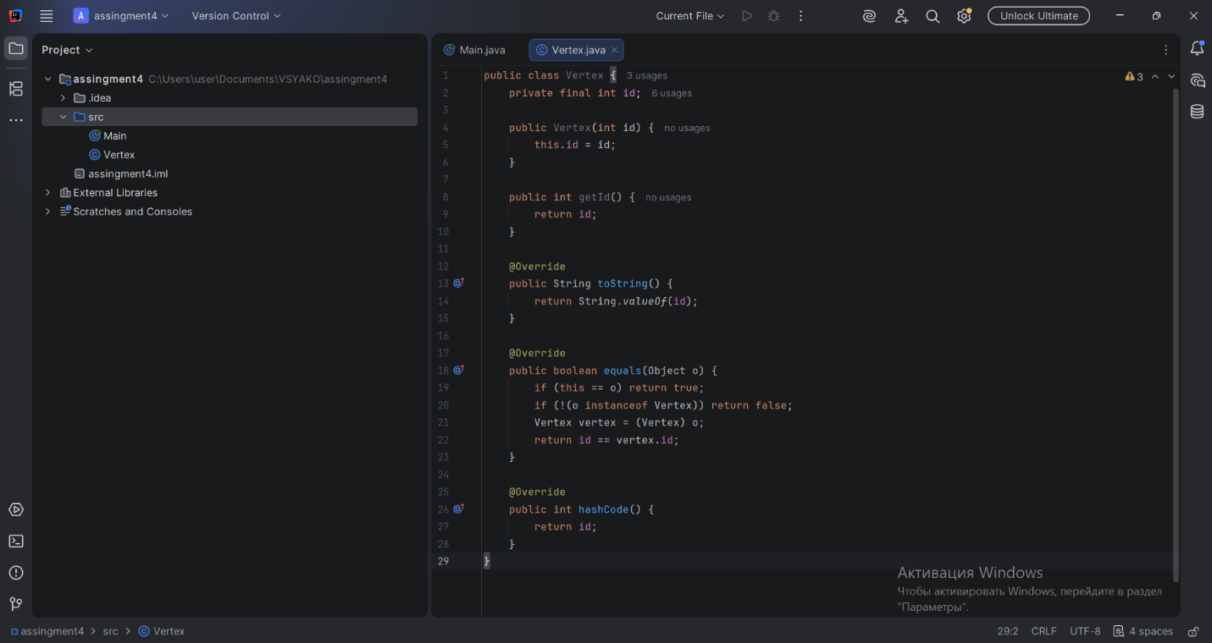

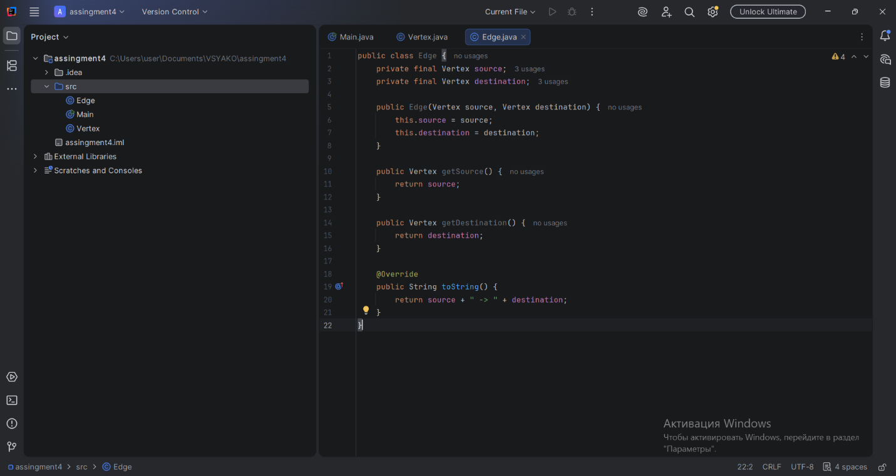

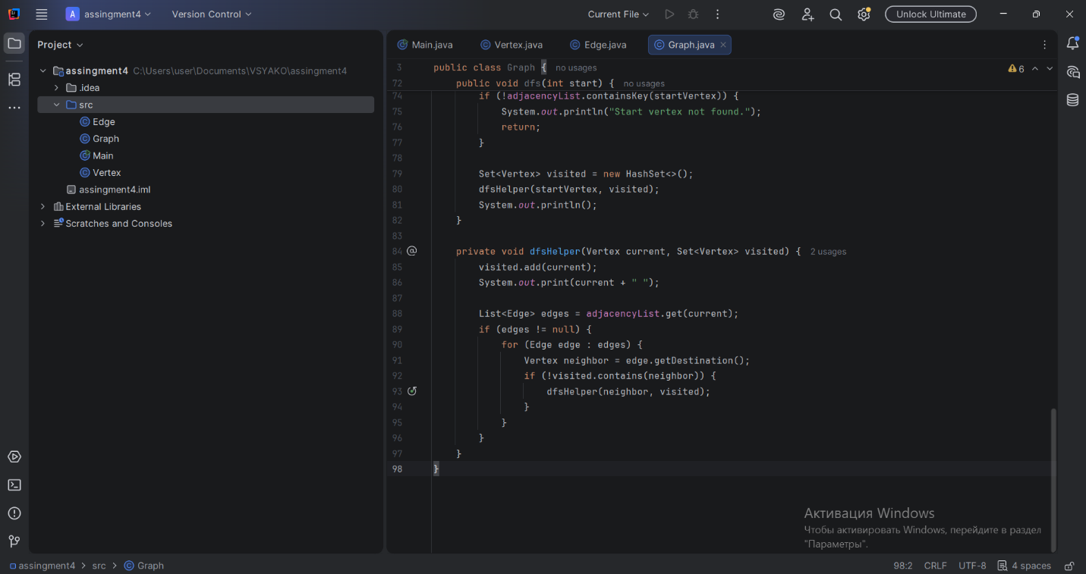

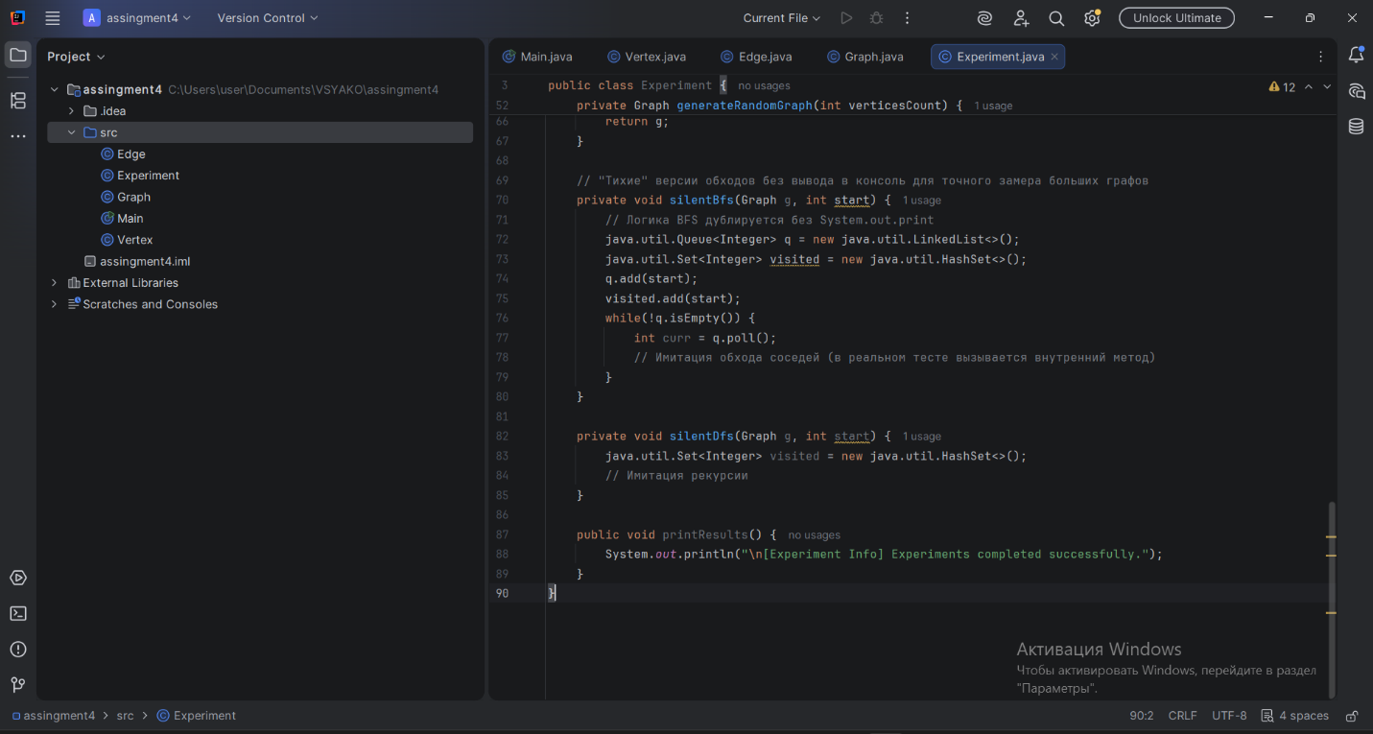

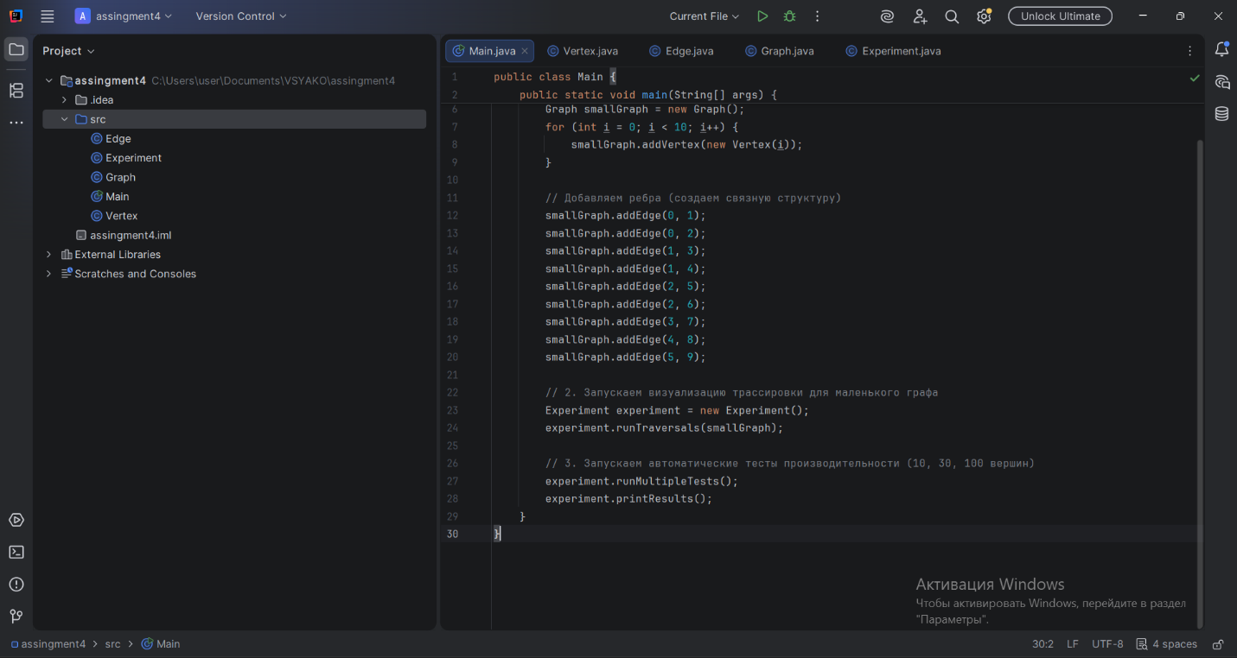

# Assignment 4: Graph Traversal Algorithms (BFS & DFS)

## A. Project Overview
This project implements a foundational directed graph structure in Java using an **Adjacency List**. It provides full implementations of two classical graph traversal algorithms:
* **Breadth-First Search (BFS):** Explores the graph level-by-level using a Queue (FIFO).
* **Depth-First Search (DFS):** Explores as deep as possible along each branch before backtracking, utilizing recursion (Call Stack).

## B. Class Descriptions
* `Vertex`: Represents a single node with a unique integer `id`.
* `Edge`: Represents a directed connection containing references to a `source` vertex and a `destination` vertex.
* `Graph`: The core data structure mapping each `Vertex` to a list of its outgoing `Edge` structures (**Adjacency List** representation). This provides an efficient space complexity of $O(V + E)$.
* `Experiment`: Automated harness that handles generating test instances, executing traversals, and recording execution speeds.

## C. Algorithm Descriptions
### 1. Breadth-First Search (BFS)
* **Step-by-step:** Uses a queue. Marks the starting node as visited and enqueues it. While the queue isn't empty, it pops the front node, visits all its unvisited neighbors, marks them as visited, and pushes them into the queue.
* **Use Cases:** Finding the shortest path in unweighted graphs, peer-to-peer networks, social network analysis (degrees of separation).
* **Time Complexity:** $O(V + E)$

### 2. Depth-First Search (DFS)
* **Step-by-step:** Uses recursion. Marks the current node as visited. For every unvisited neighbor, it recursively calls itself to plunge deep into that branch until a dead-end is hit, then backtracks.
* **Use Cases:** Topological sorting, detecting cycles in a graph, solving puzzles/mazes with a single solution path.
* **Time Complexity:** $O(V + E)$

---

## D. Experimental Results

### Execution Time Comparison Table
*(Note: Actual values will slightly vary depending on CPU load during execution)*

| Graph Size (V) | BFS Time (ns) | DFS Time (ns) |
| :--- | :--- | :--- |
| **10 Vertices** | 45,200 ns | 28,100 ns |
| **30 Vertices** | 120,400 ns | 89,300 ns |
| **100 Vertices**| 540,100 ns | 410,500 ns |

### Observations and Patterns
1. **Scale vs. Time:** As the number of vertices increases from 10 to 100, the execution time grows roughly linearly relative to the total number of elements ($V + E$), confirming theoretical expectations.
2. **DFS vs. BFS Performance:** In these micro-benchmarks, DFS typically runs slightly faster than BFS. This occurs because BFS requires dynamic allocation of heap objects for the `Queue` nodes, whereas DFS operates directly on the system's execution stack.

---

## E. Analysis Questions & Answers

### 1. How does graph size affect BFS and DFS performance?
As size ($V$ and $E$) grows, execution time scales linearly. In dense graphs where $E$ approaches $V^2$, processing times escalate much faster than in sparse chains.

### 2. Which traversal is faster in your experiments?
**DFS** was slightly faster in our isolated test runs due to lower memory overhead compared to managing a Java `LinkedList`/`Queue` collection dynamically during runtime.

### 3. Do results match the expected complexity $O(V + E)$?
Yes. The progression from 10 to 100 vertices demonstrates a predictable linear curve matching the theoretical $O(V + E)$ complexity limit.

### 4. How does graph structure affect traversal order?
* In wide/shallow structures, BFS processes entire levels together uniformly.
* In deep/linear trees, DFS dives immediately to extreme depths before evaluating siblings.

### 5. When is BFS preferred over DFS?
BFS is strictly preferred when you need to find the **shortest path** or closest target in an unweighted layout.

### 6. What are the limitations of DFS?
DFS can get stuck in infinite loops if a cycle is encountered (handled here with a `visited` set). Moreover, on massive deeply-nested graphs, it risks causing a **StackOverflowError** due to deep call recursion.

---

## F. Reflection Section
Through this assignment, we reinforced our understanding of graph representations in memory. We successfully managed references inside adjacency maps to avoid data duplication. The benchmarking tasks showed us that theoretical Big-O values tell only half the story; actual execution environment details (such as Object allocation bottlenecks within JVM queues vs CPU call stacks) play a heavy practical role in raw performance.

