Pair_Programming_Activity

TASK 1 · Data Type Detective (~8 min)
Work together (no typing yet) to decide the best C data type for each value below. Write your answers in the blanks, then discuss: why not a different type?
• A student's exam score out of 100 (whole number): int
• A product's price, e.g. 149.99: float
• A single letter grade, e.g. 'B': char
• GPA calculated to many decimal places: double

TASK 2 · Declare & Initialize (~10 min)
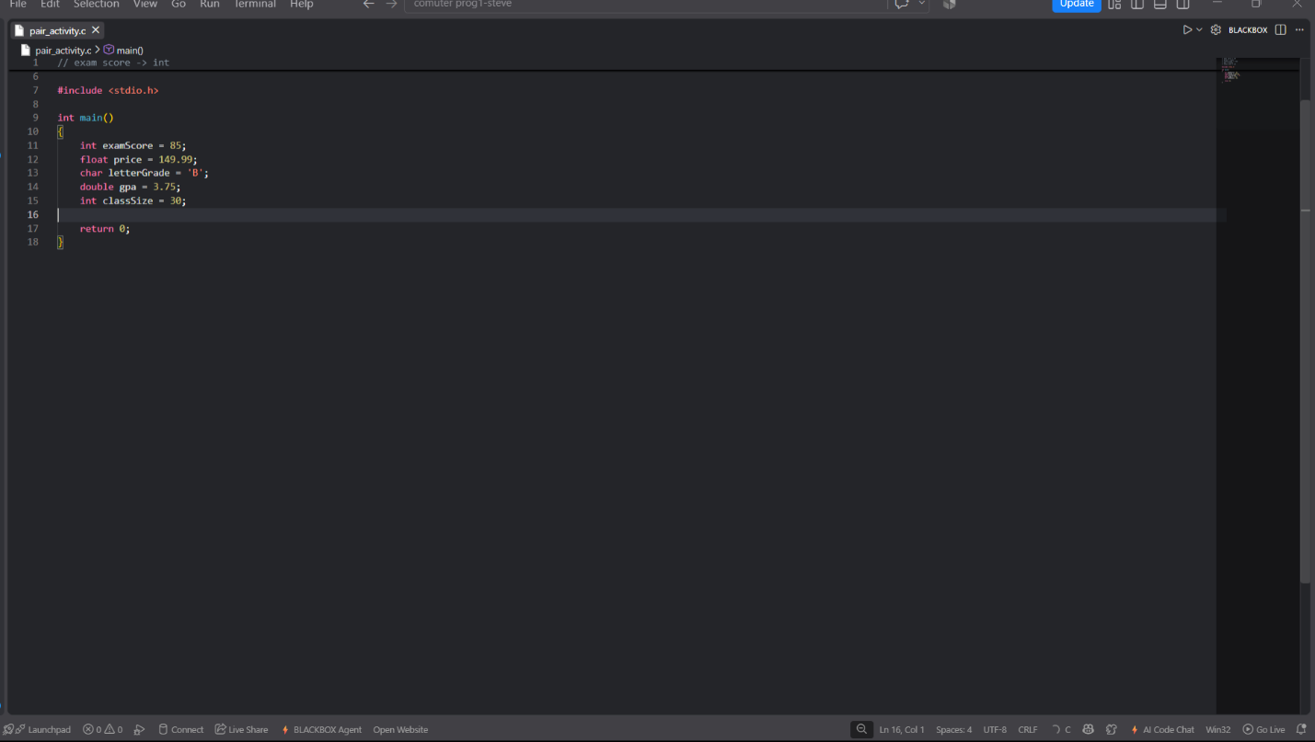

TASK 3 · Add a Constant (~6 min)

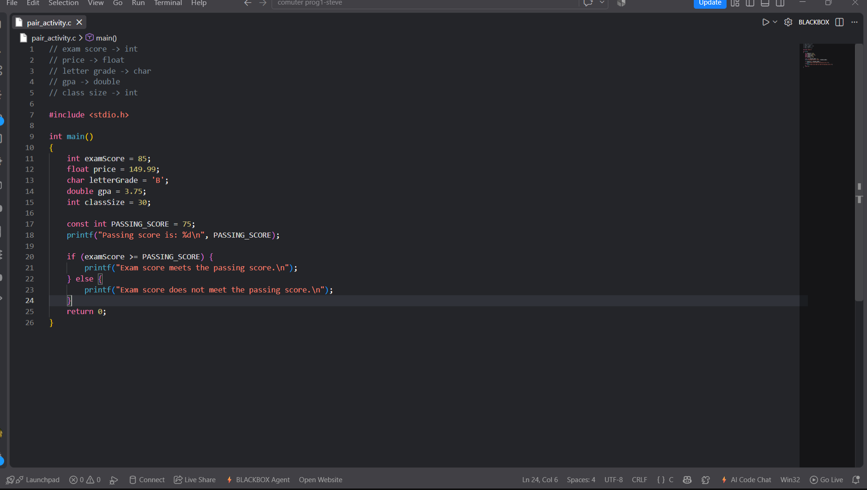
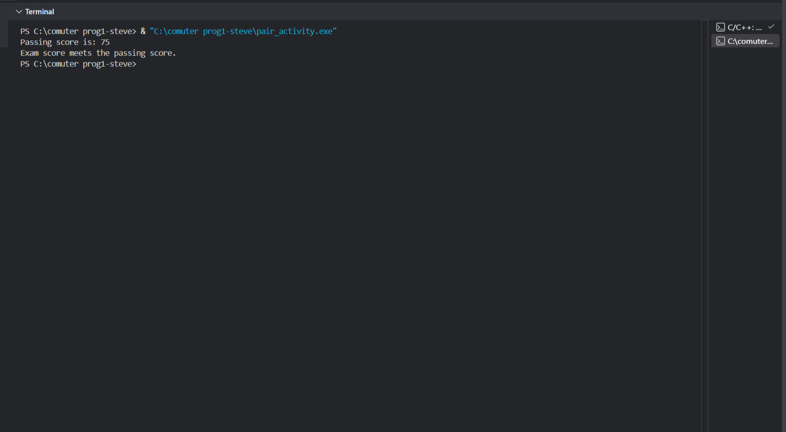

TASK 4 · Make It Interactive (~12 min)
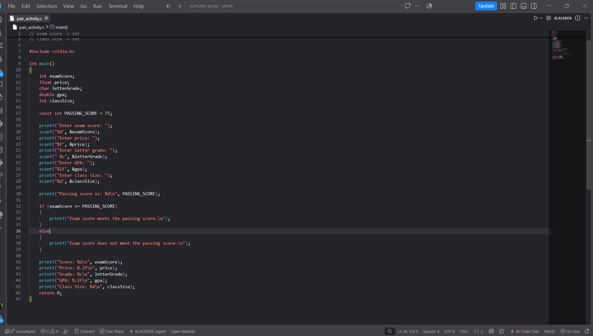

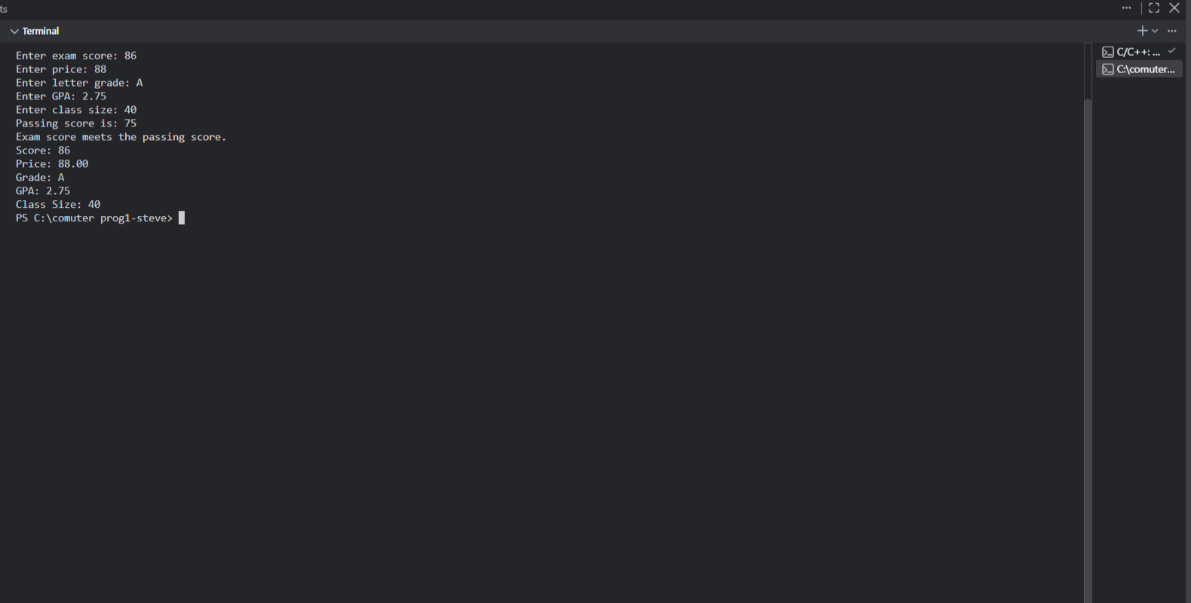

TASK 5 · Bug Hunt (~12 min)
Switch roles one more time. Below is broken code with four separate bugs. Find and fix all four as a team — talk through each one before changing it. Write the fix next to each bug.
#include <stdio.h>
int main()
{
int age;
float gpa
printf("Enter your age: ")
scanf("%d", age);
printf("Enter your GPA: ");
scanf("%d", &gpa);
printf("Age: %d, GPA: %f", age, gpa)
return 0;
}
Bug 1 : float gpa //missing semicolon ‘;’ at the end of line
Bug 2 : printf(“Enter your age: “) //missing semicolon ‘;’ at the end of line
Bug 3 : scanf(“%d, age); //missing a ‘&’ before ‘age’
Bug 4 : scanf(“%d”, &gpa); //wrong specifier it slould be ‘%f’not ‘%d’

Wrap-Up: Pair Reflection
Answer these together in a few sentences each.
- Which task caused the most disagreement between you and your partner? How did you resolve it?
Task 4 (using scanf()). We disagreed on which format specifiers to use for char and double. We solved it by checking our notes and testing the code.

- Pick one bug from Task 5. Why is it easy to miss when you're coding alone?
Bug 3 (missing & in scanf). It's easy to miss because the code looks correct and the error isn't obvious. When coding alone, you might get a crash and not know why.

- What's one thing your partner did (a habit, a way of explaining something) that you want to try yourself next time?
My partner talked through their typing out loud. I want to do that too - it helps catch mistakes and keeps both people on the same page.

