**Upload your project report and related documents in BlackBoard by 11:59PM, 04/28/2019**

**This project is not a teamwork project. You accomplish this project by yourself. You can use any programming language and make reference to existing open source code or libraries to accomplish this project.**

**Project 2. Face Detection**

Face detection and recognition is a classical AI topic (<http://aitopics.org/topic/face-recognition>). It can be used in a variety of applications that identifies human faces in digital images or videos. For example, it is used in cellphone unlocking, video surveillance, human computer interface, and image database management. In addition, face detection is gaining the interest of marketers. Face detection is an important object detection technique in commercial environment like Amazon Go (<https://www.youtube.com/watch?v=NrmMk1Myrxc>).

**Task 1:** Study the paper attached in the project 2. The paper is “A survey on face detection in the wild: Past, present and future”.

Read this paper and understand some questions like what the face detection is and what techniques of face detection are.

You can focus on one technique, such as deep neural network based method in the paper. Then, list some relevant documents like theory description, open source software, and relevant libraries. The following items are a group of examples focusing on deep neural network based face detection method. You can also use other methods listed in the paper.

For details of the convolutional neural network theory, you can reference the following link for details.

<http://yann.lecun.com/exdb/lenet/index.html>

In addition, for the convolution and pooling steps, you can reference the following link.

<http://ufldl.stanford.edu/wiki/index.php/Exercise:Convolution_and_Pooling>

Study the convolutional neural network code (any programming language is fine). There are a lot of open source convolutional neural network code online. For example, the following link provides a Python version of convolutional neural network.

<https://github.com/siddharth-agrawal/Convolutional-Neural-Network>

In order to get frame images from a streaming video, you can reference the following article and source code. You can also use any other programming languages and tools to extract frames (For example, OpenCV: http://opencv.org/).

<http://angeljohnsy.blogspot.com/2012/02/how-to-get-frames-from-video.html>

You can also use some simple methods like Haar Cascades. Here is an example of Python code which is no more than 30 lines of code for accomplishing face detection.

<https://docs.opencv.org/3.4/d7/d8b/tutorial_py_face_detection.html>

After the task 1, you would provide the answers to the following questions. These answers are required to be written into the project report.

1. What techniques are used for face detection?
2. What is difference between these techniques in the above question?
3. What technique you use to solve face detection in the project? List theory description, open source software or libraries. (Like examples of deep neural network technique list above)

**Task 2:** Download two video files “sample_video.mp4” and P2E_S5_C1 (already decomposed to video frames) from BlackBoard in the project 2 folder. The sample video provides the goals in the project. As illustrated in the following figure, three persons’ faces are automatically detected by intelligent program, and each face is grouped by a square box with different colors. Under each square box has a number which can indicate the number order of the person or serve as a tracking ID of the person appearing in the current frame.

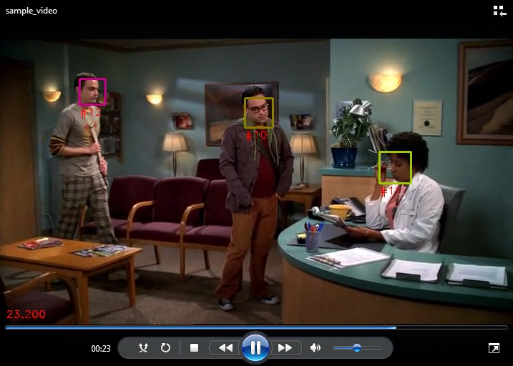

After the task 2, you video is similar to the following frame from the video “sample_video.mp4”. (Note: the following figure is just a sample. The content of the video frames “P2E_S5_C1” is different from the following sample frame.).

**Task 3:** Write your project report and build the intelligent program for the final video. The final video will be built from frame images in the processed “P2E_S5_C1”.

**Upload the following documents (compressed in a zip file) on BlackBoard for grading evaluation.**

1. **Project Report containing answers of questions in Task 1.**
2. **All source code**
3. **New video processed from the video frames “P2E_S5_C1”. In the new video, each person’s face should have been detected with a square box.**