Surname, First name:
Date:

LPHYS2131

Laboratory report

The discovery of the W and Z bosons

[ Briefly present the device and the principles of analysis which made it possible to discover the W and Z bosons at CERN's SPS accelerator by the UA1 and UA2. This presentation should not exceed 2 to 3 pages, depending on the number of graphics you decide to introduce.

The documentation you can rely on consists of:
- the reading of Nobel Prize winner C. Rubbia,
- a chapter taken from the book “experimental foundation of particle physics” by Cahn and Goldhaber
- the original article describing this discovery.
The necessary documents are available on Moodle.

You can of course also base your work on other references of your choice, but we would like to insist on the fact that it is essentially the experimental aspects (and those related to data analysis) that must be highlighted in this work. ]

Analysis of CMS data – Introduction

The purpose of this laboratory is to highlight the Z and W bosons within the data collected in 2011 by the CMS collaboration. To do this, we will work in three stages.

1. understand the data and their simulation.

Different data formats are used, with different levels of detail and sophistication. We will study some of them quickly before devoting ourselves to the simulation of the data in order to have a point of comparison with the theoretical expectations.

2. observe the Z boson and estimate the luminosity

Here we want to observe the Z boson, estimate its mass and width, and use this process to estimate the luminosity, i.e. the amount of data collected.

3. observe the W boson and measure its cross-section

Finally, we want to observe the W boson, and estimate the cross-section of the production process at the LHC.

The particles we will study are short-lived. Neither the Z boson nor the W boson can be directly observed in the detector, one can only observe the product of their decay.

[what are the main differences between the LHC and the SppS discussed just before?]

Data and simulation

Data are available in different formats, each with its specificities:
- RAW: [present the advantages and disadvantages in your own words]
- RECO: [present with advantages and disadvantages in your words]
- AOD: [present in your words the advantages and disadvantages]
- PAT: [present in your words the advantages and disadvantages]
- ntuple: [present in your words the advantages and disadvantages]

We begin by observing some events in AOD format using the CMS Event Display. The events were all selected as having either two muons or two electrons.

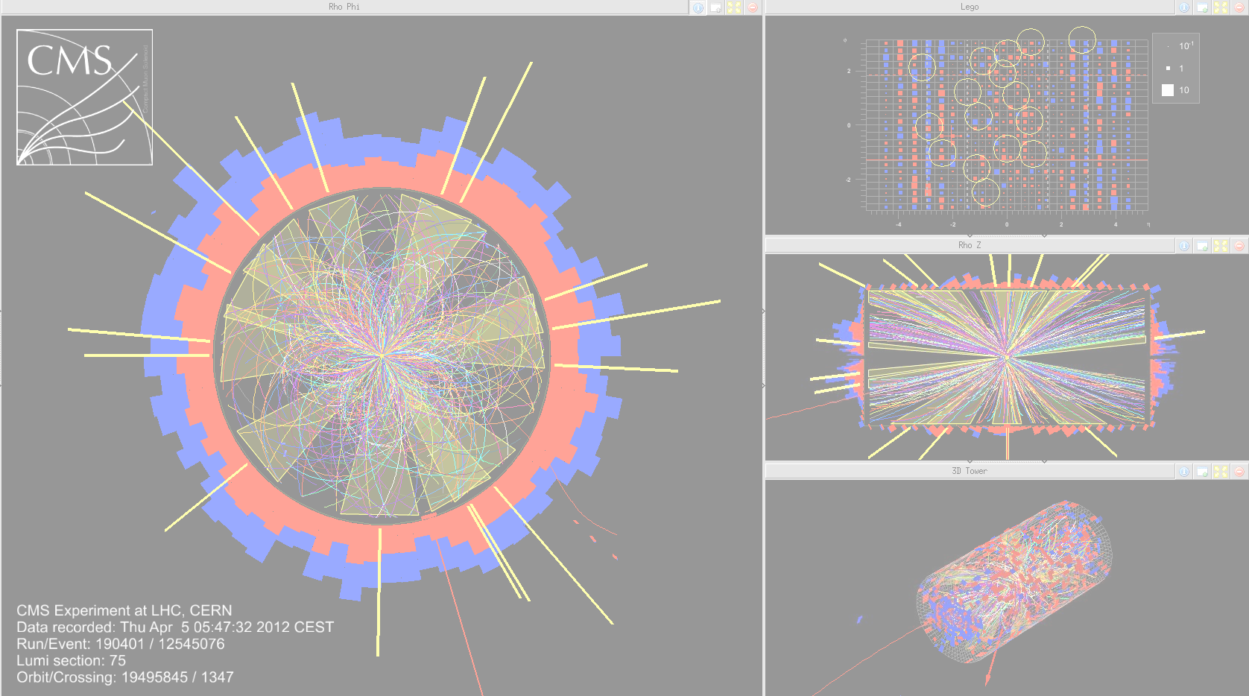
SAMPLE

[ present an event of your choice and discuss what you see there.
see https://github.com/delaere/LPHY2131/wiki/To-save-images-for-the-report ]

To be able to process many events, we create a "ntuple" file using the program WeakBosonsAnalyzer made available. The calculated quantities will be used later in the laboratory.

[describe the quantities calculated in this code, in particular invariant mass, transverse mass, angular distances, etc.]

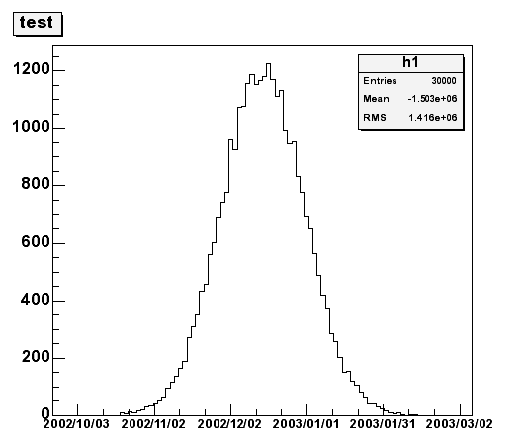  Legend (example) | Legend (example)
Legend (example) | Legend (example)

A classic approach to understanding what the data contain is to compare it to Monte Carlo simulated events based on our understanding of the theory. By simulating the response of the detector as well as the processing of the data, one obtains files which can be compared to the data.

Here we use the MadGraph program to simulate the events of interest
(pp->Z->l+l- and pp->W->lnu), we process them with a simplified version of the detector simulation (Delphi) and we produce a ntuple in the same format as the data.

process | LO/NLO | Number of events | section

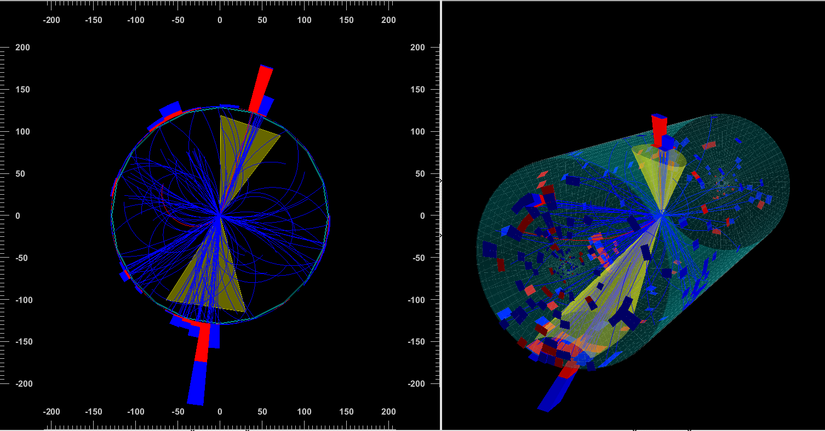
SAMPLE
SAMPLE

[present one event of your choice and discuss what you see in it. What are the main differences with a data event studied at the start of the activity?]

Measurement of luminosity

For this analysis, we have “ntuples” files obtained for the data and for the Monte Carlo simulations.
The file used for the simulations is the one obtained in the previous point, while the data file was produced on the institute's cluster by applying the procedure outlined in the previous point. Two files are available, respectively containing events that triggered the double electron or double muon “trigger”.

In this report, we will focus on the channel containing electrons/muons (to be specified).

By studying the simulation file and comparing it to the data file, we were able to deduce the following set of selection cuts:

[specify the cuts used in ROOT]

These cuts can be understood as follows:

[explain what the cuts, physically, and why they are "logical" knowing that we are looking to see a Z boson.]

[Illustrate the cuts using a few graphs]

Legend (example) | Legend (example)
Legend (example) | Legend ( example)

These cuts make it possible to obtain a pure sample of events compatible with the production of a Z boson. To determine the purity of our sample, we performed a fit with the Minuit algorithm.

Explain which functions are used to describe signal and background noise. If you deem it necessary, you can submit more than one fit. However, your result must be unique.

We obtain the following results:

Purity:
Number of selected MC events:
Number of selected data events:
Estimated number of Z bosons:
Estimated number of noise events:

Knowing the cross section of the studied signal, this allows us to estimate the integrated luminosity to which the studied data sample corresponds. We thus use the production of Z bosons as a standard (“Standard Candle”). We obtain the following value:

Luminosity:

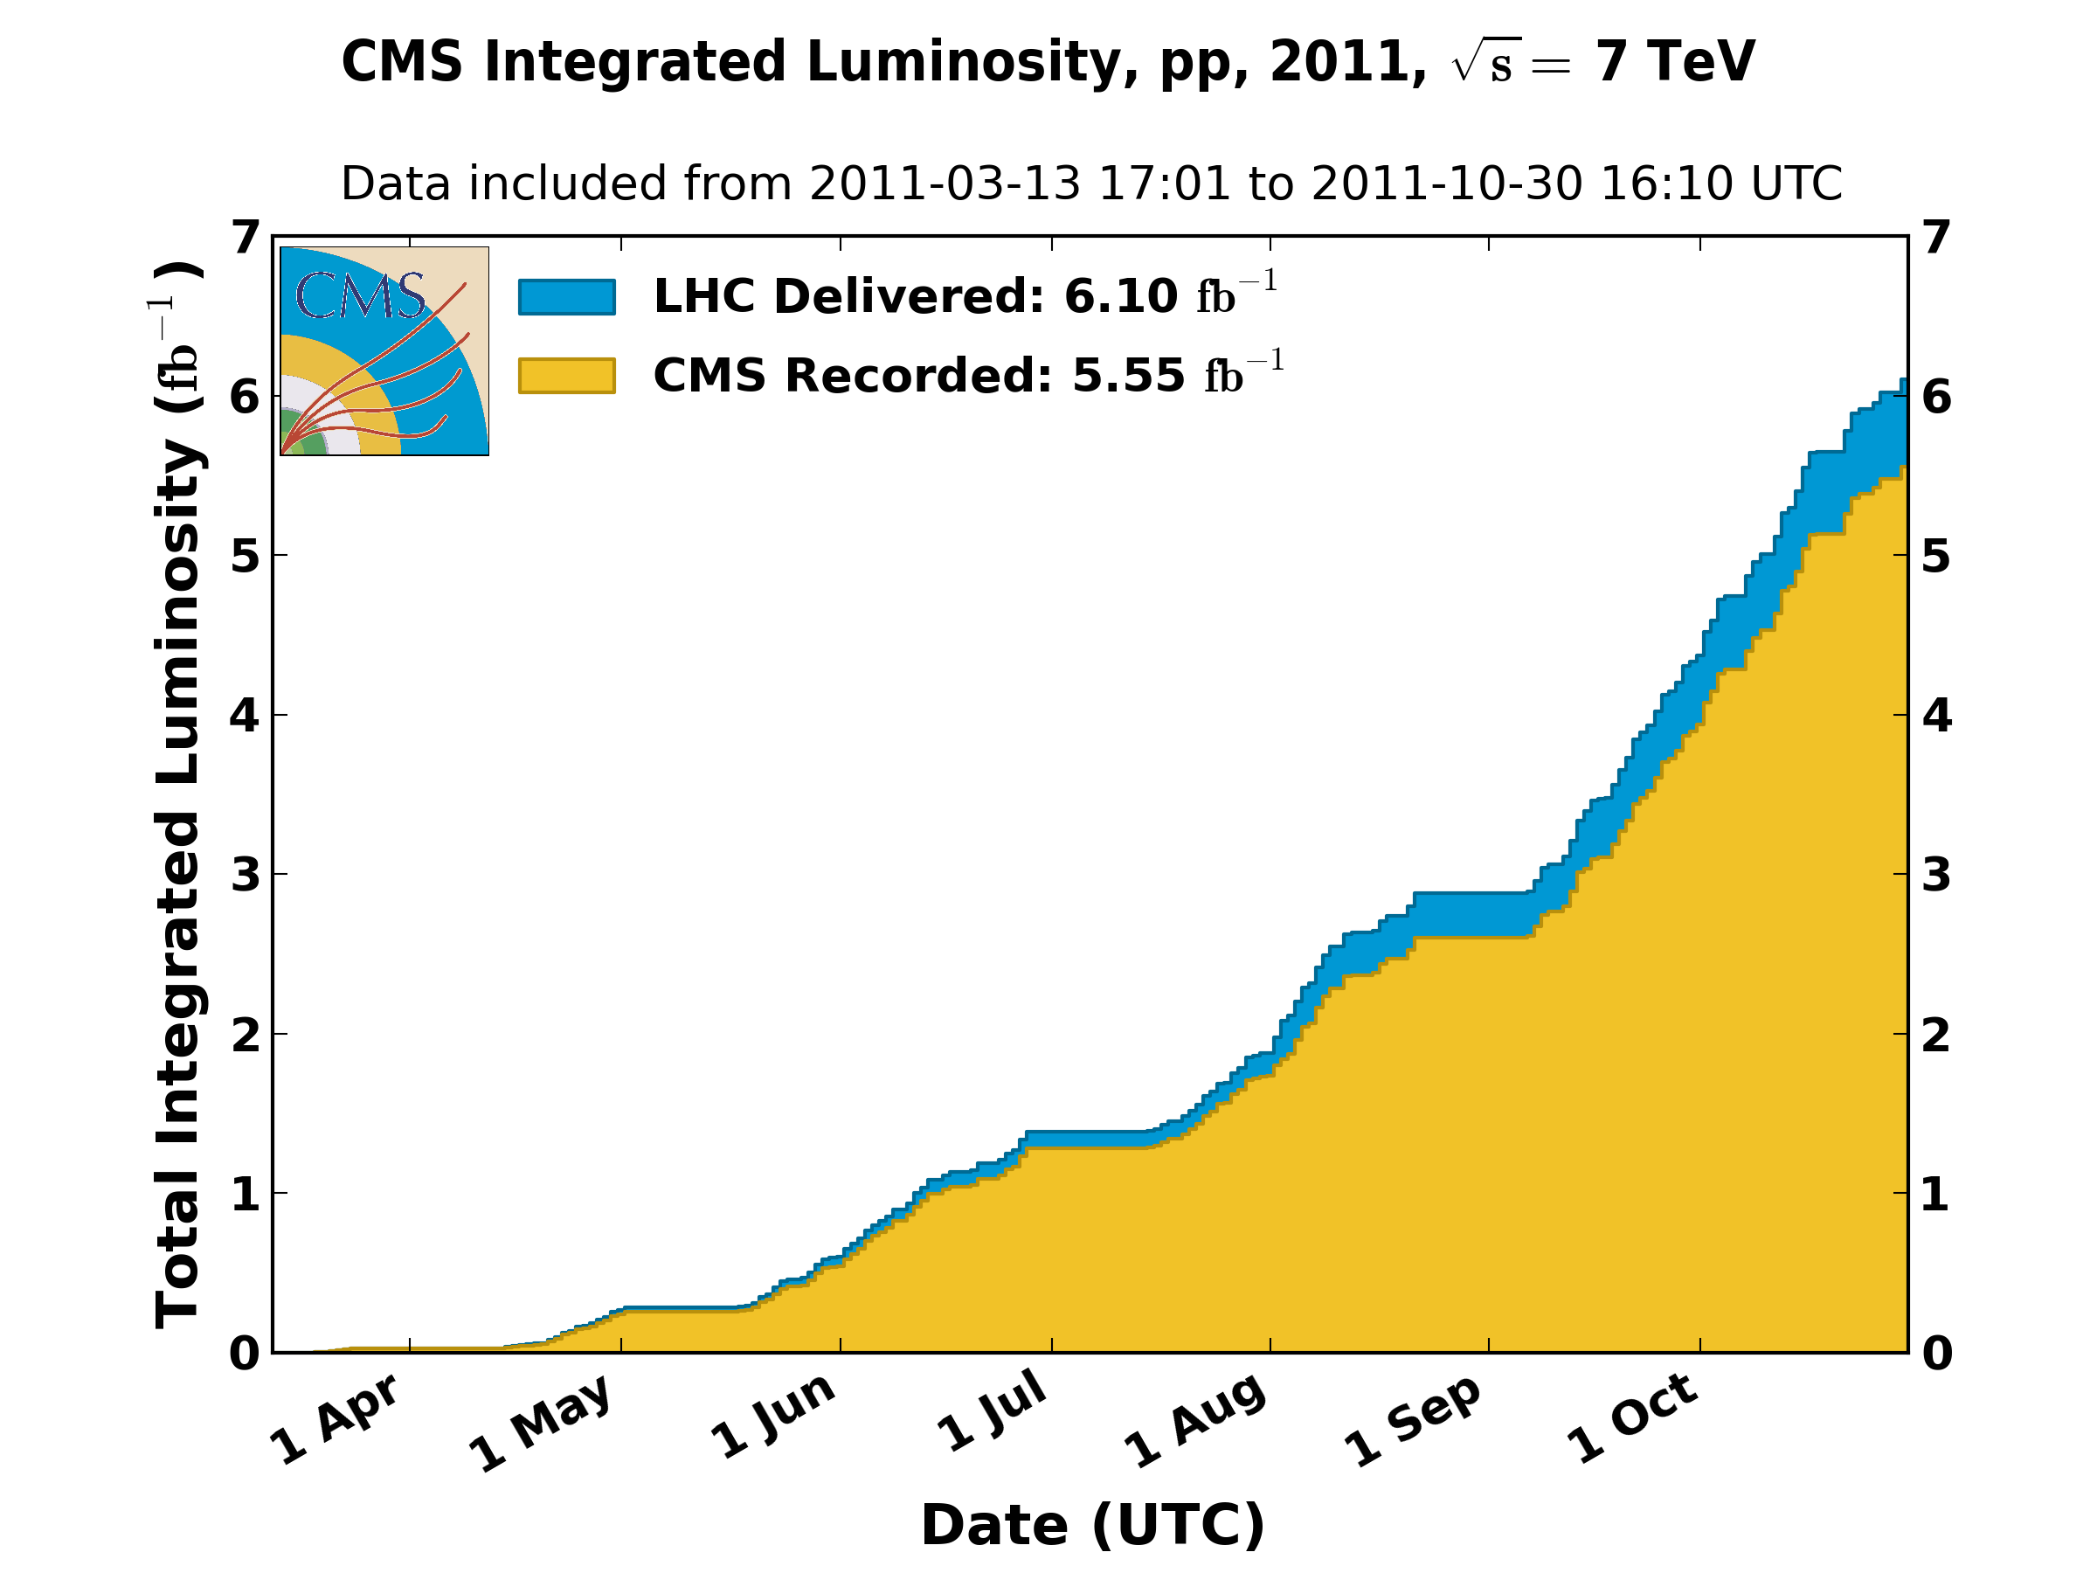
[Discuss this result by comparing it to the expected value for the period studied].

Measurement of the mass and the width of the Z boson

From the distribution obtained, we can also obtain the mass and the width of the Z boson. To do this, we carry out a fit of the distribution obtained with an appropriate function.
Explain which functions are used to describe signal and background noise. If you deem it necessary, you can submit more than one fit. However, your result for mass and width must be unique.
 | Data  (this lab) | PDG  (https://goo.gl/wx4Yi0)
Mass
Width

[Discuss the result in one paragraph. OK? Possible bias?]

[If you have had the time, discuss one or the other additional point proposed in the “Other studies” section]

Observation of the W boson
As before, we have for this analysis “ntuples” files obtained for data and for Monte Carlo simulations.
To gain precision during the – more difficult – evaluation of efficiency, we will use this time an official Monte Carlo file from the CMS collaboration, obtained by a detailed simulation of the detector. We can use the file obtained in point 2 for comparison.

In this report, we will focus on the channel containing electrons/muons (to be specified).

By studying the simulation file, and comparing it to the data file, we were able to deduce the following set of selection cuts:

[specify the cuts used in ROOT]

These cuts can be understood as follows:

[explain what the cuts do , physically, and why they are "logical" knowing that we are looking to see a W boson.]

[Illustrate the cuts using a few graphs]

Legend (example) | Legend (example)
Legend (example) | Legend (example )

These cuts make it possible to obtain a pure sample of events compatible with the production of a W boson. There remains, however, a non-negligible contamination of “QCD” events in which an electron or a muon has been erroneously reconstructed. To estimate this contribution, we construct a "control region" with the same kinematic characteristics as the "signal" region, but in which the W events are negligible as follows:

[present the strategy for constructing the control region]

The code then allows us to evaluate the purity of the sample by performing a fit of the data by two components: the signal distribution predicted by the simulation and the background noise distribution obtained in the control region.

We obtain the following results:

Purity:
Number of selected MC events:
Number of selected data events:
Estimated number of W bosons:
Estimated number of noise events:

Knowing the luminosity, we can calculate the cross section of the studied process, and compare it to the expected cross section: Cross

section W:

[Discuss the result by comparing it to the expected values]

[If you have had time, discuss one or the other point proposed in the section “Other studies”]

