SDA Project: Assignment 5

**trafficCountApp**

Application Development Report

by Tim Delaney

Bachelor of Science in Information Technology

Open Education

Dublin City University



This report is in response to Assignment 5 of SDA module and includes two deliverables. The first deliverable includes a fully developed android application. The second is a report outlining the development stages and thought processes associated with the application and any other relevant information.

Contents

1 Executive Summary 1

2 Introduction 2

2.1 Purpose of this report 2

2.2 Scope 2

2.3 Time Table 2

3 Stage 1 – Design Concept 4

3.1 Idea Generation 4

3.2 Target Market 6

3.3 Design 6

3.4 FUNCTIONALITY 6

4 Stage 2 – Use Case Design 8

4.1 Use Case Diagram 8

4.2 Use Case Tables 9

4.2.1 Enter User Details 9

4.2.2 Enter Location Details 10

4.2.3 Enter Count Details 11

4.2.1 Count Traffic 12

4.2.2 Share/Upload Count Data 13

4.2.3 Extract Data 14

5 Stage 3 - Database Design 15

5.1 Entity Diagrams 15

5.2 Relationship Matrix 16

5.3 ER Diagram 16

5.4 Assumptions 17

5.5 Entity Tables 17

6 Stage 4 – Mock-up Design 18

6.1 Screen 1 19

6.2 Screen 2 19

6.3 Screen 3 19

6.4 Screen 4 19

6.5 Screen 5 19

6.6 Screen 6 20

6.7 Screen 7 20

6.8 Screen 8 20

6.9 Screen 9 20

6.10 General 20

7 Stage 4 – Debugging and Testing 21

7.1 Debugging Issues 21

7.2 Testing Plans 21

8 Stage 5 – TBD 22

8.1 TBD 22

References 23

APPENDICES

Appendix 1: Xxxxxxx

# 

# Executive Summary

1.1 Xxxxx.

1.2 Xxxxxx:

* Xxxxxx
  + Xxx
  + Xxx
* Xxxxxx
  + XXX
  + XXX
  + Xxxx

1.3 Xxxxx:

1. Xxxxx
2. Xxxxx
3. Xxxxx

1.3 Xxxxx.

# Introduction

Xxxx

## Purpose of this report

Xxxxx

## Scope

Xxxxx

## Time Table

The original time table for this project is shown in Figure 2.1.



Figure 2.1: Original time table (21 February 2016)

# Stage 1 – Design Concept

## Idea Generation

My idea for this project is to develop an app which counts traffic at a various types of junction. I work as a civil engineer and specialise in road and traffic design. Over the last 15 years, I have undertaken numerous of traffic surveys using an A4 sheet on a clip board (see sample copy attached). The problem with this system is:

* original hardcopy data is often lost;
* details are often recorded inaccurately;
* raw data needs to be manually added and tabulated;
* data is grouped in 15 min block segments.

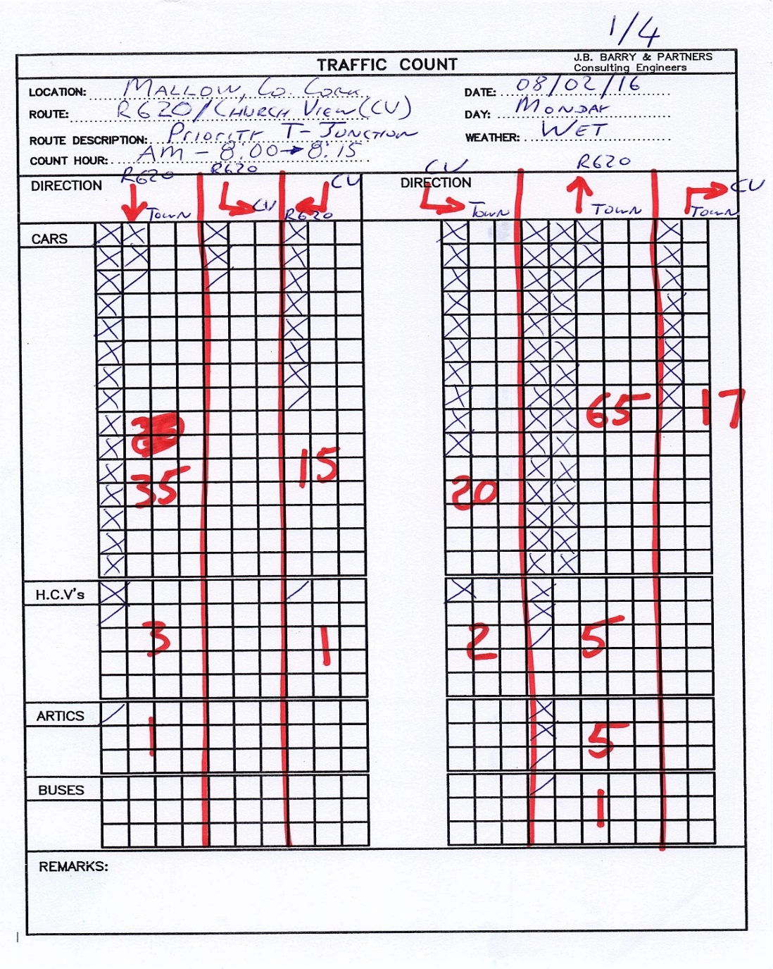

Figure 3.1: Sample of current traffic count sheet in use.

## Target Market

To provide a useful one-shop tool to complete simple traffic surveys that my colleagues and I can use. The app is not intended for a commercial market but rather as a useful tool for specialist traffic engineers and their assistants. This app will offer the following advantages over what currently exists. The app will be:

* instant, responsive, adaptable and make it easier to share data;
* simple, friendly and intuitive to use;
* cognitively mappable to the direction of traffic streams;
* more productive requiring less preparatory and manual processing;
* more precise in terms of time intervals, location and vehicle categorisation;
* easy to synchronise between multiple users during simultaneous surveys;
* less prominent for users and more rain friendly than paper + clipboard.

## Design

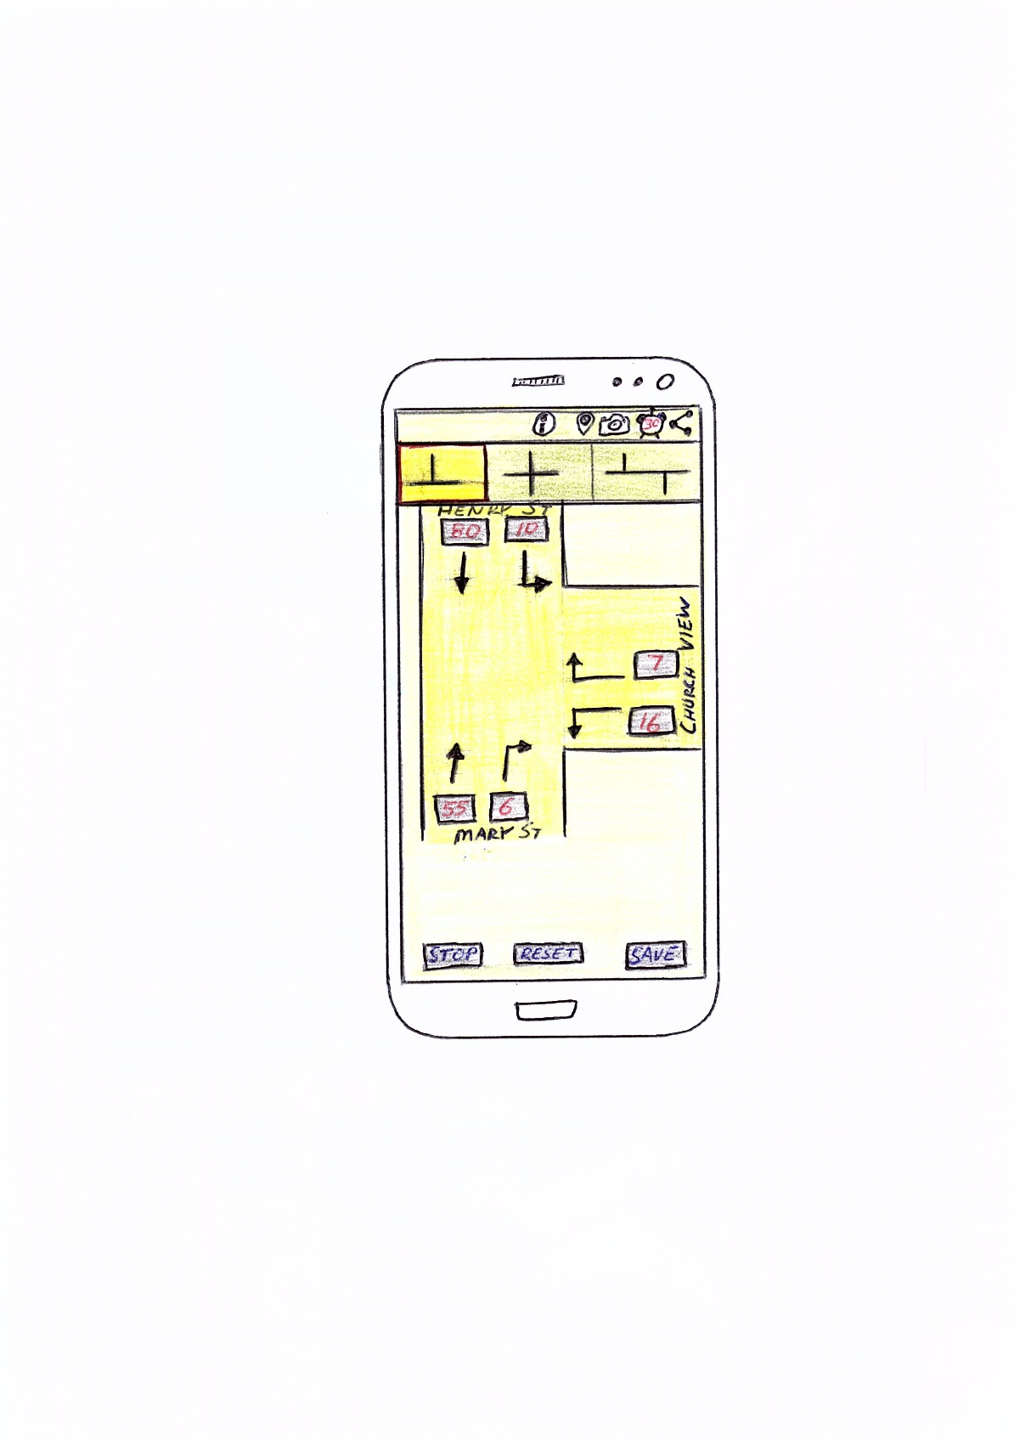An earlier decign concept mockup of the App is shown in Figure 3.2.

The app will use the following Android API classes:

* Multimedia: It will allow the saving of an associative pic (and maybe video) which will be tagged to the data;
* Sensors/Location Services: It will record the GPS coordinate of the user and pin point the junctions location on a map which will be linked to the count data;
* Networks/Google Cloud: It will upload all of the data to Google Cloud in the form of a summary or spreadsheet (depending on complexity and time); and/or
* Database: Possibly but requires further consideration.

The app will have a target SDK of 21 with a minimum SDK of 16. Figure 3.2: Early mock-up

## FUNCTIONALITY

This app will contain an action bar, tabs, fragments, user preferences/settings, notifications and toast messages. The app will use the devices own:

* camera to take a snapshot of the junction in question;
* GPS to record the users location; and
* clock to take note of the start/finish times and to allow a countdown timer

The app will use google maps to pinpoint the junction location. It will use buttons, text views and text edits. It may distinguish between ‘one-click’ and ‘double click’ of the button counter in order to allow a certain degree of classification (ie cars and HGVs). It will display a graphical image of each junction type as background.

# Stage 2 – Use Case Design

## Use Case Diagram

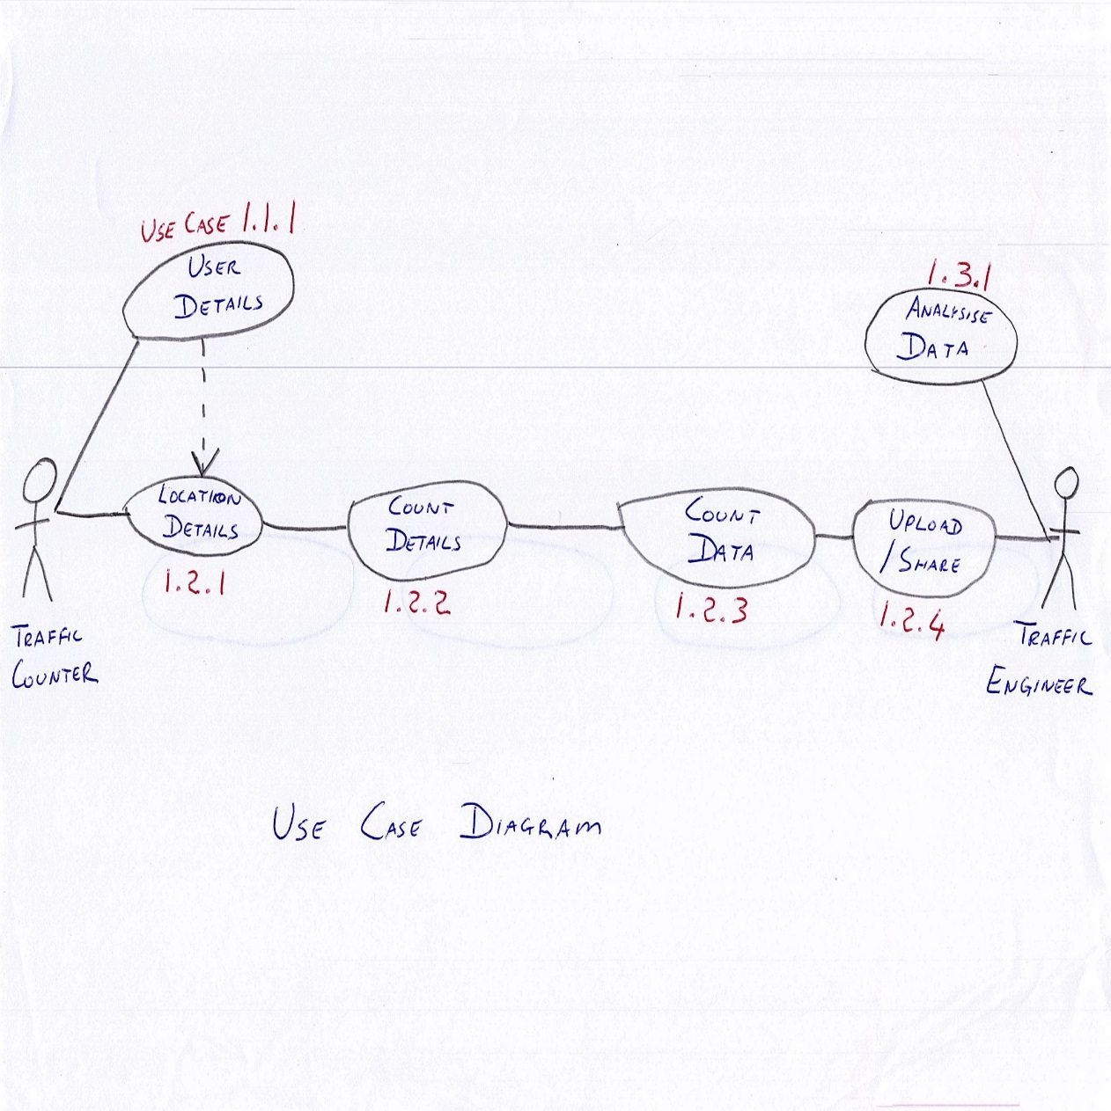

**Figure 4.1**: Use Case Diagram

## Use Case Tables

### Enter User Details

|  |  |  |  |  |
| --- | --- | --- | --- | --- |
| **Use Case ID:** | UC-1.1.1 | | | |
| **Use Case Name:** | Enter user details | | | |
| **Created By:** | Tim Delaney | | **Last Updated By:** | Tim Delaney |
| **Date Created:** | 05.03.2016 | | **Last Revision Date:** | 05.03.2016 |
| **Actors:** | | 1. Person who is to conduct a traffic count. 2. System/App. | | |
| **Description:** | | The reason for this is to link a traffic survey with a specific person. The details will include: name, employee no., position in company, mobile device used. It will not be mandatory to complete this task. This data will be store on the user’s device as a user preference. Default values may be: anonymous, null and unspecified, TBD. | | |
| **Trigger:** | | An icon in the action bar will be provided for the user to select. | | |
| **Preconditions:** | | The user must be given the App to download. | | |
| **Post conditions:** | | The user details will be linked to the data along with the date and can be used as a Primary Key for a possible database. The user may be restricted from uploading count data onto a database with first entering user details, TBD (To Be Determined). | | |
| **Normal Flow:** | | 1. From any screen, the user can click on the user preferences icon found the Action Bar 2. User enter first name, last name, employee no. and name of mobile device 3. User presses enter to submit 4. System/App saves data 5. Screen return to its previous screen | | |
| **Alternative Flows:**  **[Alternative Flow 1 – Not in Network]** | | None, except all fields do not necessary have to be completed, TBD when more is known on what criteria should be set for database uploading. | | |
| **Exceptions:** | | In step 2 of the normal flow, if the user enters an invalid employee no or very long name, it will not submit. Maybe the field with the error might be highlighted in some way, TBD. | | |
| **Includes:** | | None | | |
| **Frequency of Use:** | | This use case will be generally used only once per device, but may be updated by the user at any time. | | |
| **Special Requirements:** | | 1. Restrict first name and surname to certain field length, say 10 alphabetical characters each 2. Employee number is a certain length and specific format | | |
| **Assumptions:** | | 1. The users understands either English. 2. The user has an employee number. | | |
| **Notes and Issues:** | | 1. Will it be compulsory for a user to enter user details? 2. Will there be access limitation to certain users such upload to database? 3. Maybe use drop-down options for consistency and for ease of use purposes in the case of device used and company position? | | |

### Enter Location Details

|  |  |  |  |  |
| --- | --- | --- | --- | --- |
| **Use Case ID:** | UC-1.2.1 | | | |
| **Use Case Name:** | Enter location details | | | |
| **Created By:** | Tim Delaney | | **Last Updated By:** | Tim Delaney |
| **Date Created:** | 05.03.2016 | | **Last Revision Date:** | 05.03.2016 |
| **Actors:** | | 1. Person who is to conduct a traffic count. 2. System/App. | | |
| **Description:** | | The reason for this is to link a traffic survey with a specific junction as there could be multiple traffic survey conducted at different periods at the same junction. The details will include: nearest city/town, junction type, two road names, GPS coordinates and picture of junction (optional). This data will be stored on the user’s device and can be reused for other surveys at this location. | | |
| **Trigger:** | | A pop-up sheet will automatically appear when a junction tab is selected. This sheet will hold last inputted data to be amended accordingly. | | |
| **Preconditions:** | | The user must select a junction type tab from the action bar. | | |
| **Post conditions:** | | This data will be stored locally on the device and will also be shared/uploaded with the count data when submitted | | |
| **Normal Flow:** | | 1. From any screen, the user selects a junction type tab 2. A form will pop-up requesting the following fields to be completed:    1. Nearest city/town    2. Junction type (from drop-down menu)    3. Road Name 1    4. Road Name 2, 3 etc – depending on junction type selected    5. GPS coordinates – Optional (use devices location services)    6. Picture of junction - Optional (use devices camera) 3. User presses enter to store this data locally on the device 4. System/App saves data 5. Depending on if a successful count is completed, this data with be shared/uploaded with the count data 6. Screen changes with count details form popping up, TBD. | | |
| **Alternative Flows:**  **[Alternative Flow 1 – Not in Network]** | | If this data was previous inputted as part of an earlier count, then:   1. The form will appear with the previous junction selection detail shown 2. User skips step 2 above and continues with step 3 by simply pressing the submit button | | |
| **Exceptions:** | | A coordinates and picture of the junction is the only optional field. This allow users to use devices without these features. All other filed must be completed before this form can be successfully submitted. To quit, the user may press the back button. | | |
| **Includes:** | | The next use case (ie count details) is called following a successful submission | | |
| **Frequency of Use:** | | This use case need only be used once per junction common to multiply count periods (ie AM peak hour and PM peak hour), but may be updated by the user at any time upon repressing the junction type section tab. | | |
| **Special Requirements:** | | None | | |
| **Assumptions:** | | 1. The users understands either English. 2. The data is stored locally until such time the device is connected to a network (internet or LAN), TBD. | | |
| **Notes and Issues:** | | None as yet. | | |

### Enter Count Details

|  |  |  |  |  |
| --- | --- | --- | --- | --- |
| **Use Case ID:** | UC-1.2.2 | | | |
| **Use Case Name:** | Enter count details | | | |
| **Created By:** | Tim Delaney | | **Last Updated By:** | Tim Delaney |
| **Date Created:** | 05.03.2016 | | **Last Revision Date:** | 05.03.2016 |
| **Actors:** | | 1. Person who is to conduct a traffic count. 2. System/App. | | |
| **Description:** | | The reason for this is to link a traffic survey with a specific count details as there could be multiple traffic survey conducted at different periods at the same junction. The details will include: date, start time, finish times, weather, and road surface. This data will be stored on the user’s device and needs to be updated for every count. | | |
| **Trigger:** | | A pop-up sheet will automatically appear after the location details are submitted. This sheet will not hold previous set data but with reset to default values to be amended accordingly. | | |
| **Preconditions:** | | The user must successfully submit the location details form before this use case will automatically start. | | |
| **Post conditions:** | | This data will be stored locally on the device and will also be shared/uploaded with the count data when submitted | | |
| **Normal Flow:** | | 1. The user submits the location details form (ie previous use case) 2. A form will pop-up requesting the following fields to be completed:    1. Date (ie 05.03.16)    2. Start time (ie 17:00 format)    3. Finish time (ie 18:00 format)    4. Weather (drop-down menu)    5. Road Surface 2, 3 (drop-down menu) 3. User presses enter to store this data locally on the device 4. System/App saves data 5. Depending on if a successful count is completed, this data with be shared/uploaded with the count data 6. Screen changes to count screen opens with the appropriate junction type format and maybe a stopwatch/timer appear, TBD. | | |
| **Alternative Flows:**  **[Alternative Flow 1 – Not in Network]** | | If this data was previous inputted as part of an earlier count, then:   1. The form will appear with the previous junction selection detail shown 2. User skips step 2 above and continues with step 3 by simply pressing the submit button | | |
| **Exceptions:** | | The form submitted may accept default values, TBD. To quit, the user may press the back button. | | |
| **Includes:** | | The next use case (ie count data) is called following submission | | |
| **Frequency of Use:** | | This use case need will be used for every count period (ie AM peak, Noon peak and PM peak hours), and may be updated by the user at any time a location detailed form is submitted. | | |
| **Special Requirements:** | | None | | |
| **Assumptions:** | | 1. The users understands either English. 2. The data is stored locally until such time the device is connected to a network (internet or LAN), TBD. | | |
| **Notes and Issues:** | | Consider excluding date and time as user input and instead automatically recoding times for the first vehicle counted and the last vehicle counted which would make the app simpler to use and reduce the need for redundant data? | | |

### Count Traffic

|  |  |  |  |  |
| --- | --- | --- | --- | --- |
| **Use Case ID:** | UC-1.2.3 | | | |
| **Use Case Name:** | Count traffic | | | |
| **Created By:** | Tim Delaney | | **Last Updated By:** | Tim Delaney |
| **Date Created:** | 05.03.2016 | | **Last Revision Date:** | 05.03.2016 |
| **Actors:** | | 1. Person who is to conduct a traffic count. 2. System/App. | | |
| **Description:** | | This use case does the actual counting of vehicles and allows the resulting data to be shared with others or uploaded to a database. To count a vehicle, the user will click on an equivalent button which represents a direction of travel. Depending on the number and type of click (long vs. short), the total number and type of vehicles making certain movements are recorded. Each vehicle (or button clicked will also be save individually with its time recorded to allow for a complete and full analysis, TBC. | | |
| **Trigger:** | | After the count details form is submitted, the user can press the start button which will initiate a stopwatch/timer. The device clock will also be visible. | | |
| **Preconditions:** | | The user must submit the count details form even if it remains at its default input before this use case can be started by a button click. | | |
| **Post conditions:** | | This data will be stored locally on the device and can be shared/uploaded when connected to a network (internet or LAN). | | |
| **Normal Flow:** | | 1. The user submits the count details form (ie previous use case) 2. The user clicks on a start button at the appropriate time 3. To count a vehicle, the user click on its equivalent button which represents the direction of travel. 4. A long click of a button represents a heavy goods vehicle or bus 5. A short click represents a car or light goods vehicle 6. The time and type of each click is recorded for that direction of travel 7. These buttons with have the vehicle total (communitive sum of both cars and HGVs combined) displayed on them. This will also allow for user feedback as to the click been registered. A sound may also accompany each click and different sounds may indicate a vehicle type, TBD. 8. The count will stop when the stopwatch/timer indicates zero. 9. The user can then choose between a buttons to save the data locally to the device or to upload to a database there and then or afterwards. 10. System/App saves data 11. The user can also view a summary of the data as a toast message. | | |
| **Alternative Flows:**  **[Alternative Flow 1 – Not in Network]** | | Consideration will also be given to a pause, stop and reset button which can interrupt the above steps, TBD. | | |
| **Exceptions:** | | Consider using an undo button to in the case of miss-click, TBD. The back button may also stop the count, TBD. | | |
| **Includes:** | | The next use case (upload/share data) is called this use case. | | |
| **Frequency of Use:** | | This use case will be used for every count period. | | |
| **Special Requirements:** | | Consider a comment/remarks section to enable the user to record unexpected events such a car accidents, Garda escort or traffic signal outage. | | |
| **Assumptions:** | | The data is stored locally until such time the device is connected to a network (internet or LAN), TBD. | | |
| **Notes and Issues:** | | Instead of the timer automatically stopping the count, consider using a pause/stop/restart button. | | |

### Share/Upload Count Data

|  |  |  |  |  |
| --- | --- | --- | --- | --- |
| **Use Case ID:** | UC-1.2.4 | | | |
| **Use Case Name:** | Upload/share data | | | |
| **Created By:** | Tim Delaney | | **Last Updated By:** | Tim Delaney |
| **Date Created:** | 06.03.2016 | | **Last Revision Date:** | 06.03.2016 |
| **Actors:** | | 1. Person who is to conduct a traffic count. 2. System/App. 3. Traffic Engineer to receive an email (optional) | | |
| **Description:** | | This use case allows the users to share the count data with others by email or uploading the data to a database, TBC. | | |
| **Trigger:** | | After the traffic count is stopped, the user will be presented with a series of options such as save, email or upload the count data. | | |
| **Preconditions:** | | An count must be stopped | | |
| **Post conditions:** | | This data will be stored locally on the device and can be shared/uploaded when connected to a network (internet or LAN). | | |
| **Normal Flow:** | | 1. The user presses stop as part of the previous use case 2. The user is presented with a toast message of a summary of the count 3. The user is then presented with a more options 4. The user can save the data to their device 5. The user can share the data by email 6. The user can upload the data to a database 7. System/App saves data 8. After the user chooses one of the options, the screen will change to its home screen, TBD | | |
| **Alternative Flows:**  **[Alternative Flow 1 – Not in Network]** | | No alternative | | |
| **Exceptions:** | | Consideration will also be given to a delete button, TBD. The back button may also go back to previous saved state, TBD. | | |
| **Includes:** | | The next use case (upload/share data) is called this use case. | | |
| **Frequency of Use:** | | This use case will be used for every count period. | | |
| **Special Requirements:** | | WiFi/network connection required to upload data | | |
| **Assumptions:** | | The data is stored locally until such time the device is connected to a network (internet or LAN), TBD. | | |
| **Notes and Issues:** | | The count data is combined with the count, location and user (default values at least) details and is uploaded/shared as one entity | | |

### Extract Data

|  |  |  |  |  |
| --- | --- | --- | --- | --- |
| **Use Case ID:** | UC-1.3.1 | | | |
| **Use Case Name:** | Extract data | | | |
| **Created By:** | Tim Delaney | | **Last Updated By:** | Tim Delaney |
| **Date Created:** | 06.03.2016 | | **Last Revision Date:** | 06.03.2016 |
| **Actors:** | | 1. Traffic Engineer to extract required data 2. Database | | |
| **Description:** | | This use case allows the Traffic Engineer to access the count data. It may be possible to download the date onto an Excel spreadsheet, TBC. | | |
| **Trigger:** | | After the traffic count is uploaded. Maybe a notification could be sent to the Traffic Engineers by text or email. | | |
| **Preconditions:** | | An count data must be uploaded | | |
| **Post conditions:** | | None | | |
| **Normal Flow:** | | 1. The user presses stop as part of the previous use case 2. The user is presented with a toast message of a summary of the count | | |
| **Alternative Flows:**  **[Alternative Flow 1 – Not in Network]** | | The data may be shared directly from the traffic counter to the Traffic Engineer by email or by USB, TBD | | |
| **Exceptions:** | |  | | |
| **Includes:** | | None | | |
| **Frequency of Use:** | | This use case will be used for every count period. | | |
| **Special Requirements:** | | WiFi/network connection required to download data | | |
| **Assumptions:** | | Azure or similar will be used, TBD. | | |
| **Notes and Issues:** | | The count data will be downloaded from a database to an Excel spreadsheet, TBD | | |

# Stage 3 - Database Design

Xxxxxx.

## Entity Diagrams



## Relationship Matrix

|  |  |  |  |  |
| --- | --- | --- | --- | --- |
| Relationship Matrix | | | | |
| Entities | **User Details** | **Location Details** | **Count Details** | **Count Data** |
| User Details | 0 | 0 | 3 | 3 |
| Location Details | 0 | 0 | 2 | 0 |
| Count Details | 3 | 2 | 0 | 1W |
| Count Data | 3 | 0 | 1W | 0 |

## ER Diagram

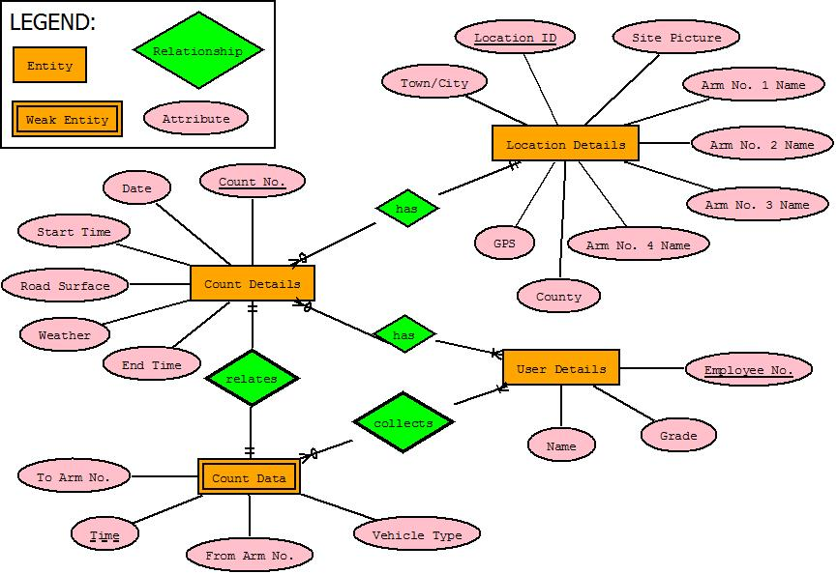

Figure 5.2: ER Diagram

## Assumptions

1. Assume maximium of 2 users per count
2. Assume GPS N and W coordinates can be combined as one input
3. Assume maximium no. of arms per junction is 4
4. Time in the Count Data Table is in milliseconds (ie long millis = System.currentTimeMillis() % 1000;)
5. Drop-down menus will be used as much as possible for consistency
6. Location ID and Count No. primary keys will automatically increment by one for each entry.

## Entity Tables

|  |  |  |
| --- | --- | --- |
| User Details | | |
| Employee_No.  (PK) | Name | Grade |
| 454002 | Tim Delaney | Associate |

|  |  |  |  |  |  |  |  |  |
| --- | --- | --- | --- | --- | --- | --- | --- | --- |
| Location Details | | | | | | | | |
| Location ID  (PK) | Town | County | GPS | Site Picture | Arm No. 1 Name | Arm No. 2 Name | Arm No. 3 Name | Arm No. 4 Name |
| 1 | Dublin | Dublin | 53.3850N, 6.2565W | ? | Collins Avenue | Ballymun Road south | Glasnevin Avenue | Ballymun Road north |

|  |  |  |  |  |  |  |  |  |
| --- | --- | --- | --- | --- | --- | --- | --- | --- |
| Count Details | | | | | | | | |
| Count _No.  (PK) | Location _ID  (FK) | Employee1 _No.  (FK) | Employee2 _No.  (FK) | Date | Start Time | End Time | Weather | Road Surface |
| 1 | 1 | 454002 | Null | 140316 | 7:45 | 9:15 | Rain | Wet |

|  |  |  |  |  |  |
| --- | --- | --- | --- | --- | --- |
| Count Data | | | | | |
| Time  (PK) | **Location ID**  **(PK) (FK)** | **Employee _No.**  **(PK) (FK)** | Vehicle_ Type | From_ Arm_No. | To_ Arm_No. |
| 27965394 | 1 | 454002 | HGV | 2 | 3 |

# Stage 4 – Mock-up Design



## Screen 1

From Figure 6.1, screen 1 will be the home screen where user details are displayed. After the App is fist download and run, it will shower default values, such as Anonymous and Not Known. The Employee No may have to be inputted as it is a primary key in the database. The user is free and encouraged to update these details. Once OK is pressed, these detail will be stored to the device for future runs.

## Screen 2

From Figure 6.1, screen 2 will appear as soon as screen 1 details are accepted. Screen 2 will look for location details. Like screen 1, default values will be displayed and this screen will hold the detail of any previous traffic count location. This activity will use implicit indent to access the phones maps and camera, although this will not be compulsory.

## Screen 3

From Figure 6.1, screen 3 will appear as soon as screen 2 details are accepted. Screen 2 will look for location details. Like screen 1, default values will be displayed and this screen will hold the detail of any previous traffic count location. This activity will use implicit indent to access the phones calendar for the date which can also be manually set.

## Screen 4

From Figure 6.1, screen 4 will appear as soon as screen 3 details are accepted. Screen 4 will allow the user to select a junction type from the tabs and then optionally edit the junction arm names (ie street names). An arm naming convention will apply which uses a north-sign resulting in arm 1 is east of the junction, arm 2 is always south and so on. A timer will appear set to the duration of the count as per the Count Details screen which is usually 90 seconds or 60 seconds.

## Screen 5

Screen 5 will display as soon as the START button is pressed, the counter will count down and the counter button will activate. The START button will NOW display and function as PAUSE (and CONTINUE as appropriate). Each time the button is pressed the number displayed on the button will increment by 1 vehicle. A short press will indicate a car and a long press (with perhaps a tone) will indicate a HGV will look for location details. Like screen 1, default values will be displayed and this screen will hold the detail of any previous traffic count location. This activity will use implicit indent to access the phones calendar for the date which can also be manually set.

## Screen 6

Screen 6 will display as soon as the counter reaches zero and the count buttons will deactivate. The PAUSE button will change to DONE.

## Screen 7

Screen 7 will display as soon as the done BUTTON is pressed. It will offer multi-options for the user to SAVE, EMAIL, UPLOAD or DELETE the data.

## Screen 8

Screen 8 will appear as soon after an option from screen 7 is picked. Figure 6.1 assumes the option to UPLOAD is picked and shows an appropriate upload in process status bar. Alternative screens (not shown in Figure 6.1) will appear to match the appropriate option.

## Screen 9

Screen 9 will be displayed as soon as the actions of Screen 7 is complete. It is a confirmation screen and allows the user to return to the home screen (screen 1).

## General

In general the above screens are only mock-up and may vary during App development. Additional screen may also be added as required. An action bar will most likely to be included to allow the user to edit user, location and count details at any stage of the count. It may be possible to allow the devise back button to undo a wrongly counted vehicle or return to the previous screen depending what screen is displayed.

# Stage 4 – Debugging and Testing

Xxxxxx.

## Debugging Issues

Xxxxxx.

## Testing Plans

Xxxxxx.

# Stage 5 – TBD

Xxxxxx.

## TBD

Xxxxxx.

# References

CSO. 2014. Central statistics office statistics. CSO.ie [Online], 2015. Available from*:* [*http://www.cso.ie/en/index.html*](http://www.cso.ie/en/index.html) [Accessed 25 April 2015].

Immink R and O’Kane B. 2009. *Start your own business: a workbook*. 3rd ed. Cork: Oak Tree Press.