Energy & Environment

Summary based on the lecture slides

by MArtin Winter

2016

Contents

Introduction 1

# Introduction

## Initial situation

Today, about 7.3 billion people live on this planet and still more than 2 billion are without access to energy as poverty remains a global problem with big differences in the distribution of wealth. Additionally, more and more people live in so-called mega-cities with more than 5 million people per city.

But not only the population is growing, with it there is also rapid growth in energy demand that leads to some societal challenges, that include **local** and **global environmental pollution**, **limited resources** and also the **societal acceptance** and **risk aspects** connected to such a growth in energy providers. Typically, 1% increase in population leads to an 1% increase in emissions. The population is growing nearly everywhere, except for the European union, this leads also to a population pyramid that isn’t a pyramid at all any more, more like a vase that keeps getting bigger at the top and shrinking at the bottom. Compared to that India has a much larger base population that may be able to sustain their elderly population.

## Global Agenda 2015

This is an **analysis** of the **top 10 trends** and takes key regional challenges and emerging issues into account that will define our future, these trends include the **rising pollution in the developing world**, the **increasing occurrence of severe weather events** and the **increasing water stress**.

#### Rising pollution in the developing world

Developing countries will suffer most from weather-related disasters and increased water stress caused by global warming, these countries are expected to bear up to 80% of the impact costs of global warming.

**Solutions** include investing in a cleaner power generation network, ensuring proper regulation and promoting clean energies, funding provided from richer countries and also cooperation to develop new low-carbon technologies. The problem always is that high carbon solutions, once implemented, are difficult to replace, therefore decisions being made today on power generation are crucial.

The cost of the increasing occurrence of extreme weather events will be highest for society’s poorest as well as the increasing water stress that will rise quite extraordinarily.

##### emerging Nuclear powers

Electricity demand in developing countries is increasing by about 5% per year, because of that alternatives to meet the electricity demand have to be found, for example nuclear power.

## World Energy outlook

The **International Energy Agency** is an autonomous agency the tries to **promote sustainable energy policies**, **improve transparency** of **international energy markets, support global collaboration** on **energy technology** and also **find solutions** to **global energy challenges**.

It takes a look different scenarios, principally the **current policies scenario**, the **new policies scenario** and also the **450 scenario**, that tries to keep the CO­­­­­­­­­2 concentration below 450 ppm eq. The biggest contributors are China, USA and India.

The power sector offers the largest possibility for additional abatement, now about every third power plan of new capacity was low carbon, to meet the 450 scenario would mean that this needs to shift to 3 out of 4 after 2030.

### Global Energy trends

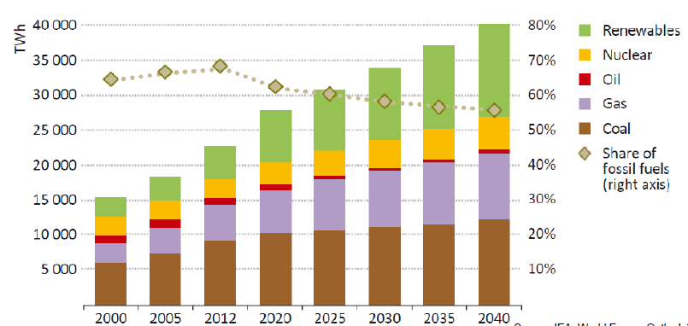The energy demand is expected to increase by 37% according to the new policies scenario or even 50% according to the current policies scenario in the next 30 years, almost all of this increased demand comes from Non-OECD countries. In general, the share of fossil fuels in the energy mix is expected to fall while the share of low carbon fuels should increase, but in total the world oil supply is also expected to rise.

#### Market outlook

Electricity remains the **fastest-growing** final form of energy and will nearly double until 2040, also gas and nuclear will replace the share of coal and oil while the share of renewable energies should nearly triple until 2040.

**Renewable energy** is rapidly increasing and driving up its share, wind power capacity additions are the second largest behind gas fired plants while PV gets the largest increase among RE with the EU remaining the largest financial supporter of RE.

### Access to Electricity

Energy poverty is still widespread, in some African countries only 15-30% of the population has access to electricity.

# Header

Test