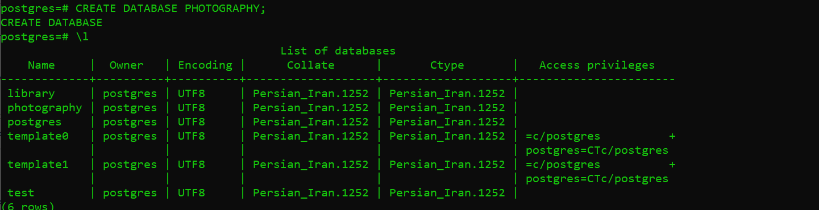

**1-1**

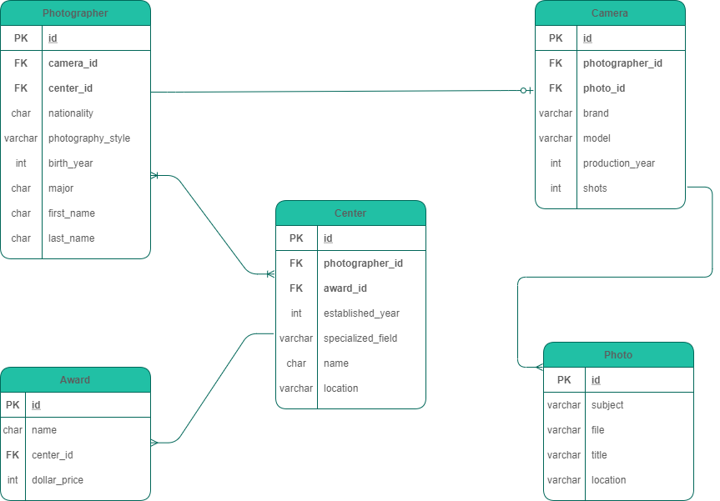

**1-2**

**1-3**

A. Connecting to the database



B. Creating tables



C. Adding the foreign keys to the tables



D. Watching details of the tables

Foreing keys

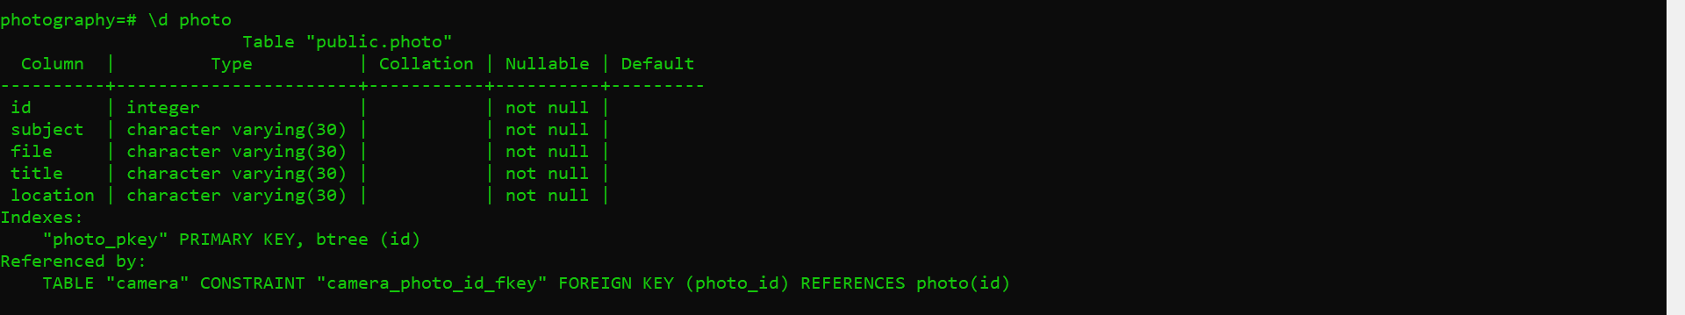

Foreing keys

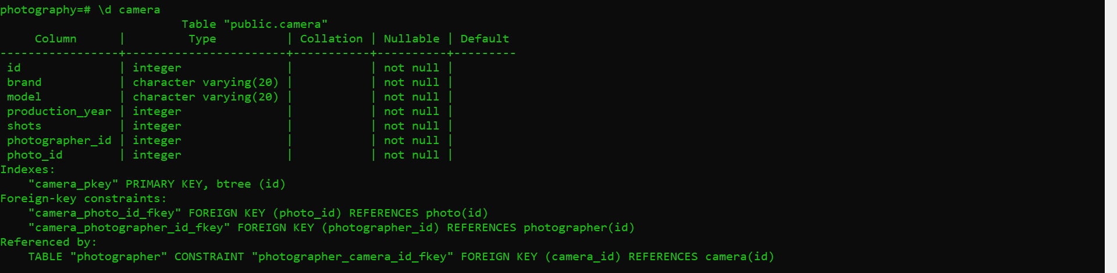

Foreing keys

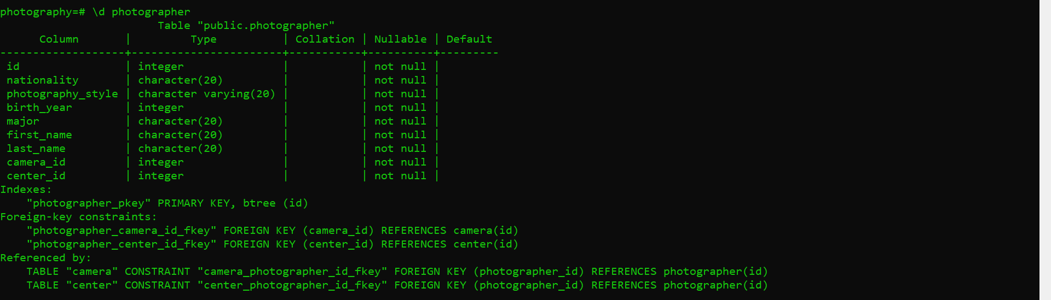

Foreing keys

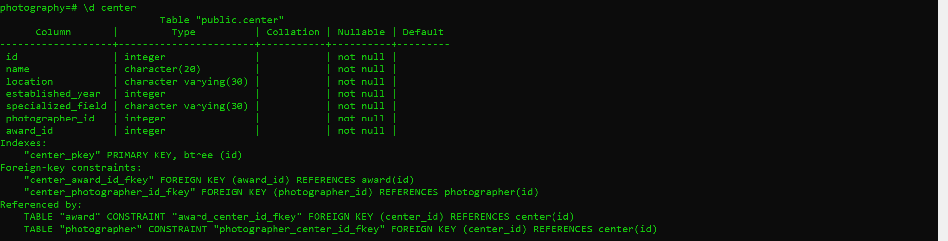

Foreing keys

