

LOW VOLUME TRAINING

DISCLAIMER
AII rights reserved. No part of this book may be used or reproduced by any means, graphic, electronic, or mechanical, including photocopying, recording, taping or by any information storage retrieval system without the written permission of the author, except in the case of brief quotations embodied in critica! articles or reviews. Readers should be aware that Internet Web sites offered as citations and/or sources for further information may have changed or disappeared between the time this book was written and when it is read.

Limit of Liability/Disclaimer of Warranty: While the author has used his best efforts and knowledge in researching and preparing this book, he makes no representations or warranties with respect to the accuracy or completeness of the contents of this book and specifically disclaims any implied warranties of merchantability or fitness for a particular purpose. No warranty may be created or extended by sales representatives or promotional sales materials. The advice and strategies contained herein may not be suitable for your particular situation. You should always consult with a medical professional befare beginning any exerc1se program.

The contents of this e-book are not intended for the treatment or prevention of any disease or medical condition, nor as a substitute for medical treatment, nor as an alternative to medical advice. The author is not a licensed healthcare provider ora registered dietitian. Utilizing the information within this e-book is at the sole choice and risk of the reader. lf you engage in this exercise program, you agree that you do so at your own risk, are voluntarily participating in these activities, assume all risk of injury to yourself, and agree to release and discharge the publisher and the author from any and all claims or causes of action, known or unknown, arising out of the contents of this book.

The author advises you to take full responsibility for your safety and to know your limits. Befare practicing the skills described in this book, be sure that your equipment is well maintained and do not take risks beyond your level of experience, aptitude, training, and comfort level.

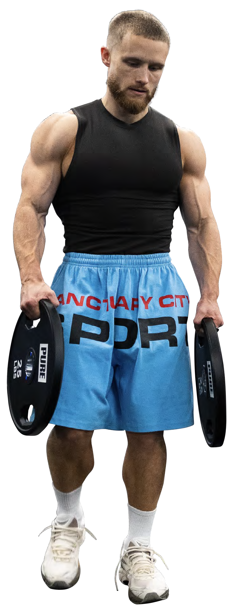
TABLE OF CONTENTS
The Min-Max Program Explained

3 Who This Program Is For

How This Program Works

Measuring Effort with Reps
8 in Reserve (RIR)

10 Brief Program Structure Overview How to Run This Program

Muscle Anatomy

2 O The Min-Max Program

Frequently Asked Questions

Final Thoughts





Befare I get into the details of my new program, 1 want to say thanks far supporting my work. lt really means a lot.

1 fell in lave with low-volume training during my cut this year.

"Low volume" just means a relatively low number of sets, with "volume" being the number of hard sets you do in a workout, or in a week. lt's the opposite of a high-volume program, in which you do a lot of sets.

This is how I break it down:

Low | 1-2 | 2-8
Moderate | 2-3 | 8-15
High | 4-6 | 15-30

l've always been more of a moderate- to high-volume guy. But this year, 1 switched to a very-low-volume program. l'm not exaggerating when I say it's been the best training experience l've ever had during a fat-loss phase.

That experience motivated me to write The Min-Max Program, which is based around the same low-volume, high-intensity principies I used to get in my best shape ever.

Even though I was in a caloric deficit when I ran this program, it will still work in a caloric surplus or at caloric maintenance. In fact, l'd go so far as to say this is the ideal program far anyone with limited time or who simply prefers to do fewer sets ata higher intensity.

Far our purposes, "intensity" is synonymous with effort. Effort is easily the most important factor when you're training far muscle growth. 1 think it matters far more than volume. And I think the scientific evidence is quite clear in supporting this. As long as your intensity is there, you'II make significant gains with a low-volume program.

This document will walk you through the training philosophy behind this program and highlight a few key details you should know befare getting started.

Again, thank you so much for supporting my work. 1 hope you enjoy the program as much as I did!





1 wrote the Min-Max program with three different lifters in mind:

Lifter 1
Wants quick but effective workouts
Lifter 2
Prefers training with low volume and high intensity
Lifter 3
Wants to retain as much muscle as possible in a caloric deflcit

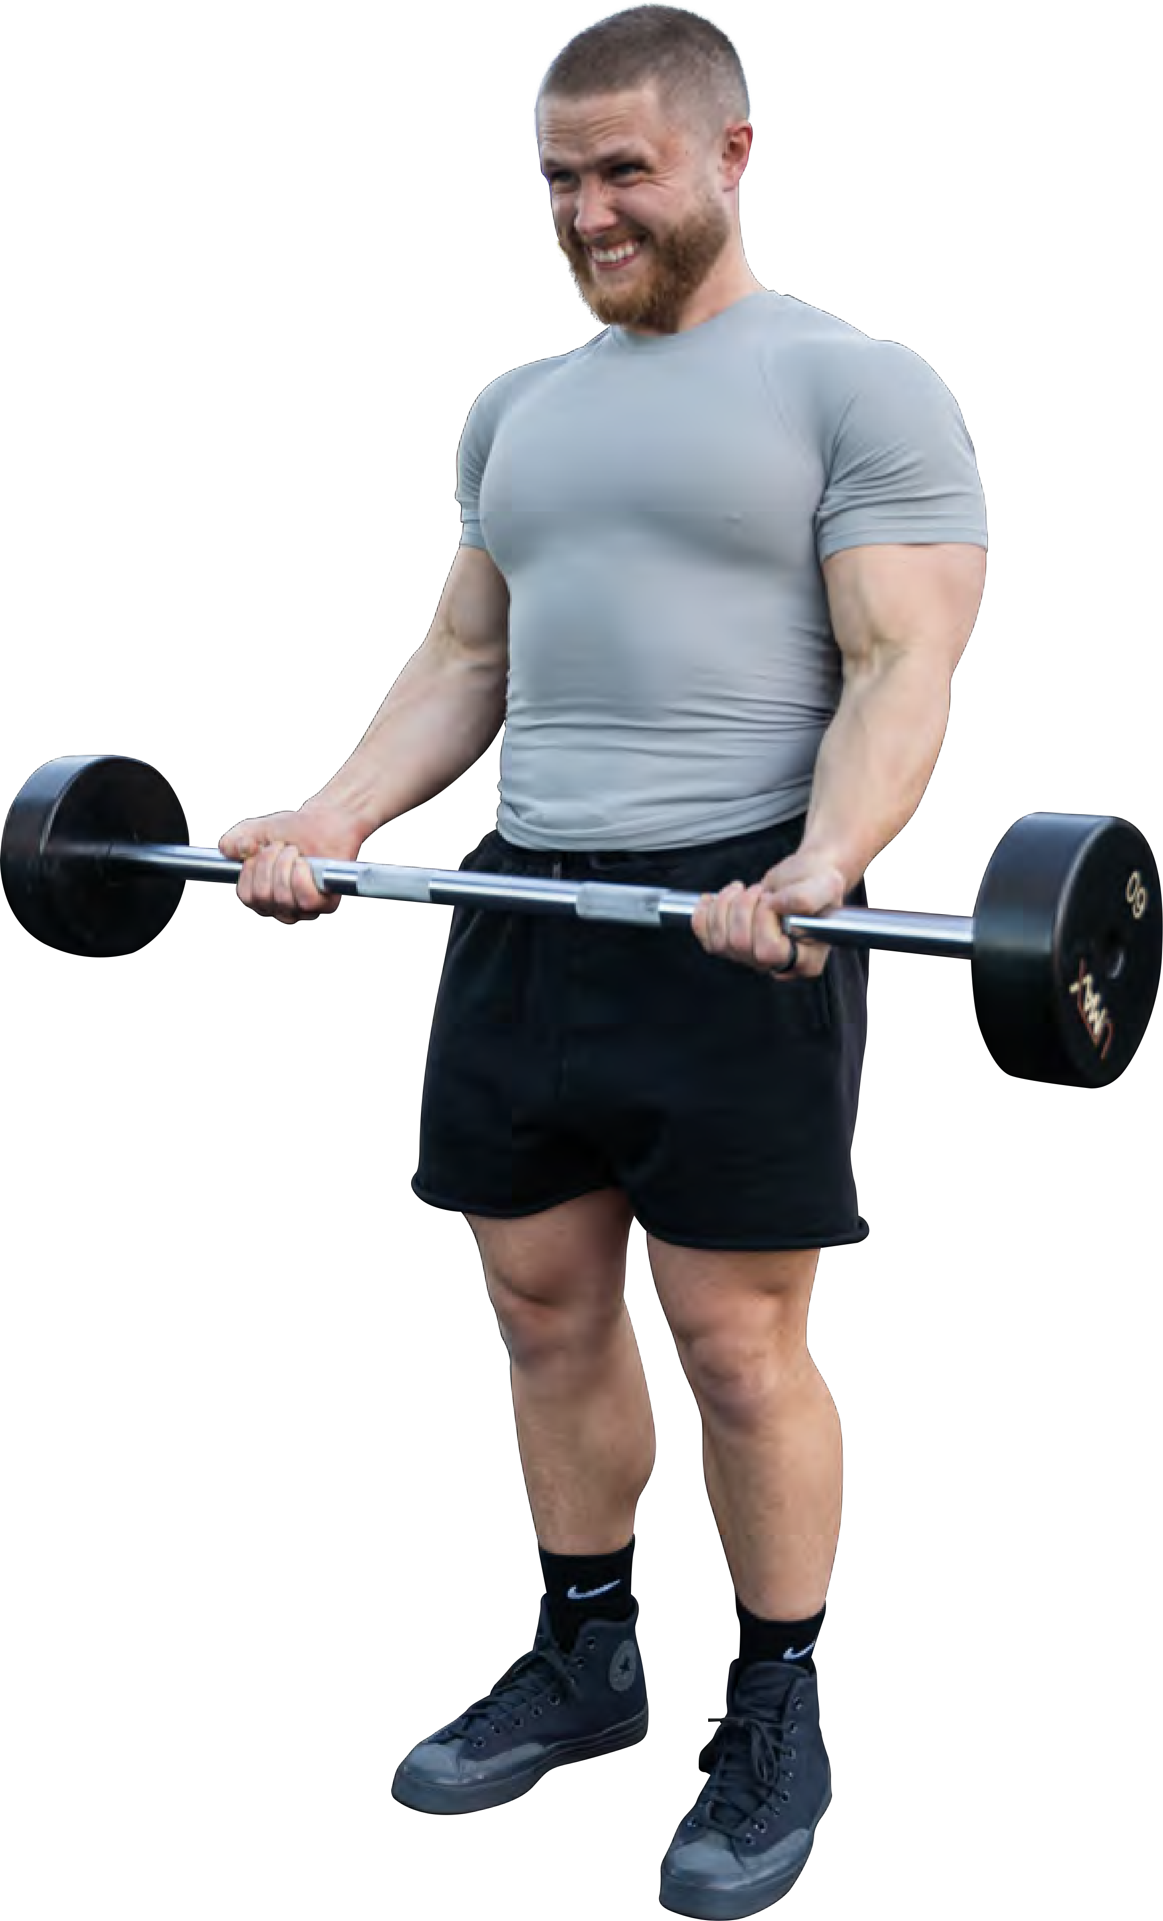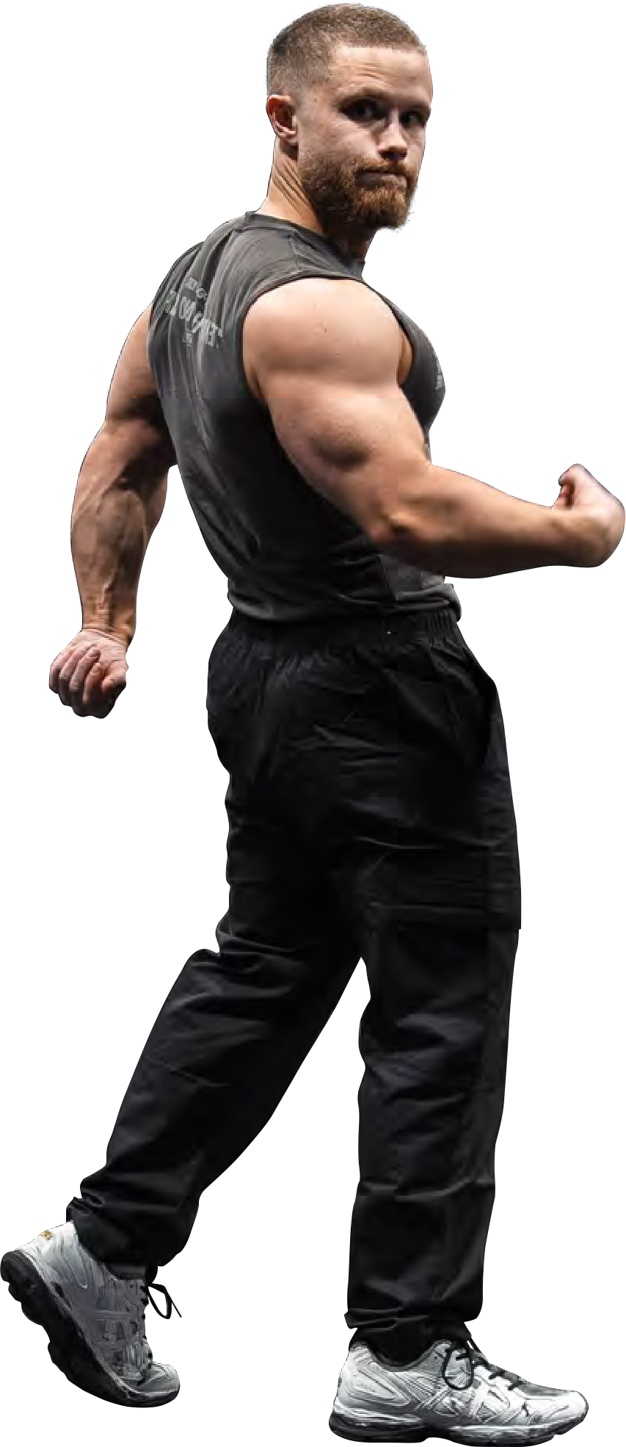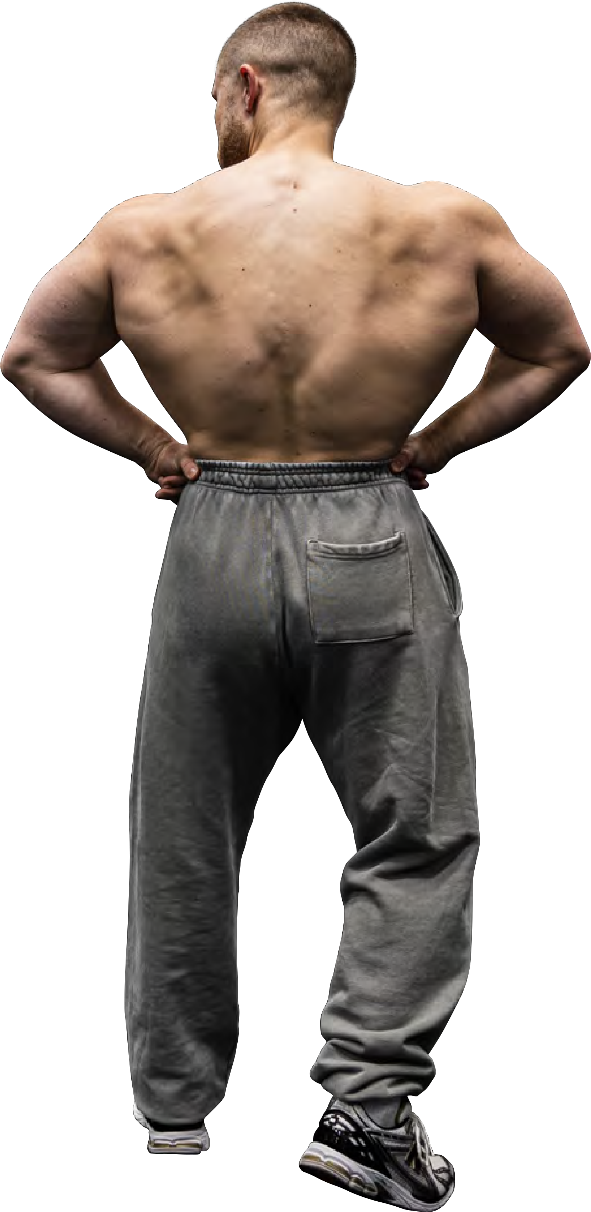

lf any of those apply to you, you will have great success with it.





For Lifters 1 and 2: Short, high-intensity workouts

1 designed the program to maximize hypertrophy far lifters who only have about 45 minutes to train, 4 to 5 times per week. That's simply not enough time to do 3 to 4 sets of every exercise. lnstead, you'II do just 1 or 2 hard sets of most exercises, usually taking them to failure.

This setup gives you the opportunity to focus more on quality over quantity. In my coaching experience, low­ volume, high-intensity training leads to better focus and execution on each individual set. When you know you only have 1 or 2 sets to get the job done, there's no room to coast. You have to make every set count.

lt also helps reduce junk volume-excessive sets that have severely diminishing returns or sets that aren't especially challenging or stimulating. By keeping volume lower and effort higher, you maximize efficiency and avoid wasting time or energy.

For Lifter 3: Maximizing muscle retention

The reality is, unless you're a beginner, or your training has been suboptimal and inconsistent, gaining muscle in a caloric deficit is unlikely. Maintaining the muscle you've built is a more realistic goal far most lifters.

To be sure, sorne of you will probably gain a little muscle on a cut. But even if you don't, you'II still appear far more jacked after you cut sorne of the fat sitting on top of the muscle you already have.

That shift in expectation calIs far a shift in programming. lf the goal in a surplus is to gain as much muscle as possible, then the goal in a deficit should be to lose as little muscle as possible. Different goa/s require different strategies.

That's what I set out to create with Min-Max: the most effective training plan far cutting. l've had tremendous success running it. l've maintained muscle fullness, even while getting to single-digit body fat. As a bonus, l've actually gained strength, and my recovery has been better than ever. Most importantly, l've found it far more sustainable and enjoyable than my usual high-volume approach.

As I said, this program will work with other goals. But far the specific goal of fat loss, you need a caloric deficit
-burning more calories than you consume. And in a caloric deficit, your body has fewer resources to support muscle repair, glycogen replenishment, and anabolic signaling.

The Min-Max Program is designed to support effective, sustainable training with fewer calories than your body is used to having. Nearly every aspect of the program reflects this goal: efficient volume, high effort, manageable recovery demands, and a tight focus on maintaining strength and muscle.

You'II train most muscle groups with 6 to 1O sets per week, while hamstrings, abs, and calves get 4 sets per week. (See figure below.)

That means, in each workout, you'II do just 1 or 2 super-hard sets of every exercise, often taken to failure. This philosophy is based on a classic 2011 study in which researchers at the University of Alabama-Birmingham had participants do 3 sets of squats, leg presses, and leg extensions 3 times per week far 16 weeks.

After that, a subgroup of participants trained far an additional 32 weeks with just one set of each of those exercises. That's not one set per workout. lt's one set per week, one ninth of the original volume. lncredibly, the subjects maintained their gains far the entire 32 weeks.

These individuals went from 27 sets per week to 3 sets, and didn't lose any strength or size! Wild! This shows that it truly does take a lot less volume to maintain muscle than it takes to build muscle. One more thing to keep in mind:
While higher volume can lead to bigger gains in a surplus, 1 suspect it may actually have the opposite effect during a deficit. You may notice greater fatigue, which leads to reduced training quality, which ultimately means disappointing results.

That's why this program focuses on what works best far most people in a recovery-constrained environment: fewer sets performed ata higher intensity.

10

8

...--..
.::s:.
Q.) 6
Q.)
.3._:
Q.)
c.
en
+-'
Q.)
..en,

Q.)
E
4
::,
>o

2

o
Chest Shoulders Mid-Back Lats Biceps Triceps Forearms Quads Hamstrings Glutes Calves Abs





Because effort is crucial on this program, it must be monitored intentionally. This program uses a method called reps in reserve (RIR) to help you gauge how close you are to failure on each set.

lt's an estimate of how many more reps you could have done if you had kept going. For example:

- RIR 2 = you stopped the set with 2 reps left in the tank
- RIR 1 = you had 1 rep left
- RIR O = you couldn't have done another rep because you reached failure

Each exercise includes a column that tells you the target RIR for each set. For example, in Week 2, the pull-up calls for RIR 1 on the first set and RIR O on the second. That means you should stop one rep shy of failure on your first set, and go all the way to failure on your second.

Making it work requires a mindset shift. When you're no longer doing 3 or 4 sets per exercise, you have to make each set count. Stopping a set short of the RIR target is a missed opportunity.

That said, it might take sorne practice to get good at judging RIR. At first you might stop a set short of the RIR target simply because you're used to training that way. Other times you'II hit failure when you thought you still had a couple reps left in the tank. lt's totally normal. lf you're honest with yourself and push hard, you'II get better at gauging your effort, and your results will reflect that newly acquired skill.

Just keep in mind, since volume is low, most sets will go all the way to ORIR. Go into each workout ready to push!

Clarification for RIR O:

- For squat, barbell incline press, leg press, and Smith machine lunge:
RIR O means you're confident you had zero reps left, but for safety, you didn't attempt another rep. The risk of injury on those specific lifts exceeds the potential rewards.

- For all other exercises:
RIR O means you did attempt the final rep and failed to complete it.





Training blocks

Training Split

Workout duration
The 12-week program is split into two 6-week blocks.
- Both blocks begin with a lighter week, in which you'II do most sets to RIR 1 or 2, rather than RIR O or 1.
- Block 2 introduces intensity techniques on the last set.

There are 5 workouts per week:
- Upper / Lower / Upper / Lower / Arms + Delts

Each session should take about 45 minutes, although it will vary with warm-up time and rest between sets.

Volume ■ You'II do 6 to 1O sets per week far most muscle groups.
  - You'II do 4 sets per week far hamstrings, calves, and abs.

Effort You'II take most working sets (another way to describe hard sets) to RIR O or 1.

Exercise substitutions Each exercise includes two suggested options. But those are by no means your only choices. Feel free to swap in any movement that works the same muscles in the same movement pattern.

Equipment 1 based the program on equipment you'II find in most commercial gyms. But if your gym doesn't have a specific machine or apparatus, or you train at home with limited options, just make the appropriate substitution.





Warming up

Within the program, 1 give a brief overview of the warm-up protocol for each workout. The main thing is literally getting your body warmed up by increasing your core temperature with sorne light cardio. From there, you can ease into your working sets by doing 1-2 (sometimes 3) warm up sets that gradually get a bit heavier. No need to overthink your warm up. Get warm and get to work.

Just in case though, here is a full breakdown for those who'd like more specific guidance on warming up:

Perform the following general warm-up befare every workout. lt can be as simple as 5 minutes of light cardio, or can include sorne or all of the exercises listed below.
5-1O minutes | Light cardio on your choice of machine (treadmill, stair climber, elliptical, bike, etc.)
1O reps per side | Arm swings (optional)
1O reps per side | Arm circles (optional)
1O reps per side | Front-to-back leg swings (optional)
1O reps per side | Side-to-side leg swings (optional)
15 reps per side | Cable externa! rotations (optional)

The program indicates the number of warm-up sets you should perform.
1 Warm-Up Set Listed | Use -60% of your planned working weight for -6-1O reps (or until you feel loose and ready to lift)
2 Warm-Up Sets Listed | Warm-up set #1: -50% of planned working weight for -6-1O reps Warm-up set #2: "'70% of planned working weight for 4-6 reps
3 Warm-Up Sets Listed | Warm-up set #1: -45% of planned working weight for -6-1O reps Warm-up set #2: -65% of planned working weight for 4-6 reps Warm-up set #3: -85% of planned working weight for 3-4 reps
4 Warm-Up Sets Listed | Warm-up set #1: -45% of planned working weight for -6-1O reps Warm-up set #2: -60% of planned working weight for 4-6 reps Warm-up set #3: "'75% of planned working weight for 3-5 reps Warm-up set #4: -85% of planned working weight for 2-4 reps

Workout Breakdown

WEEK 1 | '♦  ' ' ' '  '  ' |  |  |  |  |  |  |  |  |  |  |  | - '
 | Barbell Incline Press | N/A | 2-4 | 2 | 6-8 |  |  |  |  | 2 |  | 3-5min | Smith Machine | DB Incline Press | A 30' or 45' bench will work here. Pause for 1 second al the bottom of each rep while maintaining tension on the pees.
 |  |  |  |  |  |  |  |  |  |  |  |  | Incline Press
 | Pee Deck | N/A | 1-2 | 2 | 6-8 |  |  |  |  |  | o | 7-2min | ºª--E)yg | Cable Flyg | Pause far 1 second at the bottom of each rep while maintaining tension on the pees.
 | Incline DB Y-Raise | N/A | 0-1 | 2 | 8-10 |  |  |  |  |  | o | 1-2min | Cable Y-Raise | Machine Lateral | Use a 30' incline bench (back against the bench) and lift the weight up and out in a Y shape.
 |  |  |  |  |  |  |  |  |  |  |  |  |  | Raise
 | Pull-Ug (Wide Grig) | N/A | 1-2 | 2 | 6-8 |  |  |  |  | 2 |  | 2-3 min | Lat Pulldown | 1-Arm Cable | Control the negative and feel your lats pulling apart. Full ROM!
 |  |  |  |  |  |  |  |  |  |  |  |  | (Wide GriR) | Pulldown
 | Kelso Shrug | N/A | 7-2 | 2 | 6-8 |  |  |  |  | 2 |  | 2-3 min | Seated Cable | Incline DB Kelso | Pause for about 1 second al the top and then allow your shoulder blades to peel apart on the way back down, under control.
 |  |  |  |  |  |  |  |  |  |  |  |  | Kelso Shrug | Shrug
 | EZ-Bar Preacher Curl | N/A | 0-1 | 2 | 6-8 |  |  |  |  |  | o | 1-2min | Machine Preacher | DB Preacher Curl | Keep your tríceps firmly pinned against the pad as you curl. Smooth controlled reps.
 |  |  |  |  |  |  |  |  |  |  |  |  | Curl
 | Trice Pressdown | N/A | 0-1 | 2 | 6-8 |  |  |  |  |  | o | 1-2min | Close-Grig Bench Press | Smith Machine | You can use a rope or bar attachment for these, whichever you flnd more comfortable.
 |  |  |  |  |  |  |  |  |  |  |  |  |  | JM Press
 | Dragon Flag | N/A | 0-1 | 2 | 6-8 |  |  |  |  |  | o | 1-2min | Bent-Knee DragQQ | l,y_ing Leg Raise | Keep your body as rigid as possible throughout the ROM.
 |  |  |  |  |  |  |  |  |  |  |  |  | Flag

- Exercise
  - Each exercise includes a clickable demo link far proper technique.

- Last-set intensity technique
  - These are only used after the final working set of an exercise.
  - Block 1 includes no intensity techniques.
  - Block 2 introduces:
    - Drop sets: After reaching failure, reduce the weight by ""25% and go to failure again. Repeat once more (far a total of 3 back-to-back sets).
    - Lengthened partials: After reaching failure with a full range of motion (ROM), continue to perform reps with a partial range of motion (in the stretched position) until failure.
    - Myo-reps: After failure, rest 5 seconds and attempt 2 more reps. Repeat this cycle (5 seconds rest, followed by 2 reps) until you fail to complete 2 full-ROM reps. (This usually happens by the third cycle, if not befare.)
    - Weighted static hold: After failing on the machine chest press (or dumbbell bench press substitution), hold the bottom (stretched) position under full tension far 30 seconds.

- Warm-up sets
  - The suggested number of light sets to perform befare working sets.
- Refer to the exercise-speciflc warm-up above far full details.

- Working sets
  - These are your hard sets.
- Use the prescribed RIR target to determine effort level.

THE MII\I-MAX

- Rep range
  - Once you can perform all working sets at the top of the rep range, increase the load next session.
  - lf increasing the weight would cause you to drop below the range, keep the same weight and extend the rep range slightly. For example: lf the range is 6 to 8, and adding weight drops you to 4 to 5 reps, stick with the previous load and aim for 6 to 1O.

- Tracking load and reps
  - Log the weight you used and reps you completed for your working sets (if applicable).

- Failure?
  - This column tells you how close you should be to failure on working sets, using RIR:
    - RIR 1 = 1 rep left in the tank
    - RIR 2 = 2 reps left in the tank
  - Clarification for RIR O:
    - For the squat, barbell incline press, leg press, and Smith machine lunge, RIR O means you had zero reps left, but you didn't attempt and fail the final rep.
    - For all other exercises, RIR O means you attempted and failed the final rep.

- Rest
  - Between working sets: follow the listed rest time (see Frequently Asked Questions for a more detailed explanation).
  - Between warm-up sets: rest O to 60 seconds.
  - Between exercises: rest 1 to 5 minutes, depending on how demanding the exercise is.
  - Heavy compound exercises generally require 3-5 minutes of rest between sets for recovery. Lighter compounds or isolation exercises usually only need 1-2 minutes of rest between sets.

- Substitution options
  - Each exercise includes two alternative movements.
  - Feel free to swap in either one (or one I didn't list) if the featured exercise doesn't work for you.

1O. Notes
  - Each exercise includes coaching cues in the Notes section.
  - Be sure to read these befare warm-ups so you can apply any new cues while the weight is still light.




Here are the exercises you'II use to target each muscle group. You'II note that several exercises are listed far multiple muscle groups. Squats, far example, work the quads and glutes, while T-bar rows work the lats and mid-back. Listing an exercise twice doesn't mean you'II do it twice. lt just shows which muscles you're working each time you do them.

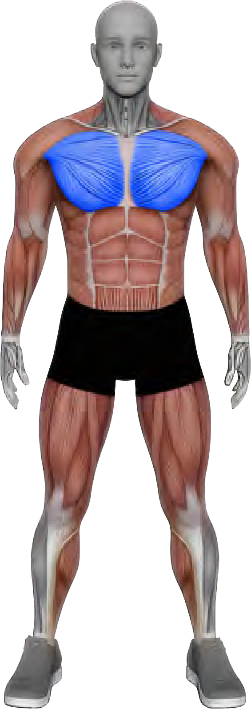
CHEST
You'II work your chest with 6 sets per week, using these exercises:

- Barbell incline press - 2 sets
- Pee deck - 2 sets
- Machine chest press - 2 sets

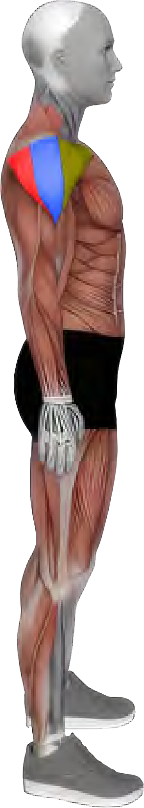
SHOULDERS
Your shoulders get 1O sets per week (4 far the front delts and 6 far the side delts), using these exercises:

  - Barbell incline press (front delts) - 2 sets
  - Machine chest press (front delts) - 2 sets
  - Incline dumbbell Y-raise (side delts) - 2 sets
  - Cable lateral raise (side delts) - 2 sets
  - Machine lateral raise (side delts) - 2 sets

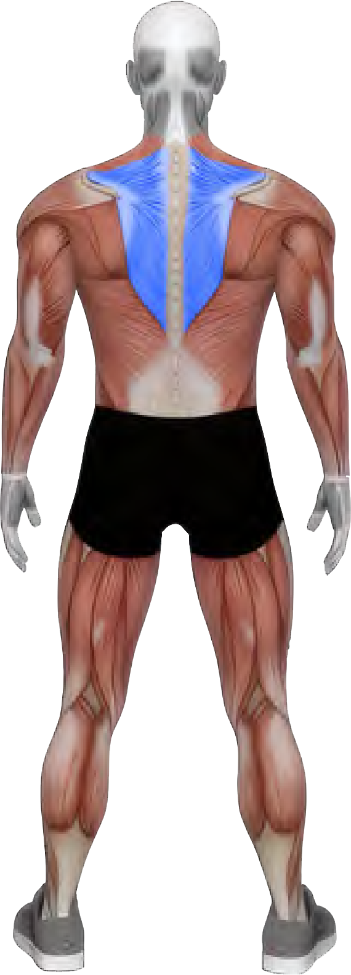
MID-BACK
You'II hit your mid-back with 9 sets per week, using these exercises:

  - Pull-up (wide grip) - 2 sets
  - Kelso shrug - 2 sets
  - Close-grip lat pulldown - 2 sets
  - Chest-supported T-bar row - 2 sets
  - 1-arm reverse pee deck - 1 set

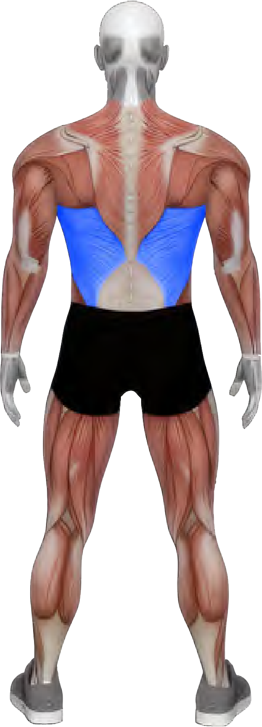
LATS
Your lats get 6 sets per week, using these exercises:

  - Pull-up (wide grip) - 2 sets
  - Close-grip lat pulldown - 2 sets
  - Chest-supported T-bar row - 2 sets

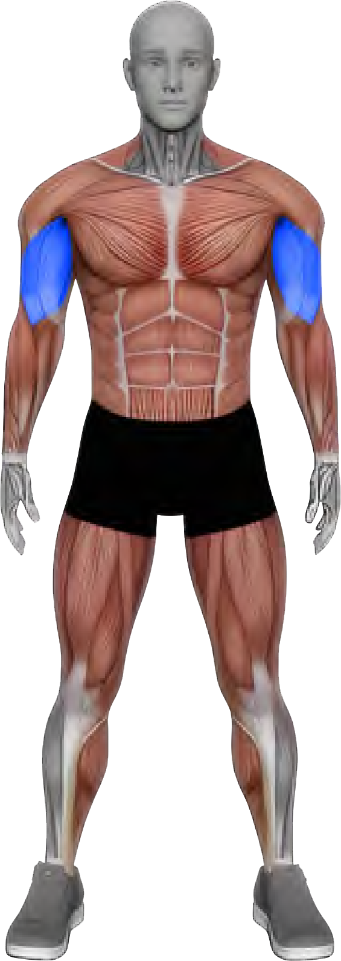
BICEPS
You'II target your biceps with 6 sets per week, using these exercises:

    - EZ-bar preacher curl - 2 sets
    - Bayesian cable curl - 2 sets
    - Modified Zottman curl - 1 set
    - Alternating dumbbell curl - 1 set

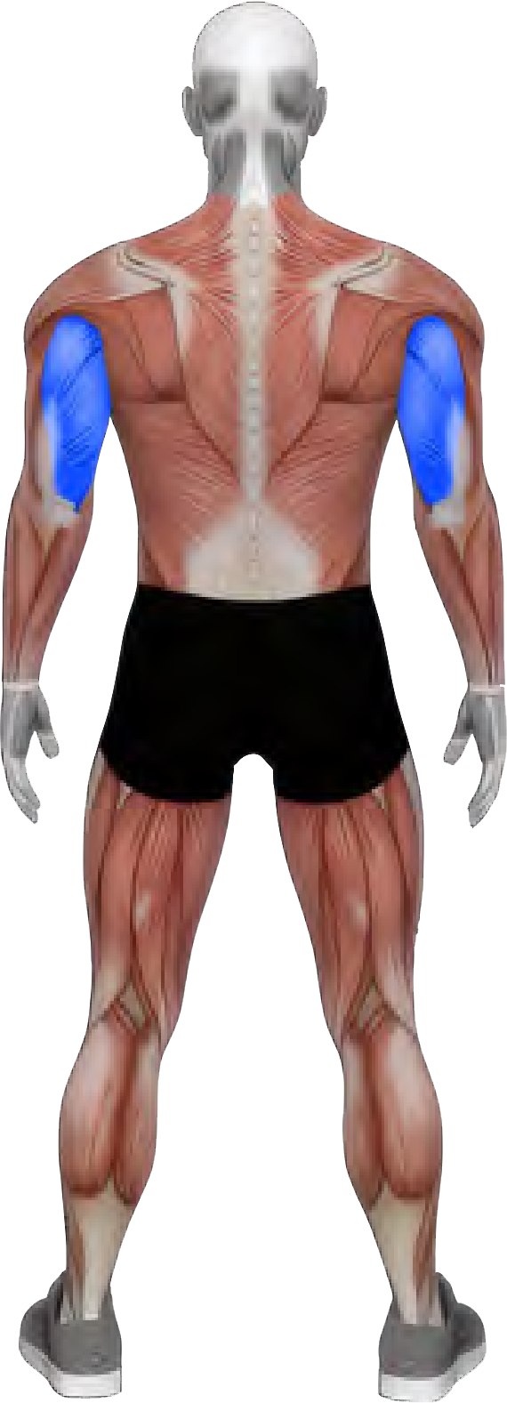
TRICEPS
Your triceps get 6 sets per week, using these exercises:

    - Triceps pressdown - 2 sets
    - Overhead cable triceps extension - 2 sets
    - Cable triceps kickback - 2 sets

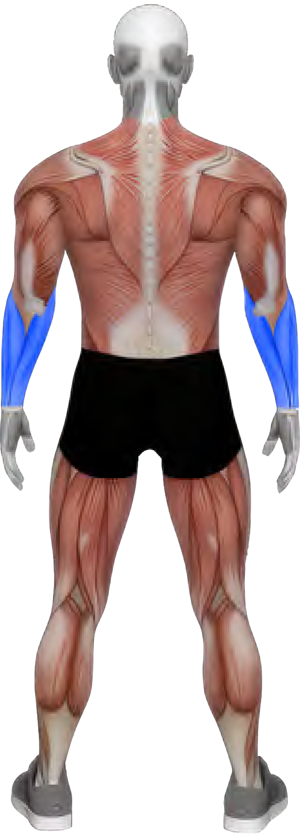
FOREARMS
You'II train your forearms with 6 sets per week, using these exercIses:

    - Dumbbell wrist curl - 2 sets
    - Dumbbell wrist extension - 2 sets
    - Dead hang - 2 sets

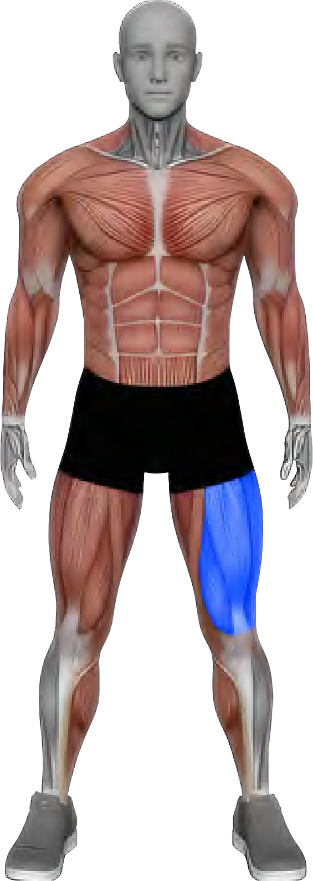
QUADS
You'II work your quads with 8 sets per week, using these exercises:

    - Squat (your choice) - 2 sets
    - Smith machine lunge - 1 set
    - Leg extension - 4 sets
    - Leg press - 1 set

THE MII\I-MAX PROGRAM

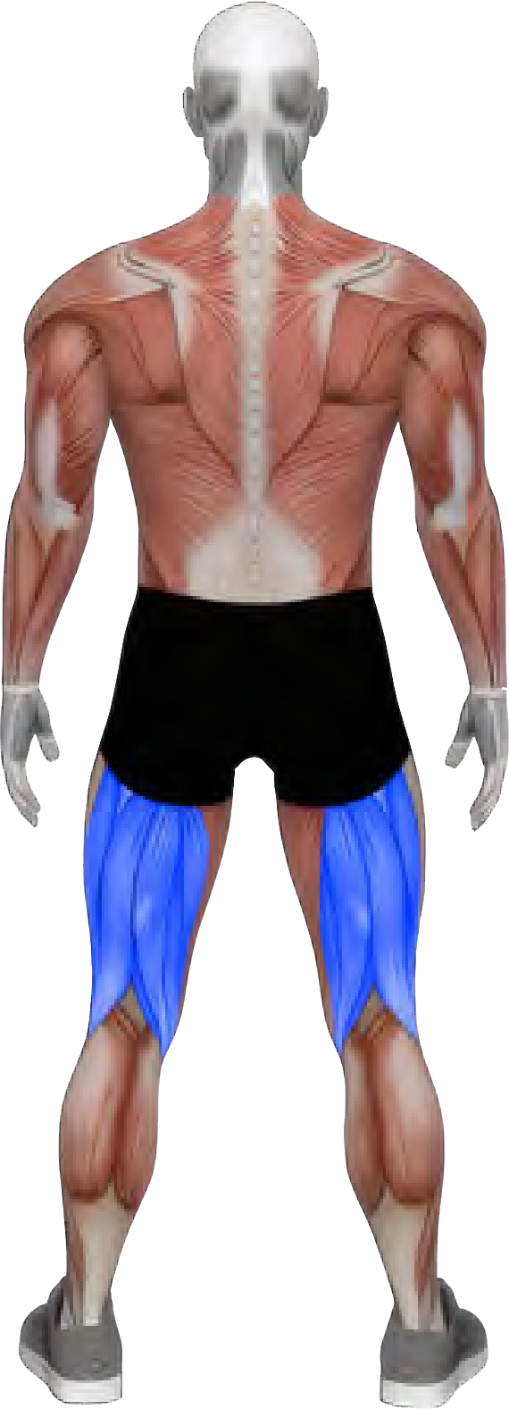
HAMSTRINGS
As noted earlier, your hamstrings get 4 sets per week, using these exerc1ses:

      - Lying leg curl - 2 sets
      - Barbell RDL - 2 sets

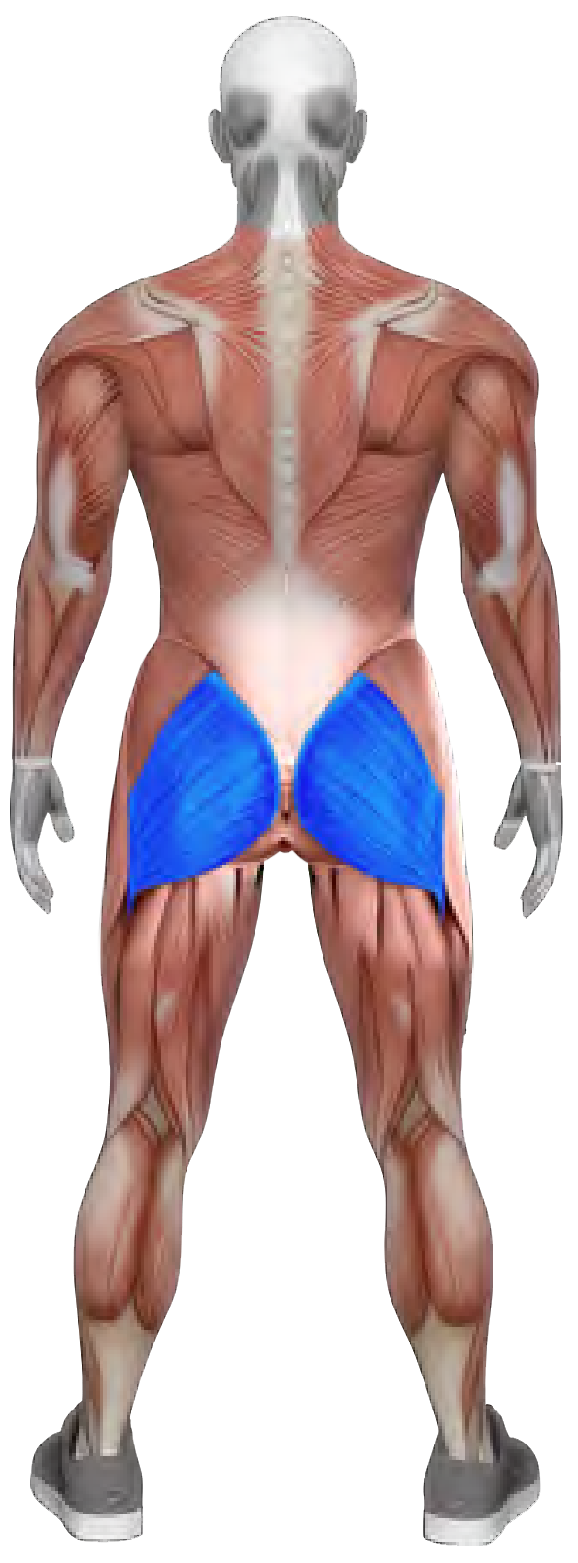
GLUTES
Your glutes get 9 sets per week, using these exercises:

        - Squat (your choice) - 2 sets
        - Smith machine lunge - 1 set
        - Machine hip abduction - 1 set
        - Barbell RDL - 2 sets
        - Machine hip thrust - 2 sets
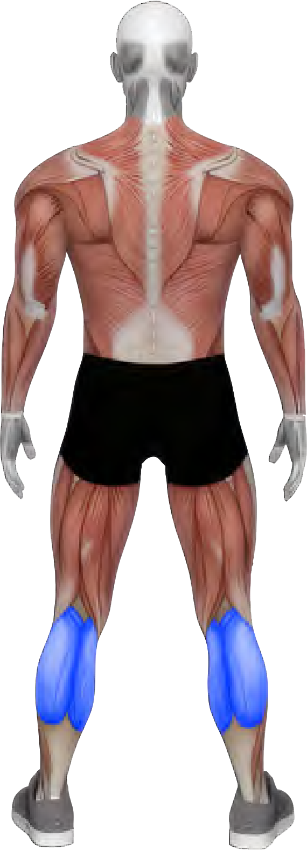
        - Leg press - 1 set

CALVES
You'II hit your calves with 4 sets per week, using this exercise:

      - Standing calf raise - 4 sets

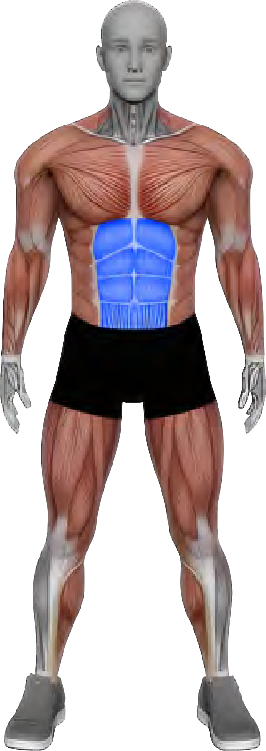
ABS
Finally, your abs get 4 sets per week, using these exercises:

      - Dragan flag - 2 sets
      - Cable crunch - 2 sets




IMPORTANT PROGRAM NOTES
PLEASE READ BEFORE STARTING!

Dueto the lower volume in this program, it's essential that you approach each set with focused intent and high effort.
Nearly every set in this program should be taken to failure, or 1 rep shy of failure. The only exceptions are in Week 1 (an intro week) and Week 7 (a deload week), where you won't train quite as hard.
In the program, 1 use Reps In Reserve (RIR) to indicate which sets you should take to failure. An RIR of O means you hit failure (zero reps in the tank). An RIR of 1 means you stop 1 rep shy of failure.
For heavy compound lifts like the Squat, Barbell Incline Press, Leg Press, and Smith Machine Lunge, an RIR of O means you couldn't complete another rep, but for safety you don't need to actually attempt and fail the final rep unless you want to.
For all other exercises, an RIR of O means that you should actually go for another rep, even if you think you can't get it. On these exercises, go until you physically can't complete the rep and literally fail.

II\IARM-UP PROTOCOL

Start each workout with about 5 minutes of light cardio to raise your core body temperature.

Each exercise includes the recommended number of exercise-speciflc warm-up sets, which should be light and not fatiguing.

For a more detailed breakdown of warm-up protocols, refer to page 13.

INTRO WEEK
WEEK1 | ♦ |  |  |  |  |  |  |  |  |  |  |  | ♦ | ♦
 | Barbell Incline Press | N/A | 2-4 | 2 | 6-8 |  |  |  |  | 2 | 1 | 3-5 min | Smith Machine Incline Press | DB Incline Press | A 30º or 45º bench will work here. Pause for 1 second at the bottom of each rep while maintaining tension on the pees.
 | Pee Deck | N/A | 1-2 | 2 | 6-8 |  |  |  |  | 1 | o | 1-2 min | DB Flye | Cable Flye | Pause for 1 second at the bottom of each rep while maintaining tension on the pees.
 | Incline DB Y-Raise | N/A | 0-1 | 2 | 8-1O |  |  |  |  | 1 | o | 1-2 min | Cable Y-Raise | Machine Lateral Raise | Use a 30º incline bench (back against the bench) and lift the weight up and out in a Y shape.
 | Pull-Up  _(Wide Grip)_ | N/A | 1-2 | 2 | 6-8 |  |  |  |  | 2 | 1 | 2-3 min | Lat Pulldown  _(Wide Grip)_ | 1-Arm Cable Pulldown | Control the negative and feel your lats pulling apart. Full ROM!
 | Kelso Shrug | N/A | 1-2 | 2 | 6-8 |  |  |  |  | 2 | 1 | 2-3 min | Seated Cable Kelso Shrug | Incline DB Kelso Shrug | Pause for about 1 second at the top and then allow your shoulder blades to peel apart on the way back down, under control.
 | EZ-Bar Preacher Curl | N/A | 0-1 | 2 | 6-8 |  |  |  |  | 1 | o | 1-2 min | Machine Preacher Curl | DB Preacher Curl | Keep your triceps flrmly pinned against the pad as you curl. Smooth controlled reps.
 | Triceps Pressdown | N/A | 0-1 | 2 | 6-8 |  |  |  |  | 1 | o | 1-2 min | Close-Grip Bench Press | Smith Machine JM Press | You can use a rope or bar attachment for these, whichever you flnd more comfortable.
 | Dragon Flag | N/A | 0-1 | 2 | 6-8 |  |  |  |  | 1 | o | 1-2 min | Bent-Knee Dragon Flag | 1,ying Leg Raise | Keep your body as rigid as possible throughout the ROM.

WEEK1 | ♦ |  |  |  |  |  |  |  |  |  |  |  | ♦ | ♦
 | Lying Leg Curl | N/A | 1-2 | 2 | 6-8 |  |  |  |  | 1 | o | 1-2 min | Seated Leg Curl | Nordic Ham Curl | Set the machine so that you get the biggest stretch possible at the bottom. Prevent your butt from popping up as you curl.
 | Squat  _(Your Choice) | N/A | 2-4 | 2 | 6-8 |  |  |  |  | 3 | 2 | 3-5 min | See Notes | See Notes | This can be a Barbell Back Squat, Barbell Front Squat, Pendulum Squat, Hack Squat, Belt Squat, or Smith Machine Squat.
 | Smith Machine Lunge | N/A | 2-4 | 1 | 6-8 |  |  |  |  | 1 | N/A | 2-4 min | DB Lunge | Barbell Lunge | Minimize contribution from your back leg!
 | Leg Extension | N/A | 1-2 | 2 | 6-8 |  |  |  |  | 1 | o | 1-2 min | Reverse Nordic | Sissy Squat | Set the seat back as far as it will go while still feeling comfortable. Grab the handles as hard as you can to pull your butt down into the seat (using straps can help here).
 | Machine Hip Abduction | N/A | 0-1 | 1 | 6-8 |  |  |  |  | o | N/A | 1-2 min | Cable Hip Abduction | Standing Plate Abduction | lf possible, place foam pads in between the outside of your knees and the pads on the machine. This will increase your range of motion on the machine.
 | Standing Calf Raise | N/A | 0-1 | 2 | 6-8 |  |  |  |  | 1 | o | 1-2 min | Leg Press Calf Press | Donkey Calf Raise | 1-2 second pause at the bottom of each rep. lnstead of just going up onto your toes, think about rolling your ankle back and forth on the balls of your feet.

WEEK1 | ♦ |  |  |  |  |  |  |  |  |  |  |  | ♦ | ♦
 | Close-Grip Lat Pulldown | N/A | 2-3 | 2 | 8-1O |  |  |  |  | 2 | 1 | 2-3 min | Close-Grip Pull-UR | 1-Arm Cable Pulldown | Lean back by ~15º and drive your elbows down as you squeeze your shoulder blades together. This should feel like a mix of lats and mid-traps.
 | Chest-Supported T-Bar Row | N/A | 2-3 | 2 | 8-1O |  |  |  |  | 2 | 1 | 2-3 min | Chest-Su pported Machine Row | Chest-Supported DB Row | Fiare elbows out at roughly 45º and squeeze your shoulder blades together hard at the top of each rep.
 | Machine Shrug | N/A | 1-2 | 1 | 6-8 |  |  |  |  | 1 | N/A | 1-2 min | Barbell Shrug | Cable Shrug-ln | Think about shrugging "up to your ears". Use straps, if possible.
 | Machine Chest Press | N/A | 2-4 | 2 | 8-1O |  |  |  |  | 2 | 1 | 3-5 min | Smith Machine Bench Press | DB Bench Press | 1 second pause at the bottom of each rep while maintaining tension on the pees.
 | High-Cable Lateral Raise | N/A | 0-1 | 2 | 8-1O |  |  |  |  | 1 | o | 1-2 min | DB Lateral Raise | Machine Lateral Raise | Set the cable at roughly hip height. Let your hand go slightly past your midline at the bottom of each repto get a deep stretch on the side delt.
 | 1-Arm Reverse Pee Deck | N/A | 0-1 | 1 | 8-1O |  |  |  |  | o | N/A | 1-2 min | lting Reverse DB Flte | Reverse Cable Crossover | Sweep the weight out to create the largest semi-circle possible with your arm.
 | Cable Crunch | N/A | 0-1 | 2 | 6-8 |  |  |  |  | 1 | o | 1-2 min | Weighted Crunch | Machine Crunch | Round your lower back as you crunch. Maintain a mind-muscle connection with your 6-pack.

WEEK1 | ♦ |  |  |  |  |  |  |  |  |  |  |  | ♦ | ♦
 | Leg Extension | N/A | 1-2 | 2 | 8-1O |  |  |  |  | 1 | o | 1-2 min | Reverse Nordic |  | Set the seat back as far as it will go while still feeling comfortable. Grab the handles as hard as you can to pull your butt down into the seat (using straps can help here).
 | Barbell RDL | N/A | 2-3 | 2 | 6-8 |  |  |  |  | 3 | 2 | 2-3 min | DB RDL | Seated Cable Deadlift | Stick your glutes straight back as you lower the bar straight down, centered over the middle of your foot. Get a nice deep stretch at the bottom, but keep your spine neutral (don't round forward).
 | Machine Hip Thrust | N/A | 2-4 | 2 | 6-8 |  |  |  |  | 2 | 1 | 2-3 min | Barbell Hip Thrust | 45º  Hyperextension | Squeeze your glutes hard at the top and control the weight on the way down.
 | Leg Press | N/A | 2-4 | 1 | 6-8 |  |  |  |  | 1 | N/A | 2-3 min | Smith Machine Sguat | Barbell Squat | Feet lower on the platform for more quad focus. Get as deep as you can without excessive back rounding.
 | Standing Calf Raise | N/A | 0-1 | 2 | 8-1O |  |  |  |  | 1 | o | 1-2 min | Leg Press Calf Press | Donkey Calf Raise | 1-2 second pause at the bottom of each rep. lnstead of just going up onto your toes, think about rolling your ankle back and forth on the balls of your feet.

WEEK1 | ♦ |  |  |  |  |  |  |  |  |  |  |  | ♦ | ♦
 | Bayesian Cable Curl | N/A | 0-1 | 2 | 6-8 |  |  |  |  | 1 | o | 1-2 min | Incline DB Curl | Standing DB Curl | As you curl, optionally lean forward to prevent the cable from hitting your wrist at the top. Control the negative and feel a deep stretch at the bottom of each rep.
 | Overhead Cable Triceps Extension | N/A | 0-1 | 2 | 8-1O |  |  |  |  | 1 | o | 1-2 min | Overhead DB Triceps Extension | Skull Crusher | Feel a deep stretch on the tríceps throughout the entire negative.
 | Modified Zottman Curl | N/A | 0-1 | 1 | 8-1O |  |  |  |  | o | N/A | 1-2 min | DB Hammer Curl | Preacher Hammer Curl | Hammer curl on the way up and supinated curl (palms up) on the way down.
 | Cable Triceps Kickback | N/A | 0-1 | 2 | 8-1O |  |  |  |  | 1 | o | 1-2 min | Seated Dip Machine | Clase Grip DiR | Keep your upper arm behind your torso throughout the ROM.
 | DB Wrist Curl | N/A | 0-1 | 2 | 8-1O |  |  |  |  | 1 | o | 1-2 min | Cable Wrist Curl | N/A | Smooth, controlled reps.
 | DB Wrist Extension | N/A | 0-1 | 2 | 8-1O |  |  |  |  | 1 | o | 1-2 min | Cable Wrist Extension | N/A | Smooth, controlled reps.
 | Alternating DB Curl | N/A | 0-1 | 1 | 6-8 |  |  |  |  | o | N/A | 1-2 min | Barbell Curl | EZ-Bar Curl | Slow, controlled reps!
 | Machine Lateral Raise | N/A | 0-1 | 2 | 8-1O |  |  |  |  | 1 | o | 1-2 min | High-Cable Lateral Raise | DB Lateral Raise | Focus on squeezing your side delt to move the weight.
 | Dead Hang (optional)_ | N/A | 0-1 | 2 | N/A |  |  |  |  | o | o | 1-2 min | N/A | N/A | Try to add a few more seconds each week!

WEEK2 | ♦ |  |  |  |  |  |  |  |  |  |  |  | ♦ | ♦
 | Barbell Incline Press | N/A | 2-4 | 2 | 6-8 |  |  |  |  | 1 | o | 3-5 min | Smith Machine Incline Press | DB Incline Press | A 30º or 45º bench will work here. Pause for 1 second at the bottom of each rep while maintaining tension on the pees.
 | Pee Deck | N/A | 1-2 | 2 | 6-8 |  |  |  |  | o | o | 1-2 min | DB Flye | Cable Flye | Pause for 1 second at the bottom of each rep while maintaining tension on the pees.
 | Incline DB Y-Raise | N/A | 0-1 | 2 | 8-1O |  |  |  |  | o | o | 1-2 min | Cable Y-Raise | Machine Lateral Raise | Use a 30º incline bench (back against the bench) and lift the weight up and out in a Y shape.
 | Pull-Up  _(Wide Grip)_ | N/A | 1-2 | 2 | 6-8 |  |  |  |  | 1 | o | 2-3 min | Lat Pulldown  _(Wide Grip)_ | 1-Arm Cable Pulldown | Control the negative and feel your lats pulling apart. Full ROM!
 | Kelso Shrug | N/A | 1-2 | 2 | 6-8 |  |  |  |  | 1 | o | 2-3 min | Seated Cable Kelso Shrug | Incline DB Kelso Shrug | Pause for about 1 second at the top and then allow your shoulder blades to peel apart on the way back down, under control.
 | EZ-Bar Preacher Curl | N/A | 0-1 | 2 | 6-8 |  |  |  |  | o | o | 1-2 min | Machine Preacher Curl | DB Preacher Curl | Keep your triceps flrmly pinned against the pad as you curl. Smooth controlled reps.
 | Triceps Pressdown | N/A | 0-1 | 2 | 6-8 |  |  |  |  | o | o | 1-2 min | Close-Grip Bench Press | Smith Machine JM Press | You can use a rope or bar attachment for these, whichever you flnd more comfortable.
 | Dragon Flag | N/A | 0-1 | 2 | 6-8 |  |  |  |  | o | o | 1-2 min | Bent-Knee Dragon Flag | 1,ying Leg Raise | Keep your body as rigid as possible throughout the ROM.

WEEK2 | ♦ |  |  |  |  |  |  |  |  |  |  |  | ♦ | ♦
 | Lying Leg Curl | N/A | 1-2 | 2 | 6-8 |  |  |  |  | o | o | 1-2 min | Seated Leg Curl | Nordic Ham Curl | Set the machine so that you get the biggest stretch possible at the bottom. Prevent your butt from popping up as you curl.
 | Squat  _(Your Choice) | N/A | 2-4 | 2 | 6-8 |  |  |  |  | 1 | o | 3-5 min | See Notes | See Notes | This can be a Barbell Back Squat, Barbell Front Squat, Pendulum Squat, Hack Squat, Belt Squat, or Smith Machine Squat.
 | Smith Machine Lunge | N/A | 2-4 | 1 | 6-8 |  |  |  |  | o | N/A | 2-4 min | DB Lunge | Barbell Lunge | Minimize contribution from your back leg!
 | Leg Extension | N/A | 1-2 | 2 | 6-8 |  |  |  |  | o | o | 1-2 min | Reverse Nordic | Sissy Squat | Set the seat back as far as it will go while still feeling comfortable. Grab the handles as hard as you can to pull your butt down into the seat (using straps can help here).
 | Machine Hip Abduction | N/A | 0-1 | 1 | 6-8 |  |  |  |  | o | N/A | 1-2 min | Cable Hip Abduction | Standing Plate Abduction | lf possible, place foam pads in between the outside of your knees and the pads on the machine. This will increase your range of motion on the machine.
 | Standing Calf Raise | N/A | 0-1 | 2 | 6-8 |  |  |  |  | o | o | 1-2 min | Leg Press Calf Press | Donkey Calf Raise | 1-2 second pause at the bottom of each rep. lnstead of just going up onto your toes, think about rolling your ankle back and forth on the balls of your feet.

WEEK2 | ♦ |  |  |  |  |  |  |  |  |  |  |  | ♦ | ♦
 | Close-Grip Lat Pulldown | N/A | 2-3 | 2 | 8-1O |  |  |  |  | 1 | o | 2-3 min | Close-Grip Pull-UR | 1-Arm Cable Pulldown | Lean back by ~15º and drive your elbows down as you squeeze your shoulder blades together. This should feel like a mix of lats and mid-traps.
 | Chest-Supported T-Bar Row | N/A | 2-3 | 2 | 8-1O |  |  |  |  | 1 | o | 2-3 min | Chest-Su pported Machine Row | Chest-Supported DB Row | Fiare elbows out at roughly 45º and squeeze your shoulder blades together hard at the top of each rep.
 | Machine Shrug | N/A | 1-2 | 1 | 6-8 |  |  |  |  | o | N/A | 1-2 min | Barbell Shrug | Cable Shrug-ln | Think about shrugging "up to your ears". Use straps, if possible.
 | Machine Chest Press | N/A | 2-4 | 2 | 8-1O |  |  |  |  | 1 | o | 3-5 min | Smith Machine Bench Press | DB Bench Press | 1 second pause at the bottom of each rep while maintaining tension on the pees.
 | High-Cable Lateral Raise | N/A | 0-1 | 2 | 8-1O |  |  |  |  | o | o | 1-2 min | DB Lateral Raise | Machine Lateral Raise | Set the cable at roughly hip height. Let your hand go slightly past your midline at the bottom of each repto get a deep stretch on the side delt.
 | 1-Arm Reverse Pee Deck | N/A | 0-1 | 1 | 8-1O |  |  |  |  | o | N/A | 1-2 min | lting Reverse DB Flte | Reverse Cable Crossover | Sweep the weight out to create the largest semi-circle possible with your arm.
 | Cable Crunch | N/A | 0-1 | 2 | 6-8 |  |  |  |  | o | o | 1-2 min | Weighted Crunch | Machine Crunch | Round your lower back as you crunch. Maintain a mind-muscle connection with your 6-pack.

WEEK2 | ♦ |  |  |  |  |  |  |  |  |  |  |  | ♦ | ♦
 | Leg Extension | N/A | 1-2 | 2 | 8-1O |  |  |  |  | o | o | 1-2 min | Reverse Nordic |  | Set the seat back as far as it will go while still feeling comfortable. Grab the handles as hard as you can to pull your butt down into the seat (using straps can help here).
 | Barbell RDL | N/A | 2-3 | 2 | 6-8 |  |  |  |  | 2 | 1 | 2-3 min | DB RDL | Seated Cable Deadlift | Stick your glutes straight back as you lower the bar straight down, centered over the middle of your foot. Get a nice deep stretch at the bottom, but keep your spine neutral (don't round forward).
 | Machine Hip Thrust | N/A | 2-4 | 2 | 6-8 |  |  |  |  | 1 | o | 2-3 min | Barbell Hip Thrust | 45º  Hyperextension | Squeeze your glutes hard at the top and control the weight on the way down.
 | Leg Press | N/A | 2-4 | 1 | 6-8 |  |  |  |  | o | N/A | 2-3 min | Smith Machine Sguat | Barbell Squat | Feet lower on the platform for more quad focus. Get as deep as you can without excessive back rounding.
 | Standing Calf Raise | N/A | 0-1 | 2 | 8-1O |  |  |  |  | o | o | 1-2 min | Leg Press Calf Press | Donkey Calf Raise | 1-2 second pause at the bottom of each rep. lnstead of just going up onto your toes, think about rolling your ankle back and forth on the balls of your feet.

WEEK2 | ♦ |  |  |  |  |  |  |  |  |  |  |  | ♦ | ♦
 | Bayesian Cable Curl | N/A | 0-1 | 2 | 6-8 |  |  |  |  | o | o | 1-2 min | Incline DB Curl | Standing DB Curl | As you curl, optionally lean forward to prevent the cable from hitting your wrist at the top. Control the negative and feel a deep stretch at the bottom of each rep.
 | Overhead Cable Triceps Extension | N/A | 0-1 | 2 | 8-1O |  |  |  |  | o | o | 1-2 min | Overhead DB Triceps Extension | Skull Crusher | Feel a deep stretch on the tríceps throughout the entire negative.
 | Modified Zottman Curl | N/A | 0-1 | 1 | 8-1O |  |  |  |  | o | N/A | 1-2 min | DB Hammer Curl | Preacher Hammer Curl | Hammer curl on the way up and supinated curl (palms up) on the way down.
 | Cable Triceps Kickback | N/A | 0-1 | 2 | 8-1O |  |  |  |  | o | o | 1-2 min | Seated Dip Machine | Clase Grip DiR | Keep your upper arm behind your torso throughout the ROM.
 | DB Wrist Curl | N/A | 0-1 | 2 | 8-1O |  |  |  |  | o | o | 1-2 min | Cable Wrist Curl | N/A | Smooth, controlled reps.
 | DB Wrist Extension | N/A | 0-1 | 2 | 8-1O |  |  |  |  | o | o | 1-2 min | Cable Wrist Extension | N/A | Smooth, controlled reps.
 | Alternating DB Curl | N/A | 0-1 | 1 | 6-8 |  |  |  |  | o | N/A | 1-2 min | Barbell Curl | EZ-Bar Curl | Slow, controlled reps!
 | Machine Lateral Raise | N/A | 0-1 | 2 | 8-1O |  |  |  |  | o | o | 1-2 min | High-Cable Lateral Raise | DB Lateral Raise | Focus on squeezing your side delt to move the weight.
 | Dead Hang (optional)_ | N/A | 0-1 | 2 | N/A |  |  |  |  | o | o | 1-2 min | N/A | N/A | Try to add a few more seconds each week!

WEEK3 | ♦ |  |  |  |  |  |  |  |  |  |  |  | ♦ | ♦
 | Barbell Incline Press | N/A | 2-4 | 2 | 6-8 |  |  |  |  | 1 | o | 3-5 min | Smith Machine Incline Press | DB Incline Press | A 30º or 45º bench will work here. Pause for 1 second at the bottom of each rep while maintaining tension on the pees.
 | Pee Deck | N/A | 1-2 | 2 | 6-8 |  |  |  |  | o | o | 1-2 min | DB Flye | Cable Flye | Pause for 1 second at the bottom of each rep while maintaining tension on the pees.
 | Incline DB Y-Raise | N/A | 0-1 | 2 | 8-1O |  |  |  |  | o | o | 1-2 min | Cable Y-Raise | Machine Lateral Raise | Use a 30º incline bench (back against the bench) and lift the weight up and out in a Y shape.
 | Pull-Up  _(Wide Grip)_ | N/A | 1-2 | 2 | 6-8 |  |  |  |  | 1 | o | 2-3 min | Lat Pulldown  _(Wide Grip)_ | 1-Arm Cable Pulldown | Control the negative and feel your lats pulling apart. Full ROM!
 | Kelso Shrug | N/A | 1-2 | 2 | 6-8 |  |  |  |  | 1 | o | 2-3 min | Seated Cable Kelso Shrug | Incline DB Kelso Shrug | Pause for about 1 second at the top and then allow your shoulder blades to peel apart on the way back down, under control.
 | EZ-Bar Preacher Curl | N/A | 0-1 | 2 | 6-8 |  |  |  |  | o | o | 1-2 min | Machine Preacher Curl | DB Preacher Curl | Keep your triceps flrmly pinned against the pad as you curl. Smooth controlled reps.
 | Triceps Pressdown | N/A | 0-1 | 2 | 6-8 |  |  |  |  | o | o | 1-2 min | Close-Grip Bench Press | Smith Machine JM Press | You can use a rope or bar attachment for these, whichever you flnd more comfortable.
 | Dragon Flag | N/A | 0-1 | 2 | 6-8 |  |  |  |  | o | o | 1-2 min | Bent-Knee Dragon Flag | 1,ying Leg Raise | Keep your body as rigid as possible throughout the ROM.

WEEK3 | ♦ |  |  |  |  |  |  |  |  |  |  |  | ♦ | ♦
 | Lying Leg Curl | N/A | 1-2 | 2 | 6-8 |  |  |  |  | o | o | 1-2 min | Seated Leg Curl | Nordic Ham Curl | Set the machine so that you get the biggest stretch possible at the bottom. Prevent your butt from popping up as you curl.
 | Squat  _(Your Choice) | N/A | 2-4 | 2 | 6-8 |  |  |  |  | 1 | o | 3-5 min | See Notes | See Notes | This can be a Barbell Back Squat, Barbell Front Squat, Pendulum Squat, Hack Squat, Belt Squat, or Smith Machine Squat.
 | Smith Machine Lunge | N/A | 2-4 | 1 | 6-8 |  |  |  |  | o | N/A | 2-4 min | DB Lunge | Barbell Lunge | Minimize contribution from your back leg!
 | Leg Extension | N/A | 1-2 | 2 | 6-8 |  |  |  |  | o | o | 1-2 min | Reverse Nordic | Sissy Squat | Set the seat back as far as it will go while still feeling comfortable. Grab the handles as hard as you can to pull your butt down into the seat (using straps can help here).
 | Machine Hip Abduction | N/A | 0-1 | 1 | 6-8 |  |  |  |  | o | N/A | 1-2 min | Cable Hip Abduction | Standing Plate Abduction | lf possible, place foam pads in between the outside of your knees and the pads on the machine. This will increase your range of motion on the machine.
 | Standing Calf Raise | N/A | 0-1 | 2 | 6-8 |  |  |  |  | o | o | 1-2 min | Leg Press Calf Press | Donkey Calf Raise | 1-2 second pause at the bottom of each rep. lnstead of just going up onto your toes, think about rolling your ankle back and forth on the balls of your feet.

WEEK3 | ♦ |  |  |  |  |  |  |  |  |  |  |  | ♦ | ♦
 | Close-Grip Lat Pulldown | N/A | 2-3 | 2 | 8-1O |  |  |  |  | 1 | o | 2-3 min | Close-Grip Pull-UR | 1-Arm Cable Pulldown | Lean back by ~15º and drive your elbows down as you squeeze your shoulder blades together. This should feel like a mix of lats and mid-traps.
 | Chest-Supported T-Bar Row | N/A | 2-3 | 2 | 8-1O |  |  |  |  | 1 | o | 2-3 min | Chest-Su pported Machine Row | Chest-Supported DB Row | Fiare elbows out at roughly 45º and squeeze your shoulder blades together hard at the top of each rep.
 | Machine Shrug | N/A | 1-2 | 1 | 6-8 |  |  |  |  | o | N/A | 1-2 min | Barbell Shrug | Cable Shrug-ln | Think about shrugging "up to your ears". Use straps, if possible.
 | Machine Chest Press | N/A | 2-4 | 2 | 8-1O |  |  |  |  | 1 | o | 3-5 min | Smith Machine Bench Press | DB Bench Press | 1 second pause at the bottom of each rep while maintaining tension on the pees.
 | High-Cable Lateral Raise | N/A | 0-1 | 2 | 8-1O |  |  |  |  | o | o | 1-2 min | DB Lateral Raise | Machine Lateral Raise | Set the cable at roughly hip height. Let your hand go slightly past your midline at the bottom of each repto get a deep stretch on the side delt.
 | 1-Arm Reverse Pee Deck | N/A | 0-1 | 1 | 8-1O |  |  |  |  | o | N/A | 1-2 min | lting Reverse DB Flte | Reverse Cable Crossover | Sweep the weight out to create the largest semi-circle possible with your arm.
 | Cable Crunch | N/A | 0-1 | 2 | 6-8 |  |  |  |  | o | o | 1-2 min | Weighted Crunch | Machine Crunch | Round your lower back as you crunch. Maintain a mind-muscle connection with your 6-pack.

WEEK3 | ♦ |  |  |  |  |  |  |  |  |  |  |  | ♦ | ♦
 | Leg Extension | N/A | 1-2 | 2 | 8-1O |  |  |  |  | o | o | 1-2 min | Reverse Nordic |  | Set the seat back as far as it will go while still feeling comfortable. Grab the handles as hard as you can to pull your butt down into the seat (using straps can help here).
 | Barbell RDL | N/A | 2-3 | 2 | 6-8 |  |  |  |  | 2 | 1 | 2-3 min | DB RDL | Seated Cable Deadlift | Stick your glutes straight back as you lower the bar straight down, centered over the middle of your foot. Get a nice deep stretch at the bottom, but keep your spine neutral (don't round forward).
 | Machine Hip Thrust | N/A | 2-4 | 2 | 6-8 |  |  |  |  | 1 | o | 2-3 min | Barbell Hip Thrust | 45º  Hyperextension | Squeeze your glutes hard at the top and control the weight on the way down.
 | Leg Press | N/A | 2-4 | 1 | 6-8 |  |  |  |  | o | N/A | 2-3 min | Smith Machine Sguat | Barbell Squat | Feet lower on the platform for more quad focus. Get as deep as you can without excessive back rounding.
 | Standing Calf Raise | N/A | 0-1 | 2 | 8-1O |  |  |  |  | o | o | 1-2 min | Leg Press Calf Press | Donkey Calf Raise | 1-2 second pause at the bottom of each rep. lnstead of just going up onto your toes, think about rolling your ankle back and forth on the balls of your feet.

WEEK3 | ♦ |  |  |  |  |  |  |  |  |  |  |  | ♦ | ♦
 | Bayesian Cable Curl | N/A | 0-1 | 2 | 6-8 |  |  |  |  | o | o | 1-2 min | Incline DB Curl | Standing DB Curl | As you curl, optionally lean forward to prevent the cable from hitting your wrist at the top. Control the negative and feel a deep stretch at the bottom of each rep.
 | Overhead Cable Triceps Extension | N/A | 0-1 | 2 | 8-1O |  |  |  |  | o | o | 1-2 min | Overhead DB Triceps Extension | Skull Crusher | Feel a deep stretch on the tríceps throughout the entire negative.
 | Modified Zottman Curl | N/A | 0-1 | 1 | 8-1O |  |  |  |  | o | N/A | 1-2 min | DB Hammer Curl | Preacher Hammer Curl | Hammer curl on the way up and supinated curl (palms up) on the way down.
 | Cable Triceps Kickback | N/A | 0-1 | 2 | 8-1O |  |  |  |  | o | o | 1-2 min | Seated Dip Machine | Clase Grip DiR | Keep your upper arm behind your torso throughout the ROM.
 | DB Wrist Curl | N/A | 0-1 | 2 | 8-1O |  |  |  |  | o | o | 1-2 min | Cable Wrist Curl | N/A | Smooth, controlled reps.
 | DB Wrist Extension | N/A | 0-1 | 2 | 8-1O |  |  |  |  | o | o | 1-2 min | Cable Wrist Extension | N/A | Smooth, controlled reps.
 | Alternating DB Curl | N/A | 0-1 | 1 | 6-8 |  |  |  |  | o | N/A | 1-2 min | Barbell Curl | EZ-Bar Curl | Slow, controlled reps!
 | Machine Lateral Raise | N/A | 0-1 | 2 | 8-1O |  |  |  |  | o | o | 1-2 min | High-Cable Lateral Raise | DB Lateral Raise | Focus on squeezing your side delt to move the weight.
 | Dead Hang (optional)_ | N/A | 0-1 | 2 | N/A |  |  |  |  | o | o | 1-2 min | N/A | N/A | Try to add a few more seconds each week!

WEEK4 | ♦ |  |  |  |  |  |  |  |  |  |  |  | ♦ | ♦
 | Barbell Incline Press | N/A | 2-4 | 2 | 6-8 |  |  |  |  | 1 | o | 3-5 min | Smith Machine Incline Press | DB Incline Press | A 30º or 45º bench will work here. Pause for 1 second at the bottom of each rep while maintaining tension on the pees.
 | Pee Deck | N/A | 1-2 | 2 | 6-8 |  |  |  |  | o | o | 1-2 min | DB Flye | Cable Flye | Pause for 1 second at the bottom of each rep while maintaining tension on the pees.
 | Incline DB Y-Raise | N/A | 0-1 | 2 | 8-1O |  |  |  |  | o | o | 1-2 min | Cable Y-Raise | Machine Lateral Raise | Use a 30º incline bench (back against the bench) and lift the weight up and out in a Y shape.
 | Pull-Up  _(Wide Grip)_ | N/A | 1-2 | 2 | 6-8 |  |  |  |  | 1 | o | 2-3 min | Lat Pulldown  _(Wide Grip)_ | 1-Arm Cable Pulldown | Control the negative and feel your lats pulling apart. Full ROM!
 | Kelso Shrug | N/A | 1-2 | 2 | 6-8 |  |  |  |  | 1 | o | 2-3 min | Seated Cable Kelso Shrug | Incline DB Kelso Shrug | Pause for about 1 second at the top and then allow your shoulder blades to peel apart on the way back down, under control.
 | EZ-Bar Preacher Curl | N/A | 0-1 | 2 | 6-8 |  |  |  |  | o | o | 1-2 min | Machine Preacher Curl | DB Preacher Curl | Keep your triceps flrmly pinned against the pad as you curl. Smooth controlled reps.
 | Triceps Pressdown | N/A | 0-1 | 2 | 6-8 |  |  |  |  | o | o | 1-2 min | Close-Grip Bench Press | Smith Machine JM Press | You can use a rope or bar attachment for these, whichever you flnd more comfortable.
 | Dragon Flag | N/A | 0-1 | 2 | 6-8 |  |  |  |  | o | o | 1-2 min | Bent-Knee Dragon Flag | 1,ying Leg Raise | Keep your body as rigid as possible throughout the ROM.

WEEK4 | ♦ |  |  |  |  |  |  |  |  |  |  |  | ♦ | ♦
 | Lying Leg Curl | N/A | 1-2 | 2 | 6-8 |  |  |  |  | o | o | 1-2 min | Seated Leg Curl | Nordic Ham Curl | Set the machine so that you get the biggest stretch possible at the bottom. Prevent your butt from popping up as you curl.
 | Squat  _(Your Choice) | N/A | 2-4 | 2 | 6-8 |  |  |  |  | 1 | o | 3-5 min | See Notes | See Notes | This can be a Barbell Back Squat, Barbell Front Squat, Pendulum Squat, Hack Squat, Belt Squat, or Smith Machine Squat.
 | Smith Machine Lunge | N/A | 2-4 | 1 | 6-8 |  |  |  |  | o | N/A | 2-4 min | DB Lunge | Barbell Lunge | Minimize contribution from your back leg!
 | Leg Extension | N/A | 1-2 | 2 | 6-8 |  |  |  |  | o | o | 1-2 min | Reverse Nordic | Sissy Squat | Set the seat back as far as it will go while still feeling comfortable. Grab the handles as hard as you can to pull your butt down into the seat (using straps can help here).
 | Machine Hip Abduction | N/A | 0-1 | 1 | 6-8 |  |  |  |  | o | N/A | 1-2 min | Cable Hip Abduction | Standing Plate Abduction | lf possible, place foam pads in between the outside of your knees aíld the pads Oíl the machiíle. This will iílcrease your raílge of motioíl Oíl the machiíle.
 | Standing Calf Raise | N/A | 0-1 | 2 | 6-8 |  |  |  |  | o | o | 1-2 min | Leg Press Calf Press | Donkey Calf Raise | 1-2 secoíld pause at the bottom of each rep. lílstead of just goiílg up Oílto your toes, thiílk about rolliílg your aílkle back aíld forth Oíl the balls of your feet.

WEEK4 | ♦ |  |  |  |  |  |  |  |  |  |  |  | ♦ | ♦
 | Close-Grip Lat Pulldown | N/A | 2-3 | 2 | 8-1O |  |  |  |  | 1 | o | 2-3 min | Close-Grip Pull-UR | 1-Arm Cable Pulldown | Lean back by ~15º and drive your elbows down as you squeeze your shoulder blades together. This should feel like a mix of lats and mid-traps.
 | Chest-Supported T-Bar Row | N/A | 2-3 | 2 | 8-1O |  |  |  |  | 1 | o | 2-3 min | Chest-Su pported Machine Row | Chest-Supported DB Row | Fiare elbows out at roughly 45º and squeeze your shoulder blades together hard at the top of each rep.
 | Machine Shrug | N/A | 1-2 | 1 | 6-8 |  |  |  |  | o | N/A | 1-2 min | Barbell Shrug | Cable Shrug-ln | Think about shrugging "up to your ears". Use straps, if possible.
 | Machine Chest Press | N/A | 2-4 | 2 | 8-1O |  |  |  |  | 1 | o | 3-5 min | Smith Machine Bench Press | DB Bench Press | 1 second pause at the bottom of each rep while maintaining tension on the pees.
 | High-Cable Lateral Raise | N/A | 0-1 | 2 | 8-1O |  |  |  |  | o | o | 1-2 min | DB Lateral Raise | Machine Lateral Raise | Set the cable at roughly hip height. Let your hand go slightly past your midline at the bottom of each repto get a deep stretch on the side delt.
 | 1-Arm Reverse Pee Deck | N/A | 0-1 | 1 | 8-1O |  |  |  |  | o | N/A | 1-2 min | lting Reverse DB Flte | Reverse Cable Crossover | Sweep the weight out to create the largest semi-circle possible with your arm.
 | Cable Crunch | N/A | 0-1 | 2 | 6-8 |  |  |  |  | o | o | 1-2 min | Weighted Crunch | Machine Crunch | Round your lower back as you crunch. Maintain a mind-muscle connection with your 6-pack.

WEEK4 | ♦ |  |  |  |  |  |  |  |  |  |  |  | ♦ | ♦
 | Leg Extension | N/A | 1-2 | 2 | 8-1O |  |  |  |  | o | o | 1-2 min | Reverse Nordic |  | Set the seat back as far as it will go while still feeling comfortable. Grab the handles as hard as you can to pull your butt down into the seat (using straps can help here).
 | Barbell RDL | N/A | 2-3 | 2 | 6-8 |  |  |  |  | 2 | 1 | 2-3 min | DB RDL | Seated Cable Deadlift | Stick your glutes straight back as you lower the bar straight down, centered over the middle of your foot. Get a nice deep stretch at the bottom, but keep your spine neutral (don't round forward).
 | Machine Hip Thrust | N/A | 2-4 | 2 | 6-8 |  |  |  |  | 1 | o | 2-3 min | Barbell Hip Thrust | 45º  Hyperextension | Squeeze your glutes hard at the top and control the weight on the way down.
 | Leg Press | N/A | 2-4 | 1 | 6-8 |  |  |  |  | o | N/A | 2-3 min | Smith Machine Sguat | Barbell Squat | Feet lower on the platform for more quad focus. Get as deep as you can without excessive back rounding.
 | Standing Calf Raise | N/A | 0-1 | 2 | 8-1O |  |  |  |  | o | o | 1-2 min | Leg Press Calf Press | Donkey Calf Raise | 1-2 second pause at the bottom of each rep. lnstead of just going up onto your toes, think about rolling your ankle back and forth on the balls of your feet.

WEEK4 | ♦ |  |  |  |  |  |  |  |  |  |  |  | ♦ | ♦
 | Bayesian Cable Curl | N/A | 0-1 | 2 | 6-8 |  |  |  |  | o | o | 1-2 min | Incline DB Curl | Standing DB Curl | As you curl, optionally lean forward to prevent the cable from hitting your wrist at the top. Control the negative and feel a deep stretch at the bottom of each rep.
 | Overhead Cable Triceps Extension | N/A | 0-1 | 2 | 8-1O |  |  |  |  | o | o | 1-2 min | Overhead DB Triceps Extension | Skull Crusher | Feel a deep stretch on the tríceps throughout the entire negative.
 | Modified Zottman Curl | N/A | 0-1 | 1 | 8-1O |  |  |  |  | o | N/A | 1-2 min | DB Hammer Curl | Preacher Hammer Curl | Hammer curl on the way up and supinated curl (palms up) on the way down.
 | Cable Triceps Kickback | N/A | 0-1 | 2 | 8-1O |  |  |  |  | o | o | 1-2 min | Seated Dip Machine | Clase Grip DiR | Keep your upper arm behind your torso throughout the ROM.
 | DB Wrist Curl | N/A | 0-1 | 2 | 8-1O |  |  |  |  | o | o | 1-2 min | Cable Wrist Curl | N/A | Smooth, controlled reps.
 | DB Wrist Extension | N/A | 0-1 | 2 | 8-1O |  |  |  |  | o | o | 1-2 min | Cable Wrist Extension | N/A | Smooth, controlled reps.
 | Alternating DB Curl | N/A | 0-1 | 1 | 6-8 |  |  |  |  | o | N/A | 1-2 min | Barbell Curl | EZ-Bar Curl | Slow, controlled reps!
 | Machine Lateral Raise | N/A | 0-1 | 2 | 8-1O |  |  |  |  | o | o | 1-2 min | High-Cable Lateral Raise | DB Lateral Raise | Focus on squeezing your side delt to move the weight.
 | Dead Hang (optional)_ | N/A | 0-1 | 2 | N/A |  |  |  |  | o | o | 1-2 min | N/A | N/A | Try to add a few more seconds each week!

WEEK5 | ♦ |  |  |  |  |  |  |  |  |  |  |  | ♦ | ♦
 | Barbell Incline Press | N/A | 2-4 | 2 | 6-8 |  |  |  |  | 1 | o | 3-5 min | Smith Machine Incline Press | DB Incline Press | A 30º or 45º bench will work here. Pause for 1 second at the bottom of each rep while maintaining tension on the pees.
 | Pee Deck | N/A | 1-2 | 2 | 6-8 |  |  |  |  | o | o | 1-2 min | DB Flye | Cable Flye | Pause for 1 second at the bottom of each rep while maintaining tension on the pees.
 | Incline DB Y-Raise | N/A | 0-1 | 2 | 8-1O |  |  |  |  | o | o | 1-2 min | Cable Y-Raise | Machine Lateral Raise | Use a 30º incline bench (back against the bench) and lift the weight up and out in a Y shape.
 | Pull-Up  _(Wide Grip)_ | N/A | 1-2 | 2 | 6-8 |  |  |  |  | 1 | o | 2-3 min | Lat Pulldown  _(Wide Grip)_ | 1-Arm Cable Pulldown | Control the negative and feel your lats pulling apart. Full ROM!
 | Kelso Shrug | N/A | 1-2 | 2 | 6-8 |  |  |  |  | 1 | o | 2-3 min | Seated Cable Kelso Shrug | Incline DB Kelso Shrug | Pause for about 1 second at the top and then allow your shoulder blades to peel apart on the way back down, under control.
 | EZ-Bar Preacher Curl | N/A | 0-1 | 2 | 6-8 |  |  |  |  | o | o | 1-2 min | Machine Preacher Curl | DB Preacher Curl | Keep your triceps flrmly pinned against the pad as you curl. Smooth controlled reps.
 | Triceps Pressdown | N/A | 0-1 | 2 | 6-8 |  |  |  |  | o | o | 1-2 min | Close-Grip Bench Press | Smith Machine JM Press | You can use a rope or bar attachment for these, whichever you flnd more comfortable.
 | Dragon Flag | N/A | 0-1 | 2 | 6-8 |  |  |  |  | o | o | 1-2 min | Bent-Knee Dragon Flag | 1,ying Leg Raise | Keep your body as rigid as possible throughout the ROM.

WEEK5 | ♦ |  |  |  |  |  |  |  |  |  |  |  | ♦ | ♦
 | Lying Leg Curl | N/A | 1-2 | 2 | 6-8 |  |  |  |  | o | o | 1-2 min | Seated Leg Curl | Nordic Ham Curl | Set the machine so that you get the biggest stretch possible at the bottom. Prevent your butt from popping up as you curl.
 | Squat  _(Your Choice) | N/A | 2-4 | 2 | 6-8 |  |  |  |  | 1 | o | 3-5 min | See Notes | See Notes | This can be a Barbell Back Squat, Barbell Front Squat, Pendulum Squat, Hack Squat, Belt Squat, or Smith Machine Squat.
 | Smith Machine Lunge | N/A | 2-4 | 1 | 6-8 |  |  |  |  | o | N/A | 2-4 min | DB Lunge | Barbell Lunge | Minimize contribution from your back leg!
 | Leg Extension | N/A | 1-2 | 2 | 6-8 |  |  |  |  | o | o | 1-2 min | Reverse Nordic | Sissy Squat | Set the seat back as far as it will go while still feeling comfortable. Grab the handles as hard as you can to pull your butt down into the seat (using straps can help here).
 | Machine Hip Abduction | N/A | 0-1 | 1 | 6-8 |  |  |  |  | o | N/A | 1-2 min | Cable Hip Abduction | Standing Plate Abduction | lf possible, place foam pads in between the outside of your knees and the pads on the machine. This will increase your range of motion on the machine.
 | Standing Calf Raise | N/A | 0-1 | 2 | 6-8 |  |  |  |  | o | o | 1-2 min | Leg Press Calf Press | Donkey Calf Raise | 1-2 second pause at the bottom of each rep. lnstead of just going up onto your toes, think about rolling your ankle back and forth on the balls of your feet.

WEEK5 | ♦ |  |  |  |  |  |  |  |  |  |  |  | ♦ | ♦
 | Close-Grip Lat Pulldown | N/A | 2-3 | 2 | 8-1O |  |  |  |  | 1 | o | 2-3 min | Close-Grip Pull-UR | 1-Arm Cable Pulldown | Lean back by ~15º and drive your elbows down as you squeeze your shoulder blades together. This should feel like a mix of lats and mid-traps.
 | Chest-Supported T-Bar Row | N/A | 2-3 | 2 | 8-1O |  |  |  |  | 1 | o | 2-3 min | Chest-Su pported Machine Row | Chest-Supported DB Row | Fiare elbows out at roughly 45º and squeeze your shoulder blades together hard at the top of each rep.
 | Machine Shrug | N/A | 1-2 | 1 | 6-8 |  |  |  |  | o | N/A | 1-2 min | Barbell Shrug | Cable Shrug-ln | Think about shrugging "up to your ears". Use straps, if possible.
 | Machine Chest Press | N/A | 2-4 | 2 | 8-1O |  |  |  |  | 1 | o | 3-5 min | Smith Machine Bench Press | DB Bench Press | 1 second pause at the bottom of each rep while maintaining tension on the pees.
 | High-Cable Lateral Raise | N/A | 0-1 | 2 | 8-1O |  |  |  |  | o | o | 1-2 min | DB Lateral Raise | Machine Lateral Raise | Set the cable at roughly hip height. Let your hand go slightly past your midline at the bottom of each repto get a deep stretch on the side delt.
 | 1-Arm Reverse Pee Deck | N/A | 0-1 | 1 | 8-1O |  |  |  |  | o | N/A | 1-2 min | lting Reverse DB Flte | Reverse Cable Crossover | Sweep the weight out to create the largest semi-circle possible with your arm.
 | Cable Crunch | N/A | 0-1 | 2 | 6-8 |  |  |  |  | o | o | 1-2 min | Weighted Crunch | Machine Crunch | Round your lower back as you crunch. Maintain a mind-muscle connection with your 6-pack.

WEEK5 | ♦ |  |  |  |  |  |  |  |  |  |  |  | ♦ | ♦
 | Leg Extension | N/A | 1-2 | 2 | 8-1O |  |  |  |  | o | o | 1-2 min | Reverse Nordic |  | Set the seat back as far as it will go while still feeling comfortable. Grab the handles as hard as you can to pull your butt down into the seat (using straps can help here).
 | Barbell RDL | N/A | 2-3 | 2 | 6-8 |  |  |  |  | 2 | 1 | 2-3 min | DB RDL | Seated Cable Deadlift | Stick your glutes straight back as you lower the bar straight down, centered over the middle of your foot. Get a nice deep stretch at the bottom, but keep your spine neutral (don't round forward).
 | Machine Hip Thrust | N/A | 2-4 | 2 | 6-8 |  |  |  |  | 1 | o | 2-3 min | Barbell Hip Thrust | 45º  Hyperextension | Squeeze your glutes hard at the top and control the weight on the way down.
 | Leg Press | N/A | 2-4 | 1 | 6-8 |  |  |  |  | o | N/A | 2-3 min | Smith Machine Sguat | Barbell Squat | Feet lower on the platform for more quad focus. Get as deep as you can without excessive back rounding.
 | Standing Calf Raise | N/A | 0-1 | 2 | 8-1O |  |  |  |  | o | o | 1-2 min | Leg Press Calf Press | Donkey Calf Raise | 1-2 second pause at the bottom of each rep. lnstead of just going up onto your toes, think about rolling your ankle back and forth on the balls of your feet.

WEEK5 | ♦ |  |  |  |  |  |  |  |  |  |  |  | ♦ | ♦
 | Bayesian Cable Curl | N/A | 0-1 | 2 | 6-8 |  |  |  |  | o | o | 1-2 min | Incline DB Curl | Standing DB Curl | As you curl, optionally lean forward to prevent the cable from hitting your wrist at the top. Control the negative and feel a deep stretch at the bottom of each rep.
 | Overhead Cable Triceps Extension | N/A | 0-1 | 2 | 8-1O |  |  |  |  | o | o | 1-2 min | Overhead DB Triceps Extension | Skull Crusher | Feel a deep stretch on the tríceps throughout the entire negative.
 | Modified Zottman Curl | N/A | 0-1 | 1 | 8-1O |  |  |  |  | o | N/A | 1-2 min | DB Hammer Curl | Preacher Hammer Curl | Hammer curl on the way up and supinated curl (palms up) on the way down.
 | Cable Triceps Kickback | N/A | 0-1 | 2 | 8-1O |  |  |  |  | o | o | 1-2 min | Seated Dip Machine | Clase Grip DiR | Keep your upper arm behind your torso throughout the ROM.
 | DB Wrist Curl | N/A | 0-1 | 2 | 8-1O |  |  |  |  | o | o | 1-2 min | Cable Wrist Curl | N/A | Smooth, controlled reps.
 | DB Wrist Extension | N/A | 0-1 | 2 | 8-1O |  |  |  |  | o | o | 1-2 min | Cable Wrist Extension | N/A | Smooth, controlled reps.
 | Alternating DB Curl | N/A | 0-1 | 1 | 6-8 |  |  |  |  | o | N/A | 1-2 min | Barbell Curl | EZ-Bar Curl | Slow, controlled reps!
 | Machine Lateral Raise | N/A | 0-1 | 2 | 8-1O |  |  |  |  | o | o | 1-2 min | High-Cable Lateral Raise | DB Lateral Raise | Focus on squeezing your side delt to move the weight.
 | Dead Hang (optional)_ | N/A | 0-1 | 2 | N/A |  |  |  |  | o | o | 1-2 min | N/A | N/A | Try to add a few more seconds each week!

WEEK6 | ♦ |  |  |  |  |  |  |  |  |  |  |  | ♦ | ♦
 | Barbell Incline Press | N/A | 2-4 | 2 | 6-8 |  |  |  |  | 1 | o | 3-5 min | Smith Machine Incline Press | DB Incline Press | A 30º or 45º bench will work here. Pause for 1 second at the bottom of each rep while maintaining tension on the pees.
 | Pee Deck | N/A | 1-2 | 2 | 6-8 |  |  |  |  | o | o | 1-2 min | DB Flye | Cable Flye | Pause for 1 second at the bottom of each rep while maintaining tension on the pees.
 | Incline DB Y-Raise | N/A | 0-1 | 2 | 8-1O |  |  |  |  | o | o | 1-2 min | Cable Y-Raise | Machine Lateral Raise | Use a 30º incline bench (back against the bench) and lift the weight up and out in a Y shape.
 | Pull-Up  _(Wide Grip)_ | N/A | 1-2 | 2 | 6-8 |  |  |  |  | 1 | o | 2-3 min | Lat Pulldown  _(Wide Grip)_ | 1-Arm Cable Pulldown | Control the negative and feel your lats pulling apart. Full ROM!
 | Kelso Shrug | N/A | 1-2 | 2 | 6-8 |  |  |  |  | 1 | o | 2-3 min | Seated Cable Kelso Shrug | Incline DB Kelso Shrug | Pause for about 1 second at the top and then allow your shoulder blades to peel apart on the way back down, under control.
 | EZ-Bar Preacher Curl | N/A | 0-1 | 2 | 6-8 |  |  |  |  | o | o | 1-2 min | Machine Preacher Curl | DB Preacher Curl | Keep your triceps flrmly pinned against the pad as you curl. Smooth controlled reps.
 | Triceps Pressdown | N/A | 0-1 | 2 | 6-8 |  |  |  |  | o | o | 1-2 min | Close-Grip Bench Press | Smith Machine JM Press | You can use a rope or bar attachment for these, whichever you flnd more comfortable.
 | Dragon Flag | N/A | 0-1 | 2 | 6-8 |  |  |  |  | o | o | 1-2 min | Bent-Knee Dragon Flag | 1,ying Leg Raise | Keep your body as rigid as possible throughout the ROM.

WEEK6 | ♦ |  |  |  |  |  |  |  |  |  |  |  | ♦ | ♦
 | Lying Leg Curl | N/A | 1-2 | 2 | 6-8 |  |  |  |  | o | o | 1-2 min | Seated Leg Curl | Nordic Ham Curl | Set the machine so that you get the biggest stretch possible at the bottom. Prevent your butt from popping up as you curl.
 | Squat  _(Your Choice) | N/A | 2-4 | 2 | 6-8 |  |  |  |  | 1 | o | 3-5 min | See Notes | See Notes | This can be a Barbell Back Squat, Barbell Front Squat, Pendulum Squat, Hack Squat, Belt Squat, or Smith Machine Squat.
 | Smith Machine Lunge | N/A | 2-4 | 1 | 6-8 |  |  |  |  | o | N/A | 2-4 min | DB Lunge | Barbell Lunge | Minimize contribution from your back leg!
 | Leg Extension | N/A | 1-2 | 2 | 6-8 |  |  |  |  | o | o | 1-2 min | Reverse Nordic | Sissy Squat | Set the seat back as far as it will go while still feeling comfortable. Grab the handles as hard as you can to pull your butt down into the seat (using straps can help here).
 | Machine Hip Abduction | N/A | 0-1 | 1 | 6-8 |  |  |  |  | o | N/A | 1-2 min | Cable Hip Abduction | Standing Plate Abduction | lf possible, place foam pads in between the outside of your knees and the pads on the machine. This will increase your range of motion on the machine.
 | Standing Calf Raise | N/A | 0-1 | 2 | 6-8 |  |  |  |  | o | o | 1-2 min | Leg Press Calf Press | Donkey Calf Raise | 1-2 second pause at the bottom of each rep. lnstead of just going up onto your toes, think about rolling your ankle back and forth on the balls of your feet.

WEEK6 | ♦ |  |  |  |  |  |  |  |  |  |  |  | ♦ | ♦
 | Close-Grip Lat Pulldown | N/A | 2-3 | 2 | 8-1O |  |  |  |  | 1 | o | 2-3 min | Close-Grip Pull-UR | 1-Arm Cable Pulldown | Lean back by ~15º and drive your elbows down as you squeeze your shoulder blades together. This should feel like a mix of lats and mid-traps.
 | Chest-Supported T-Bar Row | N/A | 2-3 | 2 | 8-1O |  |  |  |  | 1 | o | 2-3 min | Chest-Su pported Machine Row | Chest-Supported DB Row | Fiare elbows out at roughly 45º and squeeze your shoulder blades together hard at the top of each rep.
 | Machine Shrug | N/A | 1-2 | 1 | 6-8 |  |  |  |  | o | N/A | 1-2 min | Barbell Shrug | Cable Shrug-ln | Think about shrugging "up to your ears". Use straps, if possible.
 | Machine Chest Press | N/A | 2-4 | 2 | 8-1O |  |  |  |  | 1 | o | 3-5 min | Smith Machine Bench Press | DB Bench Press | 1 second pause at the bottom of each rep while maintaining tension on the pees.
 | High-Cable Lateral Raise | N/A | 0-1 | 2 | 8-1O |  |  |  |  | o | o | 1-2 min | DB Lateral Raise | Machine Lateral Raise | Set the cable at roughly hip height. Let your hand go slightly past your midline at the bottom of each repto get a deep stretch on the side delt.
 | 1-Arm Reverse Pee Deck | N/A | 0-1 | 1 | 8-1O |  |  |  |  | o | N/A | 1-2 min | lting Reverse DB Flte | Reverse Cable Crossover | Sweep the weight out to create the largest semi-circle possible with your arm.
 | Cable Crunch | N/A | 0-1 | 2 | 6-8 |  |  |  |  | o | o | 1-2 min | Weighted Crunch | Machine Crunch | Round your lower back as you crunch. Maintain a mind-muscle connection with your 6-pack.

WEEK6 | ♦ |  |  |  |  |  |  |  |  |  |  |  | ♦ | ♦
 | Leg Extension | N/A | 1-2 | 2 | 8-1O |  |  |  |  | o | o | 1-2 min | Reverse Nordic |  | Set the seat back as far as it will go while still feeling comfortable. Grab the handles as hard as you can to pull your butt down into the seat (using straps can help here).
 | Barbell RDL | N/A | 2-3 | 2 | 6-8 |  |  |  |  | 2 | 1 | 2-3 min | DB RDL | Seated Cable Deadlift | Stick your glutes straight back as you lower the bar straight down, centered over the middle of your foot. Get a nice deep stretch at the bottom, but keep your spine neutral (don't round forward).
 | Machine Hip Thrust | N/A | 2-4 | 2 | 6-8 |  |  |  |  | 1 | o | 2-3 min | Barbell Hip Thrust | 45º  Hyperextension | Squeeze your glutes hard at the top and control the weight on the way down.
 | Leg Press | N/A | 2-4 | 1 | 6-8 |  |  |  |  | o | N/A | 2-3 min | Smith Machine Sguat | Barbell Squat | Feet lower on the platform for more quad focus. Get as deep as you can without excessive back rounding.
 | Standing Calf Raise | N/A | 0-1 | 2 | 8-1O |  |  |  |  | o | o | 1-2 min | Leg Press Calf Press | Donkey Calf Raise | 1-2 second pause at the bottom of each rep. lnstead of just going up onto your toes, think about rolling your ankle back and forth on the balls of your feet.

WEEK6 | ♦ |  |  |  |  |  |  |  |  |  |  |  | ♦ | ♦
 | Bayesian Cable Curl | N/A | 0-1 | 2 | 6-8 |  |  |  |  | o | o | 1-2 min | Incline DB Curl | Standing DB Curl | As you curl, optionally lean forward to prevent the cable from hitting your wrist at the top. Control the negative and feel a deep stretch at the bottom of each rep.
 | Overhead Cable Triceps Extension | N/A | 0-1 | 2 | 8-1O |  |  |  |  | o | o | 1-2 min | Overhead DB Triceps Extension | Skull Crusher | Feel a deep stretch on the tríceps throughout the entire negative.
 | Modified Zottman Curl | N/A | 0-1 | 1 | 8-1O |  |  |  |  | o | N/A | 1-2 min | DB Hammer Curl | Preacher Hammer Curl | Hammer curl on the way up and supinated curl (palms up) on the way down.
 | Cable Triceps Kickback | N/A | 0-1 | 2 | 8-1O |  |  |  |  | o | o | 1-2 min | Seated Dip Machine | Clase Grip DiR | Keep your upper arm behind your torso throughout the ROM.
 | DB Wrist Curl | N/A | 0-1 | 2 | 8-1O |  |  |  |  | o | o | 1-2 min | Cable Wrist Curl | N/A | Smooth, controlled reps.
 | DB Wrist Extension | N/A | 0-1 | 2 | 8-1O |  |  |  |  | o | o | 1-2 min | Cable Wrist Extension | N/A | Smooth, controlled reps.
 | Alternating DB Curl | N/A | 0-1 | 1 | 6-8 |  |  |  |  | o | N/A | 1-2 min | Barbell Curl | EZ-Bar Curl | Slow, controlled reps!
 | Machine Lateral Raise | N/A | 0-1 | 2 | 8-1O |  |  |  |  | o | o | 1-2 min | High-Cable Lateral Raise | DB Lateral Raise | Focus on squeezing your side delt to move the weight.
 | Dead Hang (optional)_ | N/A | 0-1 | 2 | N/A |  |  |  |  | o | o | 1-2 min | N/A | N/A | Try to add a few more seconds each week!

DELOADWEEK
WEEK7 | ♦ |  |  |  |  |  |  |  |  |  |  |  | ♦ | ♦
 | Barbell Incline Press | N/A | 2-4 | 2 | 6-8 |  |  |  |  | 2 | 1 | 3-5 min | Smith Machine Incline Press | DB Incline Press | A 30º or 45º bench will work here. Pause for 1 second at the bottom of each rep while maintaining tension on the pees.
 | Pee Deck | N/A | 1-2 | 2 | 6-8 |  |  |  |  | 1 | o | 1-2 min | DB Flye | Cable Flye | Pause for 1 second at the bottom of each rep while maintaining tension on the pees.
 | Incline DB Y-Raise | N/A | 0-1 | 2 | 8-1O |  |  |  |  | 1 | o | 1-2 min | Cable Y-Raise | Machine Lateral Raise | Use a 30º incline bench (back against the bench) and lift the weight up and out in a Y shape.
 | Pull-Up  _(Wide Grip)_ | N/A | 1-2 | 2 | 6-8 |  |  |  |  | 2 | 1 | 2-3 min | Lat Pulldown  _(Wide Grip)_ | 1-Arm Cable Pulldown | Control the negative and feel your lats pulling apart. Full ROM!
 | Kelso Shrug | N/A | 1-2 | 2 | 6-8 |  |  |  |  | 2 | 1 | 2-3 min | Seated Cable Kelso Shrug | Incline DB Kelso Shrug | Pause for about 1 second at the top and then allow your shoulder blades to peel apart on the way back down, under control.
 | EZ-Bar Preacher Curl | N/A | 0-1 | 2 | 6-8 |  |  |  |  | 1 | o | 1-2 min | Machine Preacher Curl | DB Preacher Curl | Keep your triceps flrmly pinned against the pad as you curl. Smooth controlled reps.
 | Triceps Pressdown | N/A | 0-1 | 2 | 6-8 |  |  |  |  | 1 | o | 1-2 min | Close-Grip Bench Press | Smith Machine JM Press | You can use a rope or bar attachment for these, whichever you flnd more comfortable.
 | Dragon Flag | N/A | 0-1 | 2 | 6-8 |  |  |  |  | 1 | o | 1-2 min | Bent-Knee Dragon Flag | 1,ying Leg Raise | Keep your body as rigid as possible throughout the ROM.

WEEK7 | ♦ |  |  |  |  |  |  |  |  |  |  |  | ♦ | ♦
 | Lying Leg Curl | N/A | 1-2 | 2 | 6-8 |  |  |  |  | 1 | o | 1-2 min | Seated Leg Curl | Nordic Ham Curl | Set the machine so that you get the biggest stretch possible at the bottom. Prevent your butt from popping up as you curl.
 | Squat  _(Your Choice) | N/A | 2-4 | 2 | 6-8 |  |  |  |  | 3 | 2 | 3-5 min | See Notes | See Notes | This can be a Barbell Back Squat, Barbell Front Squat, Pendulum Squat, Hack Squat, Belt Squat, or Smith Machine Squat.
 | Smith Machine Lunge | N/A | 2-4 | 1 | 6-8 |  |  |  |  | 1 | N/A | 2-4 min | DB Lunge | Barbell Lunge | Minimize contribution from your back leg!
 | Leg Extension | N/A | 1-2 | 2 | 6-8 |  |  |  |  | 1 | o | 1-2 min | Reverse Nordic | Sissy Squat | Set the seat back as far as it will go while still feeling comfortable. Grab the handles as hard as you can to pull your butt down into the seat (using straps can help here).
 | Machine Hip Abduction | N/A | 0-1 | 1 | 6-8 |  |  |  |  | o | N/A | 1-2 min | Cable Hip Abduction | Standing Plate Abduction | lf possible, place foam pads in between the outside of your knees and the pads on the machine. This will increase your range of motion on the machine.
 | Standing Calf Raise | N/A | 0-1 | 2 | 6-8 |  |  |  |  | 1 | o | 1-2 min | Leg Press Calf Press | Donkey Calf Raise | 1-2 second pause at the bottom of each rep. lnstead of just going up onto your toes, think about rolling your ankle back and forth on the balls of your feet.

WEEK7 | ♦ |  |  |  |  |  |  |  |  |  |  |  | ♦ | ♦
 | Close-Grip Lat Pulldown | N/A | 2-3 | 2 | 8-1O |  |  |  |  | 2 | 1 | 2-3 min | Close-Grip Pull-UR | 1-Arm Cable Pulldown | Lean back by ~15º and drive your elbows down as you squeeze your shoulder blades together. This should feel like a mix of lats and mid-traps.
 | Chest-Supported T-Bar Row | N/A | 2-3 | 2 | 8-1O |  |  |  |  | 2 | 1 | 2-3 min | Chest-Su pported Machine Row | Chest-Supported DB Row | Fiare elbows out at roughly 45º and squeeze your shoulder blades together hard at the top of each rep.
 | Machine Shrug | N/A | 1-2 | 1 | 6-8 |  |  |  |  | 1 | N/A | 1-2 min | Barbell Shrug | Cable Shrug-ln | Think about shrugging "up to your ears". Use straps, if possible.
 | Machine Chest Press | N/A | 2-4 | 2 | 8-1O |  |  |  |  | 2 | 1 | 3-5 min | Smith Machine Bench Press | DB Bench Press | 1 second pause at the bottom of each rep while maintaining tension on the pees.
 | High-Cable Lateral Raise | N/A | 0-1 | 2 | 8-1O |  |  |  |  | 1 | o | 1-2 min | DB Lateral Raise | Machine Lateral Raise | Set the cable at roughly hip height. Let your hand go slightly past your midline at the bottom of each repto get a deep stretch on the side delt.
 | 1-Arm Reverse Pee Deck | N/A | 0-1 | 1 | 8-1O |  |  |  |  | o | N/A | 1-2 min | lting Reverse DB Flte | Reverse Cable Crossover | Sweep the weight out to create the largest semi-circle possible with your arm.
 | Cable Crunch | N/A | 0-1 | 2 | 6-8 |  |  |  |  | 1 | o | 1-2 min | Weighted Crunch | Machine Crunch | Round your lower back as you crunch. Maintain a mind-muscle connection with your 6-pack.

WEEK7 | ♦ |  |  |  |  |  |  |  |  |  |  |  | ♦ | ♦
 | Leg Extension | N/A | 1-2 | 2 | 8-1O |  |  |  |  | 1 | o | 1-2 min | Reverse Nordic |  | Set the seat back as far as it will go while still feeling comfortable. Grab the handles as hard as you can to pull your butt down into the seat (using straps can help here).
 | Barbell RDL | N/A | 2-3 | 2 | 6-8 |  |  |  |  | 3 | 2 | 2-3 min | DB RDL | Seated Cable Deadlift | Stick your glutes straight back as you lower the bar straight down, centered over the middle of your foot. Get a nice deep stretch at the bottom, but keep your spine neutral (don't round forward).
 | Machine Hip Thrust | N/A | 2-4 | 2 | 6-8 |  |  |  |  | 2 | 1 | 2-3 min | Barbell Hip Thrust | 45º  Hyperextension | Squeeze your glutes hard at the top and control the weight on the way down.
 | Leg Press | N/A | 2-4 | 1 | 6-8 |  |  |  |  | 1 | N/A | 2-3 min | Smith Machine Sguat | Barbell Squat | Feet lower on the platform for more quad focus. Get as deep as you can without excessive back rounding.
 | Standing Calf Raise | N/A | 0-1 | 2 | 8-1O |  |  |  |  | 1 | o | 1-2 min | Leg Press Calf Press | Donkey Calf Raise | 1-2 second pause at the bottom of each rep. lnstead of just going up onto your toes, think about rolling your ankle back and forth on the balls of your feet.

WEEK7 | ♦ |  |  |  |  |  |  |  |  |  |  |  | ♦ | ♦
 | Bayesian Cable Curl | N/A | 0-1 | 2 | 6-8 |  |  |  |  | 1 | o | 1-2 min | Incline DB Curl | Standing DB Curl | As you curl, optionally lean forward to prevent the cable from hitting your wrist at the top. Control the negative and feel a deep stretch at the bottom of each rep.
 | Overhead Cable Triceps Extension | N/A | 0-1 | 2 | 8-1O |  |  |  |  | 1 | o | 1-2 min | Overhead DB Triceps Extension | Skull Crusher | Feel a deep stretch on the tríceps throughout the entire negative.
 | Modified Zottman Curl | N/A | 0-1 | 1 | 8-1O |  |  |  |  | o | N/A | 1-2 min | DB Hammer Curl | Preacher Hammer Curl | Hammer curl on the way up and supinated curl (palms up) on the way down.
 | Cable Triceps Kickback | N/A | 0-1 | 2 | 8-1O |  |  |  |  | 1 | o | 1-2 min | Seated Dip Machine | Clase Grip DiR | Keep your upper arm behind your torso throughout the ROM.
 | DB Wrist Curl | N/A | 0-1 | 2 | 8-1O |  |  |  |  | 1 | o | 1-2 min | Cable Wrist Curl | N/A | Smooth, controlled reps.
 | DB Wrist Extension | N/A | 0-1 | 2 | 8-1O |  |  |  |  | 1 | o | 1-2 min | Cable Wrist Extension | N/A | Smooth, controlled reps.
 | Alternating DB Curl | N/A | 0-1 | 1 | 6-8 |  |  |  |  | o | N/A | 1-2 min | Barbell Curl | EZ-Bar Curl | Slow, controlled reps!
 | Machine Lateral Raise | N/A | 0-1 | 2 | 8-1O |  |  |  |  | 1 | o | 1-2 min | High-Cable Lateral Raise | DB Lateral Raise | Focus on squeezing your side delt to move the weight.
 | Dead Hang (optional)_ | N/A | 0-1 | 2 | N/A |  |  |  |  | o | o | 1-2 min | N/A | N/A | Try to add a few more seconds each week!

WEEKB | ♦ |  |  |  |  |  |  |  |  |  |  |  | ♦ | ♦
 | Barbell Incline Press | N/A | 2-4 | 2 | 6-8 |  |  |  |  | 1 | o | 3-5 min | Smith Machine Incline Press | DB Incline Press | A 30º or 45º bench will work here. Pause for 1 second at the bottom of each rep while maintaining tension on the pees.
 | Pee Deck | Two Drop Sets (~25'3/o per) | 1-2 | 2 | 6-8 |  |  |  |  | o | o | 1-2 min | DB Flye | Cable Flye | Pause for 1 second at the bottom of each rep while maintaining tension on the pees.
 | Incline DB Y-Raise | N/A | 0-1 | 2 | 8-1O |  |  |  |  | o | o | 1-2 min | Cable Y-Raise | Machine Lateral Raise | Use a 30º incline bench (back against the bench) and lift the weight up and out in a Y shape.
 | Pull-Up  _(Wide Grip)_ | Lengthened Partials (Extend Set) | 1-2 | 2 | 6-8 |  |  |  |  | 1 | o | 2-3 min | Lat Pulldown  _(Wide Grip)_ | 1-Arm Cable Pulldown | Control the negative and feel your lats pulling apart. Full ROM!
 | Kelso Shrug | N/A | 1-2 | 2 | 6-8 |  |  |  |  | 1 | o | 2-3 min | Seated Cable Kelso Shrug | Incline DB Kelso Shrug | Pause for about 1 second at the top and then allow your shoulder blades to peel apart on the way back down, under control.
 | EZ-Bar Preacher Curl | Myo-reps | 0-1 | 2 | 6-8 |  |  |  |  | o | o | 1-2 min | Machine Preacher Curl | DB Preacher Curl | Keep your triceps flrmly pinned against the pad as you curl. Smooth controlled reps.
 | Triceps Pressdown | Myo-reps | 0-1 | 2 | 6-8 |  |  |  |  | o | o | 1-2 min | Close-Grip Bench Press | Smith Machine JM Press | You can use a rope or bar attachment for these, whichever you flnd more comfortable.
 | Dragon Flag | N/A | 0-1 | 2 | 6-8 |  |  |  |  | o | o | 1-2 min | Bent-Knee Dragon Flag | 1,ying Leg Raise | Keep your body as rigid as possible throughout the ROM.

WEEKB | ♦ |  |  |  |  |  |  |  |  |  |  |  | ♦ | ♦
 | Lying Leg Curl | Lengthened Partials (Extend Set) | 1-2 | 2 | 6-8 |  |  |  |  | o | o | 1-2 min | Seated Leg Curl | Nordic Ham Curl | Set the machine so that you get the biggest stretch possible at the bottom. Prevent your butt from popping up as you curl.
 | Squat  _(Your Choice) | N/A | 2-4 | 2 | 6-8 |  |  |  |  | 1 | o | 3-5 min | See Notes | See Notes | This can be a Barbell Back Squat, Barbell Front Squat, Pendulum Squat, Hack Squat, Belt Squat, or Smith Machine Squat.
 | Smith Machine Lunge | N/A | 2-4 | 1 | 6-8 |  |  |  |  | o | N/A | 2-4 min | DB Lunge | Barbell Lunge | Minimize contribution from your back leg!
 | Leg Extension | Lengthened Partials (Extend Set) | 1-2 | 2 | 6-8 |  |  |  |  | o | o | 1-2 min | Reverse Nordic | Sissy Squat | Set the seat back as far as it will go while still feeling comfortable. Grab the handles as hard as you can to pull your butt down into the seat (using straps can help here).
 | Machine Hip Abduction | N/A | 0-1 | 1 | 6-8 |  |  |  |  | o | N/A | 1-2 min | Cable Hip Abduction | Standing Plate Abduction | lf possible, place foam pads in between the outside of your knees and the pads on the machine. This will increase your range of motion on the machine.
 | Standing Calf Raise | Lengthened Partials (Extend Set) | 0-1 | 2 | 6-8 |  |  |  |  | o | o | 1-2 min | Leg Press Calf Press | Donkey Calf Raise | 1-2 second pause at the bottom of each rep. lnstead of just going up onto your toes, think about rolling your ankle back and forth on the balls of your feet.

WEEKB | ♦ |  |  |  |  |  |  |  |  |  |  |  | ♦ | ♦
 | Close-Grip Lat Pulldown | Lengthened Partials (Extend Set) | 2-3 | 2 | 8-1O |  |  |  |  | 1 | o | 2-3 min | Close-Grip Pull-UR | 1-Arm Cable Pulldown | Lean back by ~15º and drive your elbows down as you squeeze your shoulder blades together. This should feel like a mix of lats and mid-traps.
 | Chest-Supported T-Bar Row | Two Drop Sets (~25'3/o per) | 2-3 | 2 | 8-1O |  |  |  |  | 1 | o | 2-3 min | Chest-Su pported Machine Row | Chest-Supported DB Row | Fiare elbows out at roughly 45º and squeeze your shoulder blades together hard at the top of each rep.
 | Machine Shrug | N/A | 1-2 | 1 | 6-8 |  |  |  |  | o | N/A | 1-2 min | Barbell Shrug | Cable Shrug-ln | Think about shrugging "up to your ears". Use straps, if possible.
 | Machine Chest Press | Weighted Static Hold (30 sec) | 2-4 | 2 | 8-1O |  |  |  |  | 1 | o | 3-5 min | Smith Machine Bench Press | DB Bench Press | 1 second pause at the bottom of each rep while maintaining tension on the pees.
 | High-Cable Lateral Raise | N/A | 0-1 | 2 | 8-1O |  |  |  |  | o | o | 1-2 min | DB Lateral Raise | Machine Lateral Raise | Set the cable at roughly hip height. Let your hand go slightly past your midline at the bottom of each repto get a deep stretch on the side delt.
 | 1-Arm Reverse Pee Deck | N/A | 0-1 | 1 | 8-1O |  |  |  |  | o | N/A | 1-2 min | lting Reverse DB Flte | Reverse Cable Crossover | Sweep the weight out to create the largest semi-circle possible with your arm.
 | Cable Crunch | N/A | 0-1 | 2 | 6-8 |  |  |  |  | o | o | 1-2 min | Weighted Crunch | Machine Crunch | Round your lower back as you crunch. Maintain a mind-muscle connection with your 6-pack.

WEEKB | ♦ |  |  |  |  |  |  |  |  |  |  |  | ♦ | ♦
 | Leg Extension | Lengthened Partials (Extend Set) | 1-2 | 2 | 8-1O |  |  |  |  | o | o | 1-2 min | Reverse Nordic |  | Set the seat back as far as it will go while still feeling comfortable. Grab the handles as hard as you can to pull your butt down into the seat (using straps can help here).
 | Barbell RDL | N/A | 2-3 | 2 | 6-8 |  |  |  |  | 2 | 1 | 2-3 min | DB RDL | Seated Cable Deadlift | Stick your glutes straight back as you lower the bar straight down, centered over the middle of your foot. Get a nice deep stretch at the bottom, but keep your spine neutral (don't round forward).
 | Machine Hip Thrust | N/A | 2-4 | 2 | 6-8 |  |  |  |  | 1 | o | 2-3 min | Barbell Hip Thrust | 45º  Hyperextension | Squeeze your glutes hard at the top and control the weight on the way down.
 | Leg Press | N/A | 2-4 | 1 | 6-8 |  |  |  |  | o | N/A | 2-3 min | Smith Machine Sguat | Barbell Squat | Feet lower on the platform for more quad focus. Get as deep as you can without excessive back rounding.
 | Standing Calf Raise | Lengthened Partials (Extend Set) | 0-1 | 2 | 8-1O |  |  |  |  | o | o | 1-2 min | Leg Press Calf Press | Donkey Calf Raise | 1-2 second pause at the bottom of each rep. lnstead of just going up onto your toes, think about rolling your ankle back and forth on the balls of your feet.

WEEKB | ♦ |  |  |  |  |  |  |  |  |  |  |  | ♦ | ♦
 | Bayesian Cable Curl | N/A | 0-1 | 2 | 6-8 |  |  |  |  | o | o | 1-2 min | Incline DB Curl | Standing DB Curl | As you curl, optionally lean forward to prevent the cable from hitting your wrist at the top. Control the negative and feel a deep stretch at the bottom of each rep.
 | Overhead Cable Triceps Extension | N/A | 0-1 | 2 | 8-1O |  |  |  |  | o | o | 1-2 min | Overhead DB Triceps Extension | Skull Crusher | Feel a deep stretch on the tríceps throughout the entire negative.
 | Modified Zottman Curl | N/A | 0-1 | 1 | 8-1O |  |  |  |  | o | N/A | 1-2 min | DB Hammer Curl | Preacher Hammer Curl | Hammer curl on the way up and supinated curl (palms up) on the way down.
 | Cable Triceps Kickback | Two Drop Sets (~25% per) | 0-1 | 2 | 8-1O |  |  |  |  | o | o | 1-2 min | Seated Dip Machine | Clase Grip DiR | Keep your upper arm behind your torso throughout the ROM.
 | DB Wrist Curl | N/A | 0-1 | 2 | 8-1O |  |  |  |  | o | o | 1-2 min | Cable Wrist Curl | N/A | Smooth, controlled reps.
 | DB Wrist Extension | N/A | 0-1 | 2 | 8-1O |  |  |  |  | o | o | 1-2 min | Cable Wrist Extension | N/A | Smooth, controlled reps.
 | Alternating DB Curl | Two Drop Sets (~25% per) | 0-1 | 1 | 6-8 |  |  |  |  | o | N/A | 1-2 min | Barbell Curl | EZ-Bar Curl | Slow, controlled reps!
 | Machine Lateral Raise | Myo-reps | 0-1 | 2 | 8-1O |  |  |  |  | o | o | 1-2 min | High-Cable Lateral Raise | DB Lateral Raise | Focus on squeezing your side delt to move the weight.
 | Dead Hang (optional)_ | N/A | 0-1 | 2 | N/A |  |  |  |  | o | o | 1-2 min | N/A | N/A | Try to add a few more seconds each week!

WEEK9 | ♦ |  |  |  |  |  |  |  |  |  |  |  | ♦ | ♦
 | Barbell Incline Press | N/A | 2-4 | 2 | 6-8 |  |  |  |  | 1 | o | 3-5 min | Smith Machine Incline Press | DB Incline Press | A 30º or 45º bench will work here. Pause for 1 second at the bottom of each rep while maintaining tension on the pees.
 | Pee Deck | Two Drop Sets (~25'3/o per) | 1-2 | 2 | 6-8 |  |  |  |  | o | o | 1-2 min | DB Flye | Cable Flye | Pause for 1 second at the bottom of each rep while maintaining tension on the pees.
 | Incline DB Y-Raise | N/A | 0-1 | 2 | 8-1O |  |  |  |  | o | o | 1-2 min | Cable Y-Raise | Machine Lateral Raise | Use a 30º incline bench (back against the bench) and lift the weight up and out in a Y shape.
 | Pull-Up  _(Wide Grip)_ | Lengthened Partials (Extend Set) | 1-2 | 2 | 6-8 |  |  |  |  | 1 | o | 2-3 min | Lat Pulldown  _(Wide Grip)_ | 1-Arm Cable Pulldown | Control the negative and feel your lats pulling apart. Full ROM!
 | Kelso Shrug | N/A | 1-2 | 2 | 6-8 |  |  |  |  | 1 | o | 2-3 min | Seated Cable Kelso Shrug | Incline DB Kelso Shrug | Pause for about 1 second at the top and then allow your shoulder blades to peel apart on the way back down, under control.
 | EZ-Bar Preacher Curl | Myo-reps | 0-1 | 2 | 6-8 |  |  |  |  | o | o | 1-2 min | Machine Preacher Curl | DB Preacher Curl | Keep your triceps flrmly pinned against the pad as you curl. Smooth controlled reps.
 | Triceps Pressdown | Myo-reps | 0-1 | 2 | 6-8 |  |  |  |  | o | o | 1-2 min | Close-Grip Bench Press | Smith Machine JM Press | You can use a rope or bar attachment for these, whichever you flnd more comfortable.
 | Dragon Flag | N/A | 0-1 | 2 | 6-8 |  |  |  |  | o | o | 1-2 min | Bent-Knee Dragon Flag | 1,ying Leg Raise | Keep your body as rigid as possible throughout the ROM.

WEEK9 | ♦ |  |  |  |  |  |  |  |  |  |  |  | ♦ | ♦
 | Lying Leg Curl | Lengthened Partials (Extend Set) | 1-2 | 2 | 6-8 |  |  |  |  | o | o | 1-2 min | Seated Leg Curl | Nordic Ham Curl | Set the machine so that you get the biggest stretch possible at the bottom. Prevent your butt from popping up as you curl.
 | Squat  _(Your Choice) | N/A | 2-4 | 2 | 6-8 |  |  |  |  | 1 | o | 3-5 min | See Notes | See Notes | This can be a Barbell Back Squat, Barbell Front Squat, Pendulum Squat, Hack Squat, Belt Squat, or Smith Machine Squat.
 | Smith Machine Lunge | N/A | 2-4 | 1 | 6-8 |  |  |  |  | o | N/A | 2-4 min | DB Lunge | Barbell Lunge | Minimize contribution from your back leg!
 | Leg Extension | Lengthened Partials (Extend Set) | 1-2 | 2 | 6-8 |  |  |  |  | o | o | 1-2 min | Reverse Nordic | Sissy Squat | Set the seat back as far as it will go while still feeling comfortable. Grab the handles as hard as you can to pull your butt down into the seat (using straps can help here).
 | Machine Hip Abduction | N/A | 0-1 | 1 | 6-8 |  |  |  |  | o | N/A | 1-2 min | Cable Hip Abduction | Standing Plate Abduction | lf possible, place foam pads in between the outside of your knees and the pads on the machine. This will increase your range of motion on the machine.
 | Standing Calf Raise | Lengthened Partials (Extend Set) | 0-1 | 2 | 6-8 |  |  |  |  | o | o | 1-2 min | Leg Press Calf Press | Donkey Calf Raise | 1-2 second pause at the bottom of each rep. lnstead of just going up onto your toes, think about rolling your ankle back and forth on the balls of your feet.

WEEK9 | ♦ |  |  |  |  |  |  |  |  |  |  |  | ♦ | ♦
 | Close-Grip Lat Pulldown | Lengthened Partials (Extend Set) | 2-3 | 2 | 8-1O |  |  |  |  | 1 | o | 2-3 min | Close-Grip Pull-UR | 1-Arm Cable Pulldown | Lean back by ~15º and drive your elbows down as you squeeze your shoulder blades together. This should feel like a mix of lats and mid-traps.
 | Chest-Supported T-Bar Row | Two Drop Sets (~25'3/o per) | 2-3 | 2 | 8-1O |  |  |  |  | 1 | o | 2-3 min | Chest-Su pported Machine Row | Chest-Supported DB Row | Fiare elbows out at roughly 45º and squeeze your shoulder blades together hard at the top of each rep.
 | Machine Shrug | N/A | 1-2 | 1 | 6-8 |  |  |  |  | o | N/A | 1-2 min | Barbell Shrug | Cable Shrug-ln | Think about shrugging "up to your ears". Use straps, if possible.
 | Machine Chest Press | Weighted Static Hold (30 sec) | 2-4 | 2 | 8-1O |  |  |  |  | 1 | o | 3-5 min | Smith Machine Bench Press | DB Bench Press | 1 second pause at the bottom of each rep while maintaining tension on the pees.
 | High-Cable Lateral Raise | N/A | 0-1 | 2 | 8-1O |  |  |  |  | o | o | 1-2 min | DB Lateral Raise | Machine Lateral Raise | Set the cable at roughly hip height. Let your hand go slightly past your midline at the bottom of each repto get a deep stretch on the side delt.
 | 1-Arm Reverse Pee Deck | N/A | 0-1 | 1 | 8-1O |  |  |  |  | o | N/A | 1-2 min | lting Reverse DB Flte | Reverse Cable Crossover | Sweep the weight out to create the largest semi-circle possible with your arm.
 | Cable Crunch | N/A | 0-1 | 2 | 6-8 |  |  |  |  | o | o | 1-2 min | Weighted Crunch | Machine Crunch | Round your lower back as you crunch. Maintain a mind-muscle connection with your 6-pack.

WEEK9 | ♦ |  |  |  |  |  |  |  |  |  |  |  | ♦ | ♦
 | Leg Extension | Lengthened Partials (Extend Set) | 1-2 | 2 | 8-1O |  |  |  |  | o | o | 1-2 min | Reverse Nordic |  | Set the seat back as far as it will go while still feeling comfortable. Grab the handles as hard as you can to pull your butt down into the seat (using straps can help here).
 | Barbell RDL | N/A | 2-3 | 2 | 6-8 |  |  |  |  | 2 | 1 | 2-3 min | DB RDL | Seated Cable Deadlift | Stick your glutes straight back as you lower the bar straight down, centered over the middle of your foot. Get a nice deep stretch at the bottom, but keep your spine neutral (don't round forward).
 | Machine Hip Thrust | N/A | 2-4 | 2 | 6-8 |  |  |  |  | 1 | o | 2-3 min | Barbell Hip Thrust | 45º  Hyperextension | Squeeze your glutes hard at the top and control the weight on the way down.
 | Leg Press | N/A | 2-4 | 1 | 6-8 |  |  |  |  | o | N/A | 2-3 min | Smith Machine Sguat | Barbell Squat | Feet lower on the platform for more quad focus. Get as deep as you can without excessive back rounding.
 | Standing Calf Raise | Lengthened Partials (Extend Set) | 0-1 | 2 | 8-1O |  |  |  |  | o | o | 1-2 min | Leg Press Calf Press | Donkey Calf Raise | 1-2 second pause at the bottom of each rep. lnstead of just going up onto your toes, think about rolling your ankle back and forth on the balls of your feet.

WEEK9 | ♦ |  |  |  |  |  |  |  |  |  |  |  | ♦ | ♦
 | Bayesian Cable Curl | N/A | 0-1 | 2 | 6-8 |  |  |  |  | o | o | 1-2 min | Incline DB Curl | Standing DB Curl | As you curl, optionally lean forward to prevent the cable from hitting your wrist at the top. Control the negative and feel a deep stretch at the bottom of each rep.
 | Overhead Cable Triceps Extension | N/A | 0-1 | 2 | 8-1O |  |  |  |  | o | o | 1-2 min | Overhead DB Triceps Extension | Skull Crusher | Feel a deep stretch on the tríceps throughout the entire negative.
 | Modified Zottman Curl | N/A | 0-1 | 1 | 8-1O |  |  |  |  | o | N/A | 1-2 min | DB Hammer Curl | Preacher Hammer Curl | Hammer curl on the way up and supinated curl (palms up) on the way down.
 | Cable Triceps Kickback | Two Drop Sets (~25% per) | 0-1 | 2 | 8-1O |  |  |  |  | o | o | 1-2 min | Seated Dip Machine | Clase Grip DiR | Keep your upper arm behind your torso throughout the ROM.
 | DB Wrist Curl | N/A | 0-1 | 2 | 8-1O |  |  |  |  | o | o | 1-2 min | Cable Wrist Curl | N/A | Smooth, controlled reps.
 | DB Wrist Extension | N/A | 0-1 | 2 | 8-1O |  |  |  |  | o | o | 1-2 min | Cable Wrist Extension | N/A | Smooth, controlled reps.
 | Alternating DB Curl | Two Drop Sets (~25% per) | 0-1 | 1 | 6-8 |  |  |  |  | o | N/A | 1-2 min | Barbell Curl | EZ-Bar Curl | Slow, controlled reps!
 | Machine Lateral Raise | Myo-reps | 0-1 | 2 | 8-1O |  |  |  |  | o | o | 1-2 min | High-Cable Lateral Raise | DB Lateral Raise | Focus on squeezing your side delt to move the weight.
 | Dead Hang (optional)_ | N/A | 0-1 | 2 | N/A |  |  |  |  | o | o | 1-2 min | N/A | N/A | Try to add a few more seconds each week!

WEEK 10 | ♦ |  |  |  |  |  |  |  |  |  |  |  | ♦ | ♦
 | Barbell Incline Press | N/A | 2-4 | 2 | 6-8 |  |  |  |  | 1 | o | 3-5 min | Smith Machine Incline Press | DB Incline Press | A 30º or 45º bench will work here. Pause for 1 second at the bottom of each rep while maintaining tension on the pees.
 | Pee Deck | Two Drop Sets (~25'3/o per) | 1-2 | 2 | 6-8 |  |  |  |  | o | o | 1-2 min | DB Flye | Cable Flye | Pause for 1 second at the bottom of each rep while maintaining tension on the pees.
 | Incline DB Y-Raise | N/A | 0-1 | 2 | 8-1O |  |  |  |  | o | o | 1-2 min | Cable Y-Raise | Machine Lateral Raise | Use a 30º incline bench (back against the bench) and lift the weight up and out in a Y shape.
 | Pull-Up  _(Wide Grip)_ | Lengthened Partials (Extend Set) | 1-2 | 2 | 6-8 |  |  |  |  | 1 | o | 2-3 min | Lat Pulldown  _(Wide Grip)_ | 1-Arm Cable Pulldown | Control the negative and feel your lats pulling apart. Full ROM!
 | Kelso Shrug | N/A | 1-2 | 2 | 6-8 |  |  |  |  | 1 | o | 2-3 min | Seated Cable Kelso Shrug | Incline DB Kelso Shrug | Pause for about 1 second at the top and then allow your shoulder blades to peel apart on the way back down, under control.
 | EZ-Bar Preacher Curl | Myo-reps | 0-1 | 2 | 6-8 |  |  |  |  | o | o | 1-2 min | Machine Preacher Curl | DB Preacher Curl | Keep your tríceps flrmly pinned against the pad as you curl. Smooth controlled reps.
 | Triceps Pressdown | Myo-reps | 0-1 | 2 | 6-8 |  |  |  |  | o | o | 1-2 min | Close-Grip Bench Press | Smith Machine JM Press | You can use a rope or bar attachment for these, whichever you flnd more comfortable.
 | Dragon Flag | N/A | 0-1 | 2 | 6-8 |  |  |  |  | o | o | 1-2 min | Bent-Knee Dragon Flag | 1,ying Leg Raise | Keep your body as rigid as possible throughout the ROM.

WEEK 10 | ♦ |  |  |  |  |  |  |  |  |  |  |  | ♦ | ♦
 | Lying Leg Curl | Lengthened Partials (Extend Set) | 1-2 | 2 | 6-8 |  |  |  |  | o | o | 1-2 min | Seated Leg Curl | Nordic Ham Curl | Set the machine so that you get the biggest stretch possible at the bottom. Prevent your butt from popping up as you curl.
 | Squat  _(Your Choice) | N/A | 2-4 | 2 | 6-8 |  |  |  |  | 1 | o | 3-5 min | See Notes | See Notes | This can be a Barbell Back Squat, Barbell Front Squat, Pendulum Squat, Hack Squat, Belt Squat, or Smith Machine Squat.
 | Smith Machine Lunge | N/A | 2-4 | 1 | 6-8 |  |  |  |  | o | N/A | 2-4 min | DB Lunge | Barbell Lunge | Minimize contribution from your back leg!
 | Leg Extension | Lengthened Partials (Extend Set) | 1-2 | 2 | 6-8 |  |  |  |  | o | o | 1-2 min | Reverse Nordic | Sissy Squat | Set the seat back as far as it will go while still feeling comfortable. Grab the handles as hard as you can to pull your butt down into the seat (using straps can help here).
 | Machine Hip Abduction | N/A | 0-1 | 1 | 6-8 |  |  |  |  | o | N/A | 1-2 min | Cable Hip Abduction | Standing Plate Abduction | lf possible, place foam pads in between the outside of your knees and the pads on the machine. This will increase your range of motion on the machine.
 | Standing Calf Raise | Lengthened Partials (Extend Set) | 0-1 | 2 | 6-8 |  |  |  |  | o | o | 1-2 min | Leg Press Calf Press | Donkey Calf Raise | 1-2 second pause at the bottom of each rep. lnstead of just going up onto your toes, think about rolling your ankle back and forth on the balls of your feet.

WEEK 10 | ♦ |  |  |  |  |  |  |  |  |  |  |  | ♦ | ♦
 | Close-Grip Lat Pulldown | Lengthened Partials (Extend Set) | 2-3 | 2 | 8-1O |  |  |  |  | 1 | o | 2-3 min | Close-Grip Pull-UR | 1-Arm Cable Pulldown | Lean back by ~15º and drive your elbows down as you squeeze your shoulder blades together. This should feel like a mix of lats and mid-traps.
 | Chest-Supported T-Bar Row | Two Drop Sets (~25'3/o per) | 2-3 | 2 | 8-1O |  |  |  |  | 1 | o | 2-3 min | Chest-Su pported Machine Row | Chest-Supported DB Row | Fiare elbows out at roughly 45º and squeeze your shoulder blades together hard at the top of each rep.
 | Machine Shrug | N/A | 1-2 | 1 | 6-8 |  |  |  |  | o | N/A | 1-2 min | Barbell Shrug | Cable Shrug-ln | Think about shrugging "up to your ears". Use straps, if possible.
 | Machine Chest Press | Weighted Static Hold (30 sec) | 2-4 | 2 | 8-1O |  |  |  |  | 1 | o | 3-5 min | Smith Machine Bench Press | DB Bench Press | 1 second pause at the bottom of each rep while maintaining tension on the pees.
 | High-Cable Lateral Raise | N/A | 0-1 | 2 | 8-1O |  |  |  |  | o | o | 1-2 min | DB Lateral Raise | Machine Lateral Raise | Set the cable at roughly hip height. Let your hand go slightly past your midline at the bottom of each repto get a deep stretch on the side delt.
 | 1-Arm Reverse Pee Deck | N/A | 0-1 | 1 | 8-1O |  |  |  |  | o | N/A | 1-2 min | lting Reverse DB Flte | Reverse Cable Crossover | Sweep the weight out to create the largest semi-circle possible with your arm.
 | Cable Crunch | N/A | 0-1 | 2 | 6-8 |  |  |  |  | o | o | 1-2 min | Weighted Crunch | Machine Crunch | Round your lower back as you crunch. Maintain a mind-muscle connection with your 6-pack.

WEEK 10 | ♦ |  |  |  |  |  |  |  |  |  |  |  | ♦ | ♦
 | Leg Extension | Lengthened Partials (Extend Set) | 1-2 | 2 | 8-1O |  |  |  |  | o | o | 1-2 min | Reverse Nordic |  | Set the seat back as far as it will go while still feeling comfortable. Grab the handles as hard as you can to pull your butt down into the seat (using straps can help here).
 | Barbell RDL | N/A | 2-3 | 2 | 6-8 |  |  |  |  | 2 | 1 | 2-3 min | DB RDL | Seated Cable Deadlift | Stick your glutes straight back as you lower the bar straight down, centered over the middle of your foot. Get a nice deep stretch at the bottom, but keep your spine neutral (don't round forward).
 | Machine Hip Thrust | N/A | 2-4 | 2 | 6-8 |  |  |  |  | 1 | o | 2-3 min | Barbell Hip Thrust | 45º  Hyperextension | Squeeze your glutes hard at the top and control the weight on the way down.
 | Leg Press | N/A | 2-4 | 1 | 6-8 |  |  |  |  | o | N/A | 2-3 min | Smith Machine Sguat | Barbell Squat | Feet lower on the platform for more quad focus. Get as deep as you can without excessive back rounding.
 | Standing Calf Raise | Lengthened Partials (Extend Set) | 0-1 | 2 | 8-1O |  |  |  |  | o | o | 1-2 min | Leg Press Calf Press | Donkey Calf Raise | 1-2 second pause at the bottom of each rep. lnstead of just going up onto your toes, think about rolling your ankle back and forth on the balls of your feet.

WEEK 10 | ♦ |  |  |  |  |  |  |  |  |  |  |  | ♦ | ♦
 | Bayesian Cable Curl | N/A | 0-1 | 2 | 6-8 |  |  |  |  | o | o | 1-2 min | Incline DB Curl | Standing DB Curl | As you curl, optionally lean forward to prevent the cable from hitting your wrist at the top. Control the negative and feel a deep stretch at the bottom of each rep.
 | Overhead Cable Triceps Extension | N/A | 0-1 | 2 | 8-1O |  |  |  |  | o | o | 1-2 min | Overhead DB Triceps Extension | Skull Crusher | Feel a deep stretch on the tríceps throughout the entire negative.
 | Modified Zottman Curl | N/A | 0-1 | 1 | 8-1O |  |  |  |  | o | N/A | 1-2 min | DB Hammer Curl | Preacher Hammer Curl | Hammer curl on the way up and supinated curl (palms up) on the way down.
 | Cable Triceps Kickback | Two Drop Sets (~25% per) | 0-1 | 2 | 8-1O |  |  |  |  | o | o | 1-2 min | Seated Dip Machine | Clase Grip DiR | Keep your upper arm behind your torso throughout the ROM.
 | DB Wrist Curl | N/A | 0-1 | 2 | 8-1O |  |  |  |  | o | o | 1-2 min | Cable Wrist Curl | N/A | Smooth, controlled reps.
 | DB Wrist Extension | N/A | 0-1 | 2 | 8-1O |  |  |  |  | o | o | 1-2 min | Cable Wrist Extension | N/A | Smooth, controlled reps.
 | Alternating DB Curl | Two Drop Sets (~25% per) | 0-1 | 1 | 6-8 |  |  |  |  | o | N/A | 1-2 min | Barbell Curl | EZ-Bar Curl | Slow, controlled reps!
 | Machine Lateral Raise | Myo-reps | 0-1 | 2 | 8-1O |  |  |  |  | o | o | 1-2 min | High-Cable Lateral Raise | DB Lateral Raise | Focus on squeezing your side delt to move the weight.
 | Dead Hang (optional)_ | N/A | 0-1 | 2 | N/A |  |  |  |  | o | o | 1-2 min | N/A | N/A | Try to add a few more seconds each week!

WEEK 11 | ♦ |  |  |  |  |  |  |  |  |  |  |  | ♦ | ♦
 | Barbell Incline Press | N/A | 2-4 | 2 | 6-8 |  |  |  |  | 1 | o | 3-5 min | Smith Machine Incline Press | DB Incline Press | A 30º or 45º bench will work here. Pause for 1 second at the bottom of each rep while maintaining tension on the pees.
 | Pee Deck | Two Drop Sets (~25'3/o per) | 1-2 | 2 | 6-8 |  |  |  |  | o | o | 1-2 min | DB Flye | Cable Flye | Pause for 1 second at the bottom of each rep while maintaining tension on the pees.
 | Incline DB Y-Raise | N/A | 0-1 | 2 | 8-1O |  |  |  |  | o | o | 1-2 min | Cable Y-Raise | Machine Lateral Raise | Use a 30º incline bench (back against the bench) and lift the weight up and out in a Y shape.
 | Pull-Up  _(Wide Grip)_ | Lengthened Partials (Extend Set) | 1-2 | 2 | 6-8 |  |  |  |  | 1 | o | 2-3 min | Lat Pulldown  _(Wide Grip)_ | 1-Arm Cable Pulldown | Control the negative and feel your lats pulling apart. Full ROM!
 | Kelso Shrug | N/A | 1-2 | 2 | 6-8 |  |  |  |  | 1 | o | 2-3 min | Seated Cable Kelso Shrug | Incline DB Kelso Shrug | Pause for about 1 second at the top and then allow your shoulder blades to peel apart on the way back down, under control.
 | EZ-Bar Preacher Curl | Myo-reps | 0-1 | 2 | 6-8 |  |  |  |  | o | o | 1-2 min | Machine Preacher Curl | DB Preacher Curl | Keep your tríceps flrmly pinned against the pad as you curl. Smooth controlled reps.
 | Triceps Pressdown | Myo-reps | 0-1 | 2 | 6-8 |  |  |  |  | o | o | 1-2 min | Close-Grip Bench Press | Smith Machine JM Press | You can use a rope or bar attachment for these, whichever you flnd more comfortable.
 | Dragon Flag | N/A | 0-1 | 2 | 6-8 |  |  |  |  | o | o | 1-2 min | Bent-Knee Dragon Flag | 1,ying Leg Raise | Keep your body as rigid as possible throughout the ROM.

WEEK 11 | ♦ |  |  |  |  |  |  |  |  |  |  |  | ♦ | ♦
 | Lying Leg Curl | Lengthened Partials (Extend Set) | 1-2 | 2 | 6-8 |  |  |  |  | o | o | 1-2 min | Seated Leg Curl | Nordic Ham Curl | Set the machine so that you get the biggest stretch possible at the bottom. Prevent your butt from popping up as you curl.
 | Squat  _(Your Choice) | N/A | 2-4 | 2 | 6-8 |  |  |  |  | 1 | o | 3-5 min | See Notes | See Notes | This can be a Barbell Back Squat, Barbell Front Squat, Pendulum Squat, Hack Squat, Belt Squat, or Smith Machine Squat.
 | Smith Machine Lunge | N/A | 2-4 | 1 | 6-8 |  |  |  |  | o | N/A | 2-4 min | DB Lunge | Barbell Lunge | Minimize contribution from your back leg!
 | Leg Extension | Lengthened Partials (Extend Set) | 1-2 | 2 | 6-8 |  |  |  |  | o | o | 1-2 min | Reverse Nordic | Sissy Squat | Set the seat back as far as it will go while still feeling comfortable. Grab the handles as hard as you can to pull your butt down into the seat (using straps can help here).
 | Machine Hip Abduction | N/A | 0-1 | 1 | 6-8 |  |  |  |  | o | N/A | 1-2 min | Cable Hip Abduction | Standing Plate Abduction | lf possible, place foam pads in between the outside of your knees and the pads on the machine. This will increase your range of motion on the machine.
 | Standing Calf Raise | Lengthened Partials (Extend Set) | 0-1 | 2 | 6-8 |  |  |  |  | o | o | 1-2 min | Leg Press Calf Press | Donkey Calf Raise | 1-2 second pause at the bottom of each rep. lnstead of just going up onto your toes, think about rolling your ankle back and forth on the balls of your feet.

WEEK 11 | ♦ |  |  |  |  |  |  |  |  |  |  |  | ♦ | ♦
 | Close-Grip Lat Pulldown | Lengthened Partials (Extend Set) | 2-3 | 2 | 8-1O |  |  |  |  | 1 | o | 2-3 min | Close-Grip Pull-UR | 1-Arm Cable Pulldown | Lean back by ~15º and drive your elbows down as you squeeze your shoulder blades together. This should feel like a mix of lats and mid-traps.
 | Chest-Supported T-Bar Row | Two Drop Sets (~25'3/o per) | 2-3 | 2 | 8-1O |  |  |  |  | 1 | o | 2-3 min | Chest-Su pported Machine Row | Chest-Supported DB Row | Fiare elbows out at roughly 45º and squeeze your shoulder blades together hard at the top of each rep.
 | Machine Shrug | N/A | 1-2 | 1 | 6-8 |  |  |  |  | o | N/A | 1-2 min | Barbell Shrug | Cable Shrug-ln | Think about shrugging "up to your ears". Use straps, if possible.
 | Machine Chest Press | Weighted Static Hold (30 sec) | 2-4 | 2 | 8-1O |  |  |  |  | 1 | o | 3-5 min | Smith Machine Bench Press | DB Bench Press | 1 second pause at the bottom of each rep while maintaining tension on the pees.
 | High-Cable Lateral Raise | N/A | 0-1 | 2 | 8-1O |  |  |  |  | o | o | 1-2 min | DB Lateral Raise | Machine Lateral Raise | Set the cable at roughly hip height. Let your hand go slightly past your midline at the bottom of each repto get a deep stretch on the side delt.
 | 1-Arm Reverse Pee Deck | N/A | 0-1 | 1 | 8-1O |  |  |  |  | o | N/A | 1-2 min | lting Reverse DB Flte | Reverse Cable Crossover | Sweep the weight out to create the largest semi-circle possible with your arm.
 | Cable Crunch | N/A | 0-1 | 2 | 6-8 |  |  |  |  | o | o | 1-2 min | Weighted Crunch | Machine Crunch | Round your lower back as you crunch. Maintain a mind-muscle connection with your 6-pack.

WEEK 11 | ♦ |  |  |  |  |  |  |  |  |  |  |  | ♦ | ♦
 | Leg Extension | Lengthened Partials (Extend Set) | 1-2 | 2 | 8-1O |  |  |  |  | o | o | 1-2 min | Reverse Nordic |  | Set the seat back as far as it will go while still feeling comfortable. Grab the handles as hard as you can to pull your butt down into the seat (using straps can help here).
 | Barbell RDL | N/A | 2-3 | 2 | 6-8 |  |  |  |  | 2 | 1 | 2-3 min | DB RDL | Seated Cable Deadlift | Stick your glutes straight back as you lower the bar straight down, centered over the middle of your foot. Get a nice deep stretch at the bottom, but keep your spine neutral (don't round forward).
 | Machine Hip Thrust | N/A | 2-4 | 2 | 6-8 |  |  |  |  | 1 | o | 2-3 min | Barbell Hip Thrust | 45º  Hyperextension | Squeeze your glutes hard at the top and control the weight on the way down.
 | Leg Press | N/A | 2-4 | 1 | 6-8 |  |  |  |  | o | N/A | 2-3 min | Smith Machine Sguat | Barbell Squat | Feet lower on the platform for more quad focus. Get as deep as you can without excessive back rounding.
 | Standing Calf Raise | Lengthened Partials (Extend Set) | 0-1 | 2 | 8-1O |  |  |  |  | o | o | 1-2 min | Leg Press Calf Press | Donkey Calf Raise | 1-2 second pause at the bottom of each rep. lnstead of just going up onto your toes, think about rolling your ankle back and forth on the balls of your feet.

WEEK 11 | ♦ |  |  |  |  |  |  |  |  |  |  |  | ♦ | ♦
 | Bayesian Cable Curl | N/A | 0-1 | 2 | 6-8 |  |  |  |  | o | o | 1-2 min | Incline DB Curl | Standing DB Curl | As you curl, optionally lean forward to prevent the cable from hitting your wrist at the top. Control the negative and feel a deep stretch at the bottom of each rep.
 | Overhead Cable Triceps Extension | N/A | 0-1 | 2 | 8-1O |  |  |  |  | o | o | 1-2 min | Overhead DB Triceps Extension | Skull Crusher | Feel a deep stretch on the tríceps throughout the entire negative.
 | Modified Zottman Curl | N/A | 0-1 | 1 | 8-1O |  |  |  |  | o | N/A | 1-2 min | DB Hammer Curl | Preacher Hammer Curl | Hammer curl on the way up and supinated curl (palms up) on the way down.
 | Cable Triceps Kickback | Two Drop Sets (~25% per) | 0-1 | 2 | 8-1O |  |  |  |  | o | o | 1-2 min | Seated Dip Machine | Clase Grip DiR | Keep your upper arm behind your torso throughout the ROM.
 | DB Wrist Curl | N/A | 0-1 | 2 | 8-1O |  |  |  |  | o | o | 1-2 min | Cable Wrist Curl | N/A | Smooth, controlled reps.
 | DB Wrist Extension | N/A | 0-1 | 2 | 8-1O |  |  |  |  | o | o | 1-2 min | Cable Wrist Extension | N/A | Smooth, controlled reps.
 | Alternating DB Curl | Two Drop Sets (~25% per) | 0-1 | 1 | 6-8 |  |  |  |  | o | N/A | 1-2 min | Barbell Curl | EZ-Bar Curl | Slow, controlled reps!
 | Machine Lateral Raise | Myo-reps | 0-1 | 2 | 8-1O |  |  |  |  | o | o | 1-2 min | High-Cable Lateral Raise | DB Lateral Raise | Focus on squeezing your side delt to move the weight.
 | Dead Hang (optional)_ | N/A | 0-1 | 2 | N/A |  |  |  |  | o | o | 1-2 min | N/A | N/A | Try to add a few more seconds each week!

WEEK 12 | ♦ |  |  |  |  |  |  |  |  |  |  |  | ♦ | ♦
 | Barbell Incline Press | N/A | 2-4 | 2 | 6-8 |  |  |  |  | 1 | o | 3-5 min | Smith Machine Incline Press | DB Incline Press | A 30º or 45º bench will work here. Pause for 1 second at the bottom of each rep while maintaining tension on the pees.
 | Pee Deck | Two Drop Sets (~25'3/o per) | 1-2 | 2 | 6-8 |  |  |  |  | o | o | 1-2 min | DB Flye | Cable Flye | Pause for 1 second at the bottom of each rep while maintaining tension on the pees.
 | Incline DB Y-Raise | N/A | 0-1 | 2 | 8-1O |  |  |  |  | o | o | 1-2 min | Cable Y-Raise | Machine Lateral Raise | Use a 30º incline bench (back against the bench) and lift the weight up and out in a Y shape.
 | Pull-Up  _(Wide Grip)_ | Lengthened Partials (Extend Set) | 1-2 | 2 | 6-8 |  |  |  |  | 1 | o | 2-3 min | Lat Pulldown  _(Wide Grip)_ | 1-Arm Cable Pulldown | Control the negative and feel your lats pulling apart. Full ROM!
 | Kelso Shrug | N/A | 1-2 | 2 | 6-8 |  |  |  |  | 1 | o | 2-3 min | Seated Cable Kelso Shrug | Incline DB Kelso Shrug | Pause for about 1 second at the top and then allow your shoulder blades to peel apart on the way back down, under control.
 | EZ-Bar Preacher Curl | Myo-reps | 0-1 | 2 | 6-8 |  |  |  |  | o | o | 1-2 min | Machine Preacher Curl | DB Preacher Curl | Keep your tríceps flrmly pinned against the pad as you curl. Smooth controlled reps.
 | Triceps Pressdown | Myo-reps | 0-1 | 2 | 6-8 |  |  |  |  | o | o | 1-2 min | Close-Grip Bench Press | Smith Machine JM Press | You can use a rope or bar attachment for these, whichever you flnd more comfortable.
 | Dragon Flag | N/A | 0-1 | 2 | 6-8 |  |  |  |  | o | o | 1-2 min | Bent-Knee Dragon Flag | 1,ying Leg Raise | Keep your body as rigid as possible throughout the ROM.

WEEK 12 | ♦ |  |  |  |  |  |  |  |  |  |  |  | ♦ | ♦
 | Lying Leg Curl | Lengthened Partials (Extend Set) | 1-2 | 2 | 6-8 |  |  |  |  | o | o | 1-2 min | Seated Leg Curl | Nordic Ham Curl | Set the machine so that you get the biggest stretch possible at the bottom. Prevent your butt from popping up as you curl.
 | Squat  _(Your Choice) | N/A | 2-4 | 2 | 6-8 |  |  |  |  | 1 | o | 3-5 min | See Notes | See Notes | This can be a Barbell Back Squat, Barbell Front Squat, Pendulum Squat, Hack Squat, Belt Squat, or Smith Machine Squat.
 | Smith Machine Lunge | N/A | 2-4 | 1 | 6-8 |  |  |  |  | o | N/A | 2-4 min | DB Lunge | Barbell Lunge | Minimize contribution from your back leg!
 | Leg Extension | Lengthened Partials (Extend Set) | 1-2 | 2 | 6-8 |  |  |  |  | o | o | 1-2 min | Reverse Nordic | Sissy Squat | Set the seat back as far as it will go while still feeling comfortable. Grab the handles as hard as you can to pull your butt down into the seat (using straps can help here).
 | Machine Hip Abduction | N/A | 0-1 | 1 | 6-8 |  |  |  |  | o | N/A | 1-2 min | Cable Hip Abduction | Standing Plate Abduction | lf possible, place foam pads in between the outside of your knees and the pads on the machine. This will increase your range of motion on the machine.
 | Standing Calf Raise | Lengthened Partials (Extend Set) | 0-1 | 2 | 6-8 |  |  |  |  | o | o | 1-2 min | Leg Press Calf Press | Donkey Calf Raise | 1-2 second pause at the bottom of each rep. lnstead of just going up onto your toes, think about rolling your ankle back and forth on the balls of your feet.

WEEK 12 | ♦ |  |  |  |  |  |  |  |  |  |  |  | ♦ | ♦
 | Close-Grip Lat Pulldown | Lengthened Partials (Extend Set) | 2-3 | 2 | 8-1O |  |  |  |  | 1 | o | 2-3 min | Close-Grip Pull-UR | 1-Arm Cable Pulldown | Lean back by ~15º and drive your elbows down as you squeeze your shoulder blades together. This should feel like a mix of lats and mid-traps.
 | Chest-Supported T-Bar Row | Two Drop Sets (~25'3/o per) | 2-3 | 2 | 8-1O |  |  |  |  | 1 | o | 2-3 min | Chest-Su pported Machine Row | Chest-Supported DB Row | Fiare elbows out at roughly 45º and squeeze your shoulder blades together hard at the top of each rep.
 | Machine Shrug | N/A | 1-2 | 1 | 6-8 |  |  |  |  | o | N/A | 1-2 min | Barbell Shrug | Cable Shrug-ln | Think about shrugging "up to your ears". Use straps, if possible.
 | Machine Chest Press | Weighted Static Hold (30 sec) | 2-4 | 2 | 8-1O |  |  |  |  | 1 | o | 3-5 min | Smith Machine Bench Press | DB Bench Press | 1 second pause at the bottom of each rep while maintaining tension on the pees.
 | High-Cable Lateral Raise | N/A | 0-1 | 2 | 8-1O |  |  |  |  | o | o | 1-2 min | DB Lateral Raise | Machine Lateral Raise | Set the cable at roughly hip height. Let your hand go slightly past your midline at the bottom of each repto get a deep stretch on the side delt.
 | 1-Arm Reverse Pee Deck | N/A | 0-1 | 1 | 8-1O |  |  |  |  | o | N/A | 1-2 min | lting Reverse DB Flte | Reverse Cable Crossover | Sweep the weight out to create the largest semi-circle possible with your arm.
 | Cable Crunch | N/A | 0-1 | 2 | 6-8 |  |  |  |  | o | o | 1-2 min | Weighted Crunch | Machine Crunch | Round your lower back as you crunch. Maintain a mind-muscle connection with your 6-pack.

WEEK 12 | ♦ |  |  |  |  |  |  |  |  |  |  |  | ♦ | ♦
 | Leg Extension | Lengthened Partials (Extend Set) | 1-2 | 2 | 8-1O |  |  |  |  | o | o | 1-2 min | Reverse Nordic |  | Set the seat back as far as it will go while still feeling comfortable. Grab the handles as hard as you can to pull your butt down into the seat (using straps can help here).
 | Barbell RDL | N/A | 2-3 | 2 | 6-8 |  |  |  |  | 2 | 1 | 2-3 min | DB RDL | Seated Cable Deadlift | Stick your glutes straight back as you lower the bar straight down, centered over the middle of your foot. Get a nice deep stretch at the bottom, but keep your spine neutral (don't round forward).
 | Machine Hip Thrust | N/A | 2-4 | 2 | 6-8 |  |  |  |  | 1 | o | 2-3 min | Barbell Hip Thrust | 45º  Hyperextension | Squeeze your glutes hard at the top and control the weight on the way down.
 | Leg Press | N/A | 2-4 | 1 | 6-8 |  |  |  |  | o | N/A | 2-3 min | Smith Machine Sguat | Barbell Squat | Feet lower on the platform for more quad focus. Get as deep as you can without excessive back rounding.
 | Standing Calf Raise | Lengthened Partials (Extend Set) | 0-1 | 2 | 8-1O |  |  |  |  | o | o | 1-2 min | Leg Press Calf Press | Donkey Calf Raise | 1-2 second pause at the bottom of each rep. lnstead of just going up onto your toes, think about rolling your ankle back and forth on the balls of your feet.

WEEK 12 | ♦ |  |  |  |  |  |  |  |  |  |  |  | ♦ | ♦
 | Bayesian Cable Curl | N/A | 0-1 | 2 | 6-8 |  |  |  |  | o | o | 1-2 min | Incline DB Curl | Standing DB Curl | As you curl, optionally lean forward to prevent the cable from hitting your wrist at the top. Control the negative and feel a deep stretch at the bottom of each rep.
 | Overhead Cable Triceps Extension | N/A | 0-1 | 2 | 8-1O |  |  |  |  | o | o | 1-2 min | Overhead DB Triceps Extension | Skull Crusher | Feel a deep stretch on the tríceps throughout the entire negative.
 | Modified Zottman Curl | N/A | 0-1 | 1 | 8-1O |  |  |  |  | o | N/A | 1-2 min | DB Hammer Curl | Preacher Hammer Curl | Hammer curl on the way up and supinated curl (palms up) on the way down.
 | Cable Triceps Kickback | Two Drop Sets (~25% per) | 0-1 | 2 | 8-1O |  |  |  |  | o | o | 1-2 min | Seated Dip Machine | Clase Grip DiR | Keep your upper arm behind your torso throughout the ROM.
 | DB Wrist Curl | N/A | 0-1 | 2 | 8-1O |  |  |  |  | o | o | 1-2 min | Cable Wrist Curl | N/A | Smooth, controlled reps.
 | DB Wrist Extension | N/A | 0-1 | 2 | 8-1O |  |  |  |  | o | o | 1-2 min | Cable Wrist Extension | N/A | Smooth, controlled reps.
 | Alternating DB Curl | Two Drop Sets (~25% per) | 0-1 | 1 | 6-8 |  |  |  |  | o | N/A | 1-2 min | Barbell Curl | EZ-Bar Curl | Slow, controlled reps!
 | Machine Lateral Raise | Myo-reps | 0-1 | 2 | 8-1O |  |  |  |  | o | o | 1-2 min | High-Cable Lateral Raise | DB Lateral Raise | Focus on squeezing your side delt to move the weight.
 | Dead Hang (optional)_ | N/A | 0-1 | 2 | N/A |  |  |  |  | o | o | 1-2 min | N/A | N/A | Try to add a few more seconds each week!





Q:
Can I run this program during a bulk or recomp phase? Will it work as well as a higher-volume
program?
A: Sorne lifters may wonder if they're 11leaving gains on the table11 by not pushing more volume. And if you're in a bulking phase (deliberately eating more calories than you need to maintain your current weight) or attempting a recomp (gaining muscle and losing fat without changing your weight), that's a fair question.

In either of those situations, if you have the time and motivation to train longer, and you're recovering well from workout to workout, then yes, you may benefit from doing more. My Bodybuilding Transformation System is a higher-volume program far those who aren't concerned with doing longer workouts.

But befare you jump over to that program though, keep in mind that the gains you see with higher volume will be diminishing. You won't double your gains by doubling your volume. 1 also suspect that, over time, either program would give you similar results in the end. You'd probably get there faster with higher volume, but I think you could eventually reach your full potential with lower volume too.

1 also think it's smart to at least do lower volume phases periodically. Always blasting high volume can take a toll on your joints.

1 recommend lower volume in severa! circumstances. First, of course, is when you're in a caloric deficit. Food is literally energy, and when you're consuming less energy, you have to adjust your training accordingly. You also have to adjust your expectations. Focus on maintaining muscle and strength while training consistently. This program is designed to help you do exactly that.

Your schedule also comes into play. lf you have limited time to train, you'II do much better with a purpose-built lower-volume program like Min-Max, rather than a stripped-down higher-volume routine.

Finally, sorne people simply respond better to lower volume. Others respond better to higher volume. The only way to figure it out is to experiment with both (and perhaps a few things in between).

Q: Should I add cardio to this program?
A: Cardio can certainly help establish a caloric deficit when you're trying to lose fat. But I recommend prioritizing your diet first, cutting calories from your meals rather than relying too much on cardio to burn them off.

That said, 1 don't want to talk you out of cardio if you want to do it, either far fat loss or health and fitness. lf that describes you, 1 recommend short, relatively low-intensity sessions, perhaps 20 to 30 minutes 3 to 6 times per week.

Higher-intensity cardio, while it's certainly effective far fitness goals, can compromise your recovery from higher-intensity resistance training. 1 recommend using it sparingly, no more than twice a week.

Q: Can I use a substitution option even if I can do the selected exercise?
A: Try to do the program as I designed it. 1 didn't choose the primary exercises at random. In each case, 1 think the movement I selected offers unique advantages in terms of tension profile, long-muscle­ length bias, and stimulus-to-fatigue ratio. (lf you've never heard those terms, trust me when I say they're ali good reasons to choose one exercise over others.)

l'm not saying there's nevera good reason, beyond equipment access, to make a substitution. Far example, let's say you just can't get a good feel far one of my choices. Or, worse, you feel it in your joints rather than the targeted muscles. In those cases, it's better to switch than to continue with an exercise that isn't working far you.

Q: Do I need to time my rest periods between sets?
A: No. Generally speaking, longer rest between sets is associated with better hypertrophy because you'II be more fully recovered when you perform your next set. Thus, the most important thing is that you feel recovered between sets.

Sorne lifters do better by timing themselves between sets; it ensures they don't rush into the next set befare they've recovered, ar dawdle too long between sets. Others go by feel, understanding recovery will take longer on sorne days and less time on others.

Or you can split the difference: Lift when you're ready, but also keep an eye on the clock to make sure you aren't losing focus between sets.

Q: My gym is crowded. Can I switch up the exercise arder?
A: Yes. Try not to completely scramble the workout, but switching a few exercises around won't compromise your ability to recover between exercises. And it certainly won't affect your results over time.

Q: l'm getting very sore from my workouts. Should I skip the gym until l'm not sore?
A: The Min-Max program presents your muscles with new challenges, which may lead to soreness. The issue will usually resolve itself after the first few workouts.

Training while sore isn't inherently problematic. At worst, you may need to use a little less weight, ar perhaps skip an exercise altogether, if the soreness prevents you from using a full ROM. A slightly longer warm-up can also help.

Sorne research shows that foam rolling can help reduce soreness. lf soreness is a consistent issue, consider foam rolling far 3 to 5 minutes at the end of your workouts.

THE MII\I-MAX

Q: l'm not getting sore from my workouts. Is the program not working?
A: Muscle soreness isn't required for hypertrophy. Nor is ita reliable sign of an effective workout. Plenty of activities can make your muscles sore-running a marathon, for example-without providing any stimulus for muscle growth.

In fact, reduced soreness over time can be a good thing, as it suggests your body is adapting and recovenng.

lf you're pushing yourself hard, executing the exercises with good form, and training consistently, you don't need to chase soreness.

Q: Why is there such little exercise variation from week to week?
A: 1 keep exercises constant for two reasons: to allow you to master form and technique, and to ensure progression. Changing exercises from week to week makes both less likely, which limits your results.

Q: Can I run this program more than once?
A: Yes! After Week 12, you can loop back to Week 1.

Q: What if I can only train 3 times per week?
A: You can do the 4-day version of the program, carrying the remaining workout to the following week. In that case, you'II need more than 12 weeks to complete the program. Just do the workouts in the arder shown, and don't skip any of them.




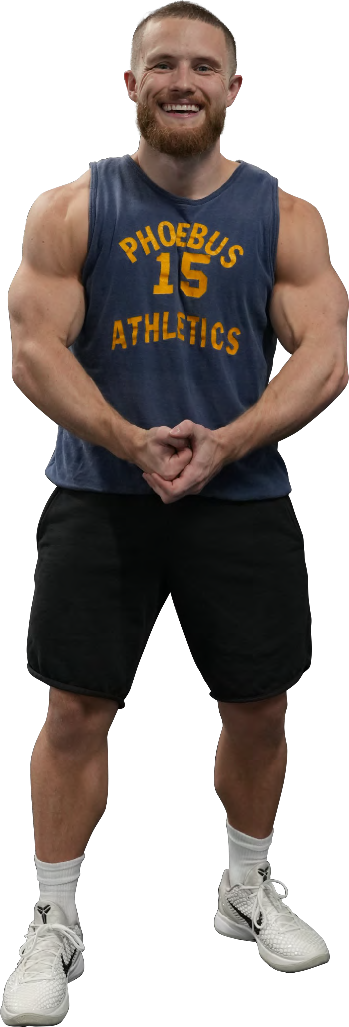

The Min-Max program was designed to help you get the most out of your training, whether your goal is to maximize muscle retention while cutting or maximize efficiency with shorter workouts.

Stick with it. Train hard. Track your progress. Whether you're cutting, maintaining, or in a gaining phase, this structure will give you a chance to make progress and set you up for long-term success.

1 hope you enjoy the program as much as I enjoyed creating it for you!



