Organic Chem

spongiforma@hitagi

Hydrocarbons

Alkanes
- less dense than water
- Saturated hydrocarbons
- Unreactive

Cracking
- alkane –> alkene + alkane (requires catalyst)
- Important as bigger alkanes can be broken down to smaller alkenes and alkanes which can be used for more fuel

Alkane types
- C1-C4
  - Gas at room temperature
  - Used as gas fuels
- C5-C17
  - Liquid
  - Gasoline/petrol is a mixture of C5-C8
  - Motor oil, kerosene, diesel:: C9-C16
- C17+
  - Solid
  - Paraffin wax
  - How does petroleum jelly prevent diager rash?
  - It coats the area with a protective gel layer that prevents moisture from getting next to skin.

Combustion/oxidation
\[ C_nH_{2n+2} + \frac{3n+1}{2}O_2 \xrightarrow{\textit{flame}} nCO_2 + (n+1)H_2O \]
(requires flame)
Complete combustion (blue flame) occurs with sufficient oxygen
Incomplete combustion occurs with greater C atoms
Soot (C particles) and CO (poisonous, odourless and colorless gas) are produced

Substitution reaction
\[ C_nH_{2n+2} + X_2 \xrightarrow{UV,rtp} C_nH_{2n+1}X + HX \]
Chain reaction
Requires UV light as a catalyst at rtp
Detectable acidic fumes with litmus paper. (HCl and HBr fumes are white)

Alkenes
Low density
Alkenes with several double bonds have a color associated with them.

Combustion
\[ C_nH_{2n} + \frac{3n}{2}O_2 \xrightarrow{\textit{flame}} nCO_2 + nH_2O \]
Requires heat

Hydrogenation/Halogenation
Alkene + Hydrogen $\rightarrow$ Alkane Requires palladium/Platinum/Nickel + heat + pressure
Alkene + Halogen $\rightarrow$ Alkyl Halide requires rtp

Polymerisation
requires heat,pressure and catalyst

Alkynes

Combustion
\[ C_nH_{2n-2} + \frac{3n-1}{2}O_2 \xrightarrow{\textit{flame}} nCO_2 + (n-1)H_2O \] Requires heat

Hydrogenation/Halogenation
Alkyne + 2 Hydrogen $\rightarrow$ Alkane Requires palladium/Platinum/Nickel + heat + pressure
Alkyne + Halogen $\rightarrow$ Alkyl Halide Require rtp

Aromatic
Non-polar Volatile Flammmable with a sooty flame Toxic, carcinogenic (some) Substituents on benzene ring modify these properties

Halogenation/Hydrogenation
\[ C_nH_n + X_2 \xrightarrow{Fe/FeX_3/AlX_3} C_nH_{n-1}X + HX \]
Requires Fe/FeX3/AlX3

Alkylation (Friedal-Crafts)
Benzene + R-X $\xrightarrow{AlX_3}$ R-Benzene + HX
Requires AlX3

Heterocyclic aromatic compounds
Heterocyclic aromatic compunds consist of at least one atom other than carbon

Alcohol

Properties

Boiling point
Increases as we go down the homologous series of alcohols. Bp increases as the molecular mass increases.

Solubility in water
Decreases down the homologous series.

Production

Fermentation
\[ C_6H_{12}O_6 \xrightarrow{\textit{yeast enzymes}} 2CH_3CH_2OH + 2CO_2 \]
anaerobic

Hydration
alkene + water -> alcohol
\[ C_2H_4 + H_2O \xrightarrow{\textit{300\textdegree{}C, 60 to 70 atm, $H_3PO_4$}} CH_3CH_2OH \]
reversible

Redox
requires acidified potassium permanganate [KMnO4] (purple to decolorized) or potassium dichromate (VI) (orange to green) [K2Cr2O7]
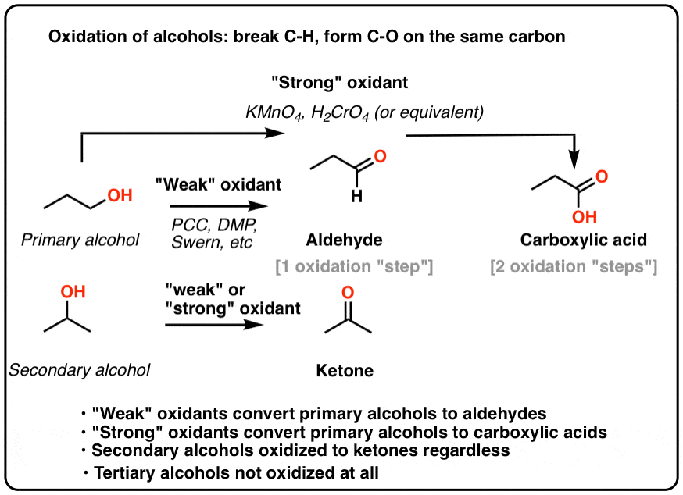

Dehydration
\[ C_2H_4 + H_2O \xrightarrow{\textit{300\textdegree{}C, 60 to 70 atm, $H_3PO_4$}} CH_3CH_2OH \]
\[ CH_3CH_2OH \xrightarrow{\textit{180\textdegree{}C, excess conc. $H_2SO_4$}} C_2H_4 + H_2O \]

Carboxylic acid

Formation
Created via oxidation of primary alcohols
primary alcohol 2[O]-> carboxylic acid + H2O

Characteristics
Pleasant odour, slightly polar, volatile, low molecular weight esters are water soluble

Neutralisation
(carboxylic) acid + base -> water + salt
(carboxylic) acid + water -> carboxlylate + hydronium (reversible)

Esterification
carboxylic acid + alcohol -> ester + water
requires heat/reflux, conc. $H_2SO_4$.
carboxylic acid loses OH, alcohol loses H.

Amines & Amides
Primary, secondary, tertiary amines (+ Ammonia)

Properties
Polar, covalent, high bp and mp.
if less than 6 carbons - soluble in water, otherwise no
primary and secondary amines have greater bp than tertiary ones as they can have hydrogen bonding
Alcohol has greater bp than primary/secondary amines as O-H is more polar than N-H
primary amines have greater bp than secondary amines as presence of alkyl groups around N reduce polarity in secondary amines

Neutralisation
when dissolved in water, they function as weak bases
RNH2 + H2O -> RNH3+ + OH-
They react with acid to form salts
RNH2 + HCl -> (RNH3)+Cl-
notice no water is formed

Condensation reaction (Amide reaction)
Carboxylic acid + (primary,secondary) amine -> (secondary,tertiary) Amide + water
requires heat primary amides can be formed with ammonia

Amides

Properties
polar
Primary amides have high bp and mp due to strong IMF/HB
Amides with <6 C are soluble, >=6 C are insoluble in water
Neutral

