Oxygen-containing compounds

spongiforma@hitagi

Alcohol

Properties

Boiling point
Increases as we go down the homologous series of alcohols. Bp increases as the Molecular mass increases.

Solubility in water
Decreases down the homologous series

Production

Fermentation
\[ C_6H_{12}O_6 \xrightarrow{\textit{yeast enzymes}} 2CH_3CH_2OH + 2CO_2 \]
anaerobic

Hydration
alkene + water -> alcohol
\[ C_2H_4 + H_2O \xrightarrow{\textit{300\textdegree{}C, 60 to 70 atm}}_{H_3PO_4} CH_3CH_2OH \]
reversible

Redox
requires acidified potassium permanganate [KMnO4] (purple to decolorized )or potassium dichromate (VI) (orange to green) [K2Cr2O7]
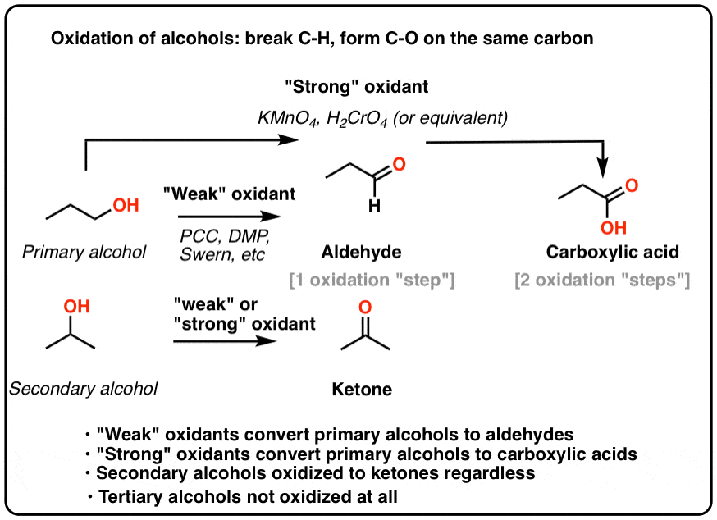

Primary alcohol
\[ R - CH_2 - O - H \rightarrow R - CH = O \rightarrow R - C = O - OH \]

Secondary alcohol

Dehydration
\[ C_2H_4 + H_2O \xrightarrow{\textit{300\textdegree{}C, 60 to 70 atm}}_{H_3PO_4} CH_3CH_2OH \]
\[ CH_3CH_2OH \xrightarrow{\textit{180\textdegree{}C,excess conc. $H_2SO_4$}} H_2SO_4C_2H_4 + H_2O \]

Carboxylic acid

Neutralisation
(carboxylic) acid + base -> water + salt

Esterification
requires heat/reflux, excess conc. $H_2SO_4$.
carboxylic acid + alcohol -> ester + water
carboxylic acid loses OH, alcohol loses H.

