1.1 .) **Crime Histogram:**

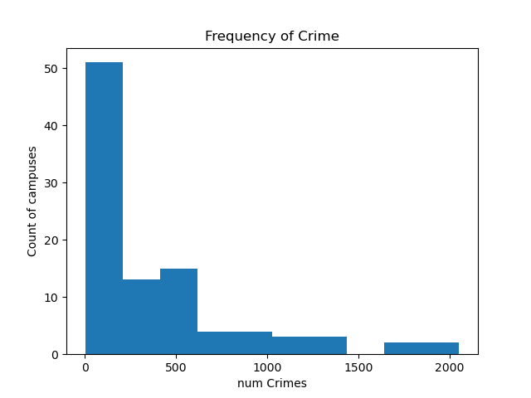

Interpretation: most points are clustered around the bottom, meaning that most universities are located in lower crime areas, with a few outliers at beyond the 1500 crimes mark. Most lie at under 500 crimes, with a large spike at between 0 and 200 crimes.

1.2 .) **Lenroll and Lcrime scatter plot:**

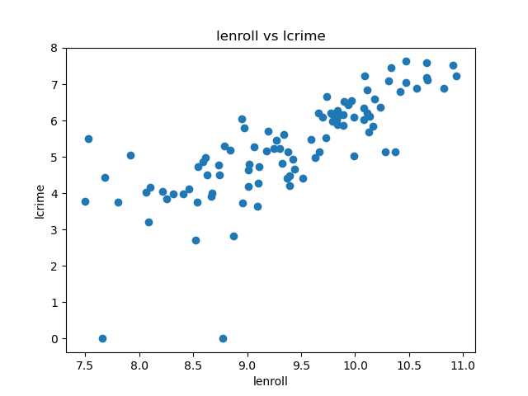

Description: There looks to be a positive relationship between the amount of crime on campus and the amount enrolled. This makes sense as a larger population would be more likely to have a larger absolute number of crimes. The relationship begins to breakdown at lower enrollment numbers.

1.3) subplots

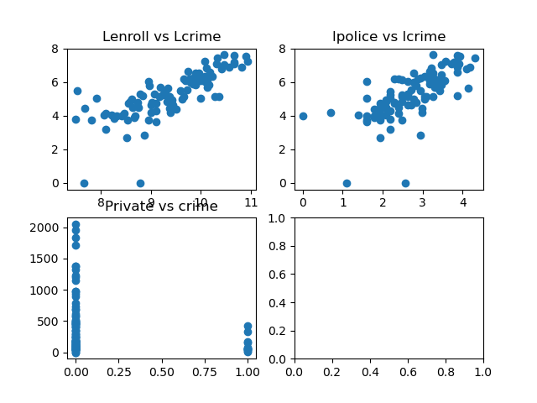

Description: both lenroll and lcrime have a positive relationship as discussed before. lpolice and lcrime also has positive effect, but lpolice is most likely result of lcrime rather than a cause of lcrime. Private schools generally feature less crime than public as shown by the scatterplots.

1.4: regression plot

