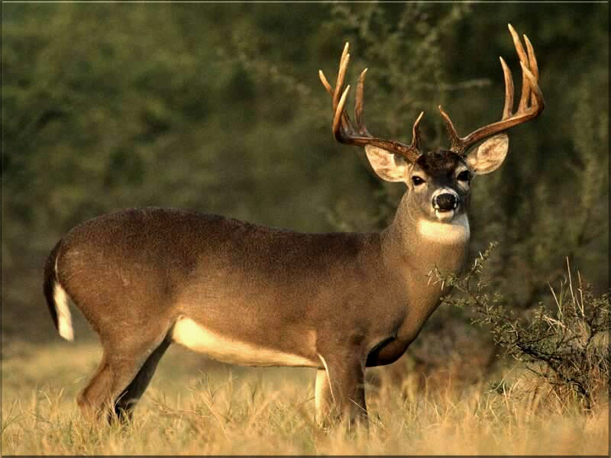 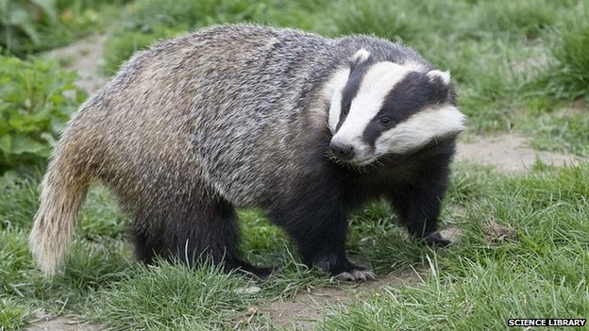

BadgEr

(Burger’s Equation)

MULe DEEr

(MULti-D Euler Equations)

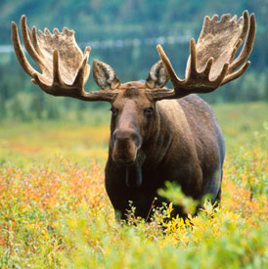

MOOSE

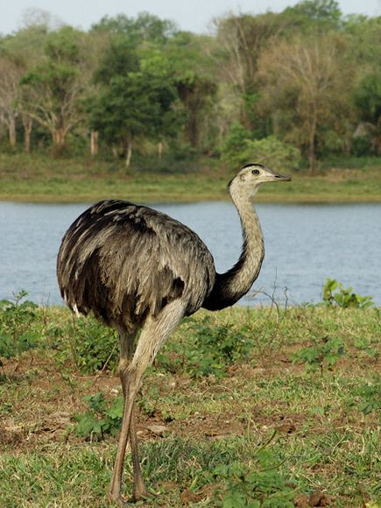 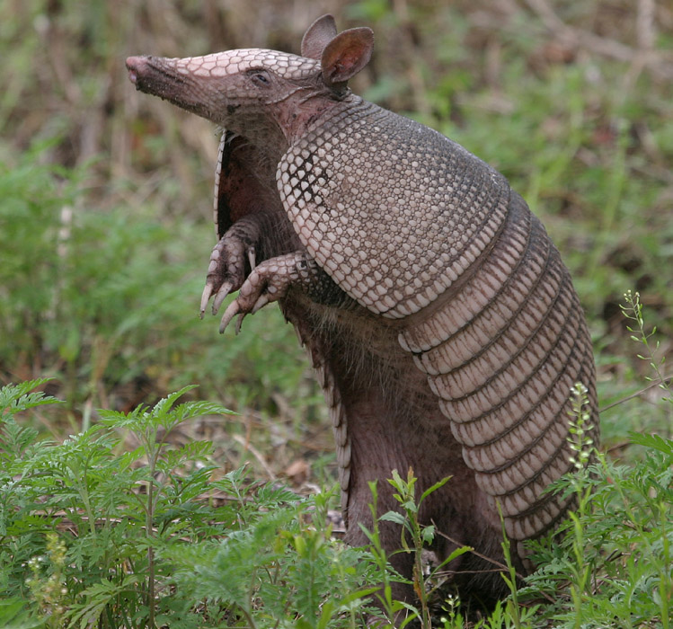

SEVEN banded arMadillo (SEVEN Equation Model)

RHEA

(Radiation-Hydrodynamic EquAtions)