

Data Technician

Name:
Course Date:
Table of contents
Day 1: Task 1 3
Day 1: Task 2 3
Day 3: Task 1 4
Day 4: Task 1: Written 6
Day 4: Task 2: SQL Practical 9
Course Notes 19
Additional Information 19

Day 1: Task 1

Please research and complete the below questions relating to key concepts of databases.

What is a primary key? | A primary key is a column or a combination of columns that uniquely identifies each record in a table. To function correctly, a primary key must satisfy three conditions: it must uniquely identify every record, it must not contain NULL values, and each table can have only one primary key. Together, these rules ensure entity integrity within the table.
How does this differ from a secondary key? | This comparison highlights how primary key operations differ from those of secondary keys. A secondary key supports searching and grouping of records, but does not uniquely identify individual rows. In contrast, a primary key uniquely identifies each record, does not allow NULL values, and appears only once per table, thereby enforcing data integrity. While primary keys ensure the integrity of data within a table, secondary keys are primarily used to improve search and indexing efficiency.
How are primary and foreign keys related? | The relationship between primary keys and foreign keys defines how tables are connected within a database. A foreign key creates a link between tables by referencing the primary key of another table. This relationship enforces data integrity by ensuring that related records remain consistent and preventing the existence of orphaned records.
Provide a real-world example of a one-to-one relationship | In a one-to-one relationship, such as between a person and a passport, each person has exactly one passport, and each passport belongs to a single person.
Provide a real-world example of a one-to-many relationship | In a one-to-many relationship, such as between customers and orders, a single customer can place multiple orders, while each order is associated with only one customer.
Provide a real-world example of a many-to-many relationship | In a many-to-many relationship, such as between students and courses, a student can enroll in multiple courses and each course can have multiple students. This type of relationship requires a junction table to act as a bridge between the two entities.

Day 1: Task 2

Please research and complete the below questions relating to key concepts of databases.

What is the difference between a relational and non-relational database? | The main distinction between relational databases and non-relational databases lies in their different data storage methods. The relational database system organizes its data into structured tables which contain rows and columns. The system establishes table relationships through primary keys and foreign keys while users access data through structured query language (SQL). The database system creates strict schema requirements which ensure that relational databases maintain complete data integrity and consistent data management.  A non-relational database (also known as a NoSQL database) stores data in a more flexible format, such as key-value pairs or document-based or wide column or graph-based data structures. The databases operate without requiring a pre-established schema and they can manage extensive datasets which undergo structural transformations throughout their lifecycle. The system offers users greater flexibility and operational efficiency while maintaining their ability to scale.
What type of data would benefit off the non-relational model?  Why? | Non-relational (NoSQL) databases are particularly well suited for managing semi-structured and unstructured data, large volumes of rapidly changing data, and datasets with highly variable formats or attributes.  Typical examples of this type of data include:  - Social media posts and other user-generated content  - IoT sensor and telemetry data  - Log files and event-stream data  - Product catalogues with frequently changing attributes  - Real-time and near-real-time analytics data  This type of data benefits from non-relational database systems primarily because they do not rely on rigid, predefined table schemas. Instead, non-relational databases support flexible and dynamic data models, allowing new fields or attributes to be added or modified without requiring costly schema redesigns or system downtime.  Additionally, non-relational databases are designed for horizontal scalability, enabling data to be distributed across multiple servers. This improves performance, fault tolerance, and availability when handling large-scale or rapidly growing datasets. As a result, applications that require high throughput, low latency, and frequent changes in data structure or functionality are well suited to non-relational databases, particularly in scenarios where strict, immediate data consistency is less critical than scalability and performance.

Day 3: Task 1

Please research the below ‘JOIN’ types, explain what they are and provide an example of the types of data it would be used on.

Self-join | A self-join is a table joined to itself. Self -join are used when the rows in the same table relate to each other  Self-joins are used where categorical data relates to itself in a hierarchy  Example: EmployeeID and ManagerID to r
Right join | A right join returns all records from the right table, plus matching records from the left table  Right joins preserve the full set of categorical records from the secondary dataset, even if reference data is missing.
Full join | A full join returns all records from both tables, whether matches exist or not.  Full joins are used when comparing categorical data across systems, ensuring no numerical data is lost on either side.
Inner join | An inner join returns only records where matching data exists in both tables.  Inner joins are typically used where categorical identifiers (e.g. CustomerID, ProductID) exist in both tables and are used to combine related numerical measures.
Cross join | A cross join produces every possible combination of rows between two tables.  Cross Joins are applied to categorical data to generate all possible combinations
Left join | Left join retrieves all records from the left table and returns all matching records from the right table.  Left join can be used in a situation when the categorical dataset is completed while the numerical data related to it may be missing.

Day 4: Task 1: Written

In your groups, discuss and complete the below activity. You can either nominate one writer or split the elements between you. Everyone however must have the completed work below:

Imagine you have been hired by a small retail business that wants to streamline its operations by creating a new database system. This database will be used to manage inventory, sales, and customer information. The business is a small corner shop that sells a range of groceries and domestic products. It might help to picture your local convenience store and think of what they sell. They also have a loyalty program, which you will need to consider when deciding what tables to create.

Write a 500-word essay explaining the steps you would take to set up and create this database. Your essay should cover the following points:
- Understanding the Business Requirements:
  - What kind of data will the database need to store?
  - Who will be the users of the database, and what will they need to accomplish?
- Designing the Database Schema:
  - How would you structure the database tables to efficiently store inventory, sales, and customer information?
  - What relationships between tables are necessary (e.g., how sales relate to inventory and customers)?
- Implementing the Database:
  - What SQL commands would you use to create the database and its tables?
  - Provide examples of SQL statements for creating tables and defining relationships between them.
- Populating the Database:
  - How would you input initial data into the database? Give examples of SQL INSERT statements.
- Maintaining the Database:
  - What measures would you take to ensure the database remains accurate and up to date?
  - How would you handle backups and data security?

Your essay should include specific examples of SQL commands and explain why each step is necessary for creating a functional and efficient database for the retail business.

Please write your 500-word essay here

Day 4: Task 2: SQL Practical

In your groups, work together to answer the below questions. It may be of benefit if one of you shares your screen with the group and as a team answer / take screen shots from there.

Setting up the database:

- Download world_db(1)
- Follow each step to create your database

For each question I would like to see both the syntax used and the output.

- Count Cities in USA: Scenario: You've been tasked with conducting a demographic analysis of cities in the United States. Your first step is to determine the total number of cities within the country to provide a baseline for further analysis.

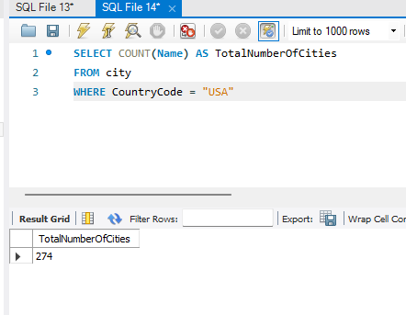

- Country with Highest Life Expectancy: Scenario: As part of a global health initiative, you've been assigned to identify the country with the highest life expectancy. This information will be crucial for prioritising healthcare resources and interventions.

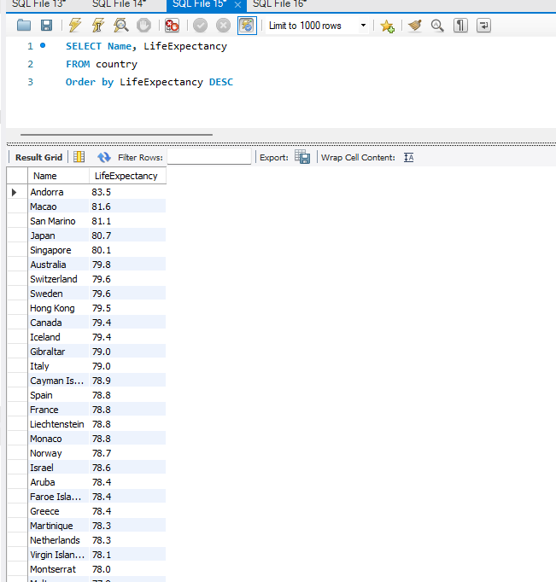

- "New Year Promotion: Featuring Cities with 'New : Scenario: In anticipation of the upcoming New Year, your travel agency is gearing up for a special promotion featuring cities with names including the word 'New'. You're tasked with swiftly compiling a list of all cities from around the world. This curated selection will be essential in creating promotional materials and enticing travellers with exciting destinations to kick off the New Year in style.

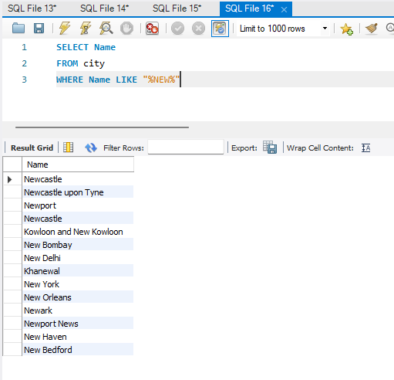

- Display Columns with Limit (First 10 Rows): Scenario: You're tasked with providing a brief overview of the most populous cities in the world. To keep the report concise, you're instructed to list only the first 10 cities by population from the database.

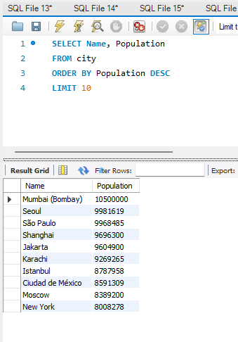

- Cities with Population Larger than 2,000,000: Scenario: A real estate developer is interested in cities with substantial population sizes for potential investment opportunities. You're tasked with identifying cities from the database with populations exceeding 2 million to focus their research efforts.

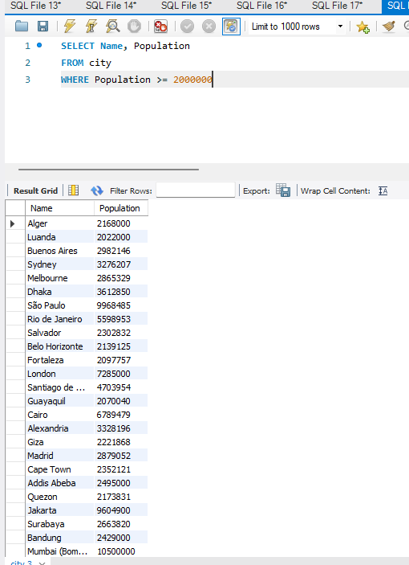

- Cities Beginning with 'Be' Prefix: Scenario: A travel blogger is planning a series of articles featuring cities with unique names. You're tasked with compiling a list of cities from the database that start with the prefix 'Be' to assist in the blogger's content creation process.

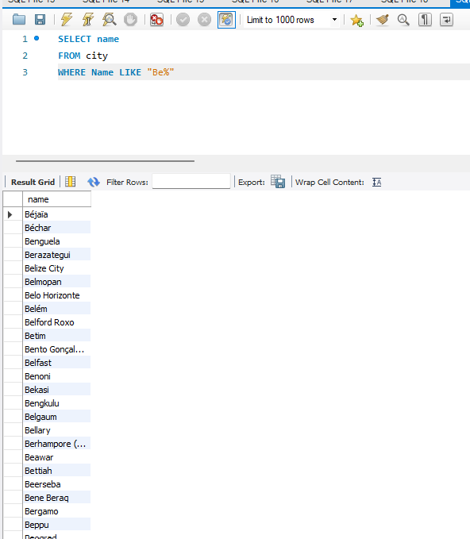

- Cities with Population Between 500,000-1,000,000: Scenario: An urban planning committee needs to identify mid-sized cities suitable for infrastructure development projects. You're tasked with identifying cities with populations ranging between 500,000 and 1 million to inform their decision-making process.

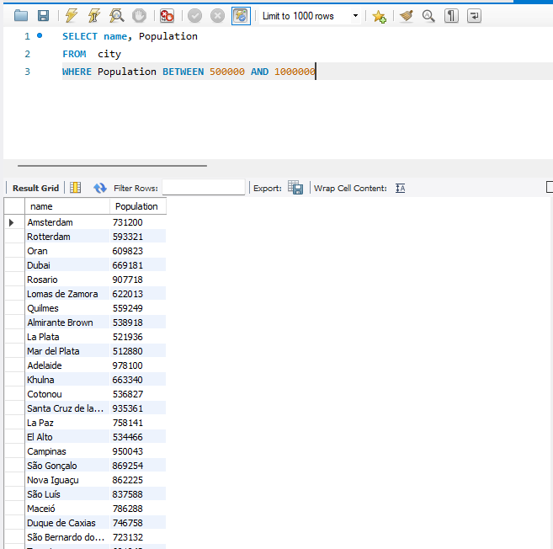

- Display Cities Sorted by Name in Ascending Order: Scenario: A geography teacher is preparing a lesson on alphabetical order using city names. You're tasked with providing a sorted list of cities from the database in ascending order by name to support the lesson plan.

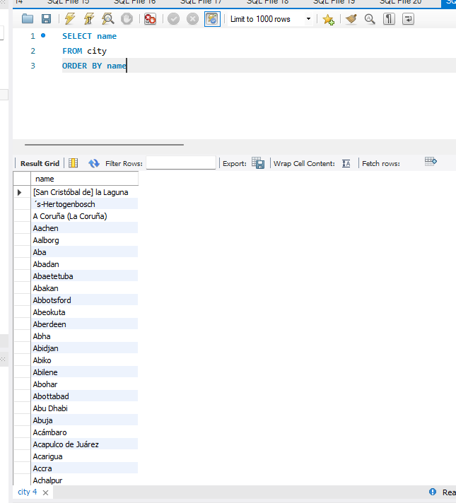

- Most Populated City: Scenario: A real estate investment firm is interested in cities with significant population densities for potential development projects. You're tasked with identifying the most populated city from the database to guide their investment decisions and strategic planning.

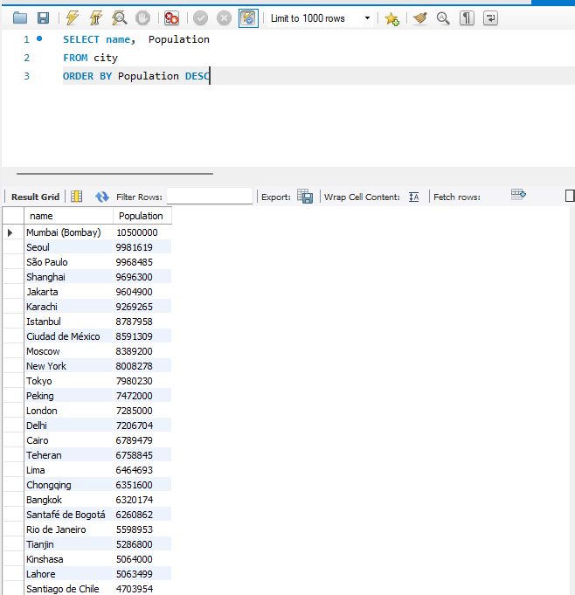

- City Name Frequency Analysis: Supporting Geography Education Scenario: In a geography class, students are learning about the distribution of city names around the world. The teacher, in preparation for a lesson on city name frequencies, wants to provide students with a list of unique city names sorted alphabetically, along with their respective counts of occurrences in the database. You're tasked with this sorted list to support the geography teacher.

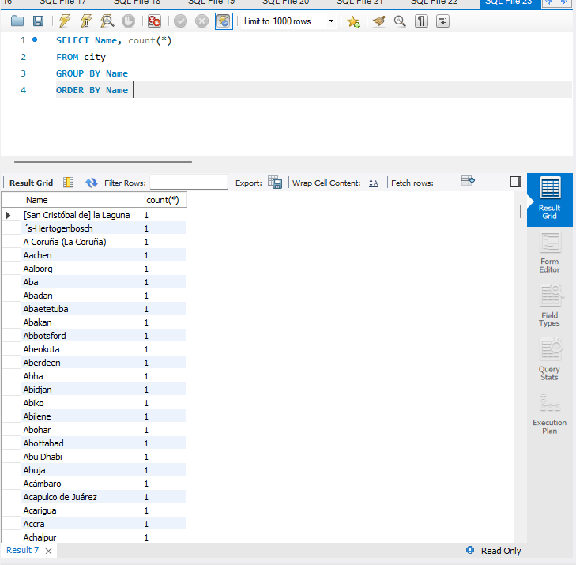

- City with the Lowest Population: Scenario: A census bureau is conducting an analysis of urban population distribution. You're tasked with identifying the city with the lowest population from the database to provide a comprehensive overview of demographic trends.

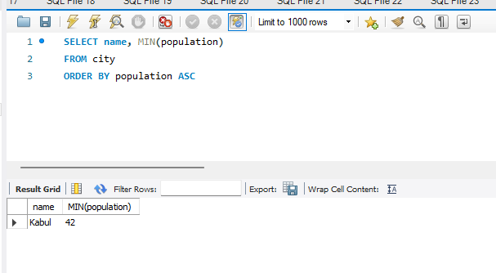

- Country with Largest Population: Scenario: A global economic research institute requires data on countries with the largest populations for a comprehensive analysis. You're tasked with identifying the country with the highest population from the database to provide valuable insights into demographic trends.

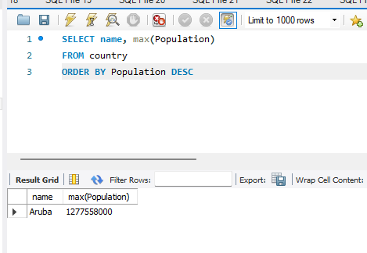

- Capital of Spain: Scenario: A travel agency is organising tours across Europe and needs accurate information on capital cities. You're tasked with identifying the capital of Spain from the database to ensure itinerary accuracy and provide travellers with essential destination information.

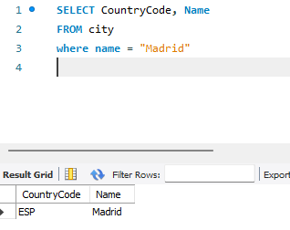

- Country with Shortest Life Expectancy: Scenario: A healthcare foundation is conducting research on global health indicators. You're tasked with identifying the country with the highest life expectancy from the database to inform their efforts in improving healthcare systems and policies.

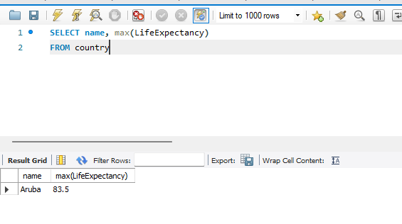

- Cities in Europe: Scenario: A European cultural exchange program is seeking to connect students with cities across the continent. You're tasked with compiling a list of cities located in Europe from the database to facilitate program planning and student engagement.
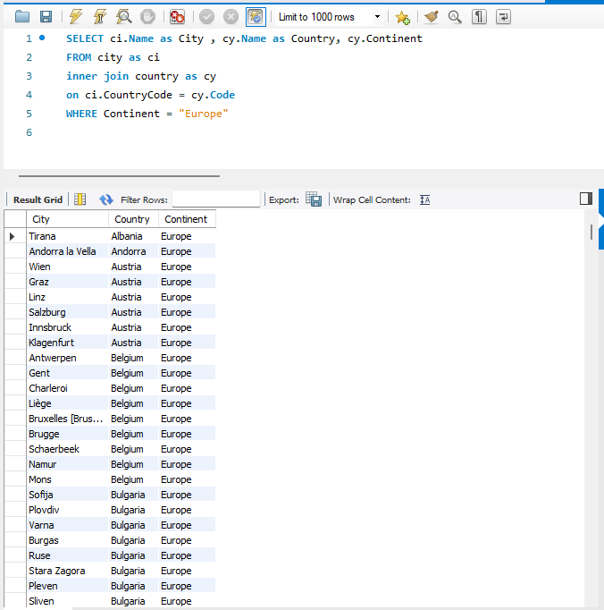

- Average Population by Country: Scenario: A demographic research team is conducting a comparative analysis of population distributions across countries. You're tasked with calculating the average population for each country from the database to provide valuable insights into global population trends.

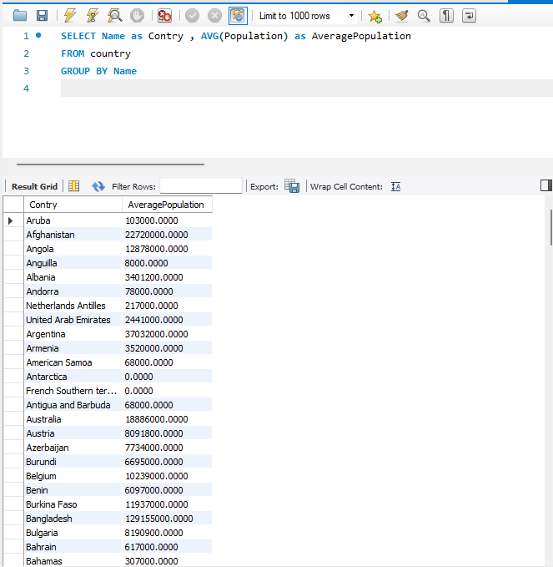

- Capital Cities Population Comparison: Scenario: A statistical analysis firm is examining population distributions between capital cities worldwide. You're tasked with comparing the populations of capital cities from different countries to identify trends and patterns in urban demographics.

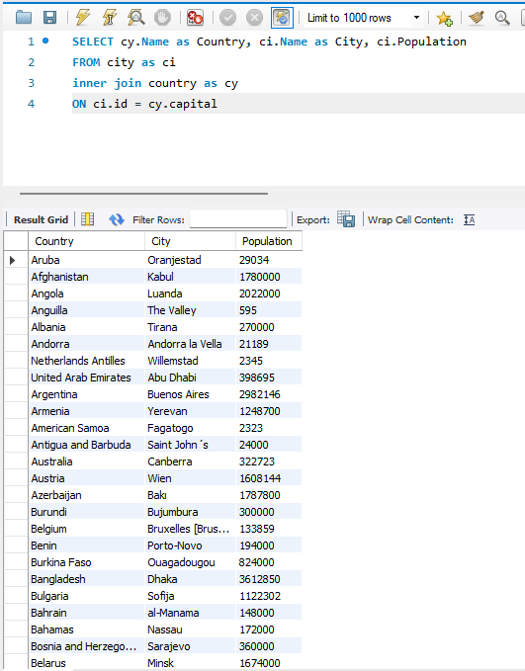

- Countries with Low Population Density: Scenario: An agricultural research institute is studying countries with low population densities for potential agricultural development projects. You're tasked with identifying countries with sparse populations from the database to support the institute's research efforts.

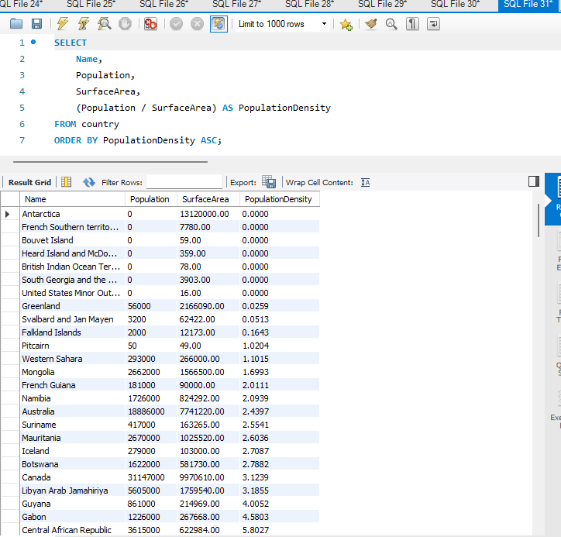

- Cities with High GDP per Capita: Scenario: An economic consulting firm is analysing cities with high GDP per capita for investment opportunities. You're tasked with identifying cities with above-average GDP per capita from the database to assist the firm in identifying potential investment destinations.

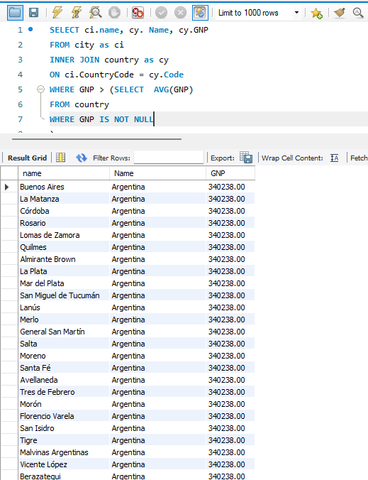

- Display Columns with Limit (Rows 31-40): Scenario: A market research firm requires detailed information on cities beyond the top rankings for a comprehensive analysis. You're tasked with providing data on cities ranked between 31st and 40th by population to ensure a thorough understanding of urban demographics.

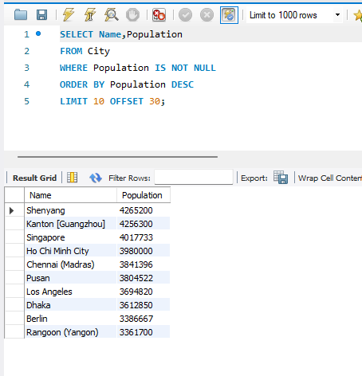

Course Notes

It is recommended to take notes from the course, use the space below to do so, or use the revision guide shared with the class:

Additional Information

We have included a range of additional links to further resources and information that you may find useful, these can be found within your revision guide.

END OF WORKBOOK

Please check through your work thoroughly before submitting and update the table of contents if required.

Please send your completed work booklet to your trainer.

