Data Technician Week 5
Workbook
Azure Data Fundamentals

Name:
Course Date:
Table of contents
Day 1: Task 1 3
Day 1: Task 2 4
Day 1: Task 3 5
Day 2: Task 1 6
Day 3: Task 1 10
Day 3: Task 2 11
Day 3: Task 3 12
Day 4: Task 1 13
Day 4: Task 2 14
1. Scenario Background 14
2. Data Laws and Regulations 14
3. Azure Service Recommendations 14
4. Data Types and Data Modelling 14
5. Data Storage Formats and Structures in Azure 15
6. Additional Considerations 15
Submission Guidelines: 15
Course Notes 18
Additional Information 19

Day 1: Task 1

Please research and complete the below questions relating to key concepts of cloud.

Be prepared to discuss the below in the group following this task.

What can cloud computing do for us in the real-world? | Cloud computing enables people and organizations to obtain IT services through internet access, providing them with storage, software, and computing resources without the need for physical equipment. The system supports remote work and online collaboration, enabling users to store data, host applications, and access services anytime they connect to the internet.  Examples:  Storing files in cloud storage.  Using online email, video conferencing, and collaboration tools  Hosting websites and applications without operating your own physical servers
How can it benefit a business? | Cloud computing provides three main benefits to businesses by enabling them to decrease their expenses and gain operational flexibility while achieving rapid business growth.  Key benefits:  - Lower upfront costs (no need to buy expensive servers). Pay only for what you use  - Users can easily increase or decrease their resource usage according to their needs  - The system provides better protection against disasters through its enhanced recovery and backup capabilities  - The system allows employees to work from home or from various locations  - The provider takes care of all system updates and maintenance tasks through automatic processes.
What’s the alternative to cloud computing? | The main alternative option available to users requires them to install computing systems in their on-premises environment. The organization executes its work by operating servers and systems from its own facility. The organization must handle all aspects of its infrastructure which includes maintaining its hardware and performing security work and executing system updates and creating backup copies.  The system experiences two main drawbacks when compared to cloud services. The system requires users to pay high initial expenses while their capacity to expand operations is restricted and their need for internal technical support staff exists. The organization takes a longer time to implement changes when compared to its competitors.
What cloud providers can we use, what are their features and functions? | The main cloud providers include:  Amazon Web Services (AWS)  The platform provides multiple services which include storage and compute and database and AI functionalities. The system operates at high scalability and reliability standards. Both large enterprises and startup companies use this solution.  Microsoft Azure  The platform provides strong integration capabilities with Windows Office and Active Directory. The platform has gained popularity among organizations that already use Microsoft products.  Google Cloud Platform (GCP) The platform provides advanced data analytics capabilities together with machine learning development tools. The platform serves as a primary choice for organizations that need to handle large data sets and artificial intelligence tasks.

Day 1: Task 2

Please research the below cloud offerings, explain what they are and examples of use cases.

Cloud Offerings | Explain what it is | When / how might you use this service in the real-world?
IaaS (Infrastructure as a service) | Provides virtual servers, storage, and networks | Used when you want full control over servers without buying hardware (e.g. hosting a website or custom application)
PaaS (Platform as a service) | Provides a platform to build and run applications without managing servers | Used by developers to build apps quickly (e.g. web apps, APIs)
SaaS (Software as a service) | Fully managed software delivered over the internet | Used for everyday applications like email, HR systems, CRM software

Day 1: Task 3

Please research the below terms and explain what they are, when they would be appropriate and a real-world example of where it could be implemented (i.e. what type of organisation).

Public Cloud | What it is  A cloud environment where computing resources (servers, storage, applications) are owned and managed by a third-party provider and shared between multiple customers over the internet.  When it’s appropriate  - When cost needs to be kept low  - When scalability and flexibility are important  - When data is not highly sensitive  - When quick setup is required  Real-world example  - Small to medium-sized businesses, startups, and individuals  - Example uses: email systems, file storage, website hosting, collaboration tools
Private Cloud | What it is  A cloud environment dedicated to a single organisation. It can be hosted on-site or by a third party, but the infrastructure is not shared with others.  When it’s appropriate  - When high security and data control are required  - When strict compliance or regulatory rules must be followed  - When performance consistency is critical  Real-world example  - Banks, healthcare providers, government organisations  - Example uses: patient record systems, financial transaction systems
Hybrid Cloud | What it is  A combination of public cloud and private cloud, where data and applications can move between them.  When it’s appropriate  - When sensitive data must stay private, but other systems can run in the public cloud  - When organisations want flexibility without fully committing to public cloud  - When transitioning from on-premises systems to cloud  Real-world example  - Large enterprises and retailers  - Example uses: customer-facing applications in public cloud, internal systems in private clou
Community Cloud | What it is  A cloud environment shared by several organisations with similar requirements, such as security, compliance, or industry standards.  When it’s appropriate  - When organisations have common goals or regulations  - When costs and resources can be shared  - When collaboration is important  Real-world example  - Universities, research institutions, government departments, NHS trusts  - Example uses: shared research platforms, shared government system

Day 2: Task 1

Describe, with examples, the three major areas that the Computer Misuse Act deals with.

Area | Description | Example
Unauthorised access | Accessing a computer system, data, or network without permission. This includes simply logging into an account you are not allowed to use. | Guessing someone’s password and logging into their email account without permission.
Unauthorised access with intent | Accessing a computer system without permission with the intention of committing another crime, such as fraud or theft. | Hacking into a company database to steal customer credit card details.
Unauthorised modification of computer materia | Changing, deleting, or damaging data without permission. This includes spreading viruses or malware. | Installing ransomware on a company’s network or deleting important business files.

The computer misuse act 1990 is an act where an individual can be criminalised because of computer related offense. Describe three extra powers that the Police and Justice Act 2006 (Computer Misuse) has added.

Description

Look at the below website to answer the questions:
https://www.gov.uk/personal-data-my-employer-can-keep-about-me

Write down three items of data which a company can store about an employee.
- Name and address
- National Insurance number
- Salary and payment details

Give three more examples of data that an employer can only store if they first get the employee’s permission.
- Medical records
- Biometric data (fingerprints, facial scans)
- Personal monitoring data (e.g. location tracking)

Conduct further research to answer the below questions.

Question | Answer
Provide one example of: Copyright infringement | Downloading movies or software illegally
Provide one example of: Plagiarism | Copying someone else’s work and claiming it as your own
What are two consequences of copyright infringement and software piracy? | - Fines  - Legal action or prosecution
Give three possible consequences for individuals when using pirated software | - Security risks (malware)  - Legal penalties  - Software may not work properly or receive updates

Listed below are some laws which we have covered today:

1. Computer Misuse Act 1990
2. Police and Justice Act 2006 (Computer Misuse)
3. Copyright, Designs and Patents Act 1988
4. Copyright (Computer Programs) Regulations 1992
5. The Health and Safety (Display Screen Equipment) Regulations 1992
6. Data Protection Act 2018
7. Consumer Rights Act 2015
- Insert a number in the first column of each row to match each of the statements with one of the above Acts.

- One of statements is incorrect and not illegal. For this statement, write ‘Not illegal’.

Act number | Clause
3 | With some exceptions, it is illegal to use unlicensed software
7 | Any product, digital or otherwise, must be fit for the purpose it is supplied for
1 | Unauthorised modification of computer material is illegal
It is not illegal | It is illegal to create or use a hacking tool for penetration testing
6 | Personal data may only be used for specified, explicit purposes
5 | Employers must provide their computer users with adequate health and safety training for any workstation they work at
2 | It is illegal to distribute hacking tools for criminal purposes
3 | It is illegal to distribute an illicit recording
6 | Personal data may not be kept longer than necessary
1 | Gaining unauthorised access to a computer system is illegal
5 | Employers must ensure that employees take regular and adequate breaks from looking at their screens
2 | It is illegal to prevent or hinder access (e.g. by a denial-of-service attack) to any program or data held in any computer
6 | Personal data must be accurate and where necessary kept up to date

Day 3: Task 1

Please complete the below lab (3) ‘Explore relational data in Azure’ and paste evidence of the completed lab in the box provided.

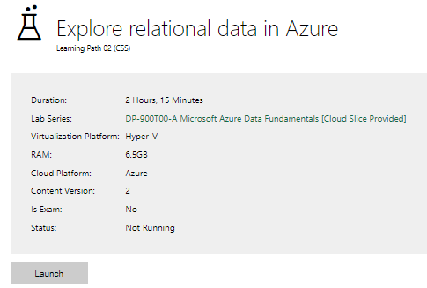

Completed lab | 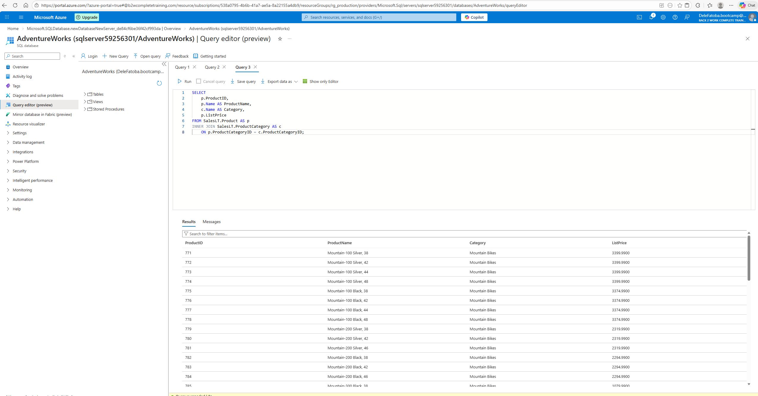

Day 3: Task 2

Please complete the below lab (4) ‘Explore non-relational data in Azure’ and paste evidence of the completed lab in the box provided.

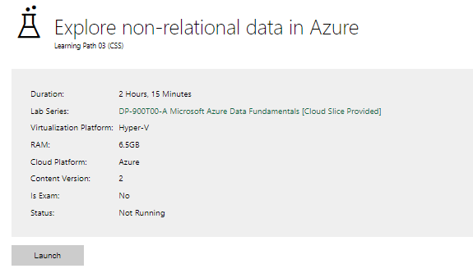

Completed lab | 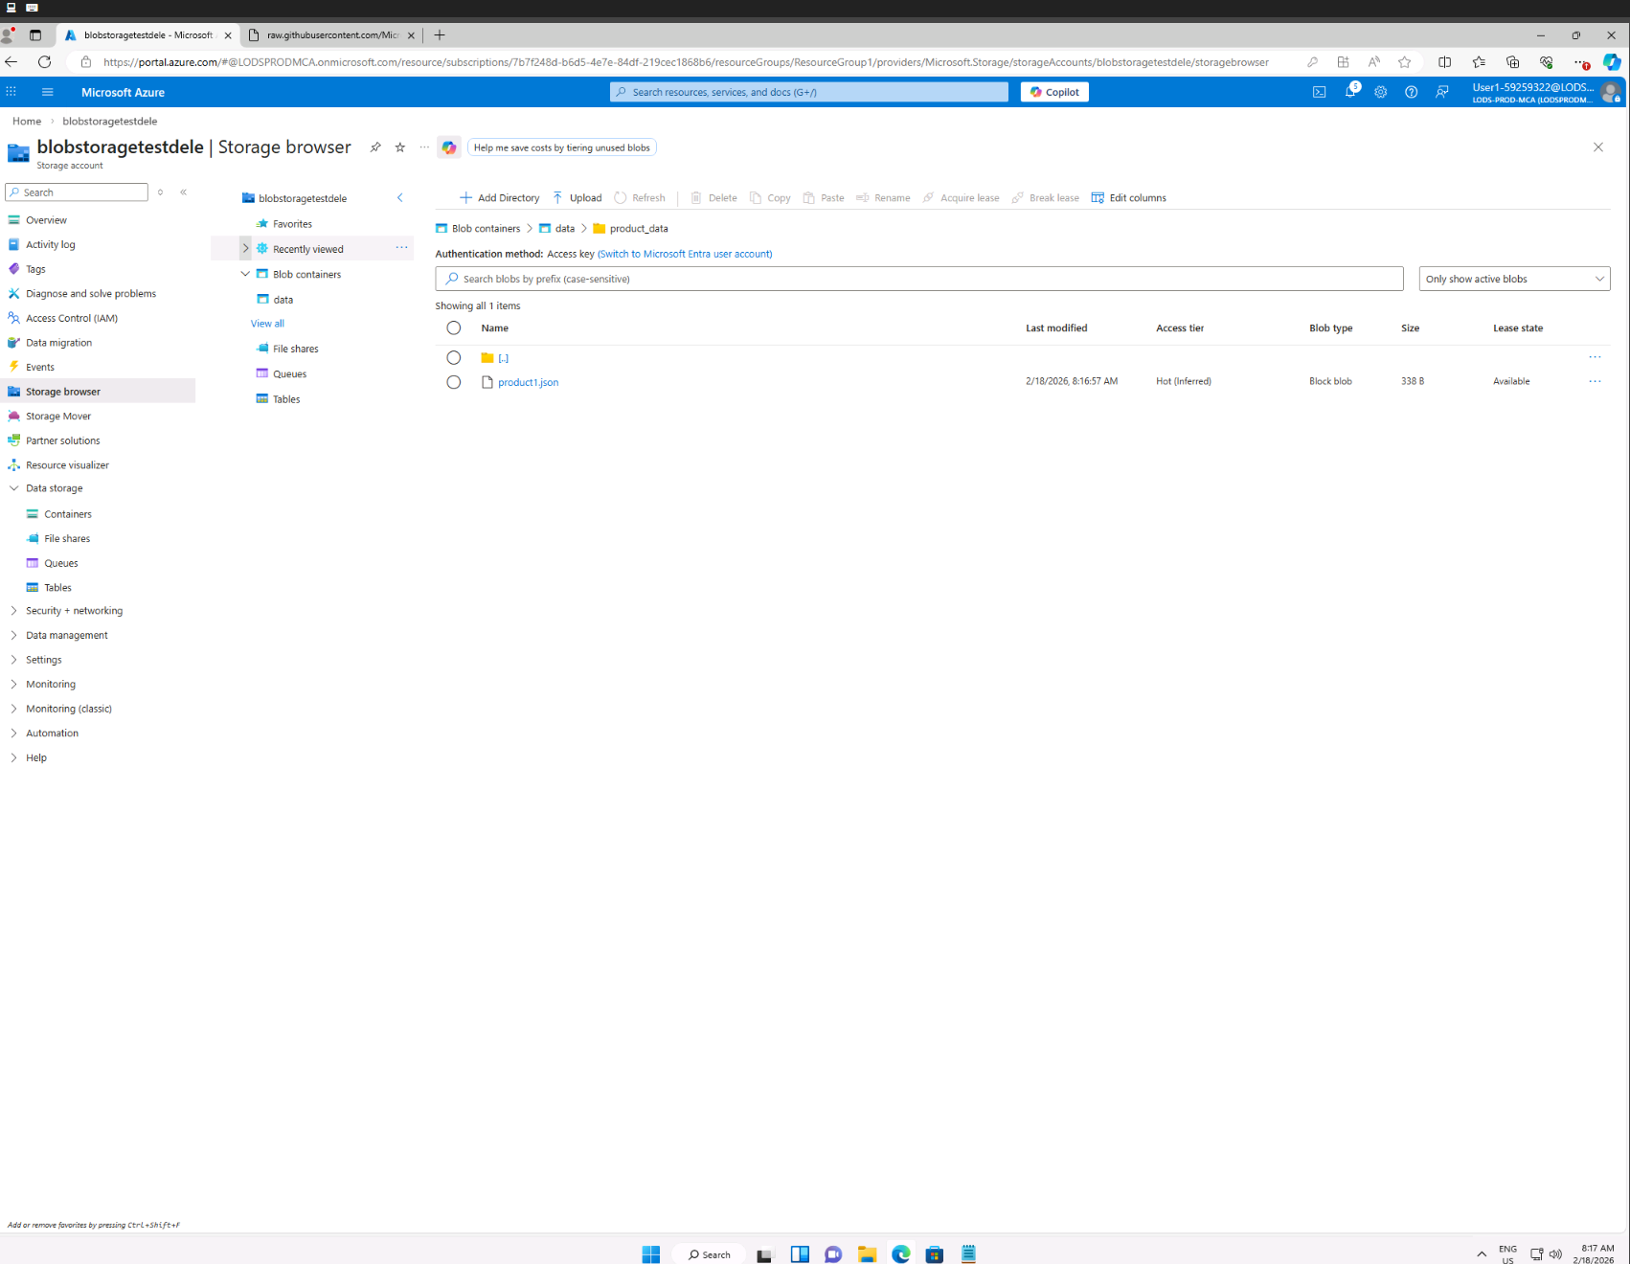  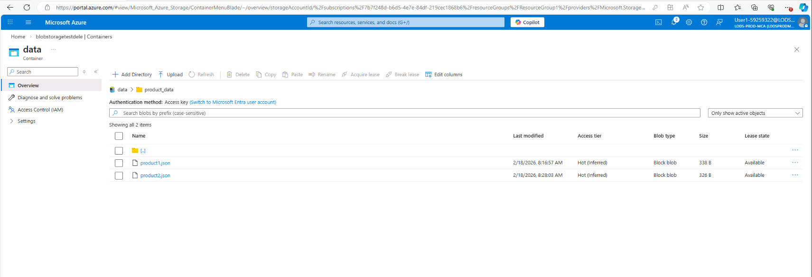  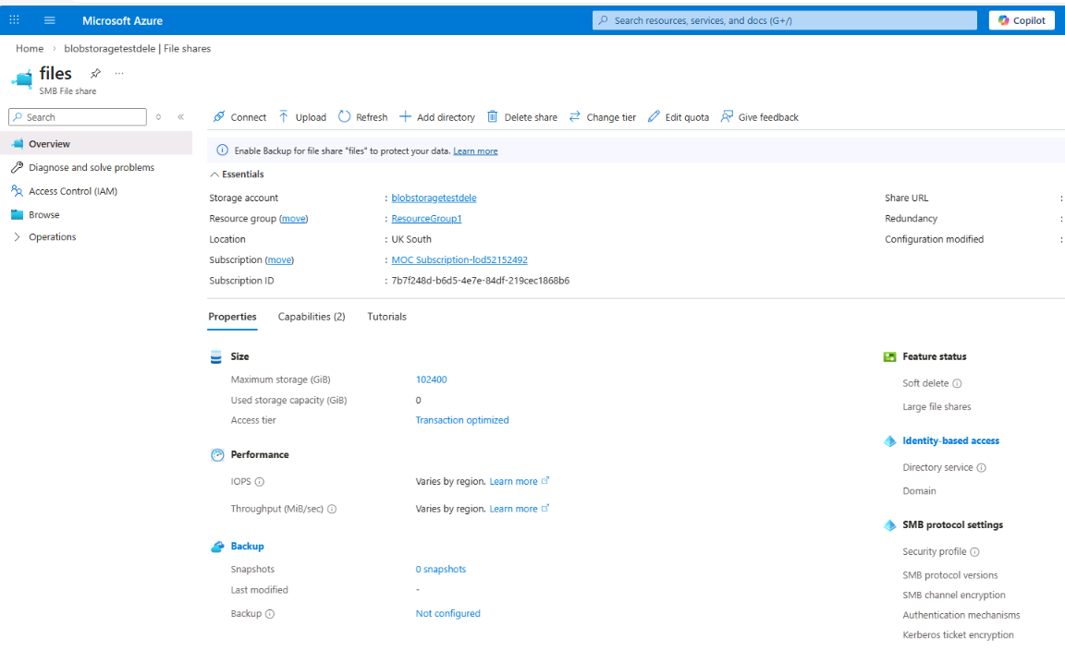
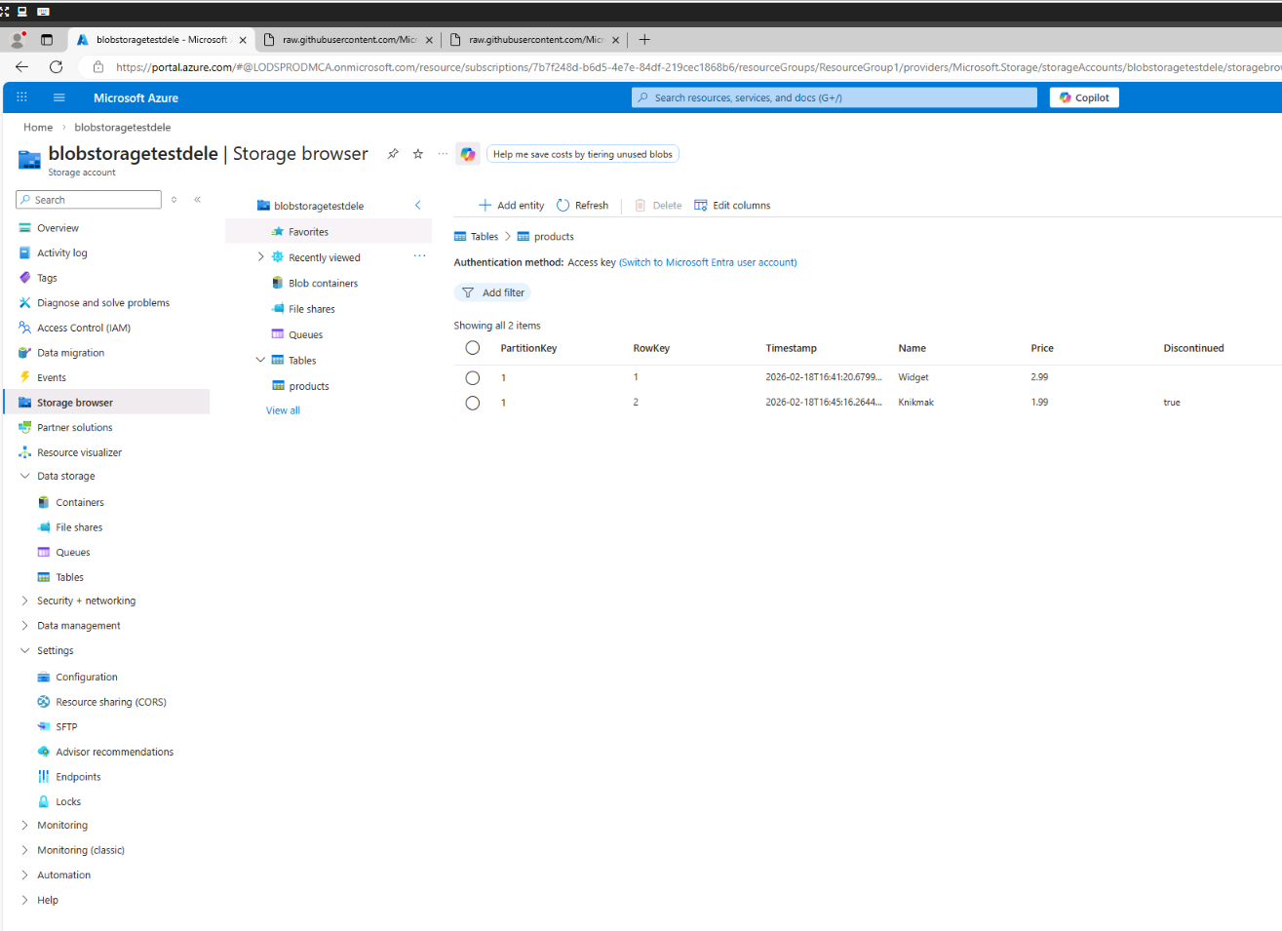

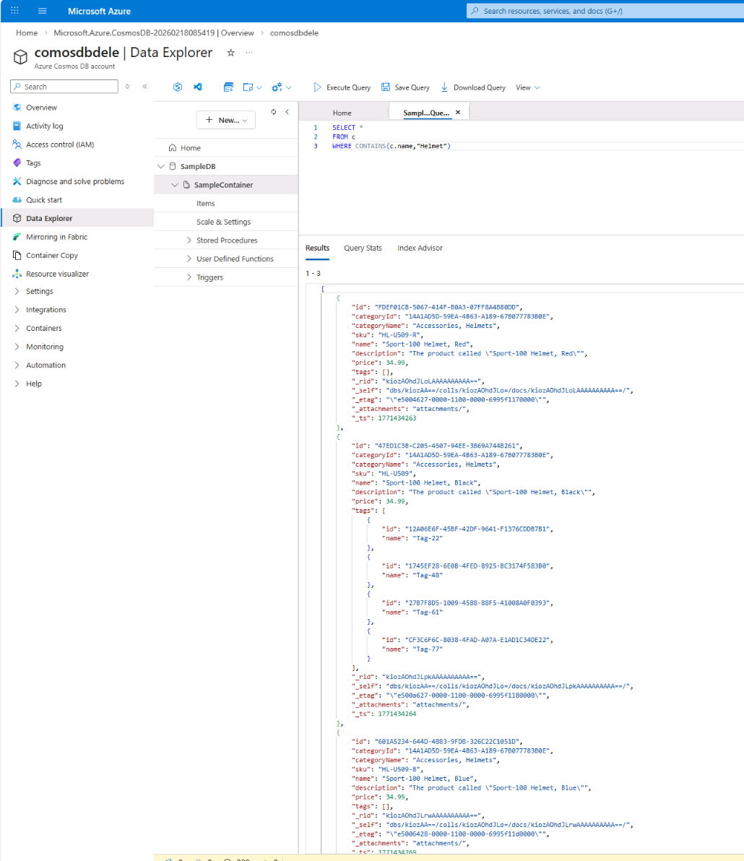

Day 3: Task 3

Please complete the below lab (5) ‘Explore data analytics in Azure’ and paste evidence of the completed lab in the box provided.

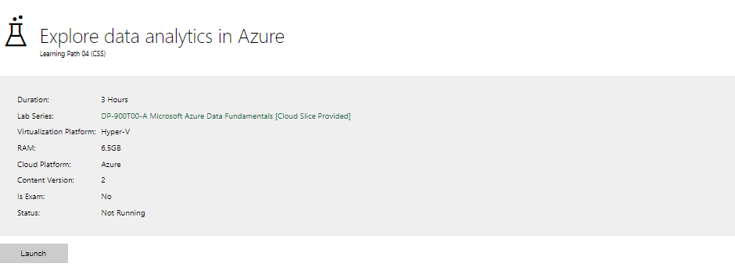

Completed lab | 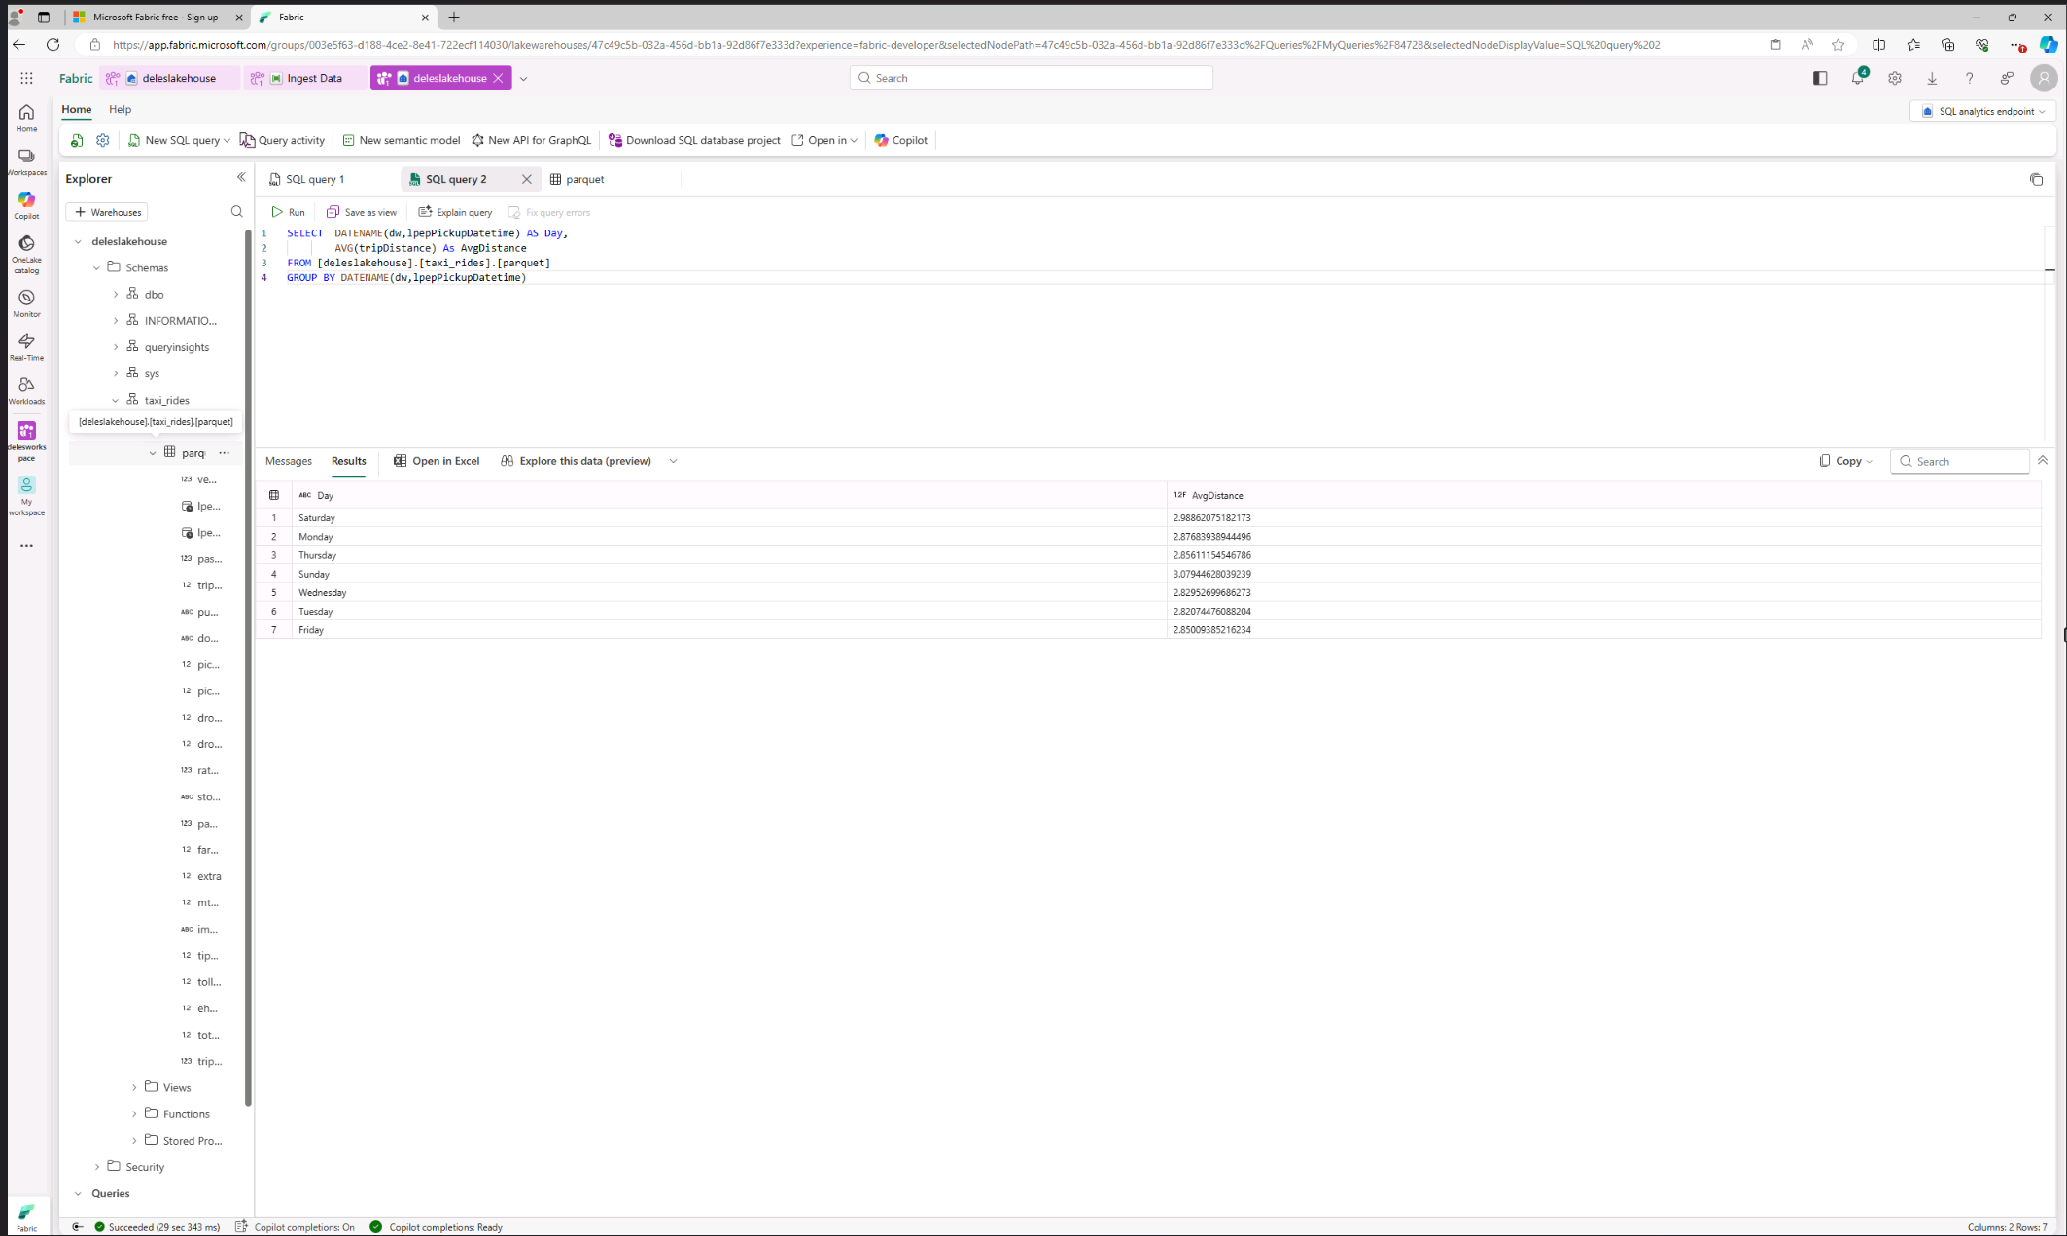

Day 4: Task 1

In your teams, complete the Azure DP-900 practice exam and paste your result below – this is open book and please research and discuss your answers as a team.

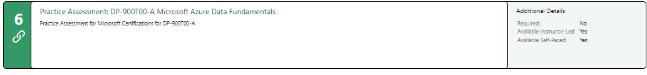
Result

Day 4: Task 2

1. Scenario Background
"Paws & Whiskers" is a growing pet shop that aims to improve its business by analysing sales, customer information, and inventory data. Currently, the data is collected manually or stored in spreadsheets. Management is interested in transitioning to Microsoft Azure to streamline data storage, analysis, and reporting, enabling them to make data-driven decisions.

2. Data Laws and Regulations
Identify and explain the data laws and regulations relevant to handling customer data within the proposal. Ensure you cover the following points:
- GDPR Compliance: Highlight the importance of adhering to the General Data Protection Regulation (GDPR), particularly as it relates to storing and processing customer information.
- Data Protection Act (DPA) 2018: Outline how the DPA 2018 may affect the way "Paws & Whiskers" collects and stores data, ensuring compliance with UK laws on data privacy.
- Other Industry Standards: Research any additional data protection standards or regulations that may apply to pet shop data, particularly if they involve sensitive or payment information.

3. Azure Service Recommendations
Recommend Microsoft Azure services that would suit the company’s data analysis needs and explain why these services are suitable. Your recommendations should include:
- Data Storage: Identify suitable storage options, such as Azure Blob Storage or Azure SQL Database, and discuss the benefits of each for storing large datasets, including inventory, sales transactions, and customer details.
- Data Analysis Tools: Recommend tools such as Azure Machine Learning for customer behaviour analysis or Azure Synapse Analytics for analysing sales trends.
- Data Integration and Automation: Explain how services like Azure Data Factory could automate data collection and integration processes, improving efficiency.

4. Data Types and Data Modelling
Define the types of data "Paws & Whiskers" will need to work with and describe your approach to data modelling:
- Data Categories: Identify key data types, such as customer demographics, transaction history, pet inventory, and product categories.
- Data Modelling Approach: Outline how you would structure this data using a relational model or a data warehouse approach, considering factors like tables, entities, relationships, and primary keys.

5. Data Storage Formats and Structures in Azure
Discuss how you would store data within Azure and the formats you would recommend:
- Data Formats: Specify recommended formats (e.g., CSV for raw data imports, JSON for structured data, Parquet for analytics) and explain why these formats are suitable for specific data types.
- Data Security and Encryption: Include recommendations for securing data using Azure’s built-in encryption features and access controls to ensure compliance with data privacy regulations.

6. Additional Considerations
Provide any other considerations that might enhance data handling and efficiency in Azure, such as:
- Backup and Disaster Recovery: Outline a backup plan using Azure Backup or Azure Site Recovery to safeguard against data loss.
- Data Visualisation: Discuss potential use of Power BI within Azure for creating dashboards that provide management with real-time insights into sales and customer trends.
- Future Scalability: Comment on how Azure services can scale as the business grows, accommodating larger datasets and more complex analyses.

Submission Guidelines:
- Structure: Ensure your report is well-organised, with sections for each task (e.g., Data Laws, Azure Services, Data Types, etc.).
- Formatting: Include headings, bullet points where appropriate, and any visuals or diagrams that support your explanations.
- References: Cite any resources or regulations referenced in the report.
- Length: Aim for 1500-2000 words.

Transitioning to Microsoft Azure would centralise data storage, automate data integration, and enable structured reporting. Azure provides secure, scalable cloud infrastructure that allows businesses to store data efficiently and analyse it using built-in analytics tools. By implementing an Azure-based data solution, “Paws & Whiskers” can:
- Centralise all data in one secure system
- Improve data accuracy and consistency
- Automate data processing
- Gain real-time insights into sales and customer trends
- Scale systems as the business grows
This proposal outlines the legal requirements, recommended Azure services, data modelling strategy, and additional considerations for implementing a secure and efficient cloud-based data solution.
Data Laws and Regulations
Handling customer data requires compliance with UK data protection laws. Since the pet shop collects customer information such as names, addresses, contact details, and transaction history, it must comply with the following regulations.
GDPR Compliance (UK GDPR)
The UK General Data Protection Regulation (UK GDPR) governs how personal data is collected, stored, and processed. Personal data refers to any information that identifies an individual.
Key GDPR principles include:
- Lawfulness, fairness, and transparency – Data must be processed for legitimate purposes, and customers must understand how their data is used.
- Purpose limitation – Data should only be used for the purpose it was collected.
- Data minimisation – Only necessary data should be collected.
- Accuracy – Data must be kept up to date.
- Storage limitation – Data should not be retained longer than required.
- Integrity and confidentiality – Appropriate security measures must protect data.
For “Paws & Whiskers,” compliance means:
- Creating a clear privacy policy
- Recording lawful bases for processing (e.g., contract for order fulfilment, consent for marketing)
- Allowing customers to access or request deletion of their data
- Implementing secure storage and access controls
Reference: UK GDPR – gov.uk data protection guidance.

Data Laws and Regulations
Handling customer data requires compliance with UK data protection laws. Since the pet shop collects customer information such as names, addresses, contact details, and transaction history, it must comply with the following regulations.
GDPR Compliance (UK GDPR)
The UK General Data Protection Regulation (UK GDPR) governs how personal data is collected, stored, and processed. Personal data refers to any information that identifies an individual.
Key GDPR principles include:
- Lawfulness, fairness, and transparency – Data must be processed for legitimate purposes, and customers must understand how their data is used.
- Purpose limitation – Data should only be used for the purpose it was collected.
- Data minimisation – Only necessary data should be collected.
- Accuracy – Data must be kept up to date.
- Storage limitation – Data should not be retained longer than required.
- Integrity and confidentiality – Appropriate security measures must protect data.
For “Paws & Whiskers,” compliance means:
- Creating a clear privacy policy
- Recording lawful bases for processing (e.g., contract for order fulfilment, consent for marketing)
- Allowing customers to access or request deletion of their data
- Implementing secure storage and access controls
Reference: UK GDPR – gov.uk data protection guidance.

Data Protection Act (DPA) 2018
The Data Protection Act 2018 supplements UK GDPR and provides the legal framework for enforcement in the UK. It ensures organisations demonstrate accountability and handle data responsibly.
The Act requires:
- Secure storage of personal data
- Documentation of data processing activities
- Respect for individual rights (e.g., subject access requests)
Azure services can support compliance by providing audit logs, encryption, and controlled user access.
Reference: Data Protection Act 2018 – legislation.gov.uk.

Other Industry Standards (Payment Data)
If the pet shop processes card payments, it must consider PCI DSS (Payment Card Industry Data Security Standard) requirements.
Best practice includes:
- Using third-party payment providers to process card details
- Avoiding storage of sensitive card data in internal systems
- Storing only transaction references
This reduces compliance complexity and enhances security.
Reference: PCI Security Standards Council.

3. Azure Service Recommendations
A structured Azure architecture should support storage, analytics, and automation while remaining cost-effective.
Data Storage
Azure SQL Database
Recommended for structured business data such as:
- Customer information
- Sales transactions
- Product inventory
Benefits:
- Managed database service (automatic updates and backups)
- Built-in security and encryption
- Supports relational modelling
- Scalable performance tiers
Azure Blob Storage / Data Lake Storage Gen2
Recommended for:
- Raw spreadsheet uploads
- Archived historical data
- Supplier files and exports
Benefits:
- Low-cost scalable storage
- Suitable for large datasets
- Supports analytics workloads
A recommended structure:
- Raw data container
- Cleaned/curated data container
- Archive container

Data Analysis Tools
Azure Synapse Analytics
Useful for analysing:
- Sales trends over time
- Product category performance
- Seasonal demand patterns
It allows structured reporting and integration with Power BI.
Azure Machine Learning (Future Phase)
Once sufficient data is collected, machine learning models can:
- Predict product demand
- Segment customers
- Identify buying patterns
This would enhance strategic decision-making.

Data Integration and Automation
Azure Data Factory (ADF)
ADF automates:
- Importing spreadsheet data
- Cleaning and transforming datasets
- Loading data into Azure SQL
Benefits:
- Reduces manual effort
- Improves data consistency
- Enables scheduled processing
Automation is essential for efficiency as the business grows.

4. Data Types and Data Modelling
Data Categories
The business will manage several data types:
- Customer Data
  - Customer ID
  - Name and contact details
  - Address (if delivery is provided)
  - Marketing consent
- Transaction Data
  - Order ID
  - Date and time
  - Products purchased
  - Quantity and total cost
- Inventory Data
  - Product ID
  - Product name and category
  - Supplier
  - Stock levels

Data Modelling Approach
Initially, a relational model in Azure SQL Database is appropriate.
Core tables:
- Customers (Primary Key: CustomerID)
- Products (Primary Key: ProductID)
- Orders (Primary Key: OrderID; Foreign Key: CustomerID)
- OrderLines (Primary Key: OrderLineID; Foreign Keys: OrderID, ProductID)
- Suppliers (Primary Key: SupplierID)
This structure ensures:
- Data integrity
- Clear relationships
- Accurate reporting
For advanced analytics, a data warehouse (star schema) can be introduced:
- FactSales table (transaction records)
- Dimension tables (Customer, Product, Date, Store)
This improves reporting performance and simplifies Power BI dashboards.

5. Data Storage Formats and Structures in Azure
Data Formats
Different formats serve different purposes:
- CSV – Suitable for raw imports from spreadsheets.
- JSON – Useful for structured API data.
- Parquet – Optimised for analytics; compressed and efficient.
Recommended approach:
- Store incoming raw files as CSV in Blob Storage
- Convert cleaned data to Parquet for analytics
- Store structured relational data in Azure SQL

Data Security and Encryption
Azure provides built-in security features:
- Encryption at rest using Transparent Data Encryption (TDE)
- Encryption in transit using TLS/HTTPS
- Role-Based Access Control (RBAC)
- Azure Key Vault for managing encryption keys
Security measures should include:
- Least-privilege access
- Strong authentication
- Monitoring and logging
These controls support GDPR and DPA compliance.
Reference: Microsoft Learn – Azure security and encryption documentation.

6. Additional Considerations
Backup and Disaster Recovery
Azure SQL includes:
- Automatic backups
- Point-in-time restore
- Geo-redundant options
Blob Storage supports replication and lifecycle policies.
A defined recovery plan should outline:
- Recovery Time Objective (RTO)
- Recovery Point Objective (RPO)
This ensures business continuity.

Data Visualisation
Power BI can connect directly to Azure SQL and Synapse to create dashboards showing:
- Sales performance
- Top-selling products
- Low-stock alerts
- Customer purchasing trends
Dashboards enable management to make timely decisions and improve profitability.

Future Scalability
Azure services scale easily:
- Increase storage capacity without hardware upgrades
- Adjust database performance tiers
- Add new stores or online channels
A phased implementation approach is recommended:
- Phase 1: Central storage and basic dashboards
- Phase 2: Data warehouse and improved analytics
- Phase 3: Machine learning and forecasting

References
- UK GDPR guidance – gov.uk
- Data Protection Act 2018 – legislation.gov.uk
- PCI DSS standards – pcisecuritystandards.org
- Microsoft Learn – Azure SQL encryption and security

Course Notes

It is recommended to take notes from the course, use the space below to do so, or use the revision guide shared with the class:

Additional Information

We have included a range of additional links to further resources and information that you may find useful, these can be found within your revision guide.

END OF WORKBOOK

Please check through your work thoroughly before submitting and update the table of contents if required.

Please send your completed work booklet to your trainer.

