**The author of this article lives and works on unceded territory of the Multnomah, Kathlamet, Clackamas, bands of Chinook, Tualatin Kalapuya, Molalla and many other Tribes who made their homes along the Columbia River.**

Subdivisions: Lochinvar

Jan de Leeuw

Version 04-20-2019

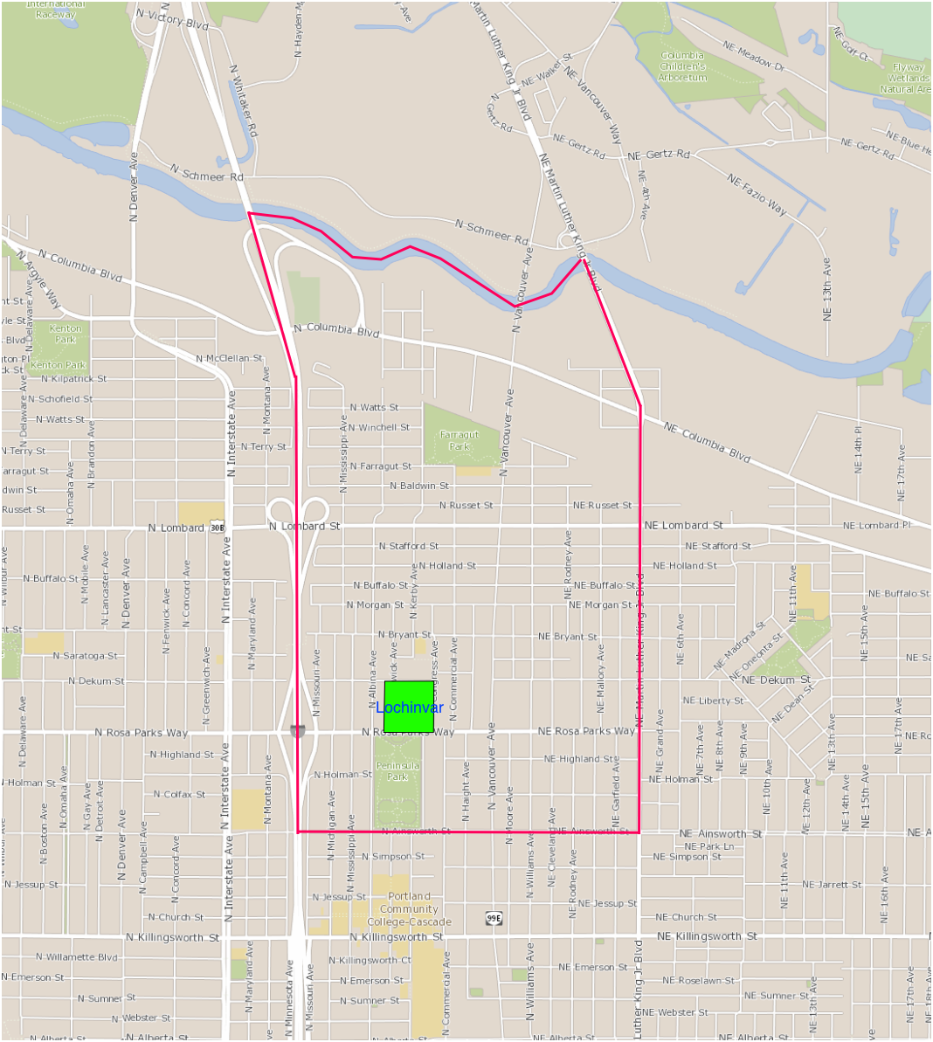

In 1889 Francis J. McKenna recorded the plat for the Lochinvar Addition, 8.02 acres, bounded by N Rosa Parks Way, N Dekum Street, N Congress Avenue and the east row of N Borthwick Avenue.

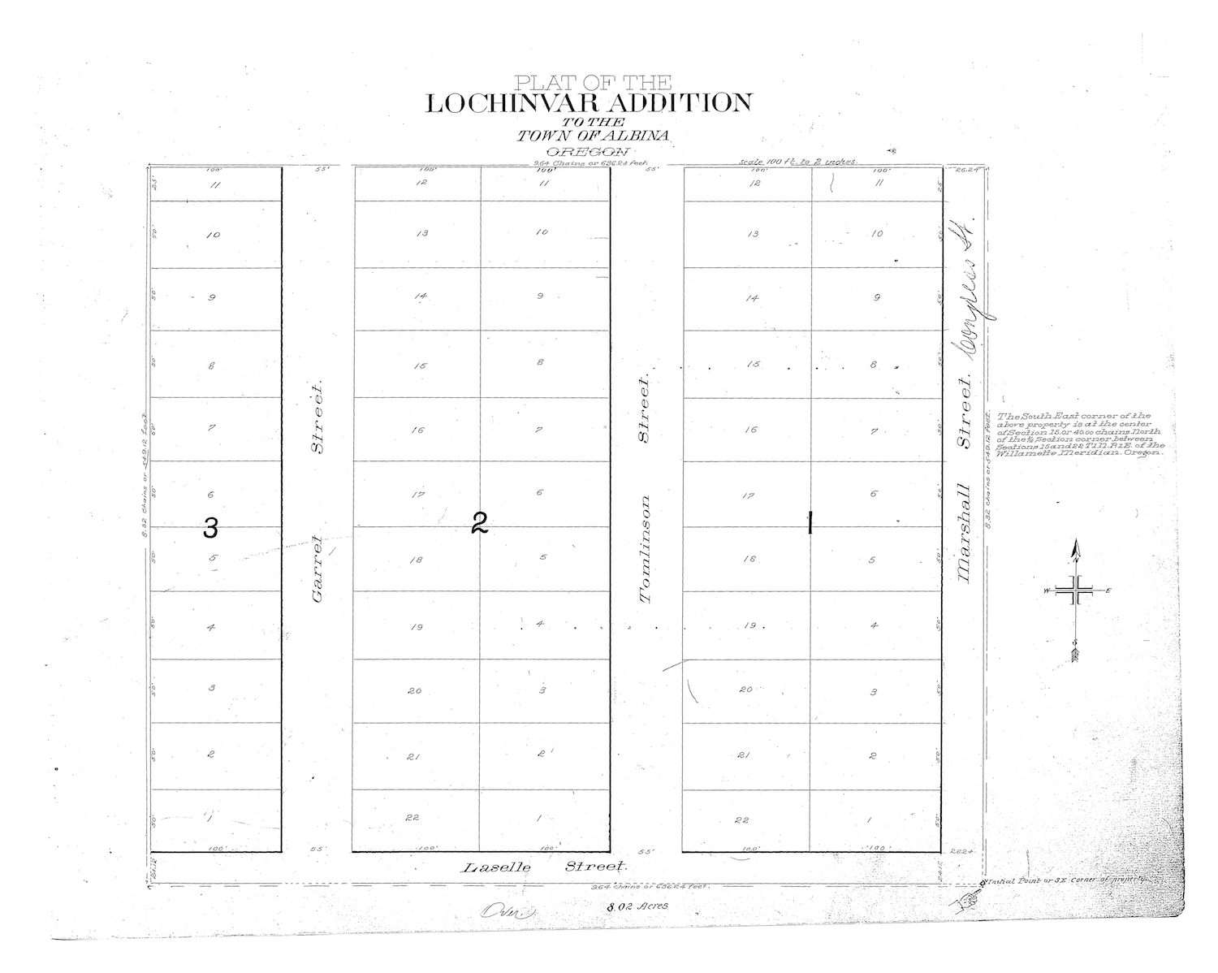

<http://www4.multco.us/Surveyimages/Plats/PL0000-0499/PL0140-014-015.PDF>

If you download the file then the handwritten plat description is the second page of the PDF. The transcript is as follows.

*Know all men by these Presents that the annexed and foregoing is a true and correct Plat of the Lochinvar Addition to the Town of Albina in the County of Multnomah and State of Oregon in Section 15 T. 1 N. R, 1 E. Willamette Meridian that the initial Part of Survay of said Addition is set forth in the Certificate of Survayor annexed to said Plat and that I, Francis I. McKenna do give grant and dedicate to the Public as Streets all those parcels of land marked and designated upon said Plat as such Streets and known as Garret Street 55 feet wide between block Two and Three, Tomlinson Street 55 feet wide between Block one and Two and Marshall Street 26.24 feet wide on East side of Block one and Laselle Street 24.12 feet wide on south side of said Addition. In Witness Whereof I have hereunto set my hand and Seal this -- day of October 1889. (signed) Francis I. McKenna*

The street names have obviously changed. In the big name change of January 12, 1892 Laselle Street became Portland Boulevard, Garret Street became Borthwick Avenue, Tomlinson Street became Kerby Street, and Marshall Street became Congress Street.

Biographical information about Francis I. McKenna is in another chapter of this book. To get a quick idea, he has a fine Wikipedia page.

<https://en.wikipedia.org/wiki/Francis_I._McKenna>

For our purposes it suffices to note that around this time (1889-1890) he, and his Conservative Real Estate and Trust Company, platted and sold the lots of University Park, Portsmouth, Good Morning Addition, Marchmont Addition, and Lochinvar Addition. There is a 1890 advertisement at the end of this section. Only Lochinvar is in Piedmont, but Good Morning Addition is in Arbor Lodge, just across the freeway.

Lochinvar is in the David Ulery DLC, in the 37 acres that John Hotts bought in 1863 from Ulery. Currently I am tracing how the eight acres for Lochinvar got to McKenna. Here is a beginning, from the Oregonian of October 24, 1889. It indicates McKenna bought the parcel from J.M. Shelby et al, but I have not found the deed yet.

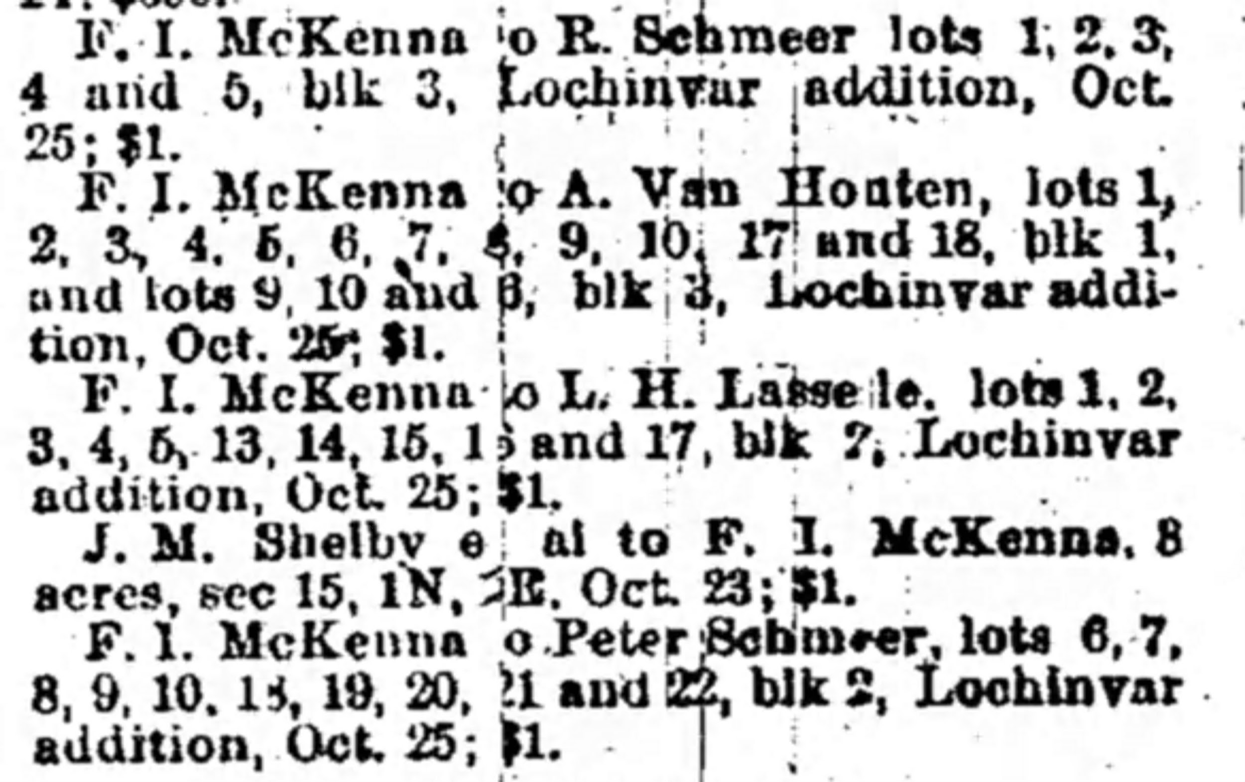

<https://drive.google.com/open?id=1WiyR0C72s6HymyORDrRLWpwCnLwMNAAG>

Note also the one dollar quit claim deeds, which give a strong indication where the actual money for buying the parcel came from. Lochinvar is 22 + 22 + 11 = 55 lots. R. Schmeer gets 5 lots, Peter Schmeer 10 lots, L.H. Laselle 10 lots, and A. van Houten 15 lots. Tomlinson 10 lots. That leaves only 5 lots for McKenna.

Also at the end of this section is a photo of the Lochinvar page of the 1906 Block Book, showing ownership of the lots at that time. There are some familiar names there. Tomlinson and Lasselle originally had streets named for them. Van Houten was the partner of McKenna in the Conservative Real Estate and Trust Company.

The two pages from the 1924-1928 Sanborn maps covering Lochinvar finally show which lots actually had houses on them and which were still empty. The huge empty lot east of Congress would later become the Kirkmar Addition.

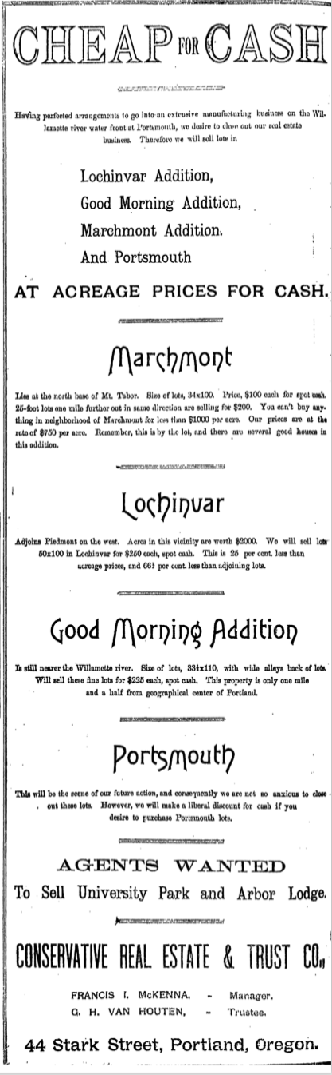

<https://drive.google.com/open?id=1hoAd5TDzYPQ0pSAquOqLjcDGwvGMNVH0>

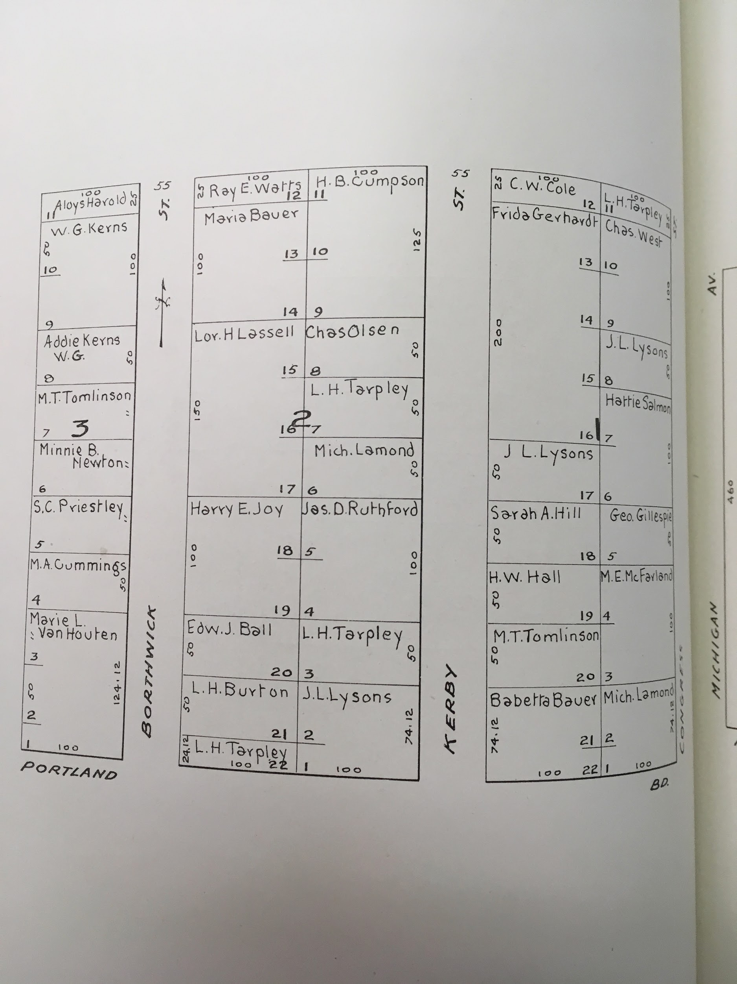

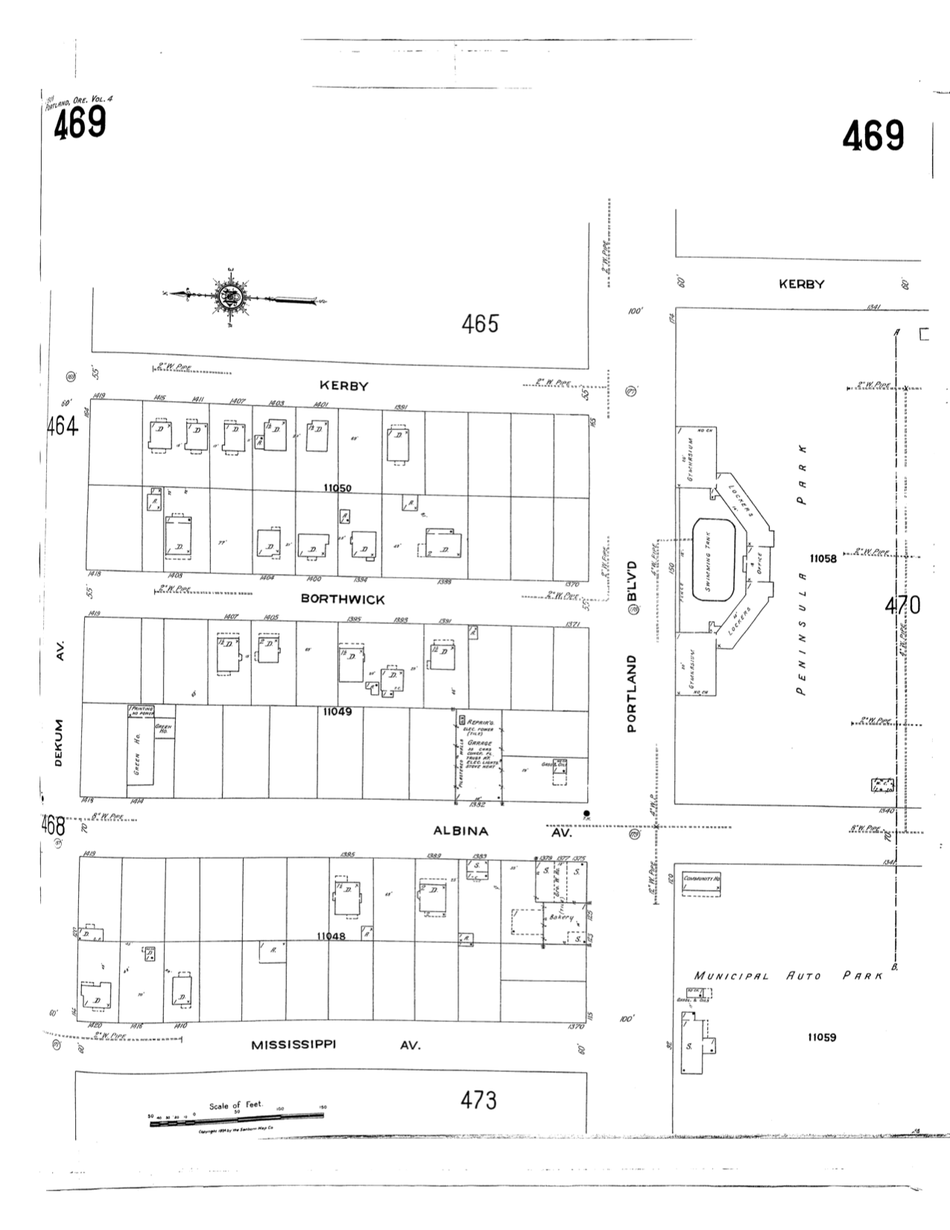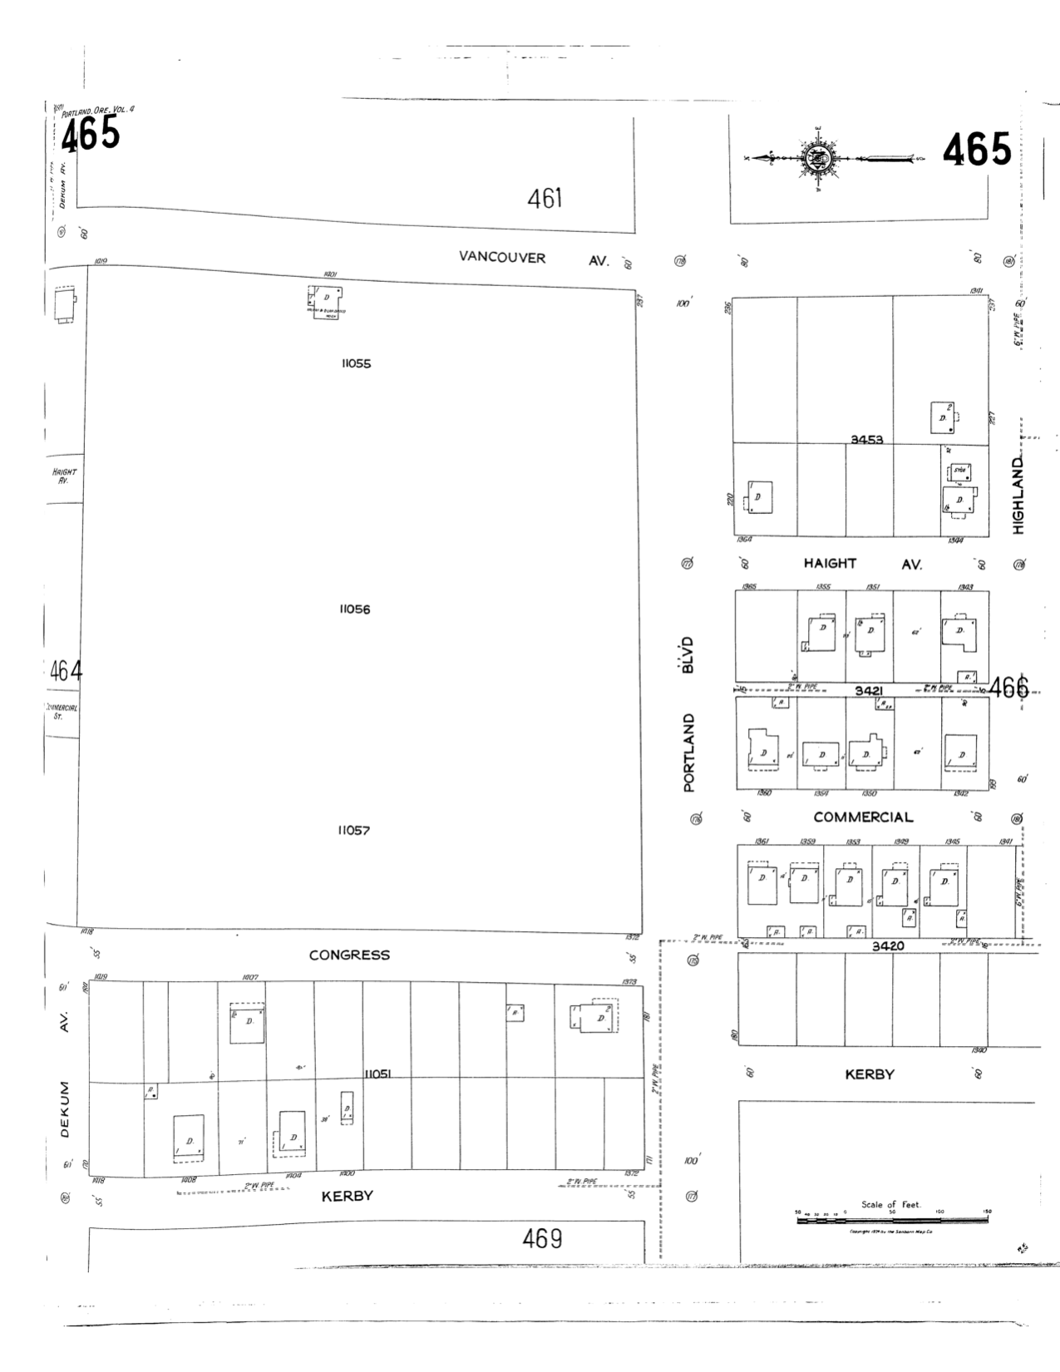

References

Wikipedia, *Francis I. McKenna*

<https://en.wikipedia.org/wiki/Francis_I._McKenna>