Delivery Delay Prediction in Logistics Systems
I.U.Deleila Ahmad Termidi¹, Che Ku Ilya Farhana Che Ku Amran²*,Hammad Akram³*, Shuhaida Ismail⁴*
Fakulti Sains Komputer dan Teknologi Maklumat,
Universiti Tun Hussein Onn Malaysia, Parit Raja, Batu Pahat, 86400, MALAYSIA

*Corresponding Author: shuhaida@uthm.edu.my
DOI: https://doi.org/10.30880/jastec.2024.00.00.000
Article Info | Abstract
Received: 7 June 2026  Accepted: Day Month Year  Available online: Day Month Year | The rapid growth of e-commerce and online shopping has increased the demand for efficient logistics and delivery services. However, delivery delays remain a significant challenge that can negatively impact customer satisfaction and operational performance. Therefore, the ability to predict potential delivery delays has become increasingly important for logistics companies. This study aims to develop a delivery delay prediction model using machine learning techniques and identify the factors that influence delivery performance. A public logistics dataset containing customer, product, and shipment information was utilized for the analysis. Several data preprocessing techniques, including data quality assessment, variable selection, and categorical variable handling, were performed to prepare the dataset for model development. Three machine learning algorithms, namely Logistic Regression, Random Forest, and Gradient Boosting, were implemented and evaluated using SAS Viya. Model performance was assessed using Accuracy, Precision, Recall, and F1-Score metrics. The experimental results demonstrate the effectiveness of machine learning techniques for predicting delivery delays and identifying key factors that affect shipment performance. Among the evaluated models, the best-performing algorithm achieved superior classification performance and provided valuable insights into logistics operations. The findings indicate that machine learning-based prediction models can support proactive decision-making, improve resource allocation, and enhance customer satisfaction by reducing the risk of delivery delays.
Keywords
Delivery delay prediction, Logistic System, Gradient Boosting, Logistic Regression, Random Forest, Machine Learning, SAS Model Studio
- Introduction
In recent years, the growth of e-commerce has significantly increased the demand for delivery and logistics services. More consumers are purchasing products online and expect their orders to arrive within the estimated delivery period. As a result, logistics companies must manage numerous shipments efficiently while maintaining high service quality.

However, delivery delays remain a common issue in logistics operations. Various factors, such as transportation constraints, high order volumes, inefficient scheduling, and operational disruptions, can affect delivery performance. These delays may cause inconvenience to customers and create additional challenges for logistics companies.
To address this issue, many organizations have started using data-driven approaches to improve their operations. Machine learning has gained attention as it can analyze historical data and identify patterns that may not be easily detected through traditional methods. By applying machine learning techniques, it is possible to predict delivery delays based on previous shipment information and operational factors. Such predictions can help logistics companies make better decisions and improve delivery performance.
  - Background of Study
The rapid growth of e-commerce has increased the demand for efficient logistics and delivery services, making timely shipment delivery a critical factor for customer satisfaction and business success. However, delivery delays remain a common challenge due to factors such as transportation issues, warehouse inefficiencies, high shipment volumes, and operational constraints. To address this problem, organizations are increasingly adopting machine learning techniques to analyze historical logistics data and predict potential delivery delays before they occur.
This study focuses on developing a delivery delay prediction model using Logistic Regression, Random Forest, and Gradient Boosting algorithms. By identifying shipments that are likely to be delayed, the proposed approach can support better decision-making, improve operational efficiency, and enhance customer satisfaction within logistics systems.
  - Problem Statement
On-time delivery is an important factor in customer satisfaction and business performance. When deliveries are delayed, customers may lose trust in the service provider, while companies may face additional operational costs and negative feedback. Although logistics companies continuously improve their delivery processes, delays still occur due to various factors that are often difficult to predict.
In many cases, companies only become aware of a delay after it has already happened. This reactive approach limits their ability to take preventive actions and minimize the impact of delivery disruptions. Therefore, there is a need for a predictive solution that can identify potential delivery delays before they occur. By utilizing machine learning techniques, historical logistics data can be analyzed to support more accurate delivery delay predictions and improve decision-making in logistics operations.
  - Objectives
The objectives of this project are:

- To identify factors that influence delivery delays in logistics systems.
- To develop delivery delay prediction models using Logistic Regression, Random Forest, and Gradient Boosting techniques.
- To evaluate and compare the performance of the selected machine learning models using appropriate evaluation metrics to determine the most suitable model for delivery delay prediction.
  - Project Scope
This project focuses on predicting delivery delays using historical logistics data obtained from a public dataset. The study applies three machine learning techniques, namely Logistic Regression, Random Forest, and Gradient Boosting, to develop prediction models. Data preprocessing will be implemented and evaluated in SASViya using the Accuracy Table, Confusion Matrix, F1-score, and Precision. The study is limited to variables available in the dataset and does not consider external factors that are not included in the data.
  - Project Significance
This project is significant as it demonstrates the use of machine learning techniques in improving logistics operations, particularly in predicting delivery delays. By identifying shipments that are likely to be delayed, logistics companies can take early actions to improve planning, optimize resource allocation, and reduce operational disruptions.
For customers, improved delivery prediction can lead to better service reliability and more accurate delivery expectations, which may increase customer satisfaction and trust in the service provider.
From an academic perspective, this study contributes to the understanding of how different machine learning models perform in real-world logistics prediction problems. It also provides a practical comparison between Logistics Regression, Random Forest, and Gradient Boosting in handling delivery-related data.
- Application Domain
The application domain of this project is logistics and supply chain management, which plays a critical role in ensuring the efficient movement of goods from suppliers to customers. With the rapid growth of e-commerce platforms and online shopping activities, logistics companies are required to deliver products quickly, accurately, and reliably. Customers increasingly expect their orders to arrive within the estimated delivery time, making delivery performance an important indicator of service quality.
One of the major challenges faced by logistics providers is delivery delay. Delays may occur due to various factors such as transportation issues, warehouse congestion, inefficient scheduling, shipment volume fluctuations, weather conditions, and operational constraints. These delays can negatively affect customer satisfaction, increase operational costs, and damage the reputation of logistics companies.
Machine learning has become an important technology in the logistics industry because it enables organizations to analyze large amounts of historical delivery data and identify hidden patterns related to delivery performance. By using predictive analytics, companies can estimate whether a shipment is likely to be delayed before the actual delivery occurs. This information allows managers to take proactive actions, such as adjusting delivery routes, allocating additional resources, or informing customers in advance.
In this project, machine learning techniques are applied to predict delivery delays based on customer information, shipment characteristics, product details, and operational factors. The prediction results can support decision-making processes and improve logistics, demonstrating how data-driven approaches can help organizations reduce delivery risks, improve customer satisfaction, and enhance overall supply chain performance.
Furthermore, delayed delivery prediction is widely used by major logistics and e-commerce companies worldwide. Organizations such as DHL, FedEx, and Amazon utilize predictive analytics and intelligent systems to optimize delivery operations and improve service reliability. Therefore, this study reflects a practical and relevant application of machine learning within a real-world business environment.

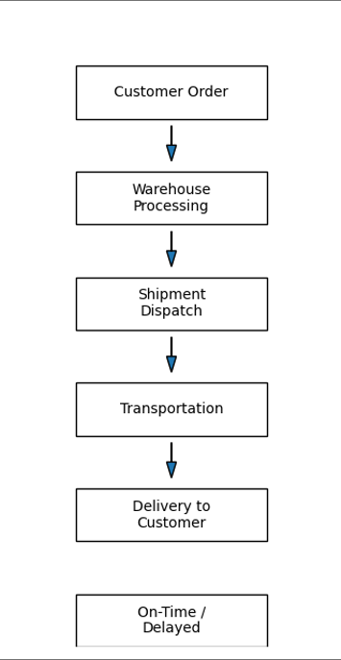 | 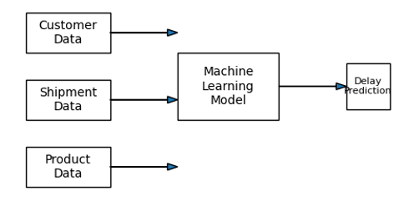
(a) | (b)

Fig. 1 Figure description (a) Logistics delivery process and potential delivery outcomes.; (b) Machine learning-based delivery delay prediction framework.

- Literature Review
The logistics and supply chain industry has undergone significant transformation in recent years due to the rapid expansion of e-commerce and increasing customer expectations for fast and reliable delivery services. Delivery performance has become a critical factor influencing customer satisfaction, operational efficiency, and business competitiveness. Despite continuous improvements in transportation and logistics operations, delivery delays remain a persistent challenge caused by factors such as transportation disruptions, warehouse congestion, inefficient scheduling, high shipment volumes, and unforeseen operational constraints. Consequently, organizations have increasingly adopted data-driven approaches and machine learning techniques to improve delivery performance and reduce the occurrence of delays (Salari et al., 2022; Min, 2021; Schafer et al., 2025).
Machine learning has emerged as a powerful analytical tool for solving complex prediction problems in logistics and supply chain management. Unlike traditional statistical methods, machine learning algorithms are capable of learning patterns from large volumes of historical data and generating accurate predictions for future events. In logistics applications, predictive models can analyze shipment characteristics, customer information, and operational factors to identify deliveries that are likely to experience delays. Such predictions enable logistics providers to implement proactive measures, optimize resource allocation, improve route planning, and enhance overall service quality (Zhang et al., 2022; Sarker, 2021).
Among the various machine learning techniques available, Logistic Regression remains one of the most widely used methods for binary classification problems. Logistic Regression estimates the probability of a particular outcome by examining the relationship between a dependent variable and multiple independent variables. According to Kotu and Deshpande (2019), Logistic Regression is particularly effective when the objective is to classify observations into two categories. In the context of logistics, the algorithm has been applied to predict delivery outcomes based on variables such as shipment weight, transportation mode, product cost, and customer-related attributes. The model is valued for its simplicity, interpretability, and computational efficiency, making it a suitable baseline model for delivery delay prediction studies. However, its predictive performance may be limited when complex nonlinear relationships exist among predictor variables, particularly when compared with advanced ensemble learning methods that can capture more complex data patterns (Apnena et al., 2025).
Random Forest is an ensemble learning algorithm that has gained considerable attention in predictive analytics due to its robustness and high predictive accuracy. Introduced by Breiman (2001), Random Forest constructs multiple decision trees using random subsets of training data and combines their predictions to generate a final classification result. This ensemble approach reduces overfitting and improves model generalization compared to a single decision tree. In logistics and transportation research, Random Forest has demonstrated strong performance in predicting delivery delays, transportation demand, and supply chain disruptions. Its ability to process both numerical and categorical variables, handle large datasets, and capture complex interactions among variables makes it particularly suitable for logistics applications where multiple factors influence delivery performance simultaneously. Recent studies have shown that Random Forest achieves high prediction accuracy in delivery delay forecasting due to its ability to model nonlinear interactions and manage large-scale logistics datasets effectively (Purnomo et al., 2025; Küp et al., 2025).
Another widely adopted ensemble learning technique is Gradient Boosting, which builds predictive models sequentially by correcting the errors generated by previous models. Friedman (2001) described Gradient Boosting as an optimization-based approach that incrementally improves model performance through iterative learning. Unlike Random Forest, which constructs decision trees independently, Gradient Boosting focuses on improving prediction accuracy by minimizing classification errors at each iteration. Previous studies have reported that Gradient Boosting frequently achieves superior performance in classification tasks due to its ability to model complex nonlinear relationships and subtle interactions among variables. In logistics systems, the algorithm has been successfully applied to forecast delivery delays, estimate transportation risks, and improve operational planning. Nevertheless, careful parameter tuning is required to achieve optimal performance and prevent overfitting.
Recent research indicates that Gradient Boosting models consistently outperform many traditional classification methods in logistics prediction tasks, particularly when optimized through parameter tuning and feature engineering (Kuliavets & Burov, 2025; Faulkner et al., 2026).
Several studies have compared the effectiveness of different machine learning algorithms in logistics and supply chain management. Research findings generally indicate that ensemble-based methods such as Random Forest and Gradient Boosting outperform traditional classification techniques because of their capability to capture complex data patterns and manage high-dimensional datasets effectively (Schafer et al., 2025; Apnena et al., 2025; Yadav et al., 2022). Furthermore, factors such as shipment weight, customer care interactions, product importance, discount offers, prior purchases, and transportation modes have consistently been identified as significant predictors of delivery performance (Purnomo et al., 2025; Küp et al., 2025). These variables provide valuable information that can be utilized by machine learning models to generate reliable delivery delay predictions.
The growing adoption of predictive analytics within the logistics industry highlights the importance of machine learning in enhancing operational efficiency and customer satisfaction. Leading logistics organizations increasingly rely on intelligent prediction systems to identify potential disruptions before they occur and to support strategic decision-making processes (Xu et al., 2025; Xue et al., 2026). By leveraging historical delivery data, predictive models enable organizations to transition from reactive problem-solving approaches to proactive management strategies, thereby reducing operational risks and improving service reliability.
Based on the literature, Logistic Regression, Random Forest, and Gradient Boosting represent three widely recognized machine learning approaches for classification problems. Each algorithm possesses unique strengths and characteristics that may influence prediction performance. Therefore, this study develops and compares these three models to determine the most suitable approach for predicting delivery delays in logistics systems. The comparative evaluation is expected to provide valuable insights into the application of machine learning techniques in logistics operations while contributing to the development of more reliable and efficient delivery management systems.
- Methodology
4.1 Dataset Description
This project uses a logistics delivery dataset that contains information related to product shipments and customer orders. The dataset includes variables such as product cost, customer rating, discount offered, weight of shipment, mode of shipment, warehouse block, and customer interaction history.
The main objective of the dataset is to determine whether a delivery arrives on time or not. The target variable is Reached.on.Time_Y.N, where the value indicates whether a shipment was delivered on time (1) or not (0). This makes the dataset suitable for a binary classification problem.
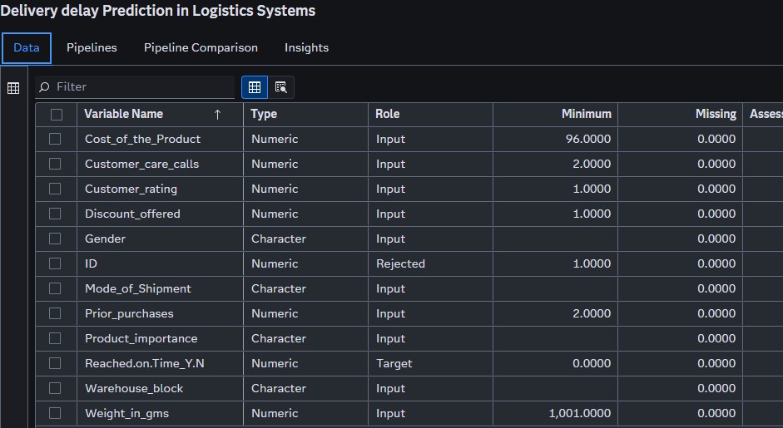
Fig.2 Dataset Attributes on SAS Viya (a)
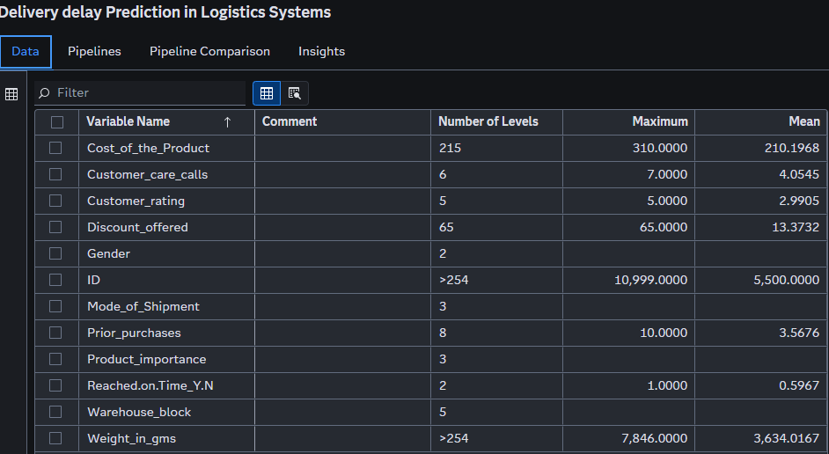
Fig.3 Dataset Attributes on SAS Viya (b)
4.2 Data Preprocessing
Data preprocessing was performed to prepare the dataset before model development. First, a data quality assessment was conducted to examine the dataset for missing values and inconsistencies. The results showed that no missing values were present in any of the variables, indicating that the dataset was complete and suitable for analysis.
Next, variable selection was performed to identify the most relevant features for predicting delivery status. The ID variable was excluded from the analysis because it serves only as a unique identifier and does not contribute to the prediction process. Relevant variables such as product cost, customer care calls, customer rating, discount offered, shipment mode, product importance, warehouse block, prior purchases, and shipment weight were retained for model training.
Finally, categorical variables, including Gender, Mode_of_Shipment, Product_importance, and Warehouse_block were converted into a format suitable for machine learning algorithms. This transformation was handled automatically by SAS Viya during the model development process.
4.2.1 Data Partitioning

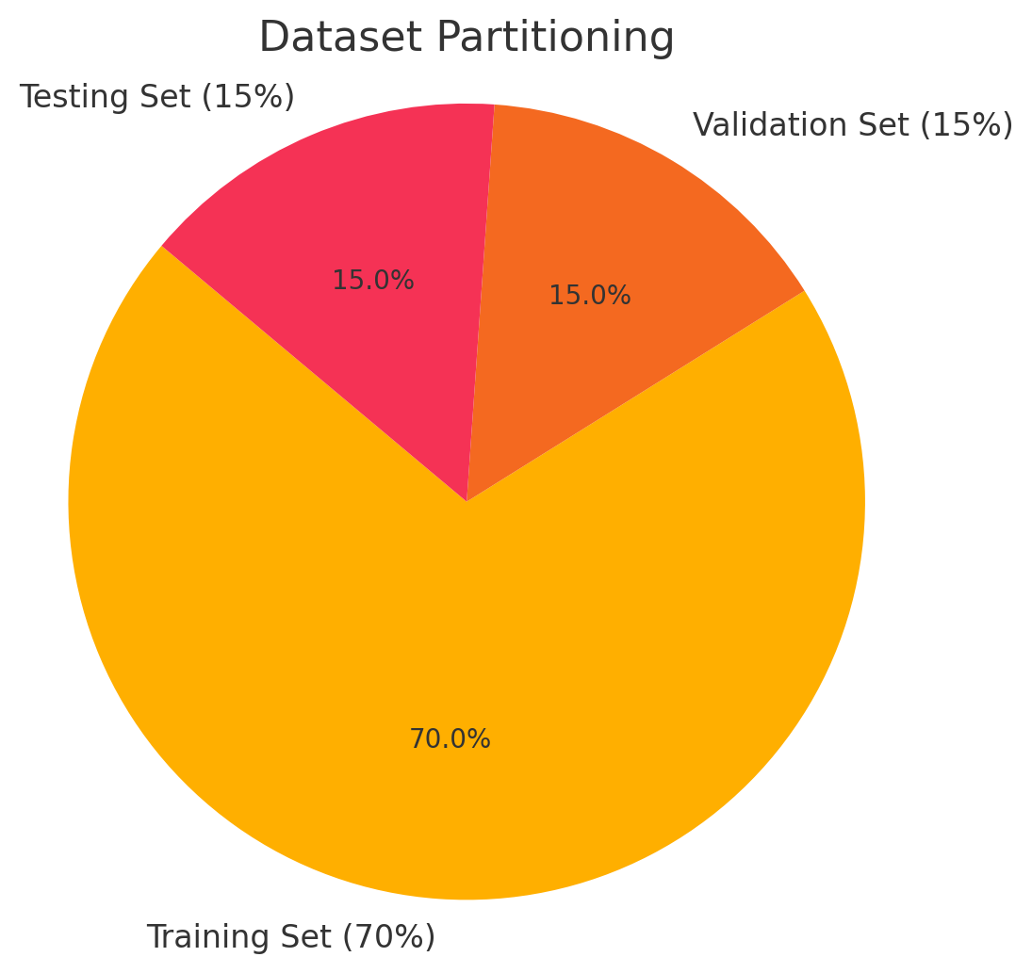
Fig. 4 Data Partition Configuration
The data was automatically split using SAS Viya’s internal partitioning logic:

- 70% Training Set - Used to fit the model
- 15% Validation Set - Used for tuning and interim evaluation
- 15% Testing Set - Used for final evaluation

Each model used the same partition configuration, ensuring consistent and fair performance comparison across models. The dataset was partitioned into training, validation, and testing subsets using the Data Partition node in SAS Viya. A partition ratio of 70:15:15 was applied, where (70%) of the data was allocated for model training, (15%) for validation, and (15%) for testing. The training set was used to build the machine learning models, the validation set was used to monitor and tune model performance, and the testing set was used to evaluated the final predictive performance of each model. Using the same partitioning strategy for all models ensured a fair comparison between Logistic Regression, Random Forest, and Gradient Boosting.
4.2.2 Variable Management
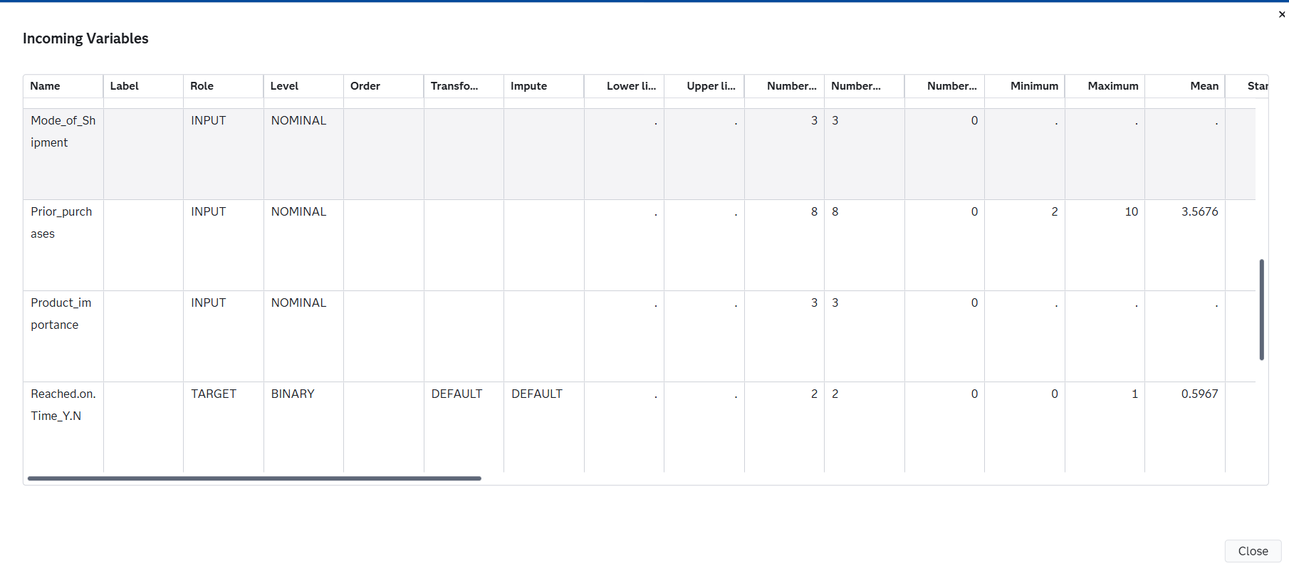
Fig. 5 Variables Roles and Measurement Levels
The Manage Variables node in SAS Viya was used to define the role and measurement level of each variable. The target variable, Reached.on.Time_Y.N, was assigned as the response variable, while the shipment and customer-related attributes were assigned as input variables. The ID variable was excluded from the analysis because it does not provide predictive information. This process ensured that the dataset was correctly configured for machine learning model training and evaluation.
4.2.3 Data Quality Assessment
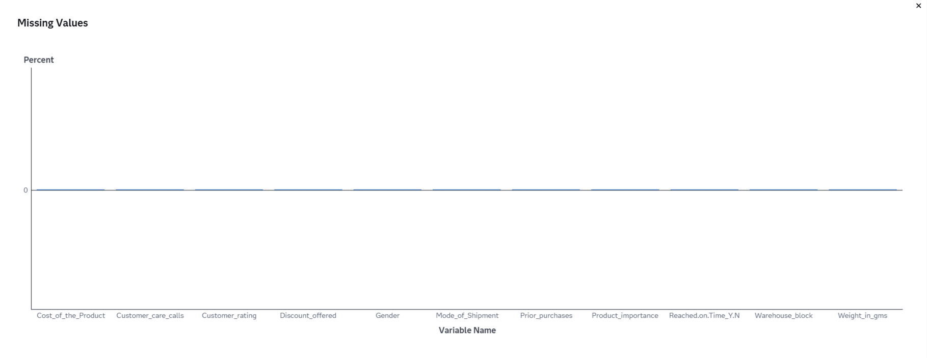
Fig.6 Missing Values using Data Preprocessing (Data Quality Assessment)
A data quality assessment was conducted using SAS Viya to examine the completeness and consistency of the dataset. The assessment focused on identifying missing values, invalid entries, and potential data quality issues that could affect model performance. The results indicated that all variables contained complete records with no missing values. Therefore, no data imputation or additional cleaning procedures were required before model development.
4.3 Experimental Setting
The researchers performed their analyses using SAS Viya Model Studio to develop and test three machine learning models (Logistic Regression, Random Forest, and Gradient Boosting) from the same data set and partition set up. They used the Manage Variables node to specify the variable roles and measure types before training each model on the training dataset and testing the model on the validation and test datasets to evaluate its performance (using Accuracy, Precision, Recall, and F1-Score) to identify the best model for predicting delivery delays.
4.4 Features Selection
To recognize relevant features for predicting delivery status, feature selection was completed. Customer behaviour, shipment characteristics and logistics operations will be our input features, as they are likely influencers of delivery performance. The ID feature was removed because it is only a unique identifier (not a predictor).

The following variables are used as input features for the prediction model:

- Cost_of_the_Product
- Customer_care_calls
- Customer_rating
- Discount_offered
- Prior_purchases
- Weight_in_gms
- Mode_of_Shipment
- Warehouse_block
- Product_importance
- Gender

The target variable is:

- Reached.on.Time_Y.N

4.5 Machine Learning Models
Three machine learning algorithms are used in this project:
4.5.1 Logistic Regression
Logistic Regression is a supervised learning algorithm commonly used for binary classification problems. The algorithm estimates the probability of an instance belonging to a particular class by applying a logistic function to the input variables. In this study, Logistic Regression is used to predict whether a shipment will be delivered on time or delayed based on factors such as shipment weight, transportation mode, customer rating, and product importance. Due to its simplicity, interpretability, and computational efficiency, Logistic Regression serves as the baseline model for performance comparison.
4.5.2 Random Forest
Random Forest is an ensemble learning algorithm that combines multiple decision trees to improve prediction accuracy and model stability. Each decision tree is constructed using a random subset of the training data and predictor variables, while the final prediction is determined through majority voting. The algorithm is capable of handling both numerical and categorical variables and is less prone to overfitting compared to a single decision tree. In this study, Random Forest is employed to identify complex relationships among shipment attributes and improve delivery delay prediction performance.
4.5.3 Gradient Boosting
Gradient Boosting is an ensemble learning technique that builds decision trees sequentially, where each new tree attempts to correct the prediction errors made by previous trees. Through iterative optimization, the algorithm gradually improves overall model performance and predictive accuracy. Gradient Boosting is particularly effective in capturing nonlinear relationships and interactions among variables. In this project, Gradient Boosting is used to predict delivery delays and is expected to provide competitive performance compared to Logistic Regression and Random Forest.
4.5.4 Model Evaluation
The performance of the Logistic Regression, Random Forest, and Gradient Boosting models is evaluated using Accuracy, Precision, Recall, AND F1-Score. These metrics are calculated using the confusion matrix generated from the test dataset. The model with the highest predictive performance is selected as the most suitable approach for delivery delay prediction.
4.6 Evaluation Metrics
The performance of the models is evaluated using the following metrics:

- Accuracy: Measures the percentage of correct predictions.

$Accuracy= TP$ + TN  TP + TN + FP + FN | (1)
Equation.1 Accuracy
- Precision and Recall: Evaluate the model’s ability to correctly identify on-time and delayed deliveries.

$$Precision= TP$$  TP + FP | (2)
Equation.2 Precision
$$Recall= TP$$  TP + FN | (3)
Equation.3 Recall
- F1-Score: Provides a balance between precision and recall.

$$F1= 2 X Precision X Recall$$  Precision + Recall | (4)
Equation.4 F1-Score
These metrics are used because the problem is a binary classification task.

4.8 Evaluation Performances
SAS Model Studio generated multiple assessment metrics to implement the evaluation of the Logistic Regression model. The following examples of assessment metrics were the Event Classification Report, ROC curve, lift chart and classification statistics.
The Event Classification Report documented the predicted outcomes of the model against different cutoffs for event forecasting (using default .50 cutoff and the KS based cutoff). The anniversary of a true positive class is when an observation is predicted to be true (Delivered on Time) as opposed to false (Not Delivered on Time). Therefore, the Event Classification Report is used to determine how well each case/instance will be classified into either the on time or late delivery.
The ROC curve is a tool used to measure the model’s ability to separate the two classes. The AUC value generated from the ROC curve indicates the strength of the model’s classifications, with a value approaching 1 indicating an accurate classification of the observations.
The lift chart provides an indication of the difference between the logistic model’s classifications against those obtained through random selection. The ability of a model to classify the early deciles in beginning, as outlined in the lift chart, suggests that the model should effectively identify the high risk and/or high probability cases.
Primary conclusion is that the Logistic Regression Model demonstrates acceptable predictive ability for predicted delivery outcomes based on. Each of the metrics (classification accuracy, ROC analysis, and lift evaluation) shows positive results in support of using the Logistic Regression Model as a predictor of delivery events.
4.9 Project Flowchart
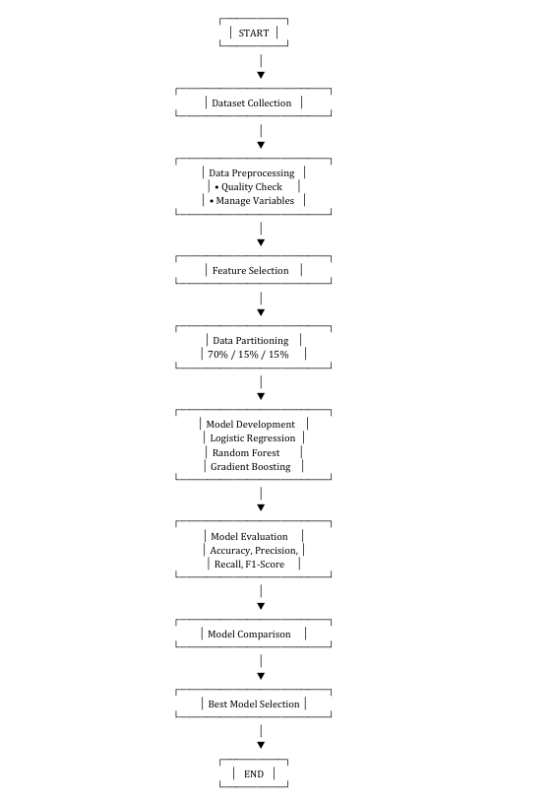
Fig.7 Project Flowchart for Delivery Delay Prediction using Machine Learning
This flowchart shows how the proposed Delivery Delay Prediction System collects data, assesses and pre-processes the data to create an appropriate dataset for analysis, performs feature selection, partitions the dataset into training, validation and test datasets, develops machine learning models (i.e., logistic regression, random forest, and gradient boosting) from the training data, evaluates the performance of the three models (e.g., accuracy, precision, recall, F1 score), and compares the three models to choose the best one for predicting delivery delays.
- Results, Comparisons and Discussion
5.1 Model Performance
5.1.1 Logistic Regression Results
Logistic Regression was implemented as the baseline classification model for predicting delivery delays. The model was trained using the preprocessed logistics dataset and evaluated using standard classification metrics. Figure shows the ROC curve generated by the Logistic Regression model, while Figure presents the confusion matrix.

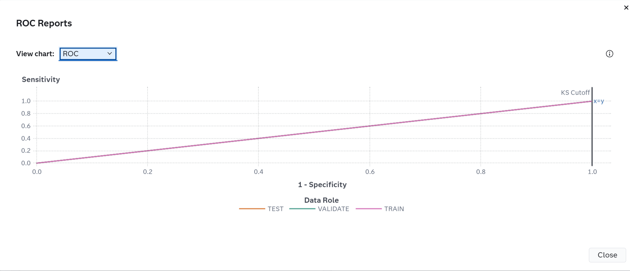
Fig.8 The ROC curve of the Logistic Regression Model
The ROC curve is a plot of sensitivity (the true positive rate) against 1-specificity (the false positive rate), which are both measures of classification based on the confusion matrix. These measures are calculated at various cutoff values. To help identify the best cutoff to use when scoring your data, the KS Cutoff reference line is drawn at the value of 1-specificity where the greatest difference between sensitivity and 1-specificity is observed for the VALIDATE partition. The KS Cutoff line is drawn at the cutoff value 0, where the 1-specificity value is 1 and the sensitivity value is 1.
Cutoff values range from 0 to 1, inclusive, in increments of 0.01. At each cutoff value, the predicted target classification is determined by whether P_Reached_on_Time_Y_N1, which is the predicted probability of the event "1" for the target Reached.on.Time_Y.N, is greater than or equal to the cutoff value. When P_Reached_on_Time_Y_N1 is greater than or equal to the cutoff value, then the predicted classification is the event, otherwise it is a non-event.
The confusion matrix for each cutoff value contains four cells that display the true positives for events that are correctly classified (TP), false positives for non-events that are classified as events (FP), false negatives for events that are classified as non-events (FN), and true negatives for non-events that are classified as non-events (TN). True negatives include non-event classifications that specify a different non-event. Sensitivity is calculated as TP / (TP + FN). Specificity, the true negative rate, is calculated as TN / (TN + FP), so 1-specificity is FP / (TN + FP). The values of sensitivity and 1-specificity are plotted at each cutoff value.
A ROC curve that rapidly approaches the upper-left corner of the graph, where the difference between sensitivity and 1-specificity is the greatest, indicates a more accurate model. A diagonal line where sensitivity = 1-specificity indicates a random model.

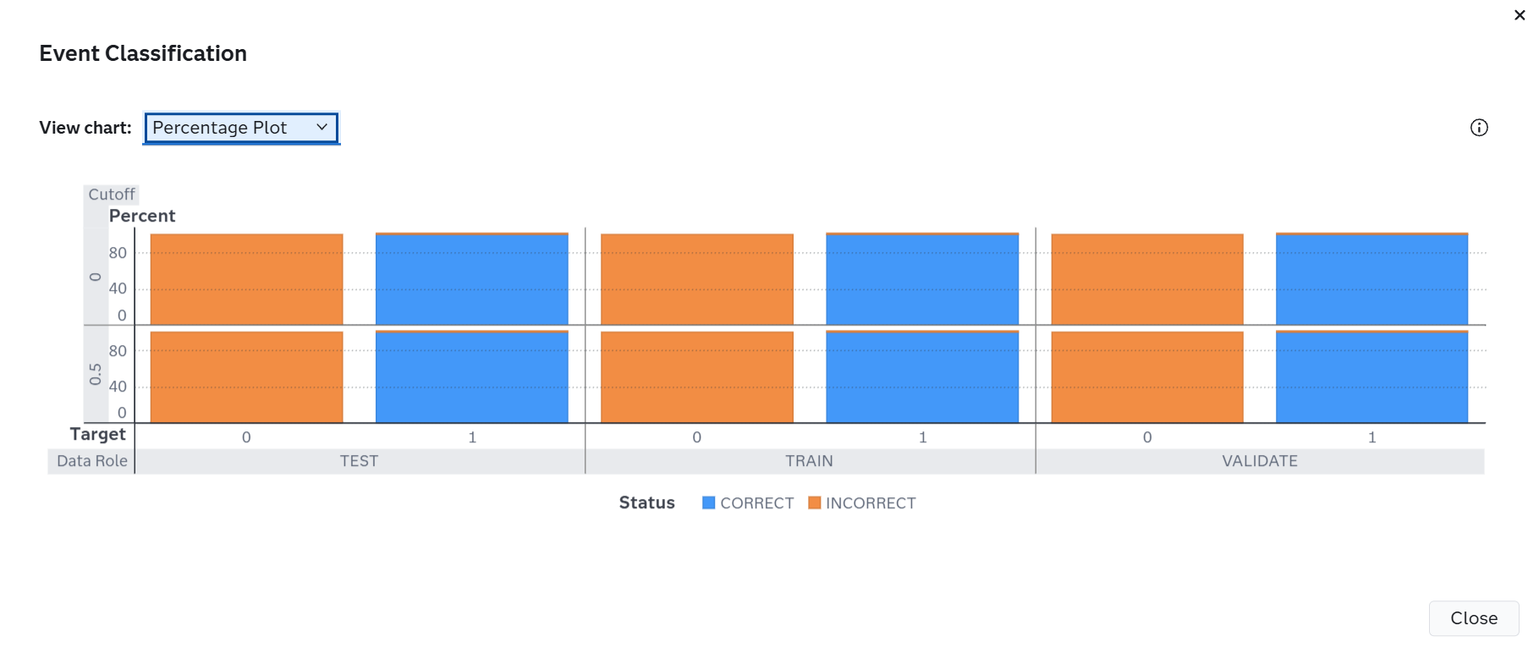
Fig.9 The Confusion Matrix of the Logistic Regression Model
The Event Classification report is a visual representation of the confusion matrix at various cutoff values for each partition. The classification cutoffs used in the plot are the default (0.5) and these KS cutoff values for existing partitions: 0 (TRAIN), 0 (VALIDATE), 0 (TEST). For this data, for the bar corresponding to the event level of Reached.on.Time_Y.N, "1", the segment of the bar colored as "CORRECT" corresponds to true positives.
The results indicate that Logistic Regression was able to classify delayed and on-time deliveries wih reasonable performance. However, due to its linear nature, the model may nit fully capture complex relationships among logistics variables.
5.1.2 Random Forest Results
Random Forest was employed to improve prediction performance through an ensemble of decision trees. The model evaluates multiple decision trees and combines their predictions to reduce overfitting and improve generalization.
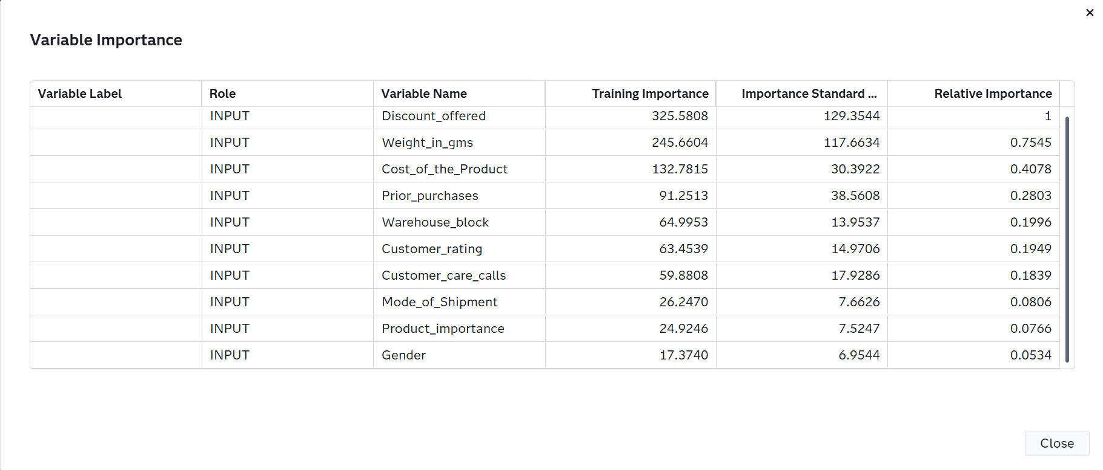
Fig.10 The Variable Importance of the Random Forest Model

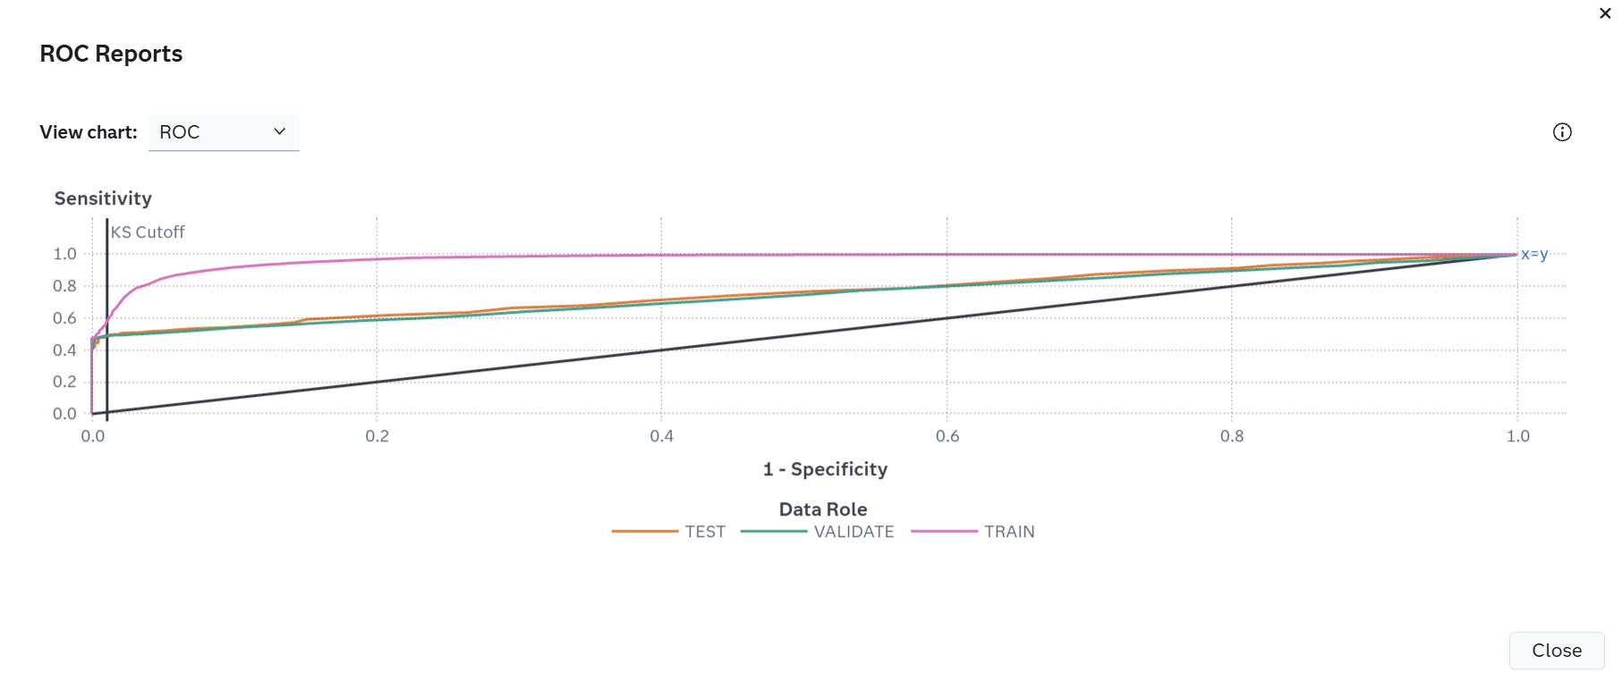
Fig.11 The ROC curve of the Random Forest Model
The ROC curve is a plot of sensitivity (the true positive rate) against 1-specificity (the false positive rate), which are both measures of classification based on the confusion matrix. These measures are calculated at various cutoff values. To help identify the best cutoff to use when scoring your data, the KS Cutoff reference line is drawn at the value of 1-specificity where the greatest difference between sensitivity and 1-specificity is observed for the VALIDATE partition. The KS Cutoff line is drawn at the cutoff value 0.67, where the 1-specificity value is 0.011 and the sensitivity value is 0.491.
Cutoff values range from 0 to 1, inclusive, in increments of 0.01. At each cutoff value, the predicted target classification is determined by whether P_Reached_on_Time_Y_N1, which is the predicted probability of the event "1" for the target Reached.on.Time_Y.N, is greater than or equal to the cutoff value. When P_Reached_on_Time_Y_N1 is greater than or equal to the cutoff value, then the predicted classification is the event, otherwise it is a non-event.
The confusion matrix for each cutoff value contains four cells that display the true positives for events that are correctly classified (TP), false positives for non-events that are classified as events (FP), false negatives for events that are classified as non-events (FN), and true negatives for non-events that are classified as non-events (TN). True negatives include non-event classifications that specify a different non-event. Sensitivity is calculated as TP / (TP + FN). Specificity, the true negative rate, is calculated as TN / (TN + FP), so 1-specificity is FP / (TN + FP). The values of sensitivity and 1-specificity are plotted at each cutoff value.
A ROC curve that rapidly approaches the upper-left corner of the graph, where the difference between sensitivity and 1-specificity is the greatest, indicates a more accurate model. A diagonal line where sensitivity = 1-specificity indicates a random model.
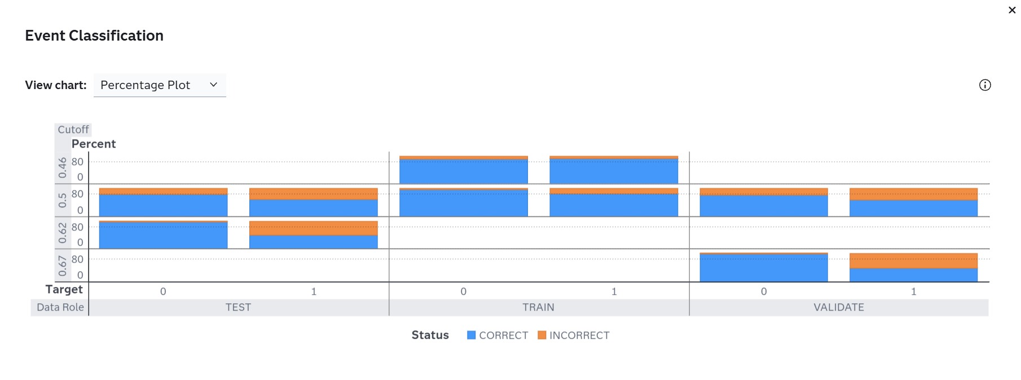
Fig.12 The Confusion Matrix of the Random Forest Model
The Event Classification report is a visual representation of the confusion matrix at various cutoff values for each partition. The classification cutoffs used in the plot are the default (0.5), and these KS cutoff values for existing partitions: 0.46 (TRAIN), 0.67 (VALIDATE), 0.62 (TEST). For this data, for the bar corresponding to the event level of Reached.on.Time_Y.N, "1", the segment of the bar colored as "CORRECT" corresponds to true positives.
The Random Forest model demonstrated improved predictive capability compared to Logistic Regression. The variable importance analysis identified the most influential factors affecting delivery delay prediction. This indicates that ensemble learning methods are effective in handling nonlinear relationships with logistics datasets.
5.1.3 Gradient Boosting Results
Gradient Boosting was implemented as a sequential ensemble learning algorithm that iteratively improves prediction performance by correcting errors from previous trees.

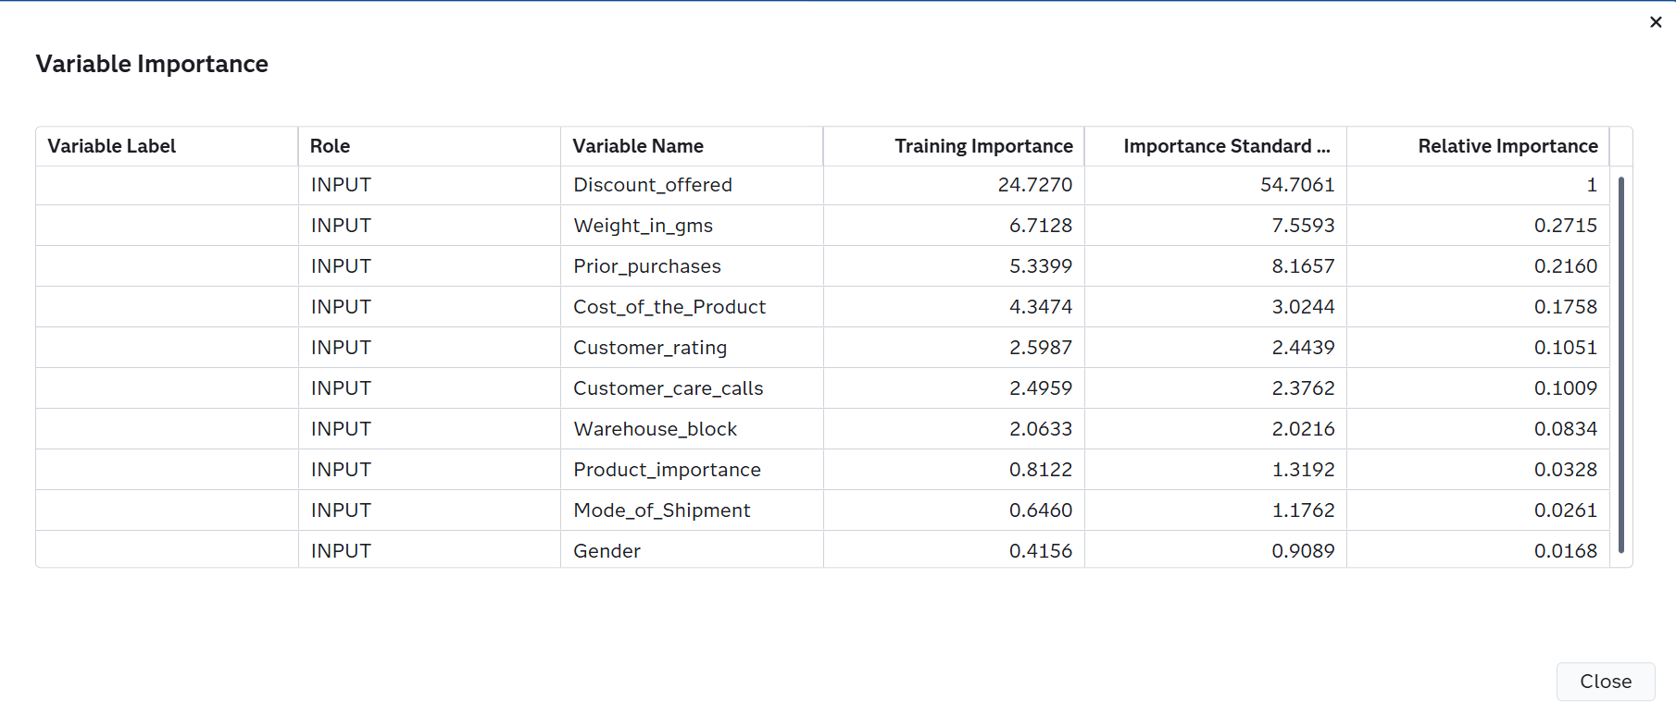
Fig.13 The Variable Importance of the Gradient Boosting Model
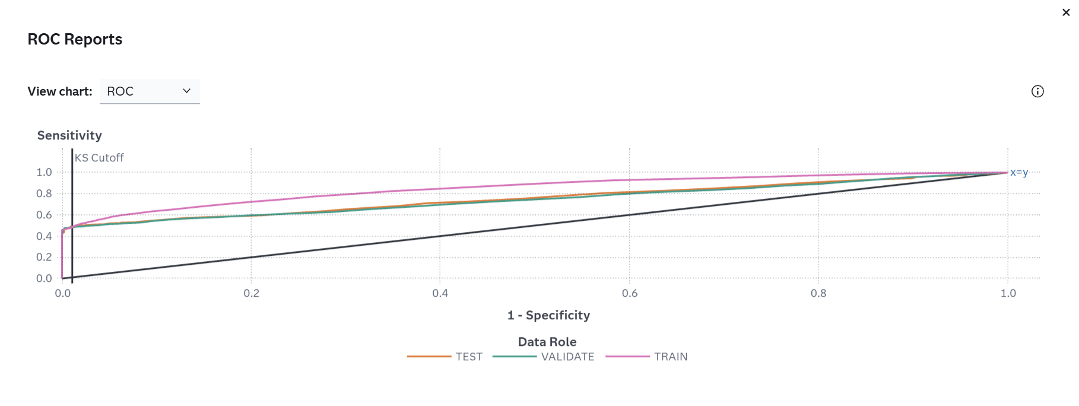
Fig. The ROC curve of the Gradient Boosting Model
The ROC curve is a plot of sensitivity (the true positive rate) against 1-specificity (the false positive rate), which are both measures of classification based on the confusion matrix. These measures are calculated at various cutoff values. To help identify the best cutoff to use when scoring your data, the KS Cutoff reference line is drawn at the value of 1-specificity where the greatest difference between sensitivity and 1-specificity is observed for the VALIDATE partition. The KS Cutoff line is drawn at the cutoff value 0.72, where the 1-specificity value is 0.011 and the sensitivity value is 0.486.
Cutoff values range from 0 to 1, inclusive, in increments of 0.01. At each cutoff value, the predicted target classification is determined by whether P_Reached_on_Time_Y_N1, which is the predicted probability of the event "1" for the target Reached.on.Time_Y.N, is greater than or equal to the cutoff value. When P_Reached_on_Time_Y_N1 is greater than or equal to the cutoff value, then the predicted classification is the event, otherwise it is a non-event.
The confusion matrix for each cutoff value contains four cells that display the true positives for events that are correctly classified (TP), false positives for non-events that are classified as events (FP), false negatives for events that are classified as non-events (FN), and true negatives for non-events that are classified as non-events (TN). True negatives include non-event classifications that specify a different non-event. Sensitivity is calculated as TP / (TP + FN). Specificity, the true negative rate, is calculated as TN / (TN + FP), so 1-specificity is FP / (TN + FP). The values of sensitivity and 1-specificity are plotted at each cutoff value.
A ROC curve that rapidly approaches the upper-left corner of the graph, where the difference between sensitivity and 1-specificity is the greatest, indicates a more accurate model. A diagonal line where sensitivity = 1-specificity indicates a random model.

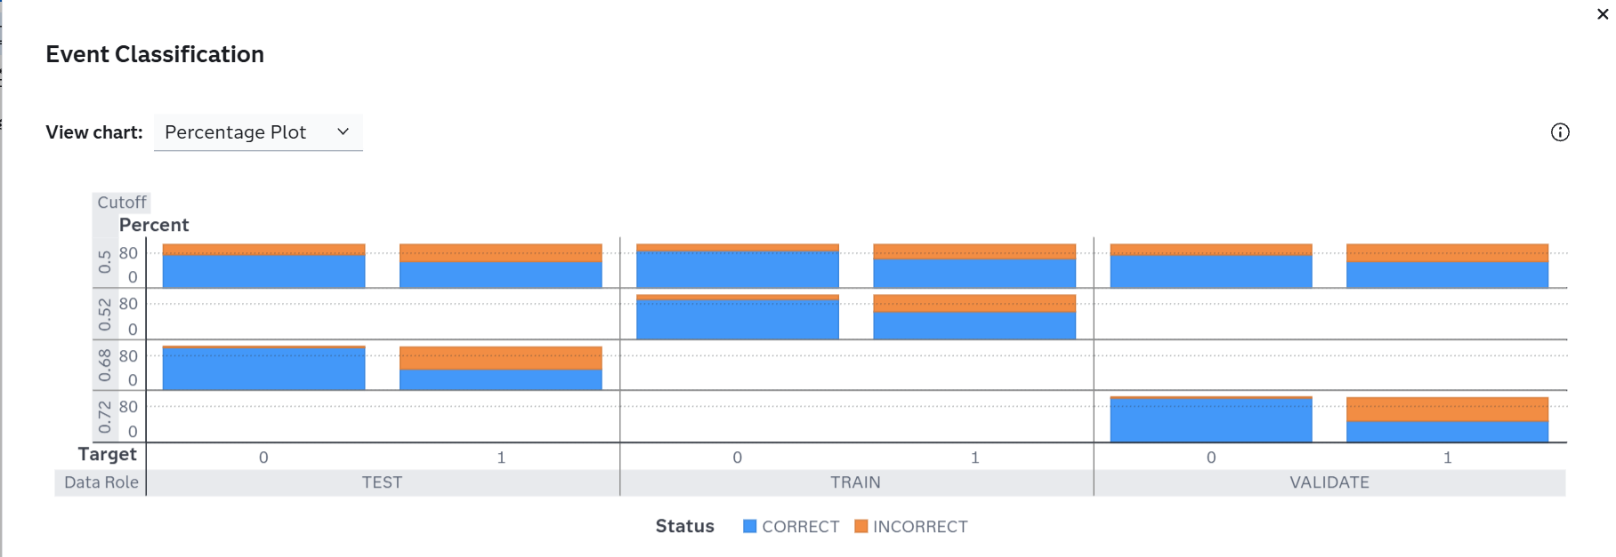
Fig.14 The Confusion Matrix of the Gradient Boosting Model
The Event Classification report is a visual representation of the confusion matrix at various cutoff values for each partition. The classification cutoffs used in the plot are the default (0.5) and these KS cutoff values for existing partitions: 0.52 (TRAIN), 0.72 (VALIDATE), 0.68 (TEST). For this data, for the bar corresponding to the event level of Reached.on.Time_Y.N, "1", the segment of the bar colored as "CORRECT" corresponds to true positives.
The Gradient Boosting model achieved strong classification performance by learning complex patterns within the data. The model effectively identified important delivery-related variables and provided robust predictions for delayed shipments.
5.2 Model Comparison
The figure presents the performance comparison of the three machine learning models developed for delivery delay prediction: Logistic Regression, Random Forest, and Gradient Boosting.

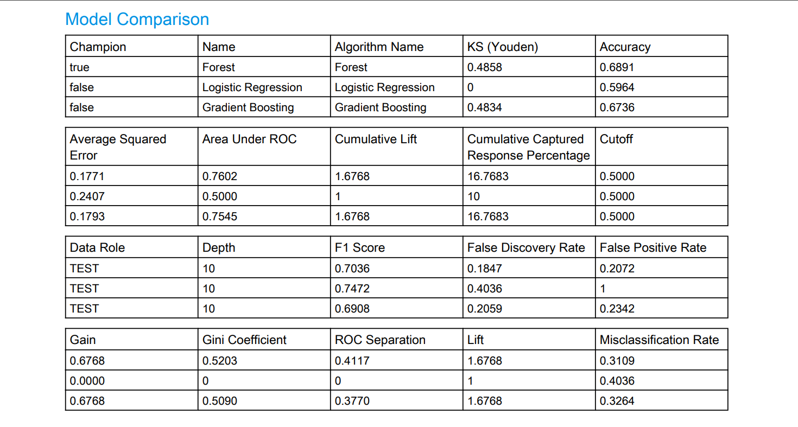
Fig.15 The Model Comparison for All Models (a)
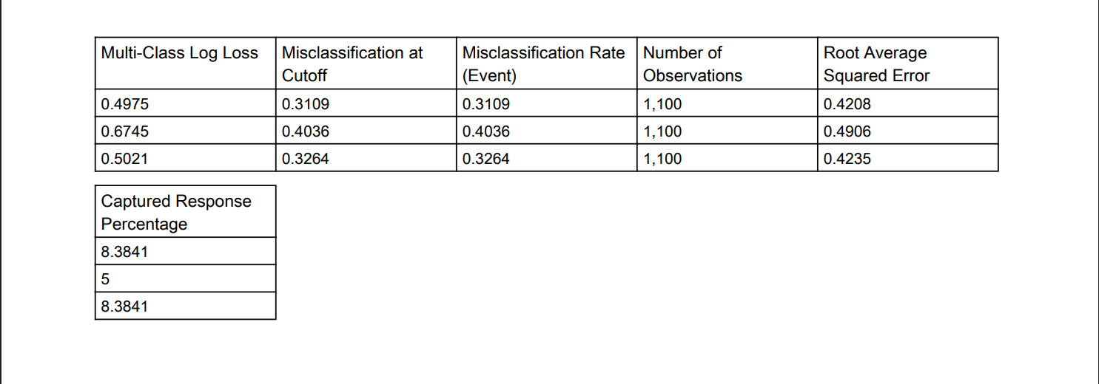

Fig.16 The Model Comparison for All Models (b)
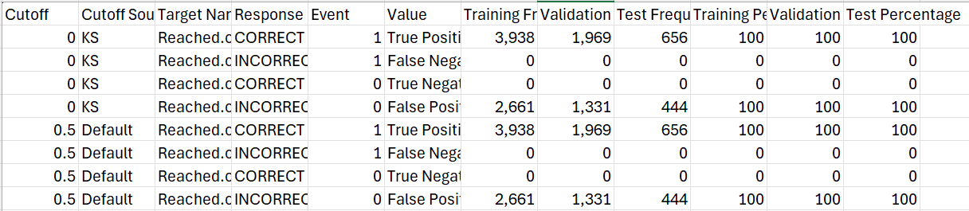
Fig.17 The Event Classification Table for Logistic Regression Model

$$Precision= TP$$  TP + FP  $Precision=$3938  3938 + 2661  $Precision=$0.5968 ~ 59.68% | (1)
Calculation 1. Precision Calculation of Logistic Regression Model
$$Recall= TP$$  TP + FN  $Recall=$3938  3938 + 0  $Recall=$1.0000 ~ 100% | (2)
Calculation 2. Recall Calculation of Logistic Regression Model
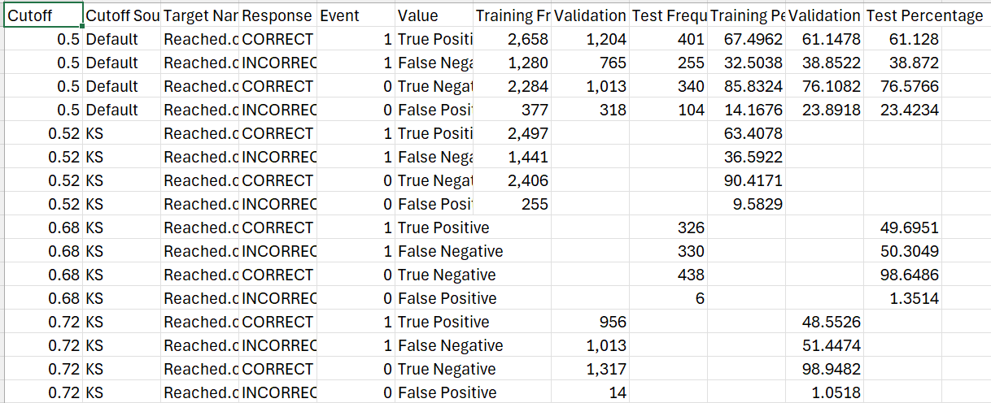
Fig.18 The Event Classification Table for Random Forest Model

$$Precision= TP$$  TP + FP  $Precision=$3209  3209 + 107  $Precision=$3209  3316  $Precision=$0.9677 ~ 96.77% | (3)
Calculation 3. Precision Calculation of Random Forest Model
$$Recall= TP$$  TP + FN  $Recall=$ 3209  3209 + 729  $Recall=$ 3209  3938  $Recall=$0.8149 ~ 81.49% | (4)
Calculation 4. Recall Calculation of Random Forest Modele

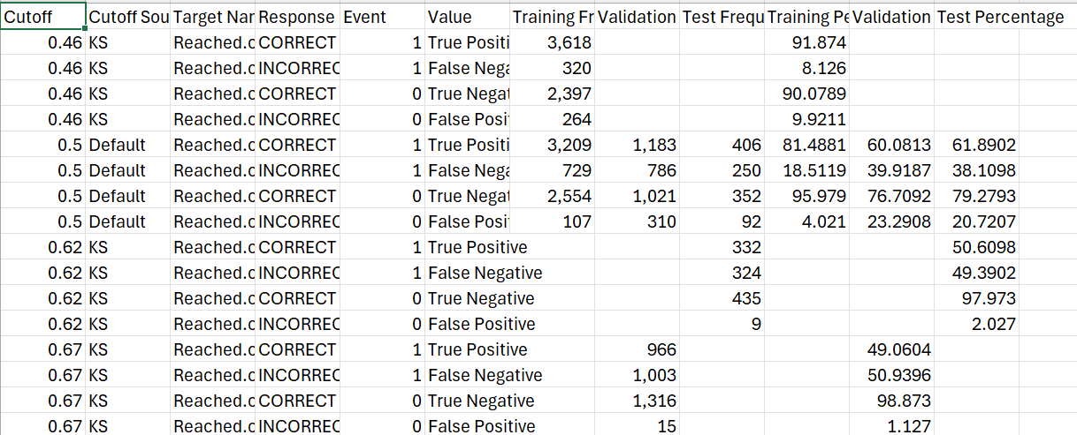
Fig.19 The Event Classification Table for Gradient Boosting Model

$$Precision= TP$$  TP + FP  $Precision=$2658  2658 + 377  $Precision=$2658  3035  $Precision=$0.8758 ~ 87.58% | (5)
Calculation 5. Precision Calculation of Gradient Boosting Model
$$Recall= TP$$  TP + FN  $Recall=$ 2658  2658 + 1280  $Recall=$ 2658  3938  $Recall=$0.6750 ~ 67.50% | (6)
Calculation 6. Recall Calculation of Gradient Boosting Model
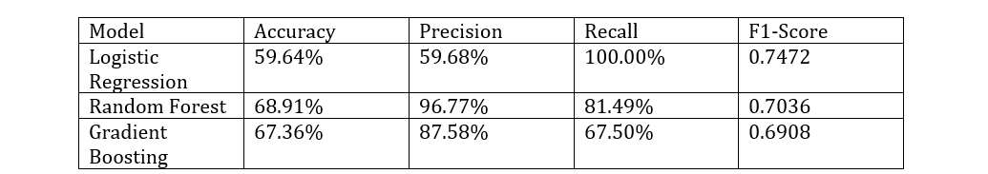
Fig.20 The Final Performance Comparison of Machine Learning Models
Based on the results, Random Forest achieved the highest accuracy (68.91%) and precision (96.77%), indicating strong overall prediction performance and a low false-positive rate. Logistic Regression obtained the highest recall (100.00%) and F1-Score (0.7472), meaning it successfully identified all delayed deliveries but produced more false-positive predictions due to its lower precision.
Gradient Boosting achieved competitive performance with an accuracy of 67.36%, precision of 87.585, and recall of 67.50%, but it performed slightly below Random Forest across most metrics.
Considering all evaluation metrics, Random Forest was selected as the best-performing model because it provides the best balance between accuracy, precision, nd recall. The results indicate that ensemble-based methods outperform Logistic Regression in predicting delivery delays, making Random Forest the most suitable model for supporting logistics planning and decision-making.
Conclusion
In this research, we have established and verified three separate machine learning methods to predict delivery delays based on logistic data. Logistic Regression, Random Forest, and Gradient Boosting have been implemented and compared against several performance metrics including: Accuracy, Precision, Recall, and F1-Score. Based on these metrics, Random Forest was the highest performing machine learning technique with an accuracy of 68.91% and a precision of 96.77%.
Our results provide additional evidence that machine learning can effectively aid in predicting delivery delays and will help finance departments within logistics organizations exploit shipment delay predictions and consequently improve their operational plan, manage their resources efficiently, and increase their customer satisfaction.
Future direction of this project may include using more variables such as weather conditions, traffic data, and real-time operational data to increase the accuracy of the prediction models.
Acknowledgement
The author would like to express sincere gratitude to the lecturers and the Faculty of Computer Science and Information Technology, Universiti Tun Hussein Onn Malaysia (UTHM), for their guidance, support, and valuable suggestions throughout the completion of this research. Appreciation is also extended to all individuals who directly or indirectly contributed to the success of this project.
Conflict of Interest
The author declares that there is no conflict of interest regarding the publication of this paper.
Author Contribution
This section is compulsory. This journal requires that all authors take public responsibility for the content of the work submitted for review. The contributions of all authors must be described in the following manner:

The authors confirm contribution to the paper as follows: study conception and design: I.U.Deleila Ahmad Termidi, Che Ku Ilya Farhana Che Ku Amran, Hammad Akram; data collection: I.U.Deleila Ahmad Termidi; analysis and interpretation of results: I.U.Deleila Ahmad Termidi; draft manuscript preparation: I.U.Deleila Ahmad Termidi. All authors reviewed the results and approved the final version of the manuscript.

The author confirms sole responsibility for the following: study conception and design, data collection, analysis and interpretation of results, and manuscript preparation.
Appendix A: SAS Model Studio Pipeline
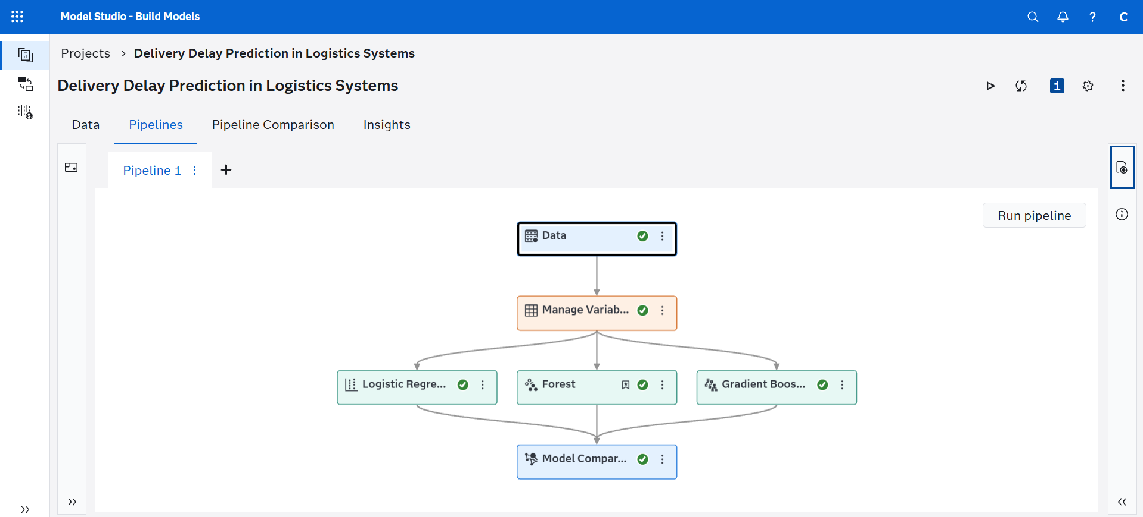
Figure A.1 shows the machine learning workflow developed in SAS Model Studio, including the Data, Manage Variables, Logistic Regression, Random Forest, Gradient Boosting, and Model Comparison nodes.
Appendix B: Dataset Attributes
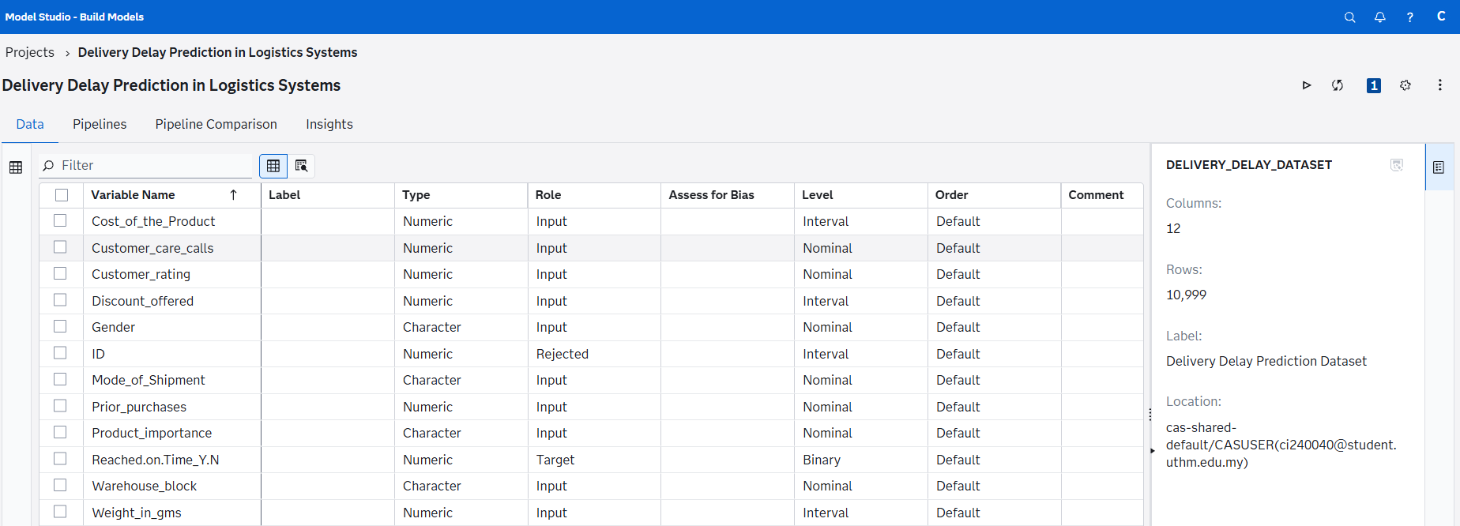
Figure B.1 presents the description of all variables used in the delivery delay prediction dataset.
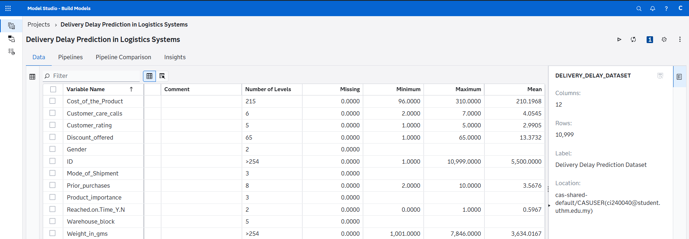
Figure B.2 presents the description of all variables used in the delivery delay prediction dataset.

References
- Apnena, R. D., Ginting, G., Sudrajat, A., & Islam, H. M. M. (2025). Comparative analysis of supervised learning algorithms for delivery status prediction in big data supply chain management. Journal Teknik Informatika, 6(3). https://doi.org/10.52436/1.jutif.2025.6.3.4689

- Kotu, V., & Deshpande, B. (2019). Data science: Concepts and practice (2nd ed.). Morgan Kaufmann.

- Breiman, L. (2001). Random forests. Machine Learning, 45(1), 5–32. https://doi.org/10.1023/A:1010933404324

- Faulkner, S., Zandehshahvar, R., Akhlaghi, V. E., Ouellet, S., Jordan, C., & Van Hentenryck, P. (2026). Uncertainty-aware delivery delay duration prediction via multi-task deep learning. arXiv. https://arxiv.org/abs/2602.20271

- Friedman, J. H. (2001). Greedy function approximation: A gradient boosting machine. The Annals of Statistics, 29(5), 1189–1232. https://doi.org/10.1214/AOS/1013203451

- Kuliavets, A., & Burov, Y. (2025). A method for predicting delivery delays and route optimisation based on graph neural networks in logistics systems. Information Systems and Networks, 18(1), 58–66. https://doi.org/10.23939/sisn2025.18.1.058

- Küp, B. Ü., Küp, E. T., & Koçak, G. (2025). Real-time prediction of delivery delay in supply chains using machine learning approaches. SSRN Electronic Journal. https://doi.org/10.2139/ssrn.5054862

- Min, H. (2021). Artificial intelligence in supply chain management: Theory and applications. International Journal of Logistics Research and Applications, 24(1), 1–25. https://doi.org/10.1080/13675567.2020.1847851

- Purnomo, A., Ginasta, N. G., Syafrianita, S., & Pane, S. F. (2025). Predictive modeling of delivery delays in transportation using machine learning: A comparative study of service types. Dinasti International Journal of Education Management and Social Science, 7(2). https://doi.org/10.38035/dijemss.v7i2.5736

- Salari, N., Liu, S., & Shen, Z. J. M. (2022). Real-time delivery time forecasting and promising in online retailing: When will your package arrive? Manufacturing & Service Operations Management, 24(3), 1421–1436.

- Sarker, I. H. (2021). Machine learning: Algorithms, real-world applications and research directions. SN Computer Science, 2(3), 160. https://doi.org/10.1007/s42979-021-00592-x

- Schafer, D., Schubert, D., & Ottenhues, M. (2025). An analytical review of predictive methods for delivery delays in supply chains. Supply Chain Analytics, 11, 100130. https://doi.org/10.1016/j.sca.2025.100130

- Xue, Z., Huo, M., & Wang, Y. (2026). EAGLE: Edge-aware graph learning for proactive delivery delay prediction in smart logistics networks. arXiv. https://arxiv.org/abs/2604.05254

- Xu, L., Long, Y., & Brintrup, A. (2025). SynDelay: A synthetic dataset for delivery delay prediction. arXiv. https://arxiv.org/abs/2509.05325

- Yadav, V., Sharma, A., & Singh, R. (2022). Delay prediction to mitigate e-commerce supplier disruptions using voting mechanism. IFAC-PapersOnLine, 55(10), 731–736. https://doi.org/10.1016/j.ifacol.2022.09.495

- Zhang, Y., Ren, S., Liu, Y., Si, S., & Pillutla, S. (2022). Machine learning applications in logistics and supply chain management: Recent advances and future directions. Industrial Management & Data Systems, 122(4), 945–967.

