For the Generated Table, refer to the attached excel sheet.

Legend Description:

P10(x): The degree 10 polynomial from nodes 10 to 20

P20(x): The degree 20 polynomial from nodes 5 to 25

P30(x): The degree 30 polynomial from nodes 0 to 30

F(x): The original Polynomial 1/(1+x^2)

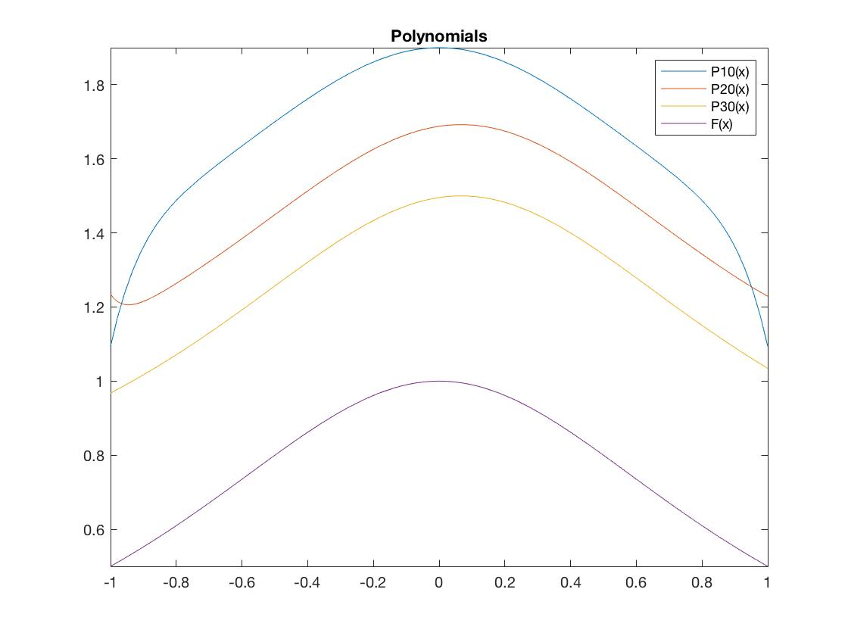

The accuracy does not necessarily increase with the increase of the polynomial order.

This claim is based on the fact that P10(x) is closer to F(x) than P20(x) is.

P10(x) P20(x) P30(x)

Error: 1.71000 2.89332 0.78149