**Super rough draft:**

**Are Police Racially Profiling When They Stop People?**

Following the shootings of Michael Brown in Ferguson, Philando Castile in Minnesota and many others across the country, news story after news story covered instances of officer-involved shootings of unarmed African Americans.

The Black Lives Matter movement rose up and rallied social media and communities of color to protest patterns of racism and brutality. Race became the center of a national debate, changing the national conversation about policing in America.

But as usual, Americans are deeply divided on the issue: where one side perceives injustice and violence toward black bodies, the other focuses on the hardships that come with policing and the respect for those in uniform.

For some cities, it wasn't too long ago when police forces around the country were under intense public scrutiny.

In 2001, the Los Angeles Police Department was placed under a federal consent decree after a decade of policing crises that began with the beating of Rodney King in 1991, followed by the Rampart police corruption scandal in 1999. The Department of Justice (DOJ) threatened to sue the City of Los Angeles over a pattern-and-practice of police misconduct.

Until 2013, the Los Angeles Police Department was under a 12-year federal consent decree that required officers to document the race and ethnicity of each person they encountered. Other state and local law enforcement agencies also have been imposed with consent decrees or “memos of understanding” by the DOJ. They have included: Pittsburgh, [Cleveland](http://www.justice.gov/file/441426/download), Oakland, New Orleans, Portland, Oregon, Cincinnati, New York City, Detroit, the Virgin Islands PD, Seattle, Albuquerque and Newark.

In 2015, California passed a law, [AB 953](https://leginfo.legislature.ca.gov/faces/billNavClient.xhtml?bill_id=201520160AB953), that began requiring its state and local police agencies to document and make public the ethnicity and race of individuals they stopped while patrolling vehicles and pedestrians. While most police officers are not happy about it, civil rights activists say that the "racial profiling" bill is a glimmer of progress because the public's ability to track and scrutinize police interactions with citizens.

"I don't feel comfortable with this law and many others here don't either," says Sergeant Lee DeBrabander of the Long Beach Police Department's gang and narcotics unit. "I don't racially profile, and I've never have either. But now I feel like I'm being forced to racially profile."

The seasoned officer admits that there are the occasional 'bad apples' in the police force, but he feels that the majority of cops have their hearts in the right place.

"This racial profiling bill is only likely to increase crime," DeBrabander continues, "Officers are going to feel hesitant about approaching persons of color or even anyone. They'll become less inclined to do so because of all the paperwork they'd have to fill out."

Jim Bueermann, president of the National Police Foundation, champions a holistic approach to community policing as police chief. He recognizes that the police carry some of the blame for people's distrust of law enforcement.

“Police have the job to protect citizens, and while they’re doing that, they shouldn’t offend them to a level where they damage their relationship with the people,” he continued. “This is what the New York Police Department didn't get when they implemented their stop-question-and-frisk strategy.”

"The problem is my own belief is that policing needs its version of what's called the Hippocratic oath right in medicine," Bueermann concedes. “There's this thing that purports to tell physicians above all why you're treating the patient and trying to cure them. Don't do any harm to the patients."

To assess the LAPD for racial profiling, I analyzed the department's data from its 21 patrol Divisions and its four major bureaus. The patrol divisions represent stops conducted by the local and their corresponding geographical areas.

## Introducing the Data

Between January 1, 2010, and April 9, 2018, there have been 1,048,575 stops, combining vehicle and pedestrian stop data. The overall breakdown reveals the following:

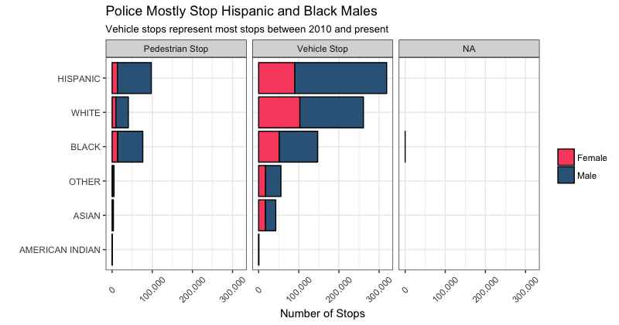

This result doesn’t show much. Los Angeles is inhabited predominantly by Hispanics and Whites. Below, a table from the [2015 census data](http://www.census.gov/quickfacts/table/PST045216/06037,00) shows the demographic breakdown of the city.

|  |  |
| --- | --- |
| **Population Type (single race only)** | **Population % of LA County** |
| Hispanic or Latino | 48.6% |
| White alone, not Hispanic or Latino | 28.5% |
| Asian alone | 11.6% |
| Black or African American alone | 9.0% |
| American Indian and Alaska Native alone | 0.9% |

After breaking down the police stop data by race, we see that most stops involve Hispanics and Blacks in *almost* all divisions.

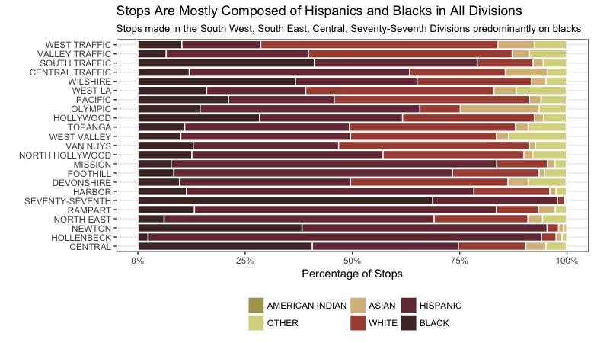

While comparing police stop data with population data is often used to assess the level of racial discrimination, this method is not perfect. Commander Dennis Kato of LAPD's West Bureau says that looking at race and geography alone can be misleading.

"In reality, police that are assigned to patrol certain areas are going to encounter more people who are Latino or Black or White or whatever is the dominant community there," explains Kato. "Because even though LA is a pretty diverse city, it's kind of spread out and segregated-- I mean you get certain enclaves of people based on culture. That's not a bad thing, it's just how it can to be."

The maps below show the number of police stops conducted by the 21 patrol patrol divisions between 2010 and April 2018. Colors follow a 10-interval graduated color ramp. The lower the number, the lighter the color, which is light yellow. The higher the number, the darker the fill color, which can be as dark as black.

The results show that most vehicle stops occur in the Central, Van Nuys and Southwest Divisions. On the other hand, pedestrian stops seem to concentrate in the Hollywood, downtown and south central areas of LA.

PEDESTRIAN STOPS VEHICLE STOPS

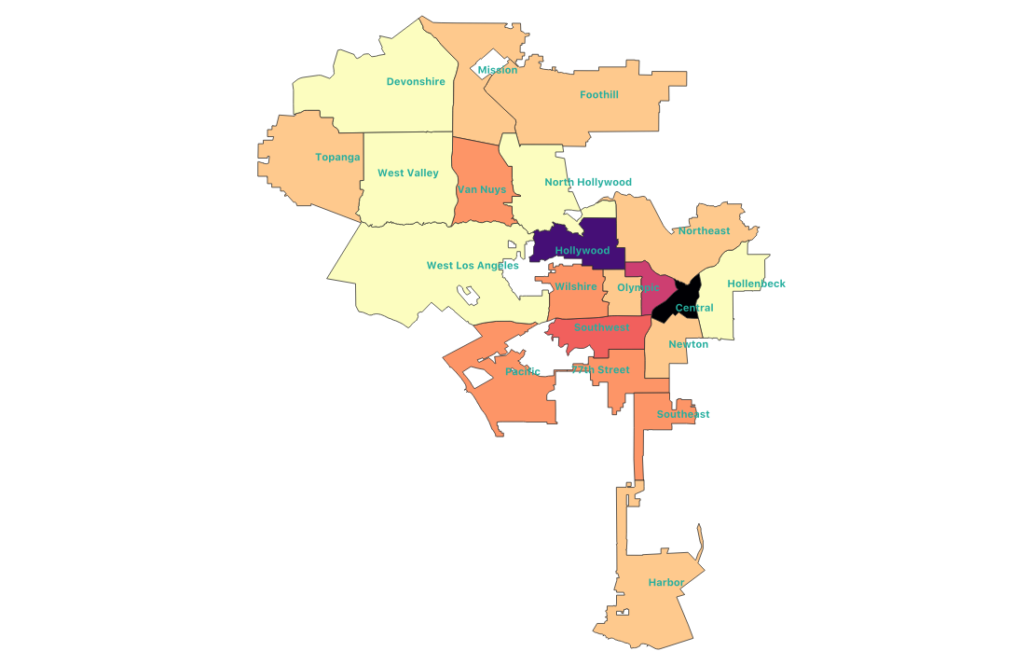 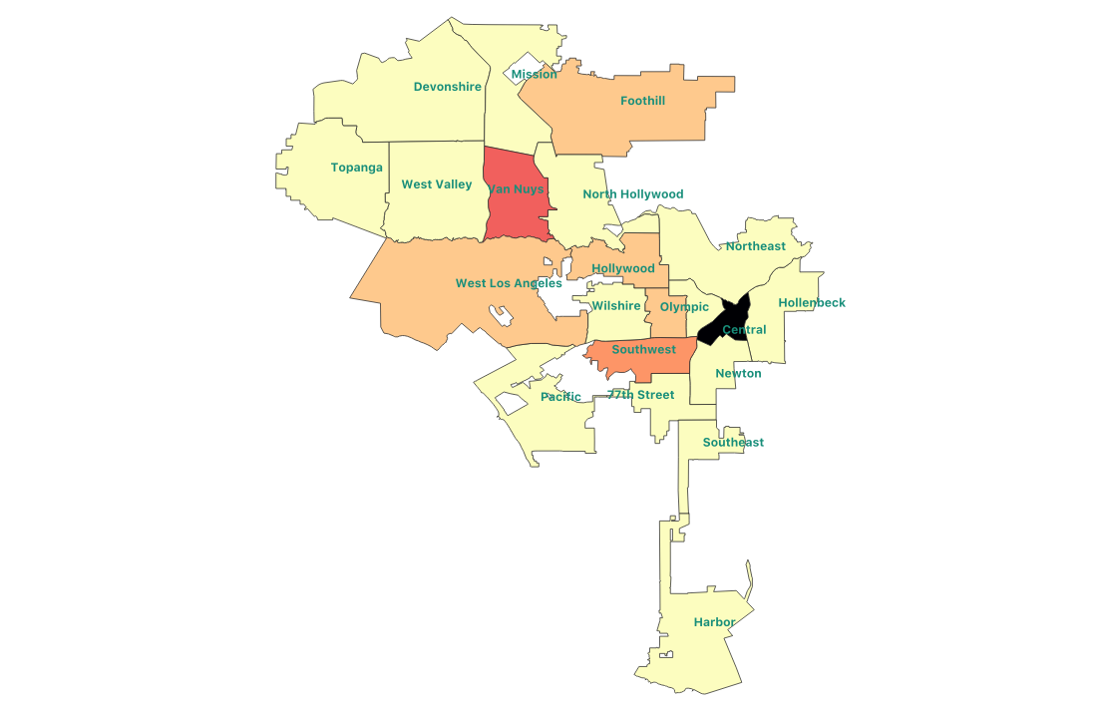

While may not show much about racial profiling in police stops, the shades of police stop counts seem to show areas that have higher rates of crime, or places where there might be more tourists or places to party, like the Hollywood and downtown areas.

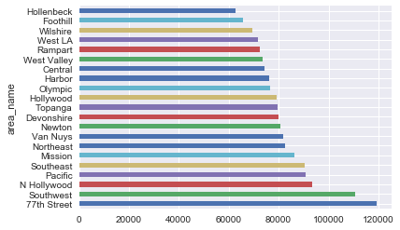

But perhaps the types of crime committed in an area can tell us more about policing. The clustermap below normalizes the distribution of crimes across all divisions of the LAPD.

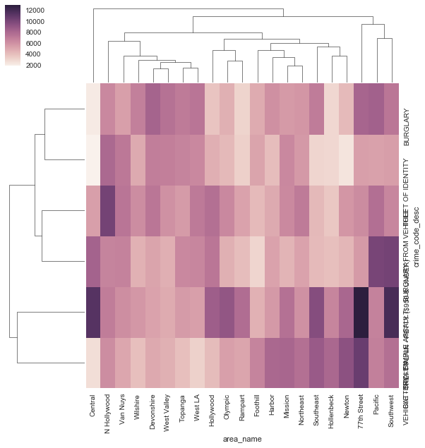

We see that are more crimes involving battery and assault are reported in the 77th Street, Central and Southwest divisions.

…

Aggressive policing systems created resentment and, distrust, and fear in many minority communities.