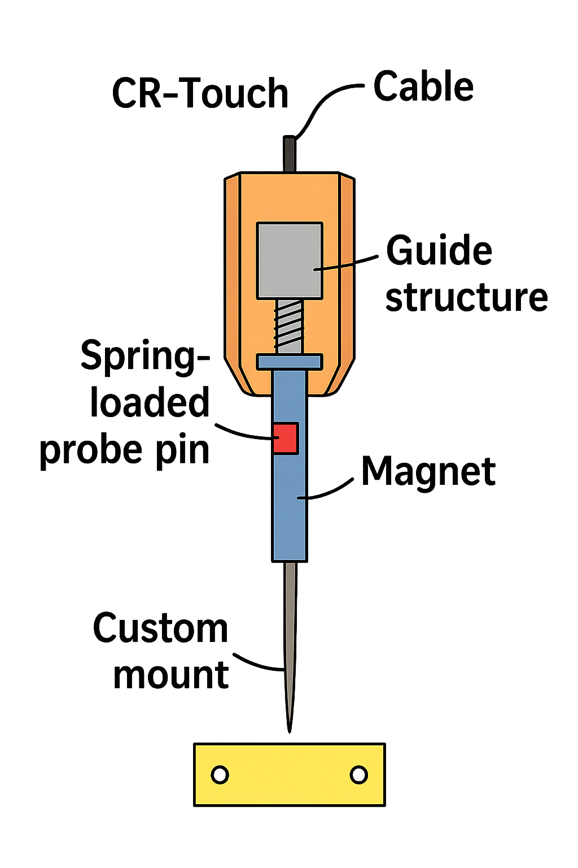
CR-Touch → Educational Macro-SPM Z-Probe Project (Final Version)

Project Overview
This project converts a Creality CR-Touch auto-leveling sensor into a contact-based Z probe for macro-scale surface scanning. The system demonstrates core principles of scanning probe microscopy (SPM) using low-cost, accessible components. Two probe tip configurations are supported: a rigid steel needle (recommended for stability) and a pogo-pin probe (optional, safer but less precise).
Figure: System overview (sensor, guide, probe tip, magnet)

1. Working Principle
The CR-Touch contains a spring-loaded probe and a small internal magnet. A Hall-effect sensor detects magnet displacement and a microcontroller outputs a digital trigger. Replacing the probe tip with a needle or pogo pin converts the device into a precise contact probe. The added external guide improves vertical stability and repeatability.

2. Bill of Materials (BOM)
REQUIRED PARTS:
- Creality CR-Touch sensor
- Neodymium magnet 2x2 mm (mandatory, pogo pins are NOT magnetic)
- PTFE tube 2 mm OD / 1 mm ID
- M3 screws
PROBE OPTIONS:
Option A (Recommended): Steel needle (~1 mm diameter)
Option B (Optional): Pogo pin (P50-B1 or P75-B1, spring-loaded, requires glued magnet)
3D PRINTED PARTS:
- CR-Touch mount
- Guide tube holder
- Calibration shims

3. Probe Tip Options (Important Decision)
Steel Needle:
- High repeatability
- Single spring system (CR-Touch only)
- Sharp tip for better spatial resolution
Pogo Pin (P50/P75):
- Built-in spring (safer contact)
- Requires external magnet attachment
- Creates double-spring system -> lower measurement precision

4. CAD and Mechanical Design
- Guide hole: 2.0–2.1 mm
- Guide length: 10–15 mm
- Mount must be rigid
- Probe axis must be perfectly vertical
- Ensure smooth motion with minimal friction

5. Assembly Instructions
1. Remove original CR-Touch probe pin
2. Prepare probe:
- Needle: cut to ~18 mm
- Pogo pin: use full length
3. Glue magnet to top (centered and aligned)
4. Insert with original spring
5. Print and install guide + PTFE tube
6. Mount to printer using printed mount
7. Align probe vertically

6. Testing Procedure
- Power CR-Touch
- Press probe manually
- Verify consistent trigger point
- If unstable: adjust magnet position
- Ensure smooth motion without sticking

7. Safety Notes
- Needle tips are sharp → handle carefully
- Use slow Z movement
- Avoid hard collisions
- Keep magnets away from electronics

8. Summary
This system provides a low-cost, educational Z-probe solution. For best performance use a steel needle. For safer contact a pogo pin can be used, but requires compromises in precision.

