ANECO Customer Sanitation
System Overview and Workflow Summary
Presented to:
JHONEL
Marketing Officer
Corporate Communications and Public Relations Office
Agusan del Norte Electric Cooperative, Inc. (ANECO, Inc.)
Developed by:
JAMES MICARANDAYO
RHOWIN JOHN LUMALES
JHON LAWRENCE PAG-IWAYAN
WENDEL REY SALAUM
Date: April 7, 2026
System Version: 1.0

A Message to Our Requestor
This system is a customer account verification and application management platform for sanitation or utility-related consumer records. It allows customers to verify their identity, review their account information, and request updates, while administrators review, approve, decline, and track those requests in one central dashboard.
What Is This System?
It is a web-based application built to manage customer account and application records. The customer side starts with an account number check, then an ID-based verification step, followed by a guided form where the customer can request corrections or ownership-related updates. The administrator side provides a secure dashboard for viewing applications, reviewing submitted changes, approving or declining requests, and checking activity logs and notifications.
Who Uses It?
The platform supports three main user roles. Their responsibilities are summarized below.
User Type | Who They Are | What They Do
Customer / Account Holder | The person linked to an account number | Enters an account number, completes ID verification, views account details, selects the reason for update, edits allowed fields, and submits change requests.
Administrator | Authorized office staff with login access | Signs in, reviews all applications, checks pending, approved, and declined records, views customer details, edits records, approves or declines requests, and monitors logs and notifications.
Staff / Viewer | Internal users supported by the data model | Intended for internal access with limited responsibilities such as viewing records or assisting operations, depending on the assigned role.
How Does a Customer Use the System?
The customer journey begins on the home page and moves through account checking, ID verification, guided editing, and request submission.
The customer first enters an account number on the home page. If the account exists, the system moves to ID verification, where the camera or uploaded image is checked using OCR to compare the ID name against the account owner name. After successful verification, the customer selects the reason for the request, edits allowed fields, reviews a summary of changes, provides an active mobile number, and submits the request. The system then stores the update as pending and creates a notification for tracking.
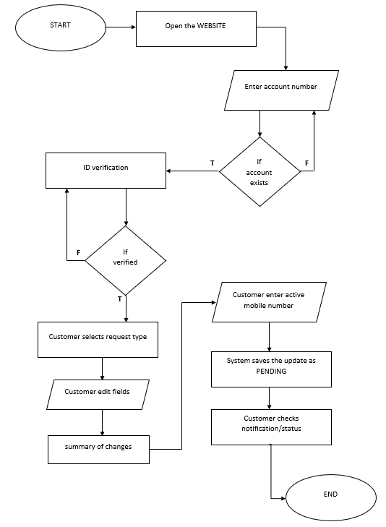
Figure 1. Customer workflow from account checking to request submission.
What Can the Administrator Do?
The administrator can sign in through a protected login page, review application records, and decide whether each request should be approved, declined, or updated.
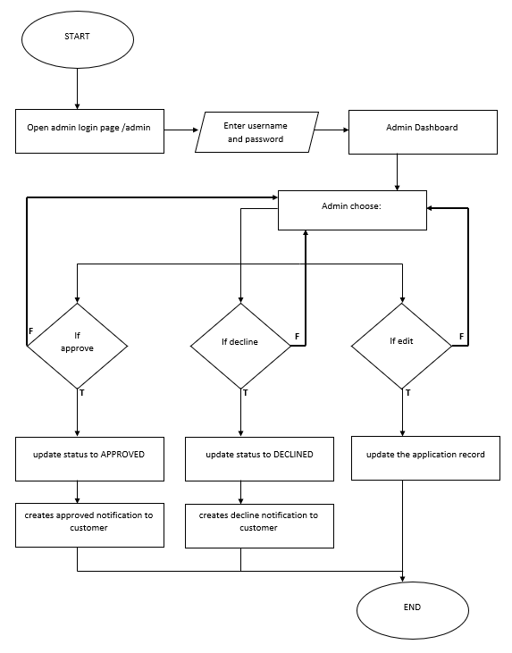
Figure 2. Administrator workflow for reviewing, editing, approving, and declining applications.
Administrator capabilities include:
• View customer and application records in detail
• Review customer-submitted changes
• Edit record details
• Approve requests
• Decline requests
• See notifications tied to applications
• View activity logs or audit history
• Delete applications if the user has full admin rights
What Makes This System Safe and Reliable?
The system includes several safeguards that support secure access, traceable actions, and dependable record handling.
• Admin pages and admin APIs require authentication through NextAuth.
• Passwords are checked using hashed-password comparison with bcrypt.
• Admin sessions use short-lived JWT-based sessions.
• Application actions such as create, update, approve, decline, and delete are logged in an activity log.
• Notifications are recorded per application so status changes are traceable.
• Customer updates are stored with before-and-after differences in metadata, which helps review and audit.
• Mobile numbers are validated before customer-submitted edits are accepted.
• The database structure enforces unique account and record numbers and keeps related records linked properly.
We appreciate the opportunity to develop this platform and are available for support.
Respectfully submitted,
JAMES MICARANDAYO
RHOWIN JOHN LUMALES
JHON LAWRENCE PAG-IWAYAN
WENDEL REY SALAUM
Interns, ANECO

