ANECO FEEDBACK SYSTEM
System Overview — Client Reference Document

Document Title | ANECO Feedback System — Client Reference
Version | 1.0
Date | April 8, 2026
Prepared For | ANECO — MA’AM IRENE NAYVE
Document Status | Final

1. What Is This System?
The ANECO Feedback System is a digital tool that allows customers to rate and comment on the service they received from ANECO personnel. Feedback is collected through a kiosk device — a screen set up in a service area that customers can use right after being assisted.
Once feedback is submitted, ANECO staff can log in to view reports and analytics that summarize how customers rated each service question. This helps the organization identify areas where personnel are performing well and areas that may need improvement.
2. Who Uses the System?
There are three types of users in the system:
User Type | Who They Are | What They Can Do
Administrator | The system manager, typically an IT or operations officer. | Full access — manages all accounts, all forms, all feedback, and activity logs.
Personnel | An ANECO staff member assigned to a service area. | Creates survey forms, views customer feedback reports, and downloads reports.
Kiosk User  (Customer) | A customer who recently received service from ANECO. | Answers the survey on the kiosk screen. No login required.

Flowchart of the System:
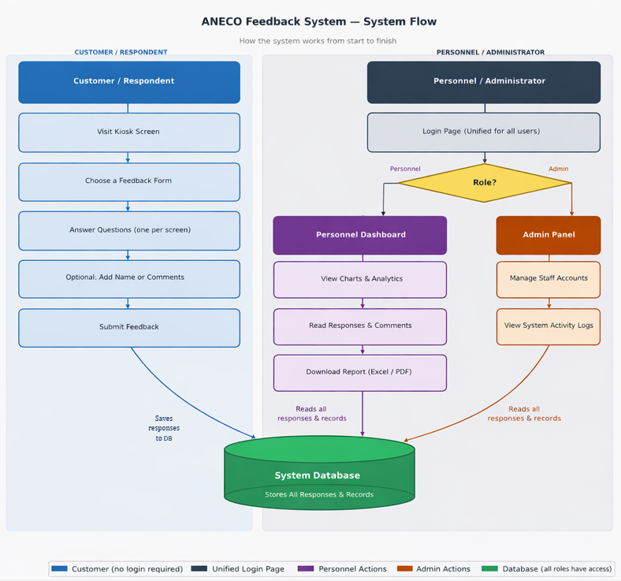

3. How Does It Work? — Step by Step
The system follows a simple four-step process:
Step 1 — Set Up the Survey Form
A Personnel staff member logs in and creates a survey form. The form contains a list of questions that customers will be asked to rate. Questions can be grouped by topic, and the system always includes an "Overall Satisfaction" question at the end.
Step 2 — Customer Submits Feedback on the Kiosk
A customer approaches the kiosk device after being assisted. They select the active form, rate each question on a 1-to-5 scale (from Strongly Disagree to Strongly Agree), and optionally leave a written comment. If a customer skips a question, it is recorded as "N/A" — no question is forced to be answered.
Step 3 — Staff Reviews the Results
After submissions come in, the assigned personnel can log in and view the analytics page for that form. They can see how many customers responded to each question and what ratings were given. The dashboard also shows a weekly chart of how many responses were received each day.
Step 4 — Download a Report
When needed, the personnel can download a formatted report in PDF format. The PDF report includes a professional header with the form name, personnel name, date range, and a complete table of results — suitable for submission or review by management.
4. Features at a Glance
Below is a summary of what each user type can do in the system:
Feature | Admin | Personnel | Customer (Kiosk)
Create and manage survey forms | ✓ | ✓
Submit feedback through the kiosk |  |  | ✓
View response analytics and charts | ✓ | ✓
Download PDF reports | ✓ | ✓
Manage personnel staff accounts | ✓
View all forms and submissions | ✓ | ✓
View system activity logs | ✓

5. Understanding the Analytics
When a personnel staff member opens the Responses page for a form, they will see a detailed table showing how customers answered each survey question.
The table shows the following for each question:
- Strongly Agree / Agree / Neutral / Disagree / Strongly Disagree How many customers selected each rating.
- N/A How many customers skipped the question without selecting a rating.
- Total Responses The total number of customers who saw this question.
- Overall (%) The satisfaction rate — calculated as the percentage of customers who selected "Agree" or "Strongly Agree" out of those who actually answered the question.

The Overall (%) uses this formula:
Overall (%) = (Strongly Agree + Agree + Neutral) ÷ (Total Responses − N/A) × 100

Color indicators help staff quickly read the results:
- Green (75% and above)— Good performance
- Orange (50% to 74%)— Acceptable, but can be improved
- Red (below 50%)— Needs attention

6. The Dashboard
When a staff member logs in, they land on the Dashboard — a quick summary screen. It displays:
- Total Forms — The total number of active survey forms created by that staff member.
- Total Responses — The total number of individual feedback submissions received across all forms.

The dashboard also shows two charts: a Submission Trend chart that displays how many responses were received per day during the current week, and a Form Ratings chart showing the average satisfaction score per form. Staff can use the date filters to view trends for any time period they choose.
7. Downloading Reports
Reports can be downloaded in two formats directly from the Responses page:
Format | Best Used For | Contents
PDF | Formal reporting, management submission | Formatted document with header, personnel info, tally table, and footnotes.

The PDF report includes a professional header with the system name, form title, personnel name, the date range of included responses, and the total number of respondents. A confidentiality footer is printed on every page.
8. Quick Terms to Know
- Form — A survey created by personnel containing a list of rated questions.
- Kiosk — The screen/device where customers submit their feedback. No login needed.
- Feedback — A single completed survey submission from one customer.
- N/A — Means the customer did not answer that particular question.
- Overall (%) — The satisfaction rate for a question, based on "Agree" and "Strongly Agree" answers only.
- Dashboard — The home screen for staff — shows a summary of forms and responses at a glance.
- Analytics — Charts and tables that break down how customers rated each question.
- Admin — The system manager who oversees all accounts, forms, and activity.

Developed By:
JAMES MICARANDAYO
RHOWIN JOHN LUMALES
JHON LAWRENCE PAG-IWAYAN
WENDEL REY SALAUM

ANECO Feedback System — Client Reference Document | Confidential | April 8, 2026

