FILES NEEDED TO INSTALL

CSentiment.py requires you to install wkhtmltopdf

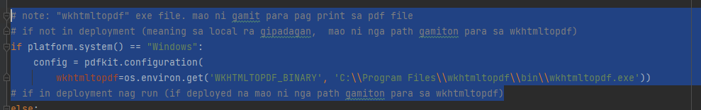

wkthmltopdf | <https://wkhtmltopdf.org/downloads.html>

CSentiment.py needs REST API client (testing purposes)

<https://www.postman.com/product/rest-client/>

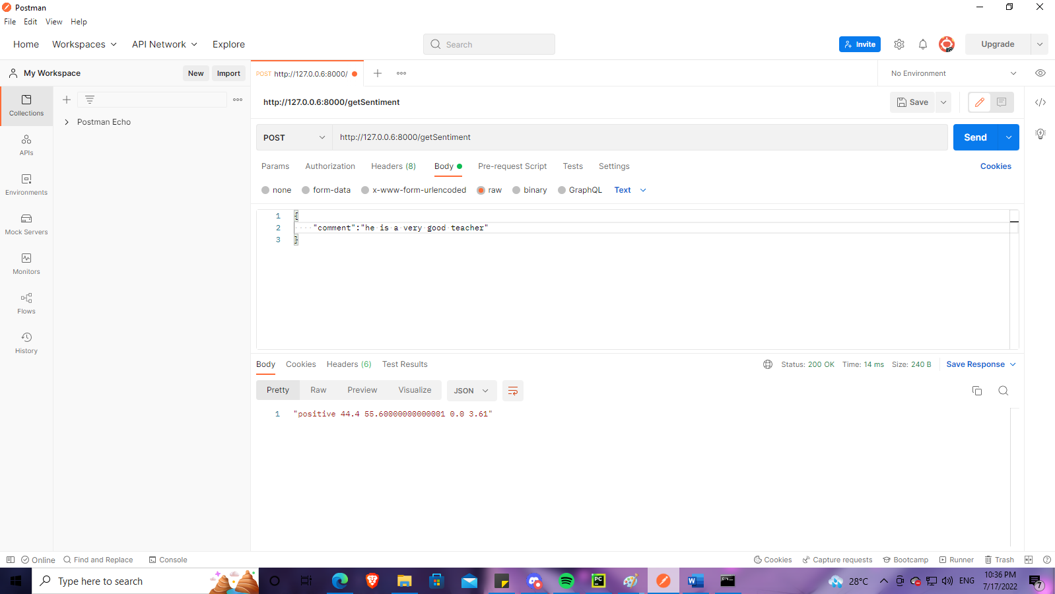

STARTING CSENTIMENT.PY

1. Before starting CSentiment.py, it is **important** to run **NaiveBayes_Model.py** first

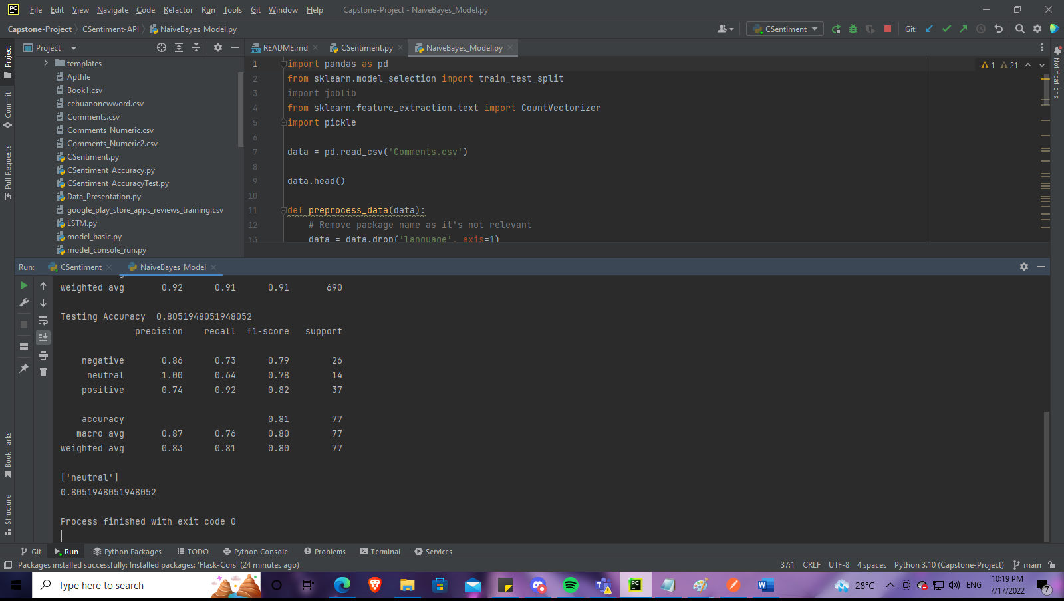

1. 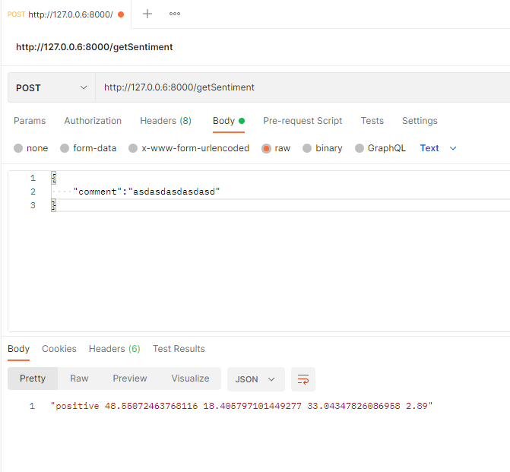You must first check if the neutral value is correct. (ex: ‘asdasdasdasdasd’ should obviously output neutral)

If the API is not showing the correct output.   
- asdasdasdasdasd should output neutral 0 100 0 0.00 | sentiment [pos] [neu] [neg] [score]  
- get the pos neu neg values from the ‘supposedly neutral’ wrong output (could be a different value)



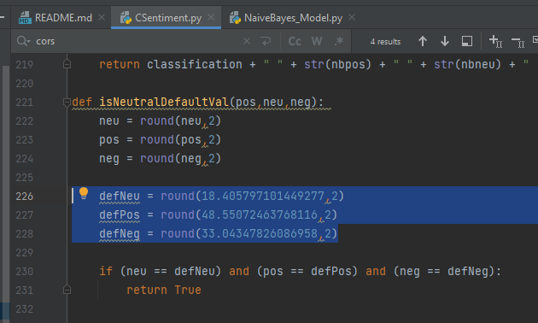

- And paste it inside **isNeutralDefaultVal** function to automatically correct wrong neutral outputs

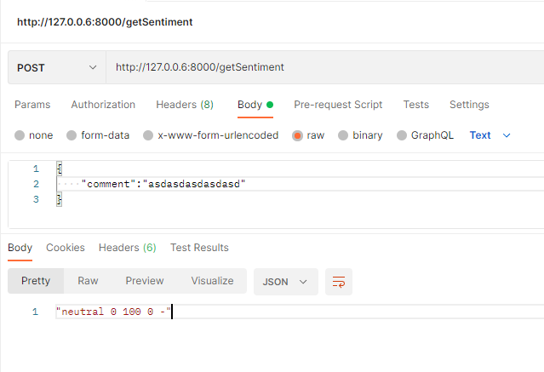

IMPORTANT:

- The incorrect output of neutral occurs only when there are changes in the dataset.

- If the API is showing the correct neutral output, then there’s no need to modify the isNeutralDefaultVal function

Ex: input: asdasdasdasdasd   
output: "neutral 0 100 0 -"