---README

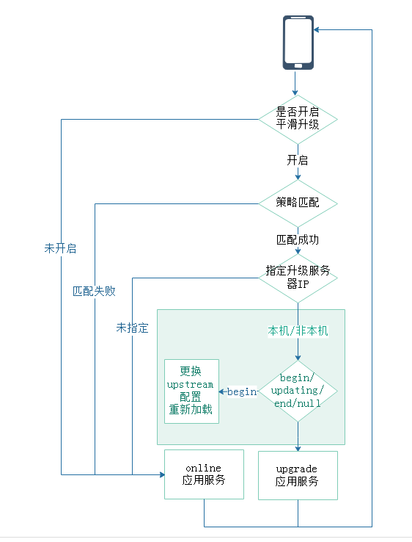

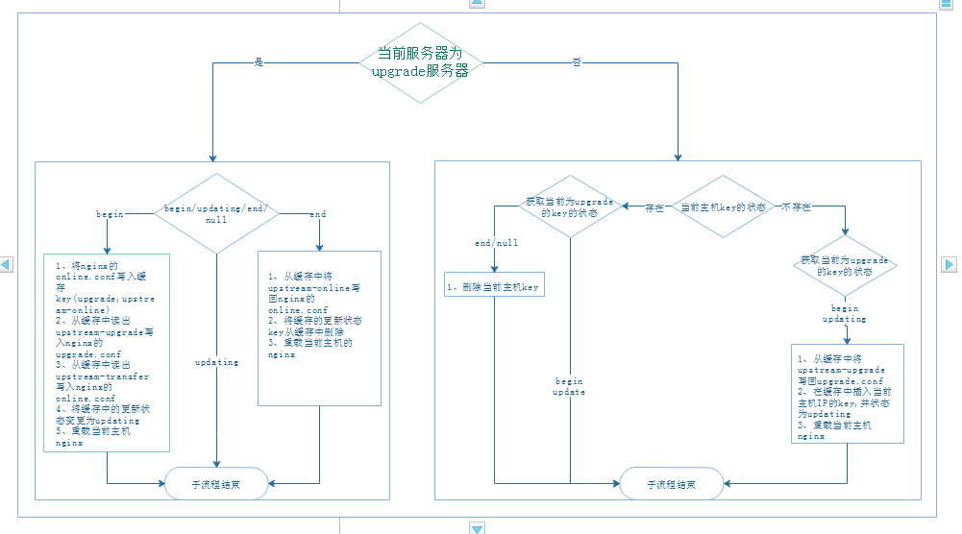

---README

hash-key/hset

upgrade

-------switch:on/off [平滑升级开关]

-------proxy:"{'ip','head','version','phone'}" [支持策略,当多选时，每个策略至少满足一个]

-------proxy_ip:"{'192.168.1.2','192.168.1.3'}"

-------proxy_head:"{'test1','test2'}"

-------proxy_version:"{'3.0.4','3.0.5'}"

-------proxy_phone:"{'13600000000','13700000000'}"

-------update:'192.168.1.2' [当前upgrade服务器IP]

-------192.16.1.2:begin/updating/end [初始值为begin]

-------upstream_online:"upstream online {\n\tserver 192.168.1.212:8001;\n\tserver 192.168.1.212:8002;\n}\n\n\n\n"　[现网配置备份]

-------upstream_upgrade:"upstream upgrade {\n\tserver 192.168.1.2:8001;\n\tserver 192.168.1.2:8002;\n}\n\n\n\n" [重置upgrade配置]

-------upstream_transfer:"upstream online {\n\tserver 192.168.1.213:8001;\n\tserver 192.168.1.213:8002;\n}\n\n\n\n"　[重置upgrade服务器的online配置]