JWT Authentication API

Spring Boot • Spring Security • JWT • PostgreSQL
Tiempo estimado 10h aproximadamente
Backend Authentication System built with Spring Boot
Technologies
- Java 21
- Spring Boot
- Spring Security
- JWT Authentication
- Spring Data JPA
- Hibernate
- PostgreSQL
- Docker
- Maven
- RESTful APIs
- Postman
- Swagger UI
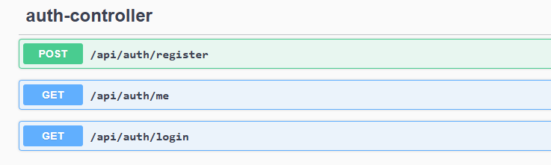
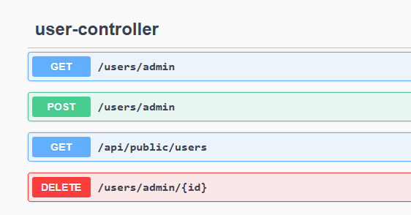

Project Description

This project demonstrates a complete authentication system for REST APIs using JSON Web Tokens (JWT).
Implemented features include:
- User Registration
- User Login
- Password Encryption (BCrypt)
- JWT Generation
- JWT Validation
- Protected REST Endpoints
- Stateless Authentication
- Global Exception Handling
- DTO Pattern
- Layered Architecture

Project Goals
- Secure REST APIs
- Demonstrate Spring Security integration
- Follow clean architecture principles
- Separate business logic from authentication logic

Project Structure
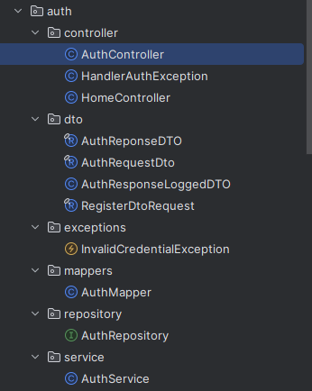
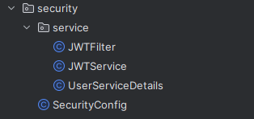

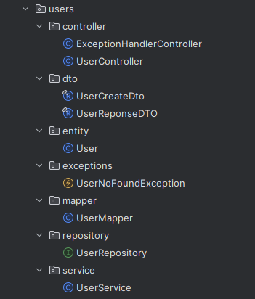

Database
PostgreSQL running inside Docker
Tecnologías:
- PostgreSQL
- Docker Container
- Spring Data JPA
- Hibernate ORM

base de datos en postgresql

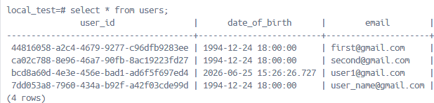

API Demonstration

Register User: POST:- /api/auth/register
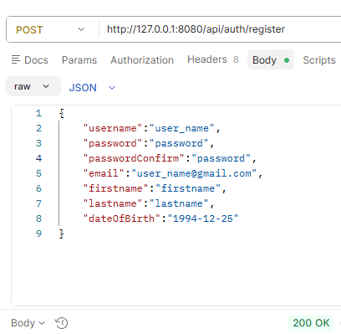

Login POST:- /api/auth/login
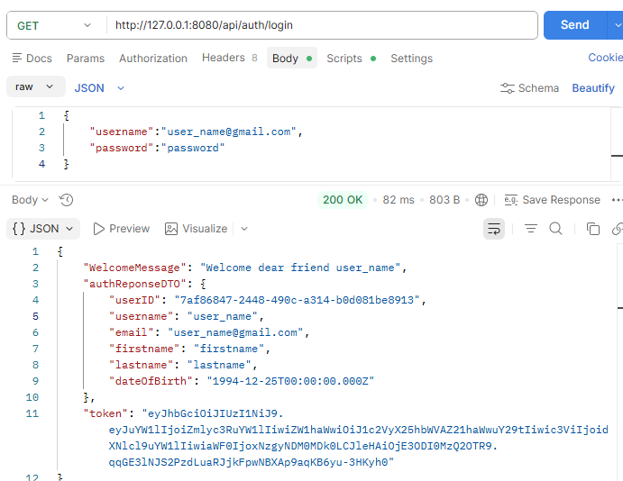
Protected Endpoints

login user: GET:- /api/auth/me bearer token
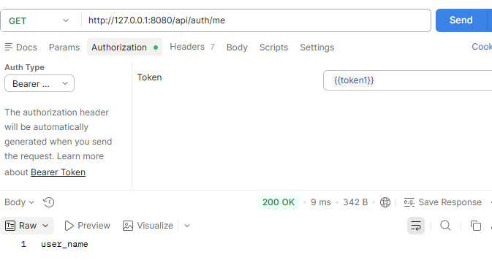
login user: GET:- /api/auth/me no auth
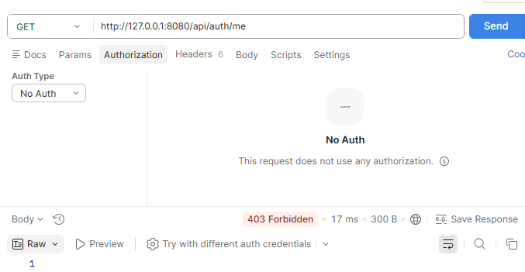

Security Features

Implemented Security
✔ Password Encryption using BCrypt
✔ JWT Authentication
✔ Stateless Sessions
✔ Authentication Filter
✔ Security Context
✔ Spring Security Integration
✔ Protected REST Endpoints
✔ Exception Handling
✔ Token Validation

