Kyra Zhu, Delia Carlino

November 10, 2023

MATH 7360-01

Mid-term Report

In our course project, we are investigating the patterns and determinants of Non-Communicable Disease (NCD) mortality datasets to understand how NCDs are transmitted and potential changes in their transmission rates across genders, causes, and more. The dataset we have used comprises both qualitative and quantitative mortality data attributed to NCDs, categorized by year, cause, disease type, region, and sex. This data is sourced from the World Health Organization (WHO). Since NCDs display high global mortality rates, according to the WHO, understanding the patterns and trends in NCD-related mortalities is important for prevention.

Using R for data analysis, we have made some progress and gained significant insights into NCDs. The overall trend in NCD-related mortality demonstrates a consistent increase.

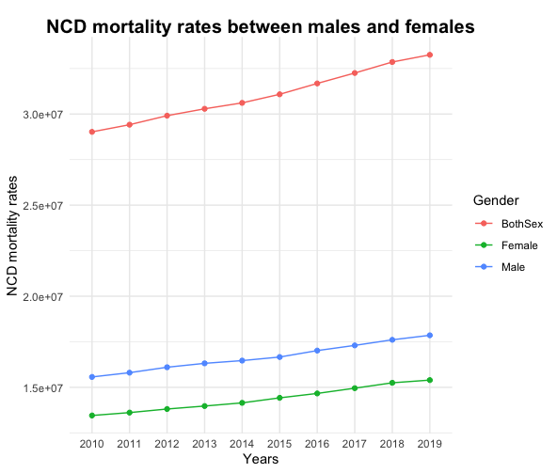

Figure 2. NCD mortality rates between males and females

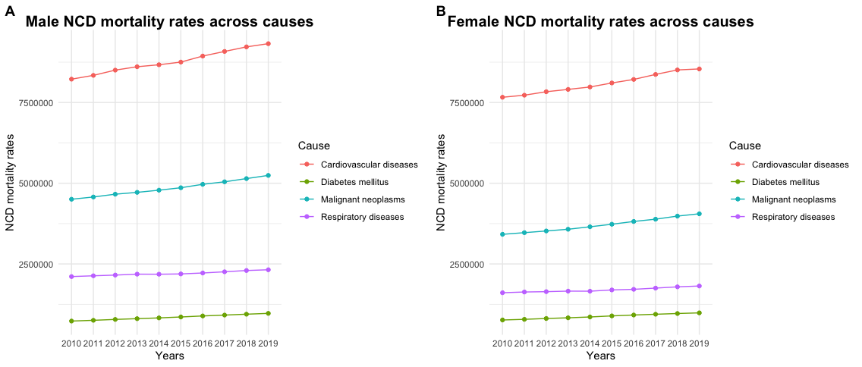

Figure 3. NCD mortality rates across disease types for both genders

Meanwhile, Our observations reveal a notable discrepancy in NCD mortality rates between males and females (Fig. 2). Understanding the underlying factors contributing to this gender-based difference is a significant aspect that warrants further investigation, providing insights in tailored preventive strategies and interventions. Additionally, the prominence of cardiovascular diseases in the landscape of NCD-related mortality for both genders is a crucial finding (Fig. 3).

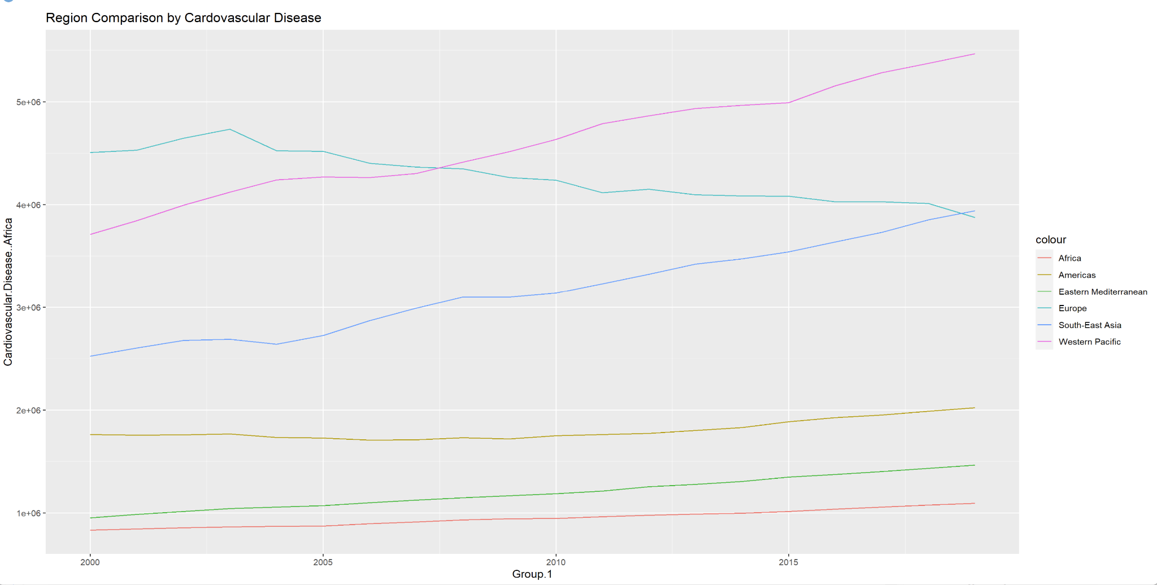

Figure 4. Cardiovascular disease mortality rates across regions

We also examined the effects of the different non-communicable diseases on the international regions, as defined by the World Health Organization. This investigation is still ongoing; however, preliminary data has shown interesting results in trends over time. For example, the data in Figure 4 shows a significant increase in cardiovascular mortality in both the Western Pacific and South-East Asia. This observation warrants further investigation into the potential causes of increased mortality as well as into measures that can be taken to prevent a continuation of this trend.

Our ongoing work is to continue working on our analysis through R, aiming to generate a more comprehensive and detailed final report and potential implications or insights from the data since knowing the nuances in NCD patterns across different demographics, regions, and over time could be essential and important. Data visualization, such as this, will allow public health officials to focus their resources on areas where there exist either major health discrepancies or concerning trends in mortality. Specifically from this data, we can see that there needs to be a concerted effort into prevention of cardiovascular disease, especially in South-East Asia and the Western Pacific, and understanding the drivers of sex based health discrepencies.

Works Cited:

*Noncommunicable diseases: Mortality*. (n.d.). Retrieved September 7, 2023, from<https://www.who.int/data/gho/data/themes/topics/topic-details/GHO/ncd-mortality>