* creare produs

Forma endpoint: {{baseUrl}}/stripe/product/createProduct

Date trimise prin request:

{

    "name" : "test_prod",

    "description" : "test description",

    "price" : 1,

    "currency" : "RON",

    "nickname" : "tst"

}

* get produse

Forma endpoint: {{baseUrl}}/stripe/product/getProducts

Date returnate prin request:

{

"error": false,

"message": "All OK",

"products": {

"object": "list",

"data": [

{

"id": "prod_ODa7j7iW4eHNeU",

"object": "product",

"active": true,

"attributes": [],

"created": 1688714373,

"default_price": {

"id": "price_1NR8x0JG50fcfdm2JAosSLpP",

"object": "price",

"active": true,

"billing_scheme": "per_unit",

"created": 1688714374,

"currency": "ron",

"custom_unit_amount": null,

"livemode": false,

"lookup_key": null,

"metadata": [],

"nickname": "tst",

"product": "prod_ODa7j7iW4eHNeU",

"recurring": null,

"tax_behavior": "unspecified",

"tiers_mode": null,

"transform_quantity": null,

"type": "one_time",

"unit_amount": 1,

"unit_amount_decimal": "1"

},

"description": "test description",

"images": [],

"livemode": false,

"metadata": [],

"name": "test_prod2",

"package_dimensions": null,

"shippable": null,

"statement_descriptor": null,

"tax_code": null,

"type": "service",

"unit_label": null,

"updated": 1688714374,

"url": null

},

....

* generare link plata

Forma endpoint: {{baseUrl}}/stripe/product/createRoadAssistanceLink

Date trimise prin request:

{

    "price" : {

                    "id": "price_1LjljYJG50fcfdm240z0RrNm",

                    "object": "price",

                    "active": **true**,

                    "quantity" : 1,

                    "billing_scheme": "per_unit",

                    "created": 1687947424,

                    "currency": "ron",

                    "custom_unit_amount": **null**,

                    "livemode": **false**,

                    "lookup_key": **null**,

                    "metadata": [],

                    "nickname": "tst",

                    "product": "prod_OAFwSQ8mffrI7n",

                    "recurring": **null**,

                    "tax_behavior": "unspecified",

                    "tiers_mode": **null**,

                    "transform_quantity": **null**,

                    "type": "one_time",

                    "unit_amount": 1,

                    "unit_amount_decimal": "1"

                },

    "allow_promotion_codes" : **false**,

    "currency" : "RON",

    "subscription_id" : 14613

}

(aici id-ul din price reprezinta id-ul produsului sau pachetului dorit)

Date returnate:

{

    "error": **false**,

    "message": "All OK",

    "url": "https://buy.stripe.com/test_8wM2bM35v9us9qM4gI"

}

* trimitere mail link de plata

Forma endpoint: {{baseUrl}}/email/sendStripePaymentEmail

Date trimise prin request:

[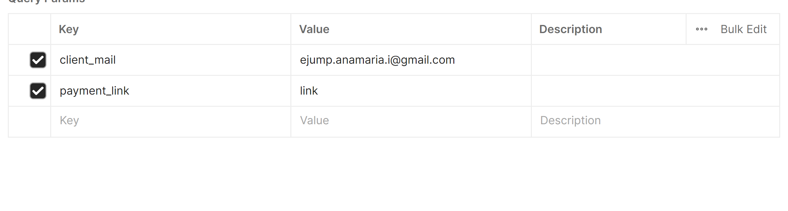](https://app.asana.com/app/asana/-/get_asset?asset_id=1205059281744321)