1. 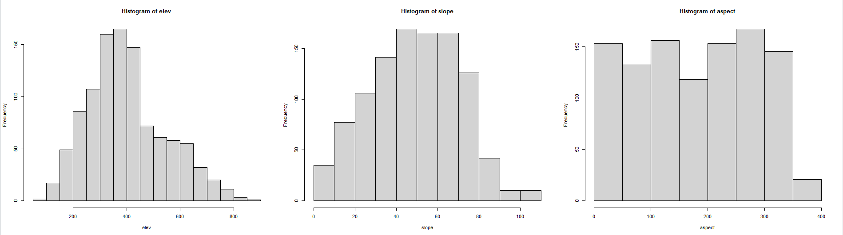Histograms
2. The histogram shows that most of the sampling sites were lower in elevation. Sites between 350 and 400 meters had the highest frequency, closely followed by sites between 300 and 350 meters. The data is not evenly distributed as the counts for the upper elevations, a larger range, are much more similar and flatter in distribution than the counts below 400m which climb more steeply. There is also a steeper drop in the number of counts after a 450 meters and the numbers stay low, whereas the numbers slowly build from zero to 400m.
3. The units of “slope” in this data set are measures of slope percentage. Slope percentage is a metric calculated from the rise and run (height over length) of the slope face which calculates a percentage, or grade of steepness. The data does not indicate what unit was used to calculate grade, it simply shows the resulting percentage calculation.
4. Most of the sample sites are not flat, and the percentage of the slope ranges from 0 to over 100 degrees. The slopes are similarly distributed to the elevation data, with the most counts in the middle categories from 40 to 65 percent slope. There are more counts of flatter slopes, but far fewer counts of steeper slopes. The majority of the data is centered in the middle of the range. On slopes very 65 degrees the counts drop more sharply than they do on counts lees than 45 degrees, and the pattern continues to either end of the data set. This indicates that the majority of testing sites were mild to moderately sloped.
5. Aspect is a measure of the direction a slope faces. It operates like a compass, staring with north at zero degrees, 90 degrees is east, south is 180, west is 270, and back to north at 0/360. The use of numbered degrees provides a much more precise measurement than using the cardinal directions alone.
6. The distribution of aspect was relatively evenly distributed, there were a similar number of testing sites on most every direction. The final column of the histogram appears to be uneven, but in fact in only represents 10 degrees of possible directions instead of 50 like the other categories, so it is not so much of an outlier. The majority of sites were in a W/SW direction, but not by much as N/NE and SE were close behind.
7. 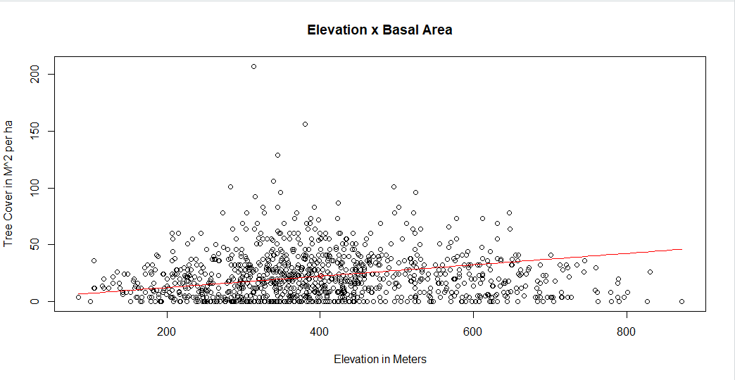­­

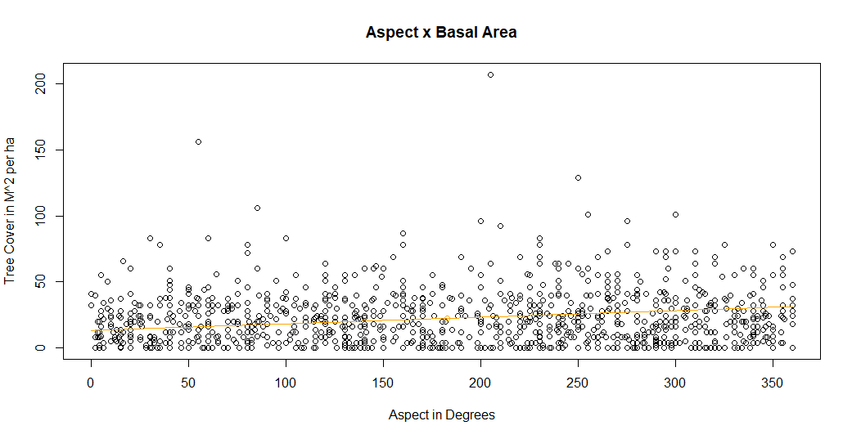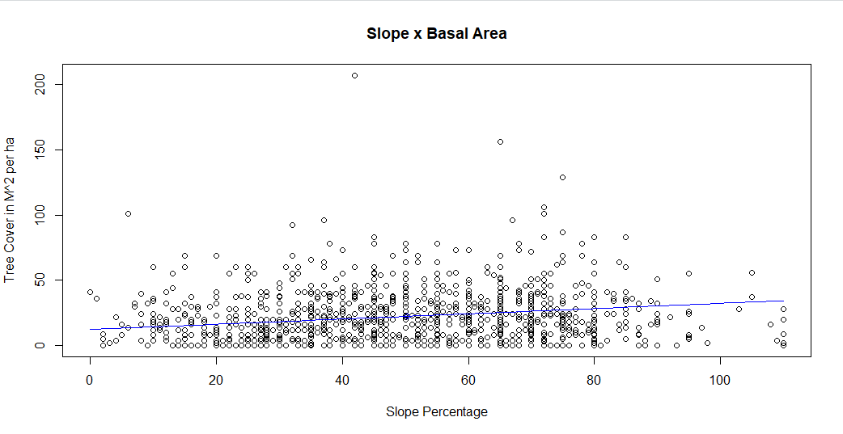

* 1. For elevation, I did not notice a clear association with tree cover. There is a slight density on the left half of the graph, but it reflects the look of the data on the right, just more heavily populated. My linear model is a pretty good fit for the data, but as there’s not much association, it’s tough to find a best fit line.
  2. For slope, there’s again not much association, but there is a very slight increasing trend of higher tree cover at slopes with steeper grades. A better fitting line might be sort of low power function to account for this slight increase.
  3. Again, for aspect, there is not much noticeable association between the two variables. The distribution of tree cover remains very similar across all slope direction. A best fit line, like the one I did, would likely be linear to show that there is very little association between the factors.