1. *What type of data is contained in the variable a?*
   1. Variable a contains text so it is a character data type.
2. *What type of data is contained in the variable b1?*
   1. Variable b1 is a numeric data
3. *What type of data is contained in the variable b2?*
   1. Variable b2 is a string so it is character data.
4. *What happens when you add b1 and b2 and why?*
   1. You would result in an error, adding two different types of data, numeric and character.
5. *Are the variables b1 and c1 of the same type?*
   1. B1 and c1 are both numeric data types, c1 is an integer set of values.
6. *Explain what happens when you add b1 and c1. Consider both the number of elements in each variable and the data types*.
   1. You will end up with 4 numeric values, the value of b1 added to each integer in c1, so (45.6, 46.6, 47.6, 48.6).
7. *Show the R code you used to create v1.*
   1. > v1 = c(-2:2)
8. *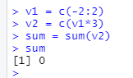Show the R code you used to create v2*.
   1. > v2 = c(v1*3)
9. *Show the R code you used to calculate the sum of elements in v2*.
   1. > sum = sum(v2) and >sum
10. 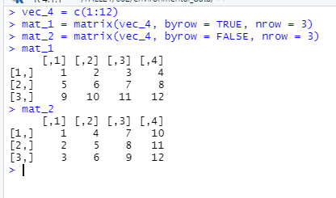*Show the code you used to create mat_1.*
11. *Show the code you used to create mat_2.*
12. *Show the R code you used to create my_list_1.*
13. 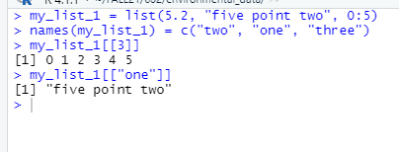*Show the R code that would select third element of the list.*
14. *Show the R code that selects the list element with the name “one”.*
15. *Show the R code that you used to create my_bool_vec.*
    1. 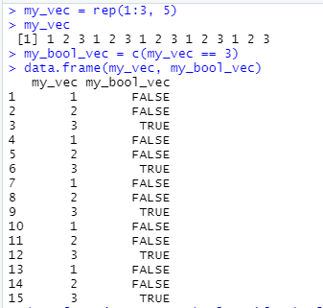
16. *Show the R code that you used to perform the subsetting.*
    1. **