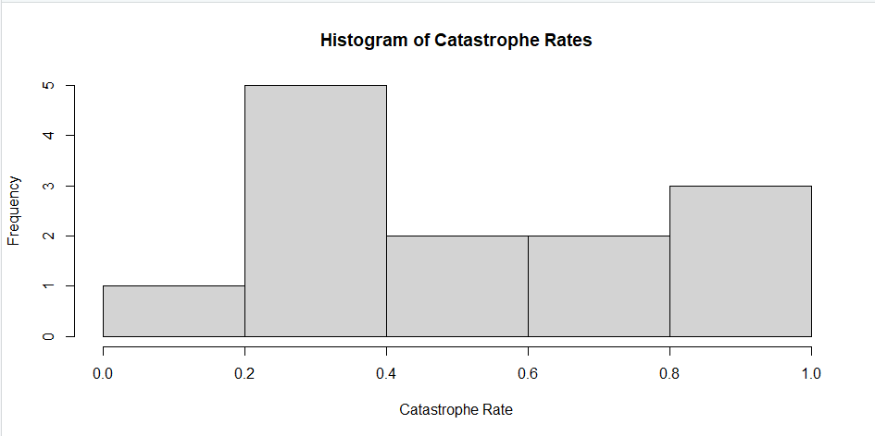

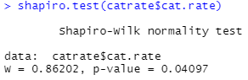

1. The null hypothesis for the Shapiro test is that the data was sampled from a normal distribution.
2. The p-value is less than the standard alpha of 0.05 so there is strong evidence to reject the null, so there is strong evidence that the data came from a non-normal distribution.

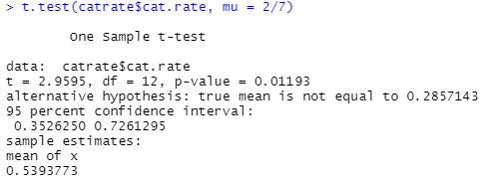

1. The null hypothesis is that there is no difference between the catastrophic rate and the pond late-filling rate.
2. This is a two-tailed t-test because we are looking for a difference, not necessarily a sided (greater/less than) difference.
3. The p-value form the test is .01193. If this was a false positive rate, then this would mean that in one out every 100 experiments (~1%) you would have a false positive value.
4. The confidence interval was a 95% interval from 0.353 to 0.726 the interval does not include 0.
5. From the t-test, there is evidence to reject the null because the p-value is less than the standard of 0.05, but it is not so much less so the evidence is definitely present, but not that strong.

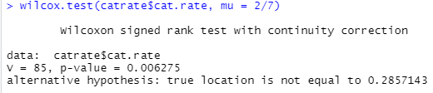

1. P-value for Wilcoxon = 0.006275, P-value for T-test = .01193. Both values are less than alpha (.05), but the value for the Wilcoxon test is an order of magnitude smaller than the T-test value.
2. In this case there is strong evidence to reject the null hypothesis because the p-value is much smaller than the established value of alpha (.05).
3. In both cases, we reject the null because the p-values are smaller than the alpha of .05. For the t-test this means that there is a difference between the observed catastrophe rate and catastrophe rate specifically from late pond-filling. In the Wilcoxon test, this means that there is also a difference between the two, but this time it accounts for the fact that the sample is not normally distributed.
4. I think that the Wilcoxon test is more appropriate for this data set. Both the histogram and the Shapiro test indicate that the data is not normally distributed, so the Wilcoxon test is adjusted for the non-normality.

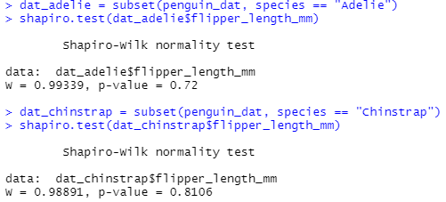

1. The p-values in both cases are greater than the standard alpha of .05 so this means that we do not have sufficient evidence to reject the null. The null hypothesis being that the data came from a normally distributed population.

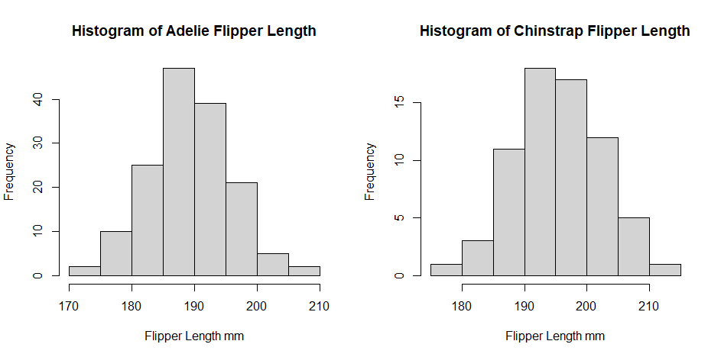

1. The alternative hypothesis is that there is a difference in flipper length between the two penguin species.

