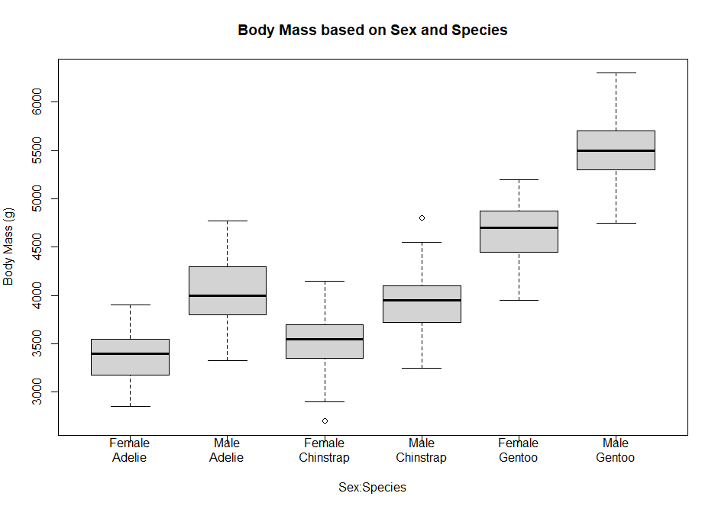

1. Looking at the box plots, it does look like in every species, the male penguins are heavier than the females. The means for each are higher, as well as the spread of values within the box.
2. I do think adding sex to the model will produce a better fit. In the case of Gentoo penguins, the difference between the sexes is significant, as well as the difference between male and female Gentoo. For Adelie and Chinstrap the differences between sexes and species are not as dramatic, but definitely present based on visual analysis of the plot. If the model accounted for the difference at hand, it would definitely improve predictions.
3. 
4. The base case for this model is Female Adelie penguins, represented by the intercept in the summary table.
5. To calculate the average body mass of a female chinstrap, you need the coefficients for “(Intercept)” which stands for female, and then “speciesChinstrap” to designate species.
6. The predicted average body mass is for Female Chinstrap is 3368.84 + 158.37 = 3527.21 grams.
7. The observed average mass of Female Chinstrap is 3527.206 grams.