1. In the scenario, perhaps it is observed that seeds of one species are disappearing at a different rate than the other, so researchers want to know if this is a statistically significant event. It could just be random chance that the difference is noticed, or it could be that the predator prefers one of the seed types, so running a hypothesis test will help answer this question. In this case the null hypothesis would be that seed predation does not differ between the two species.
2. 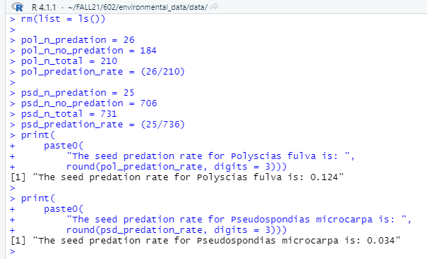

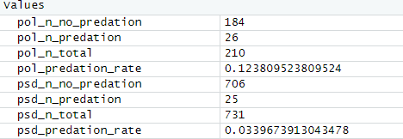

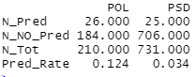

2. The seed ratios would be the total number adjusted for predation, so it would be the two predation rates: .124/.034 = 3.62. If there was no difference in the rates, they would be equal and the ratio would equal 1.