Example

David

## Esto es TExto

Sys.time()

## [1] "2024-05-24 10:07:52 -03"

Lalala

plot(BASE)

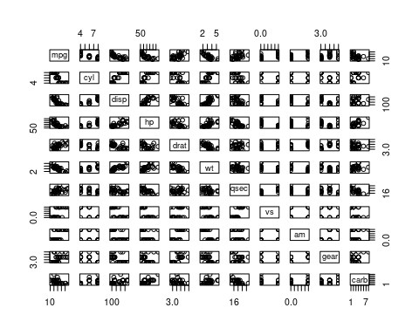

# Aislamos una variable en particular de la base de datos.  
VR <- BASE[,selected_var_pos]  
VR

## [1] 21.0 21.0 22.8 21.4 18.7 18.1 14.3 24.4 22.8 19.2 17.8 16.4 17.3 15.2 10.4  
## [16] 10.4 14.7 32.4 30.4 33.9 21.5 15.5 15.2 13.3 19.2 27.3 26.0 30.4 15.8 19.7  
## [31] 15.0 21.4

# Media  
mean(VR)

## [1] 20.09062

# Mediana   
median(VR)

## [1] 19.2

# Minimo  
min(VR)

## [1] 10.4

# Maximo  
max(VR)

## [1] 33.9

# Cantidad de Datos  
length(VR)

## [1] 32

# Varianza  
var(VR)

## [1] 36.3241

# Desvio Estandard  
sd(VR)

## [1] 6.026948

# Summary  
summary(VR)

## Min. 1st Qu. Median Mean 3rd Qu. Max.   
## 10.40 15.43 19.20 20.09 22.80 33.90

# Objeto MEDIDAS  
MEDIDAS <- summary(VR)  
MEDIDAS

## Min. 1st Qu. Median Mean 3rd Qu. Max.   
## 10.40 15.43 19.20 20.09 22.80 33.90

# Solo algunas MEDIDAS  
MEDIDAS[c(2,3,5)]

## 1st Qu. Median 3rd Qu.   
## 15.425 19.200 22.800