How2Run:
First we can compile our program while it is in the same folder with books.csv:
g++ -Wall -Werror assg1.cpp -I include -o assg1 -lm

We can run it with this:
./assg1

Statistics:

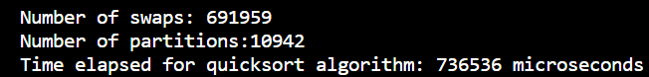

Best case for the quick sort algorithm is T(n) = T(n/2) + T(n/2) + cn, when every split is even. By master theorem, best case running time is

