COLLEGE OF COMPUTING AND INFORMATICS
CSEB5133 DATA VISUALIZATION PROGRAMMING
SEM 2 2025/2026

LAB 1: DATA PREPROCESSING AND CLEANING

Objectives
Introduction to data preprocessing and cleaning using Tableau Prep Builder.

Instruction
- This is an individual lab exercise.
- You are compulsory to complete ALL QUESTIONS.
- Submit all the files, docx (Lab Question), Tableau Desktop (<yourIDno>.twbx) via Brighten.
- Submission deadline: End of lab session.

STEPS
- Download the dataset from Brighten. Filename: Student_dataset
- Using Tableau Prep Builder software:
- Perform connection to the dataset.
- Cleaning the dataset.
- In Tableau Prep Builder: i) Connect to the dataset. ii) Begin cleaning the data. iii) Create a new calculated field named Course based on the Student ID. Hint: The first two characters of the Student ID represent the course code.
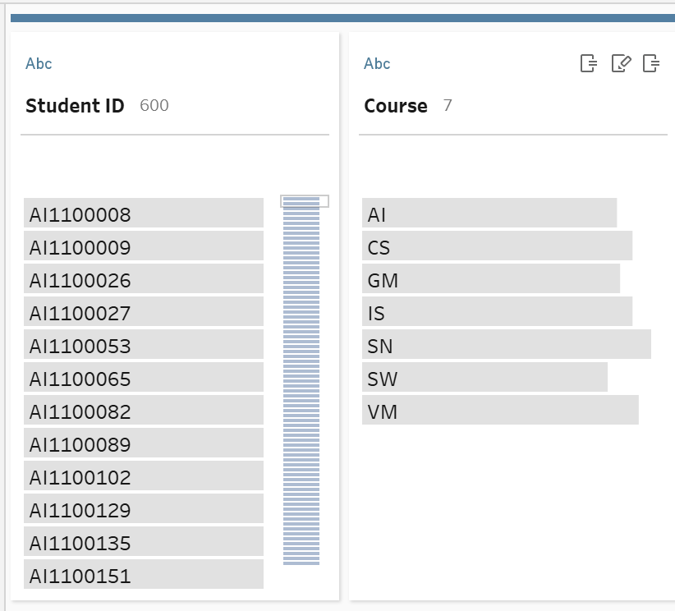

- Review the remaining fields and remove any fields that are unnecessary.
- Generate the output file and complete the data preparation process.

- Using Tableau Desktop software, generate a graphical representation to demonstrate your analysis on the following:

LEVEL: EASY
Question 1
Students Status Analytics
Create a pie chart to visualize student distribution by status.
- Which status category has the highest number of students?
[2 marks]
2nd class lower
- What percentage of students are classified as 1st class?
[3 marks]
23.50%
LEVEL: MODERATE
Question 2
Funding Analysis
- Identify the top three (3) courses with the highest number of students receiving scholarships.
[5 marks]
SN, CS, AI
- Which funding type has the highest number of students classified as Under Monitoring?
[5 marks]
Self-Sponsored
Question 3
Course Performance Comparison
- Which course demonstrates the strongest overall academic performance? Justify based on the distribution of Status?
[4 marks]
VM demonstrates the strongest overall academic performance, as it records the highest number of students achieving First Class status. Furthermore, the majority of VM students fall within the Second Class Lower and above categories, indicating that their academic achievement is consistently strong.
- Which course has the highest number of students under monitoring?
[2 marks]
IS
- Identify one course where 2nd class upper students dominate over other categories.
[2 marks]
SN
- Compare SN and SW. Which program demonstrates stronger academic outcomes?
[2 marks]
1st class: SN > SW
2nd class lower: SW > SN
2nd class upper: SN > SW
Under monitoring: SN > SW
Overall, SN shows stronger academic performance compared to SW, as it leads in three academic classifications, whereas SW only leads in the Second Class Lower category.

