Dale Livingston II

10/18/2026
SDC330
2.6 Course Project: Application Design

Table of Contents
Updated Project Proposal 3
Project Overview 3
Purpose 3
Application Design 3
User Interaction and Output 3
Data Storage 4
Class definitions 4
Customer class 4
Loan Class 5
PersonalLoan Class 5
LoanApplication Class 6
LoanDatabase Class 6
App Class 7
Class Relationships 8
UML diagram 8
Database design - SQLite 9

Updated Project Proposal

Project Overview
For my Java project, I will create a Loan Application Management System that allows customers to enter their personal and financial information to apply for a loan. The application will collect information such as customer’s name, annual income, credit score, requested amount, and loan term.
The program will use this information to determine if the customer meets the initial requirements for a loan. It will also calculate interest rate and monthly payment. The results will be displayed to the user in terminal.

Purpose
The purpose of this application is to make the loan application process easier by allowing customers to enter their information and receive a decision. Instead of manually reviewing the loan information, the program will check the customer’s income and credit score against the requirements established in the application.

Application Design
The application will use Java classes to organize the different parts of the program. The Customer class will store customer information, while the Loan class will contain the requested loan amount, term, and interest rate.
The PersonalLoan class will extend Loan to demonstrate inheritance. The LoanApplication class will use Customer and Loan objects to demonstrate composition.
The application will also use a LoanDatabase class to handle storing and retrieving information from SQLite.

User Interaction and Output
The user will interact with the application through a menu displayed in the terminal. The menu will allow the user to create a new loan application, view existing applications, update information, delete applications, and exit the program.
After submitting a loan application, the program will display the customer’s name, requested loan amount, loan term, estimated interest rate, monthly payment and applications status.
If the customer does not meet the requirements, the application will display a reason for the denial, such as a low credit score of insufficient income.

Data Storage
The application will use a SQLite database to store customer and loan application information. The database will contain three tables: Customers, Loans, and LoanApplications.
The Customers table will store personal and financial information. The Loans table will store the loan amount, term, interest rate, and loan type. The LoanApplications table will connect the customer and loan records and store the application status.
Using SQLite will allow users to create, view, update, and delete loan applications without losing the information when the program closes.

Class definitions

Customer class
purpose: The customer class will store the personal and financial information provided by the customer when applying for a loan.
Properties:
- customerID int
- name string
- annualIncome double
- creditScore int
Methods:
- Customer() – constructor that initializes the customer information
- getName() – Returns the customer’s name
- getAnnualIncome – Returns the customer’s annual income
- getCreditScore() – Returns the customer’s credit score.
- setAnnualIncome – Updates the customer’s annual income
- setCreditScore() – Updates the customer’s credit score
Special considerations: Properties will be private, and public getter and setter methods will allow the application to access and update customer information.

Loan Class
Purpose: The Loan class will store the requested loan information and calculate the estimated monthly payment.
Properties:
- loanAmount double
- loanTerm int
- interrestRate double
Methods:
- Loan() – Constructor that initializes the loan information
- getLoanAmount() – Returns the requested loan amount
- getLoanTerm() – Returns the loan term in months
- gerInterestRate() – Returns the estimated annual interest rate
- calculateMonthlyPayment() – Calculates the estimated monthly payment based on the loan amount, interest rate, and loan term
Special Considerations: The Loan class will be the parent class for personal Loan class type. The class will use private properties and public methods. The monthly payment calculation will be used to provide customers with an estimated payment amount.

PersonalLoan Class
Purpose: The PersonalLoan class will extend the Loan class and represent a personal loan.
Properties:
- Inherits loanAmount, loanTerm and interestRate from Loan.
Methods:
- PersonalLoan() – Constructor that initializes the personal loan information
- calculateMonthlyPayment() – Overrides the method from the Loan class to calculate the monthly payment.
Special Considerations: This class will demonstrate inheritance and polymorphism. The PersonalLoan class will inherit the properties and methods of the Loan class and override the monthly payment method.

LoanApplication Class
Purpose: The LoanApplication class will connect the customer’s information with the requested loan and determine whether the customer meets the initial loan requirements.
Properties:
- applicationId int
- customer Customer
- loan Loan
- status String
Methods:
- LoanApplication() – Constructor that initializes the application information
- checkEligiblity() – Checks whether the customer meets the loan requirements
- getDecisionReason() – Returns the reason for an approval or denial
- getStatus() – Returns the current application status
- getApplicationSummary() – returns formatted loan information, including the customer name, loan amount, loan term, estimated interest rate, monthly payment, and application status.
Special Considerations: This class will demonstrate composition because it contains Customer and Loan objects. It will use the customer’s annual income and credit score to determine initial eligibility. The getApplicaitonSummary() method will format the results so they can be displayed in the CLI.

LoanDatabase Class
Purpose: The LoanDatabase class will handle communication between the Java application and the SQLite database.
Properties:
- connection Connection
Methods:
- connect() – Establishes a connection to the SQLite database.
- saveApplication() – Saves a new loan application
- getApplications() – Retrieves stored loan applications
- updateApplication() – Updates an existing loan application
- deleteApplication() – Deletes a loan application
Special Considerations: This class will handle the database operations separately from the application logic. It will use SQLite to store customer and loan information so users can create, view, update, and delete application.

App Class
Purpose: The App class will be the main class that runs the Loan Application Management System and provides the CLI menu
There are no properties
Methods:
- main() – Starts the application
- displayMenu() – Displays the available menu options to the user.
Special Considerations: The App class will use the Java Scanner class to receive the user input and System.out.println() to display information in the terminal. The menu will allow users to create new loan applications, view existing applications, update information, delete applications, and exit the program.

Class Relationships
Concept | Classes | Description
Inheritance | Loan -> PersonaLoan | PersonalLoan extends Loan
Polymorphism | Loan and PersonalLoan | PersonalLoan overrides calculateeMonthlyPayment()
Composition | LoanApplication, Customer, Loan | LoanApplication contains Customer and Loan objects
Encapsulation | All data classes | Private properties with public methods to access or update data
Database | LoanDatabase | Manages SQLite operations
CLI | App | Handles user input and displays information

UML diagram
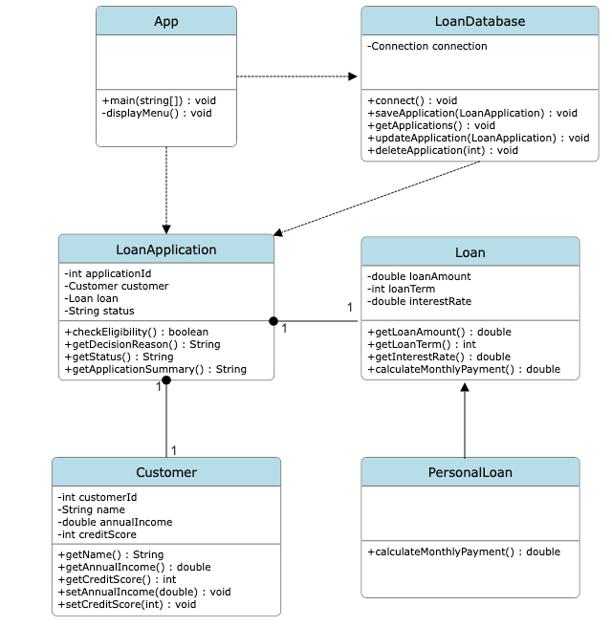

Database design - SQLite
Customers
Field | SQLite type | Description
Customer_id | Integer Primary Key | Unique customer ID
Name | Text | Customer’s name
Annual_income | Real | Annual income
Credit_score | Integer | Credit Score

Loans
Field | SQLite type | Description
Loan_id | Integer Primary Key | Unique loan ID
Loan_amount | Real | Requested loan amount
Loan_term | Integer | Loan term in months
Interest_rate | Real | Estimated annual interest rate
Loan_type | Text | Type of loan

LoanApplications
Field | SQLite type | Description
Application_id | Integer Primary Key | Unique application ID
Customer_id | Integer | Foreign key to Customers
Loan_id | Integer | Foreign key to Loans
Status | Text | Approved or denied
Decision_reason | Text | Explanation of decision

