Locate the SMARTGlove folder

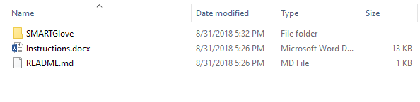

Navigate to the SmartGlove.unity file by opening SMARTGlove -> Assets -> Scenes -> SmartGlove.unity

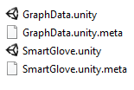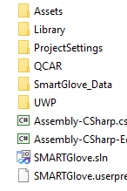 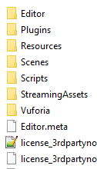

Open SmartGlove.unity by double clicking on the file. A unity loading screen should popup.



When Unity finishes opening you should see a screen like this

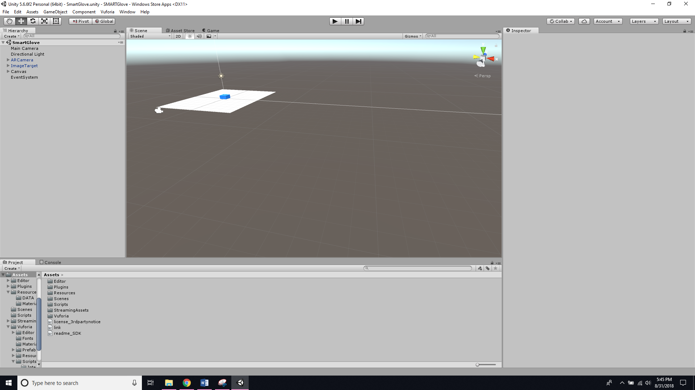

Press the play button located at the top center of the screen



Now you should see a screen like the one below

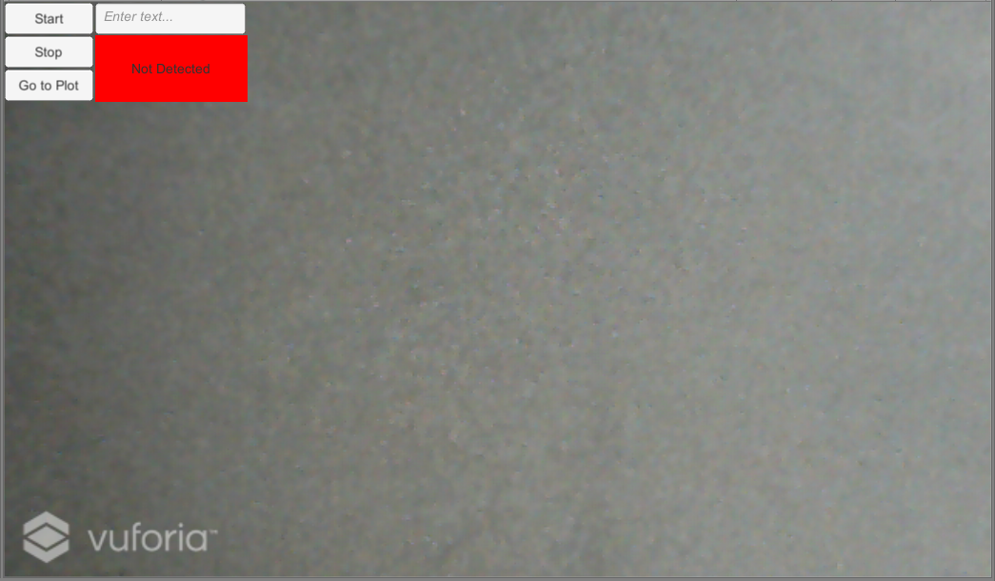

Secure the image target on your arm or the patients arm using the Velcro straps.

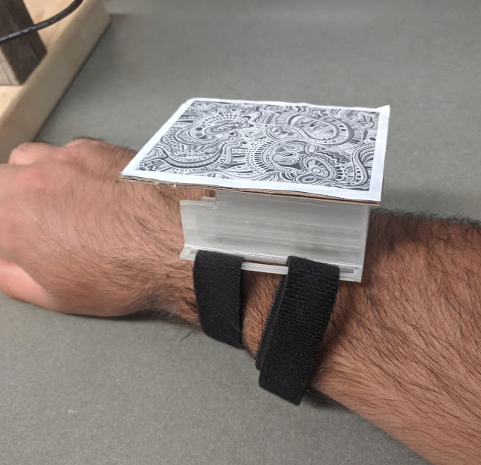

Align the image target on the left side of the screen. When the image target is detected, a blue box will display, and the detection box will turn green.

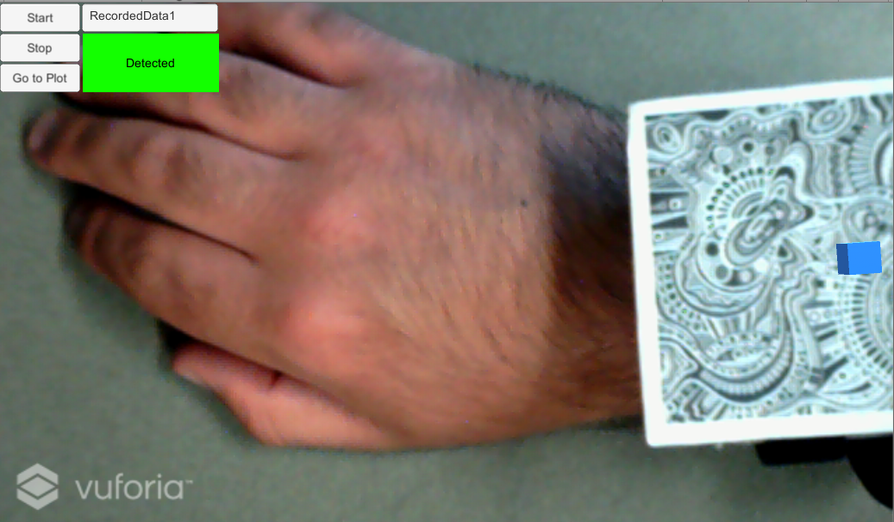

Enter in a filename in the text field and press start.

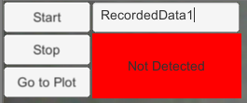

When you have finished recording data press the stop button

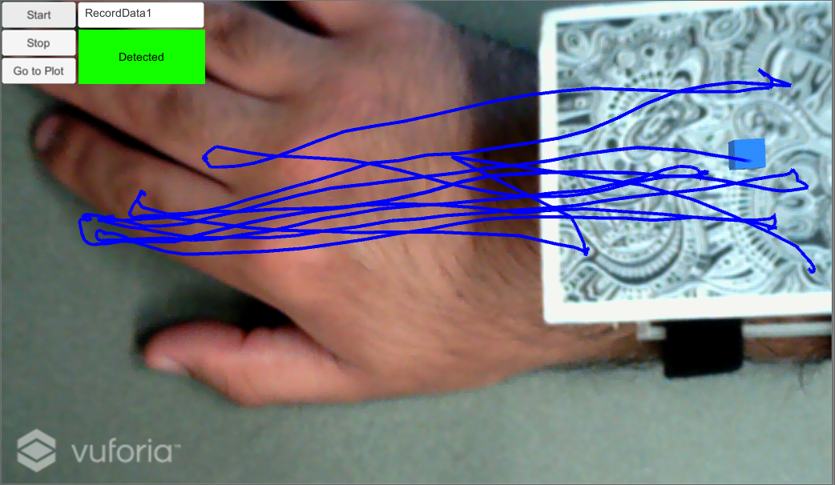

To see a plot of the data, press the go to plot button



Now you should be loaded into the graph screen as show below

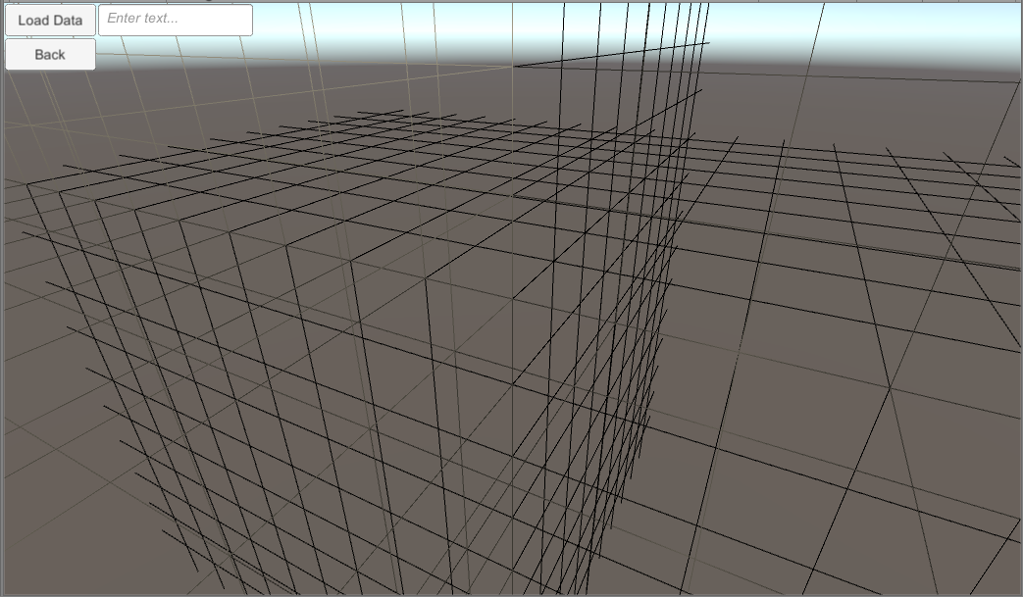

Enter the name of your file and press load data to plot it



The graph will now plot the users hand position along the axis.

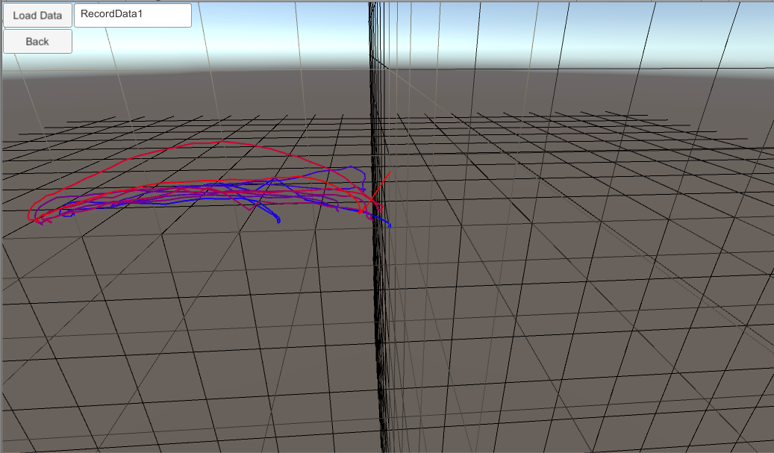

This concludes the instructions for using the Unity Smart Glove Program