**Azure Blueprints**

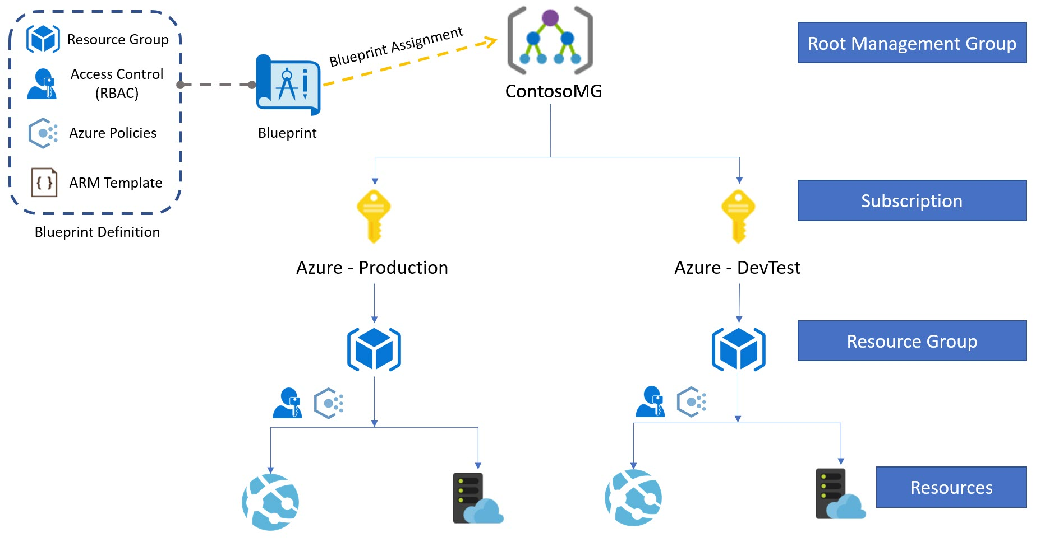

**Task 1: Add Reader User**

**Task 2: Create Blueprint Definition**

**Task 3: Assign Blueprint to Management Group**

**Task 4: Verify Blueprint Resources**

**Task 1: Add Reader User**

**Step 1:** Open **Microsoft Azure Portal**

<https://portal.azure.com>

**Step 2:** Select **Azure Active Directory**

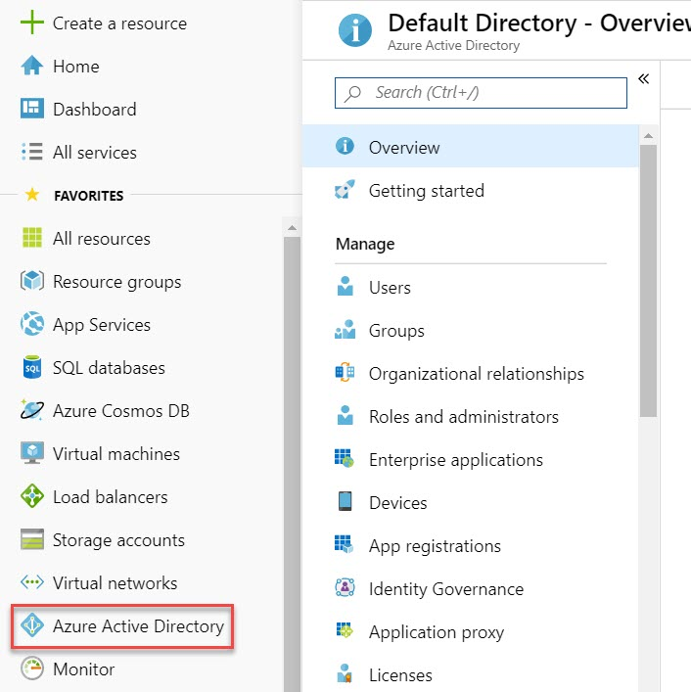

Click on **Users**

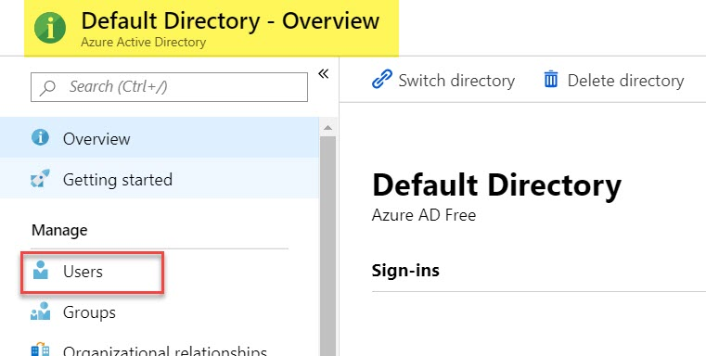

**Step 3:** Click on **+ New User**

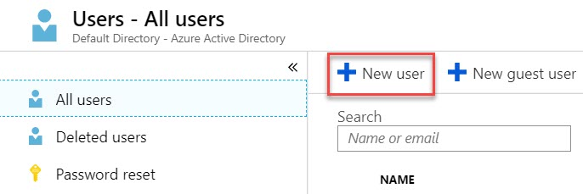

**Step 4:** Create New User

Name: **reader**

Username: [**reader@tenantname.onmicrosoft.com**](mailto:reader@tenantname.onmicrosoft.com)

Directory Role: **User**

Password: **Show Password** & Copy Password in Notepad

Click on **Create** button

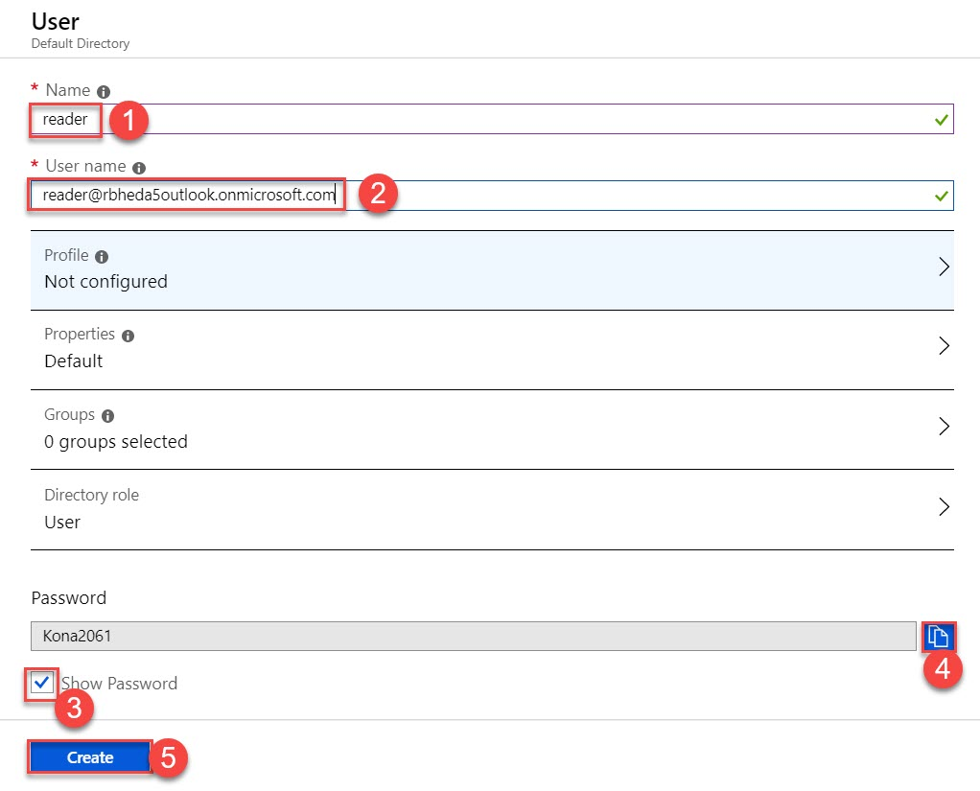

**Task 2: Create Blueprint Definition**

**Step 5:** Create Blueprint

**All Services** -> search for “**blueprint**” -> Click on **Blueprints**

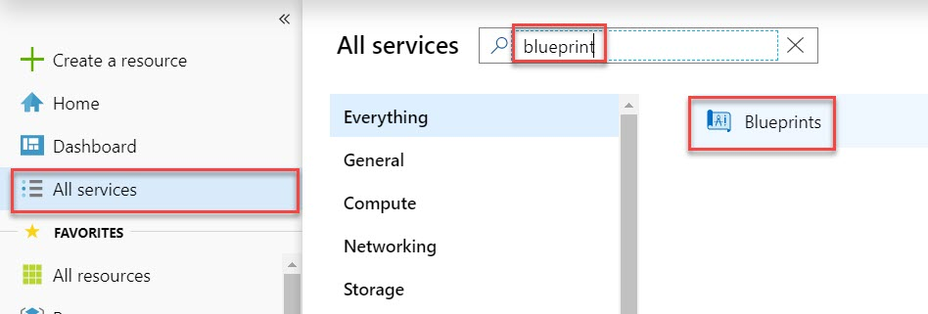

**Step 6:** First Select **Blueprint definitions** & click on **+ Create blueprint**

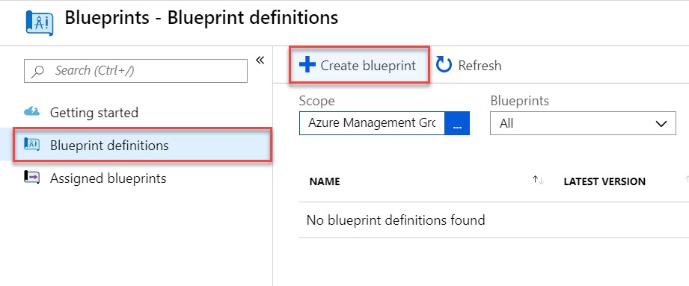

**Step 7:** Choose **Blank Blueprint**

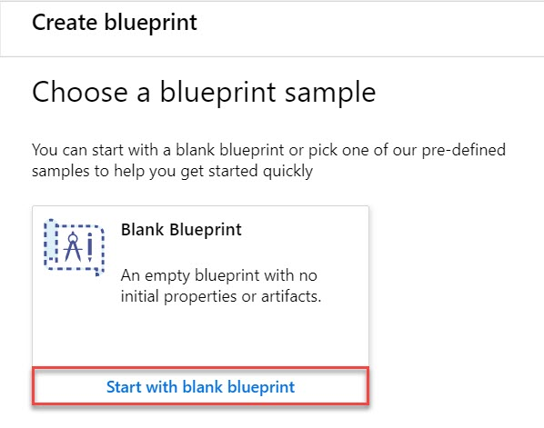

**Step 8:** Create Blueprint

Blueprint name: **MyBlueprint**

Definition location: Click on **Browse** option

Select Management Group: **Azure Management Group1 (ContosoMG)**

Click on **Select** button.

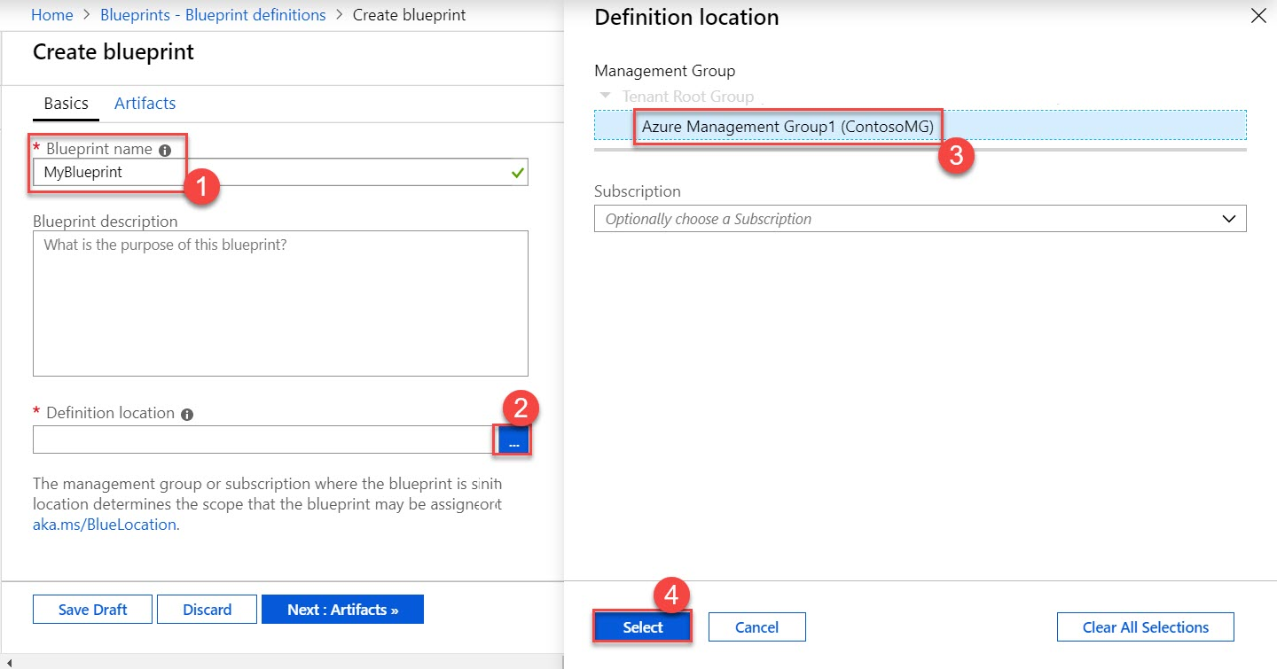

Click on **Next Artifacts >>** button.

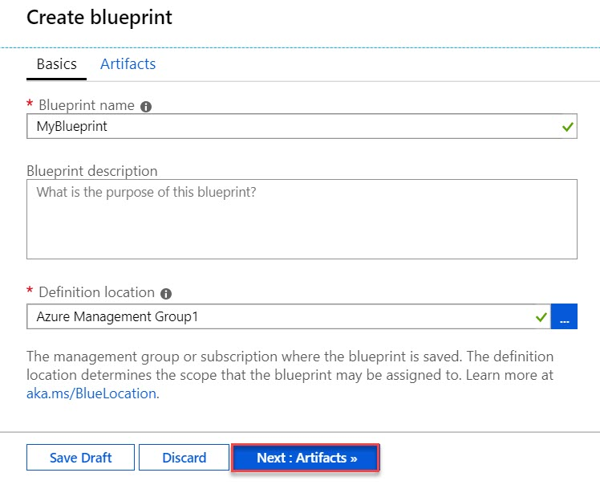

**Step 9:** Artifacts option will be there

Click on **+ Add artifact…**

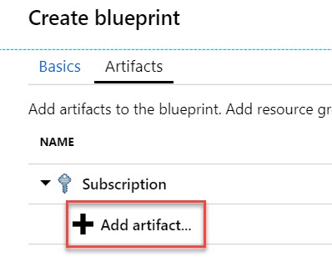

Artifact type: **Resource Group**

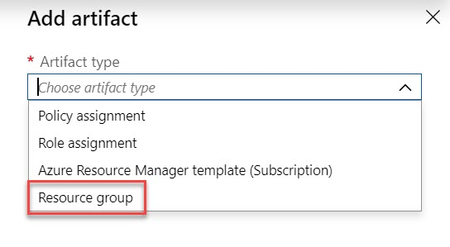

**Step 10:**

**Uncheck Resource Group** option

Enter Resource Group Name: **MyRG**

**Uncheck Location** option

Choose Location: **Southeast Asia**

Click on **Add** button

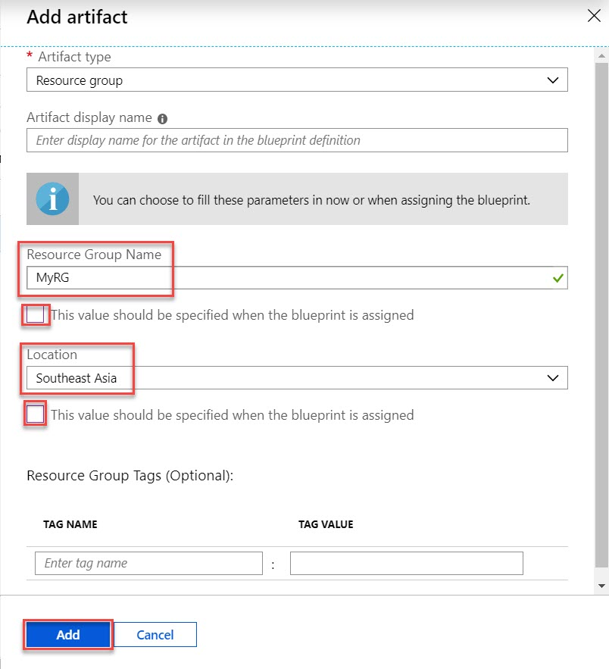

**Step 11:** Click on **Add artifact….**

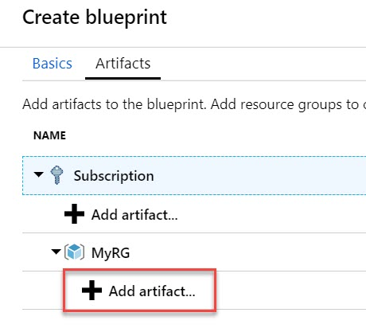

**Step 12:** Select Artifact: **Role Assignment**

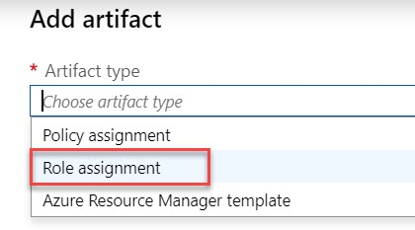

Role: **Reader**

**Uncheck Add User** option

Type **reader** and **select email id from drop-down menu**

Click on **Add** button.

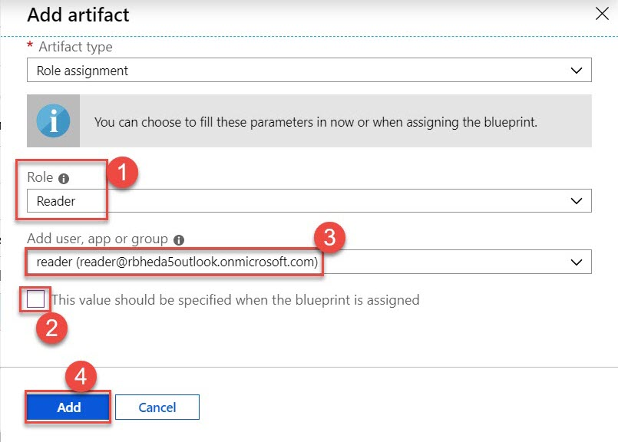

**Step 13:** One more time click on **+ Add artifact…**

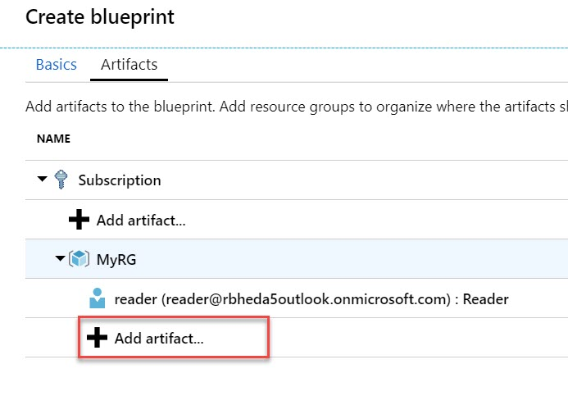

**Step 14:** Add Artifact: **Policy assignment**

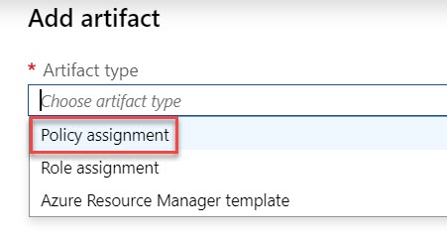

Search for “**location**” and select **Allowed locations**

Click on **Add** button.

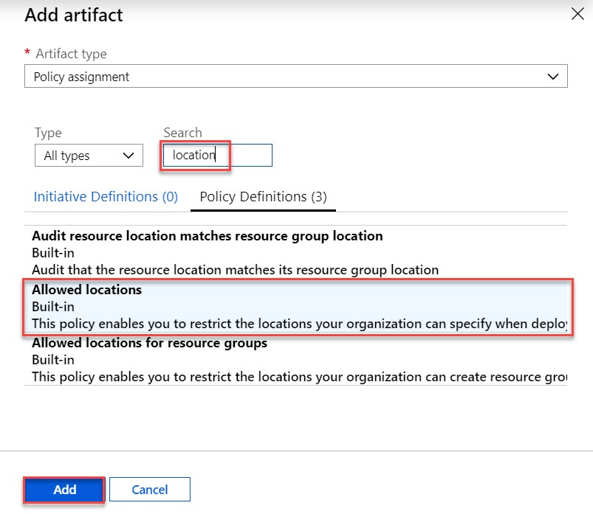

**Step 15:** Click on **Allow location artifacts**

**Uncheck Allow Location** option

Select Allowed Location: **Southeast Asia**

Click on **Save** button.

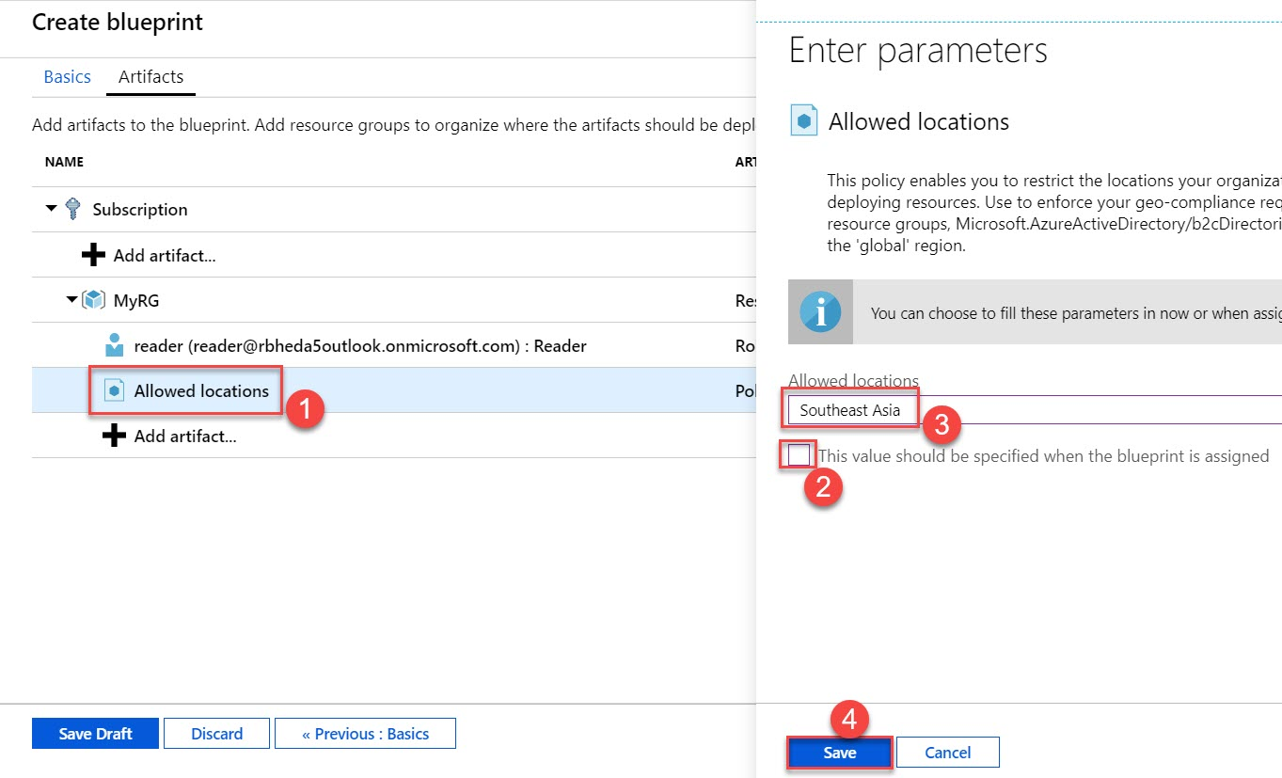

**Step 16:** Click on **+ Add artifact…**

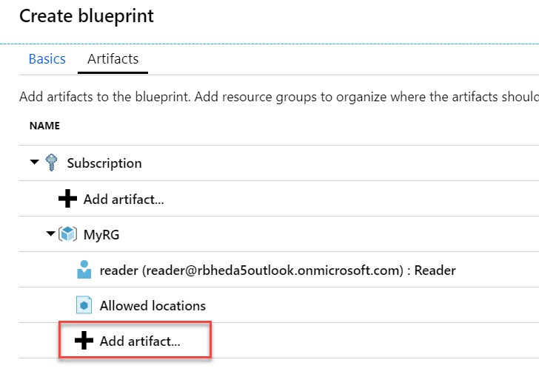

**Step 17:** Add artifact

Artifact type: **Azure Resource Manager template**

Artifact display name: **Create Sample Web App**

Template: **Copy-Paste below Code**

Click on **Add** button.

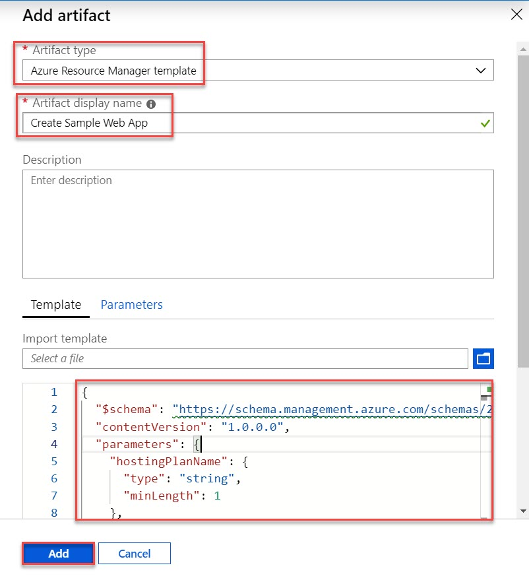

{

"$schema": "https://schema.management.azure.com/schemas/2015-01-01/deploymentTemplate.json#",

"contentVersion": "1.0.0.0",

"parameters": {

"hostingPlanName": {

"type": "string",

"minLength": 1

},

"skuName": {

"type": "string",

"defaultValue": "F1",

"allowedValues": [

"F1",

"D1",

"B1",

"B2",

"B3",

"S1"

],

"metadata": {

"description": "Describes plan's pricing tier and capacity. Check details at https://azure.microsoft.com/en-us/pricing/details/app-service/"

}

}

},

"variables": {

"webSiteName": "[concat('webSite', uniqueString(resourceGroup().id))]"

},

"resources": [

{

"apiVersion": "2015-08-01",

"name": "[parameters('hostingPlanName')]",

"type": "Microsoft.Web/serverfarms",

"location": "[resourceGroup().location]",

"tags": {

"displayName": "HostingPlan"

},

"sku": {

"name": "[parameters('skuName')]"

},

"properties": {

"name": "[parameters('hostingPlanName')]"

}

},

{

"apiVersion": "2015-08-01",

"name": "[variables('webSiteName')]",

"type": "Microsoft.Web/sites",

"location": "[resourceGroup().location]",

"tags": {

"[concat('hidden-related:', resourceGroup().id, '/providers/Microsoft.Web/serverfarms/', parameters('hostingPlanName'))]": "Resource",

"displayName": "Website"

},

"dependsOn": [

"[resourceId('Microsoft.Web/serverfarms/', parameters('hostingPlanName'))]"

],

"properties": {

"name": "[variables('webSiteName')]",

"serverFarmId": "[resourceId('Microsoft.Web/serverfarms', parameters('hostingPlanName'))]"

}

}

]

}

**Step 18:** After adding all Artifacts, Click on **Save Draft** button.

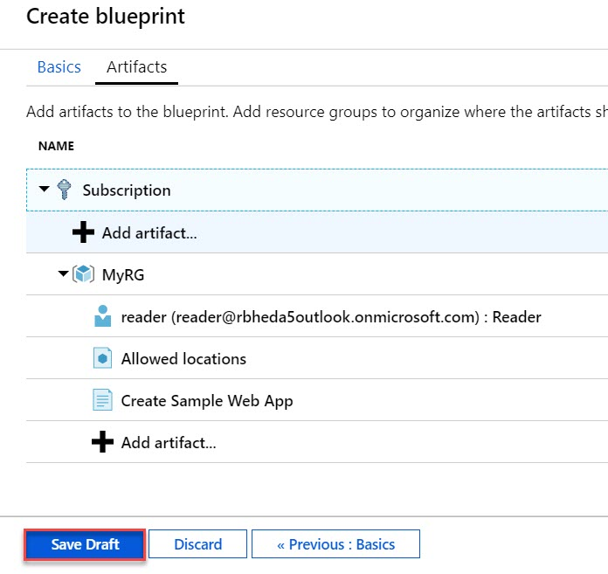

**Step 19:** Recently created **MyBlueprint** available under **Blueprint definitions**.

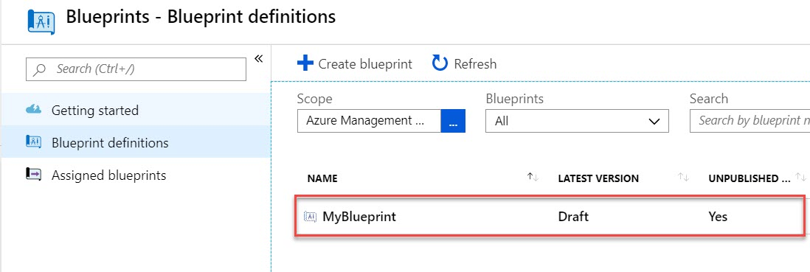

**Step 20:** Time to Publish this Blueprint

Click on **Publish blueprint**.

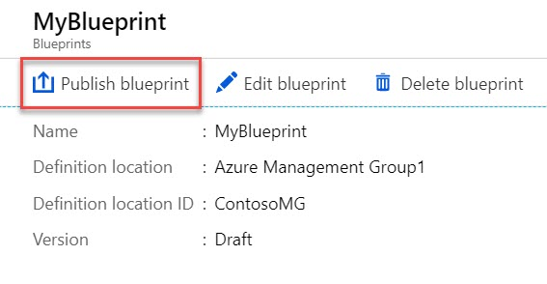

**Step 21:** Enter version: **1.0**

Click on **Publish** button.

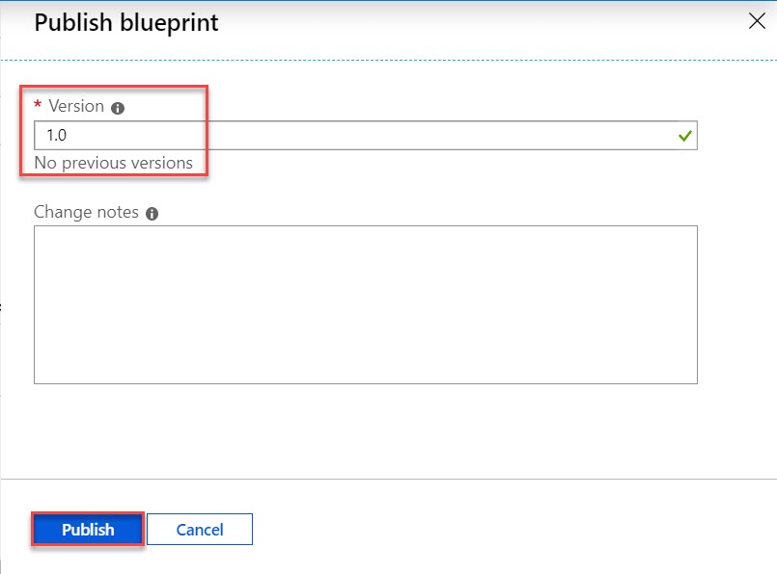

**Task 3: Assign Blueprint to Management Group**

**Step 22:** Now Assign this Blueprint.

Click on **Assign blueprint** option

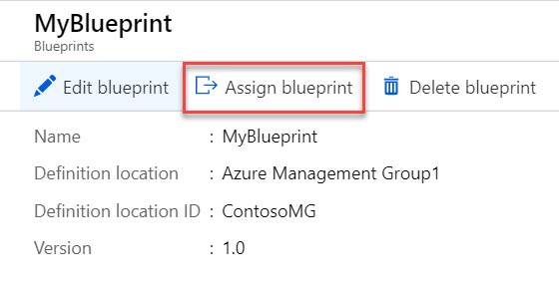

**Step 23:** First select **Azure Subscription** wherever you want to assign this blueprint

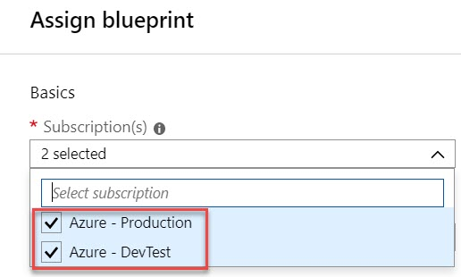

Assignment name: **Assignment-MyBlueprint**

Location: **Southeast Asia**

Blueprint definition version: **1.0**

Lock Assignment: **Leave with default option but if require can configured.**

Managed Identity: **System assigned**

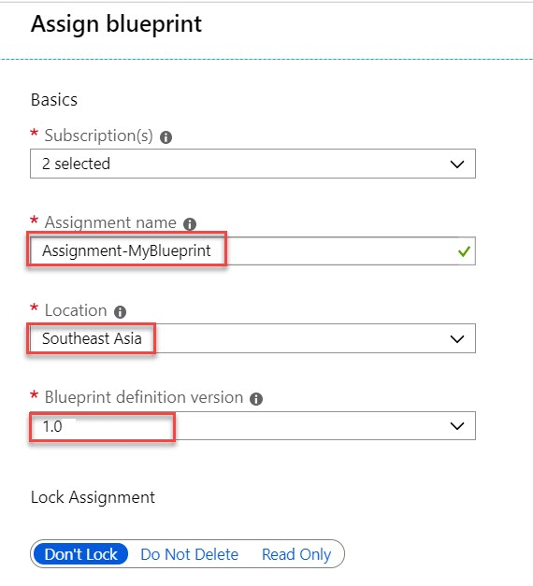

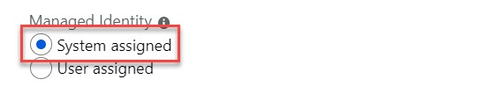

Verify other details MyRG, Allowed locations

**Create Sample Web App**

Hosting Plan: **Enter Hosting Plan Name Ex. MyWebAppPlan**

SKU Name: **B1**

Click on **Assign** button.

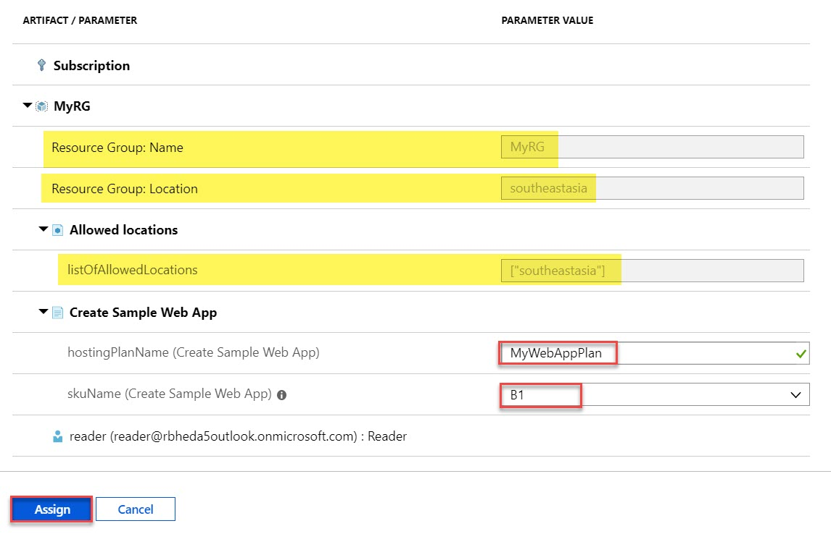

**Step 24:** Navigate to **Assigned blueprints** option click on any blueprint

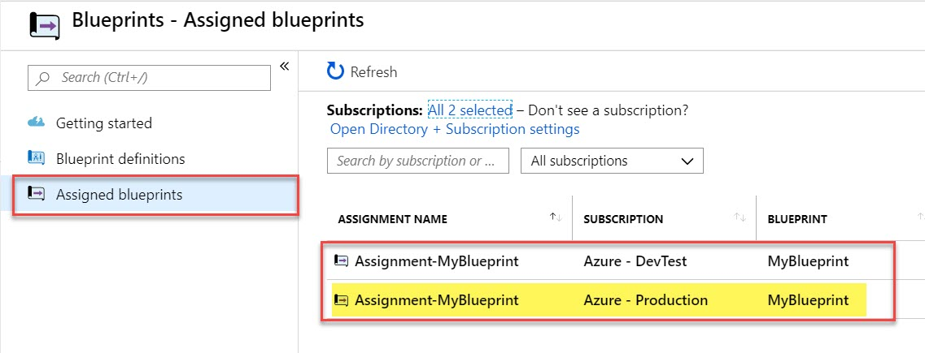

Deployment is going on

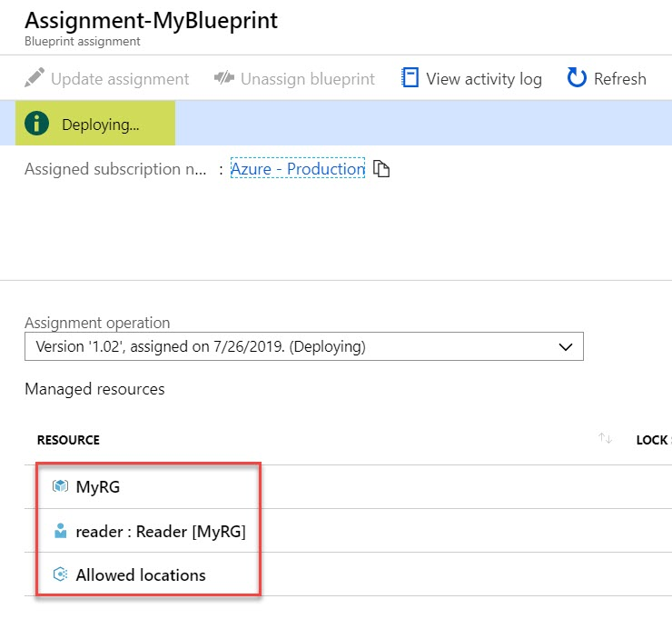

When successfully assign, you can see all resources deployed

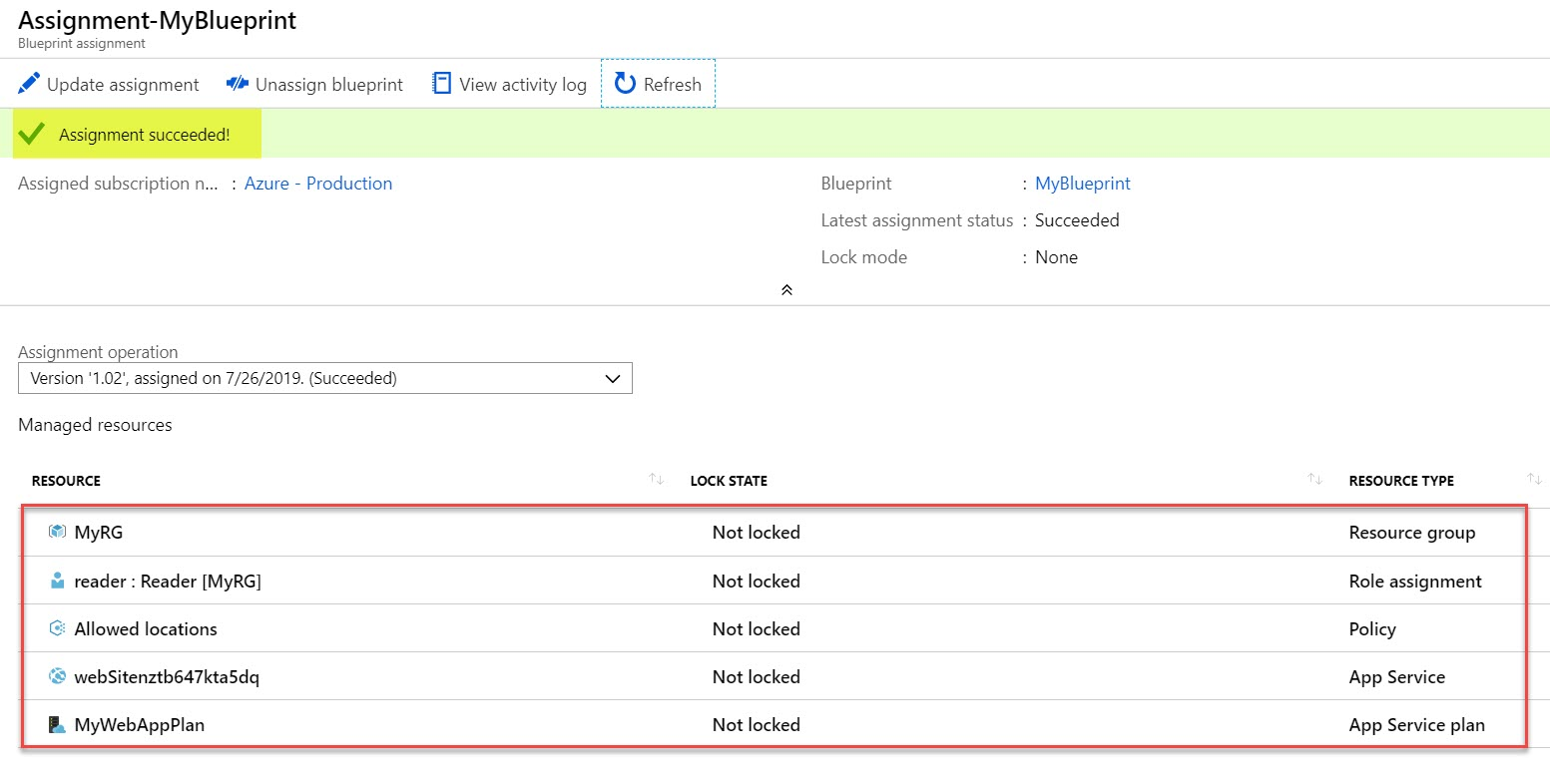

**Step 25:** Navigate to **Resource Groups**. Resource Group created in both Azure Subscription

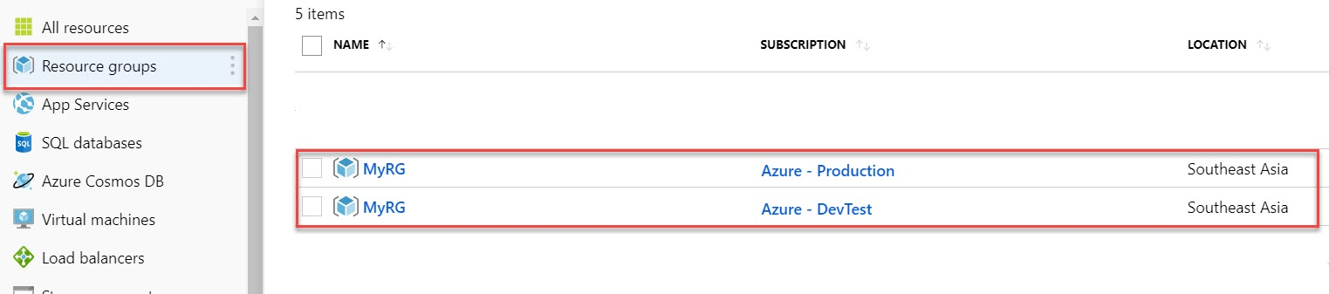

Via ARM Template we have deployed Web App so to verify click on App Services

Select Resource Group: **MyRG** & **Group by Subscription**

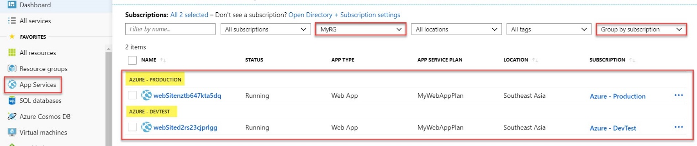

**Step 26:** Open any **Resource Group**.

Select **Access Control (IAM)** and **reader** is available under **Reader role**.

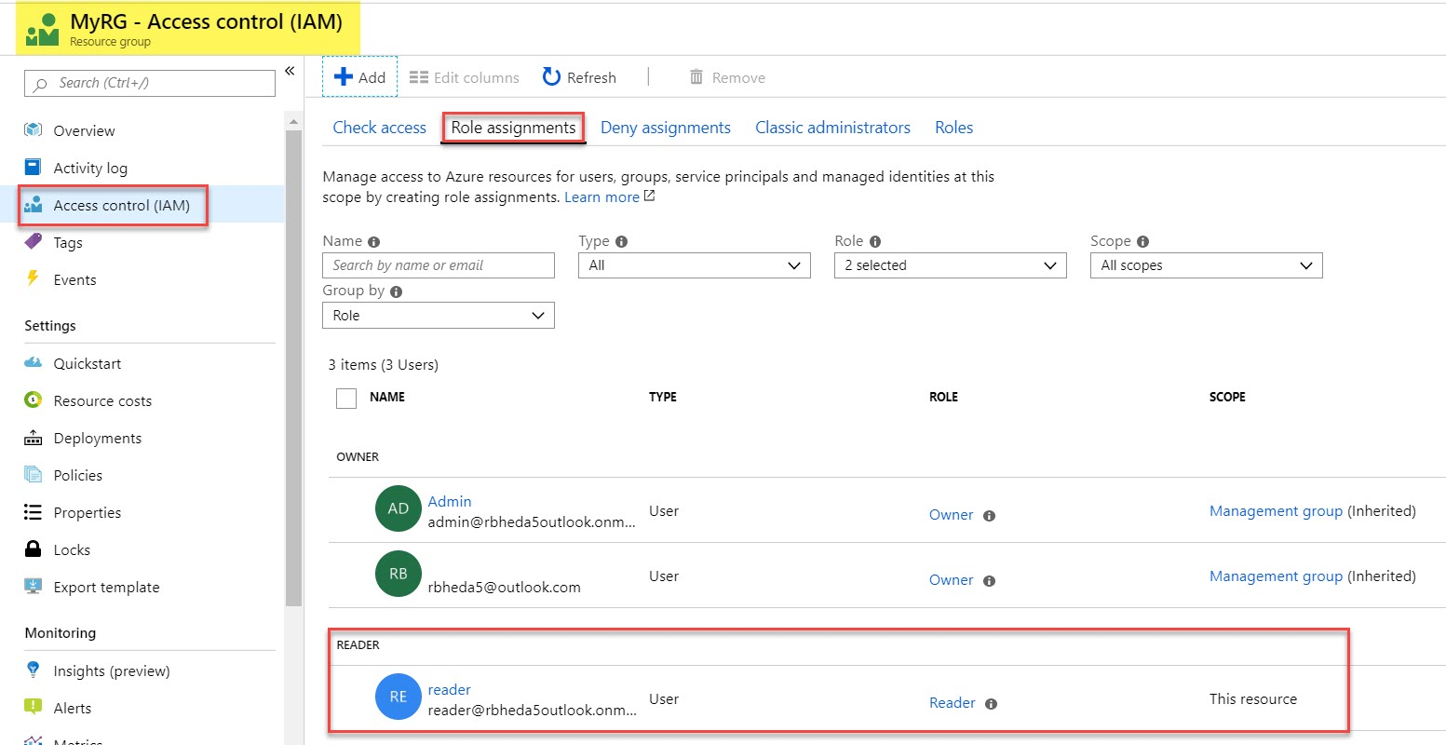

**Task 4: Verify Blueprint Resources**

**Step 27:** Start another browser or private browsing. Open Microsoft Azure Portal

Enter reader member credentials.

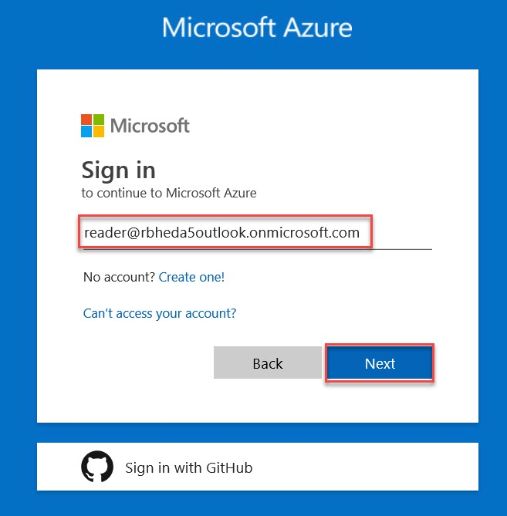

**Step 28:** **MyRG** Resource Group available in this member as well.

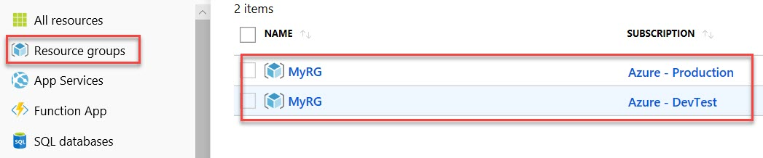

**Step 29:** Open any Resource Group.

Now you can notice **Delete Resource Group** option is disable because this member is reader.

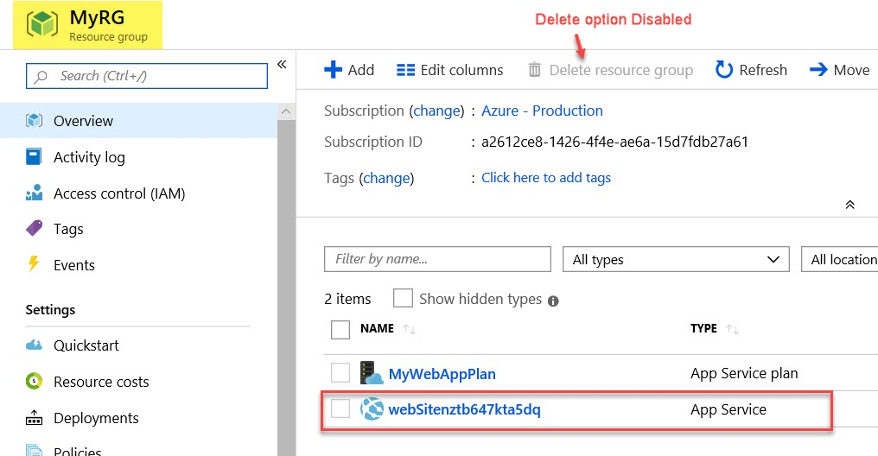

Select **Web App** & other option is also disable

