**Azure Management Group**

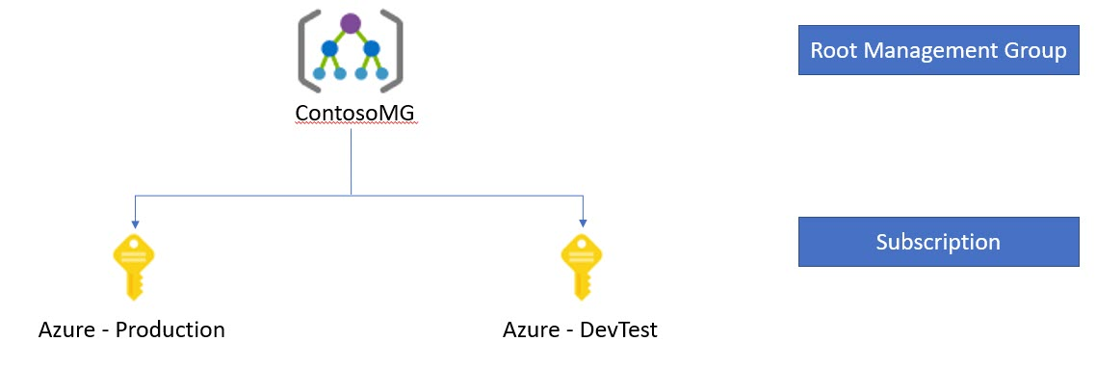

**Task 1: Create Admin Member in Azure Active Directory**

**Task 2: Create Management Group & Add Azure Subscription**

**Task 3: Configure Access Control (IAM) in Management Group**

**Task 4: Configure Policy – Definitions & Assignment**

**Note: For this demo require minimum two subscription in one account**

**Task 1: Create Admin Member in Azure Active Directory**

**Step 1:** Open **Microsoft Azure Portal**

<https://portal.azure.com>

**Step 2:** Create **Admin User**

Select **Azure Active Directory**

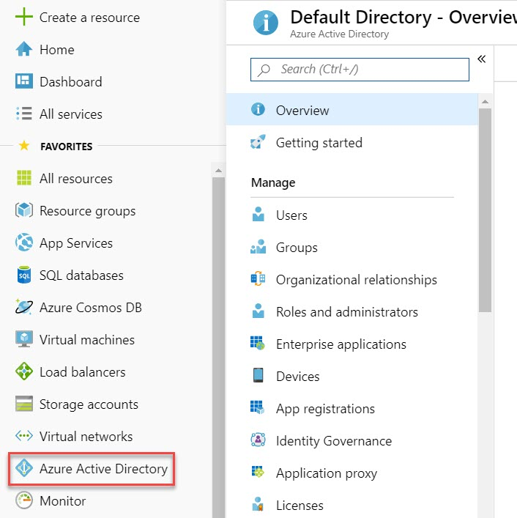

**Step 3:** Click on **Users**

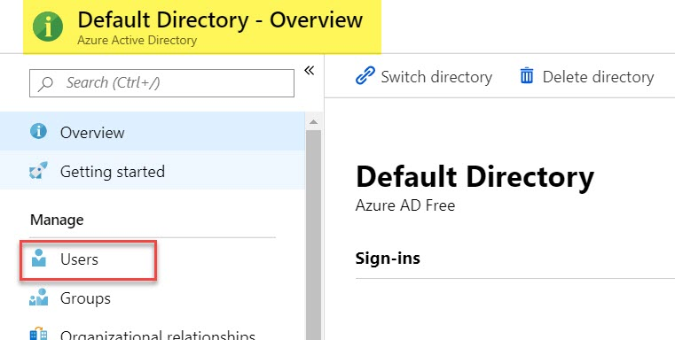

**Step 4:** Click on **+ New User**

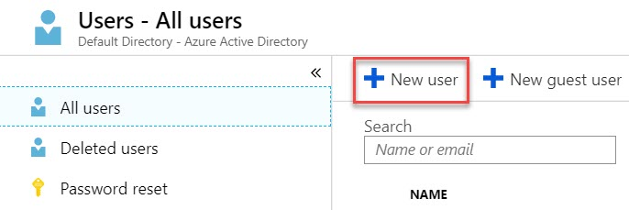

**Step 5:** Create New User

Name: **admin**

Username: **[admin@domainname.onmicrosoft.com](mailto:admin@domainname.onmicrosoft.com)**

Directory role: **Global administrator**

Click on **OK** button.

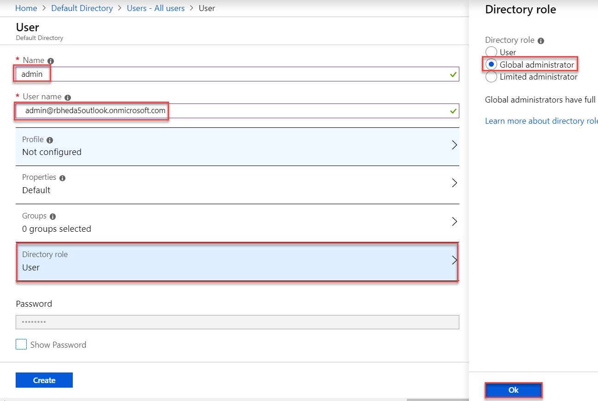

Click on **Show Password** and Copy this password in Notepad

Click on **Create** button.

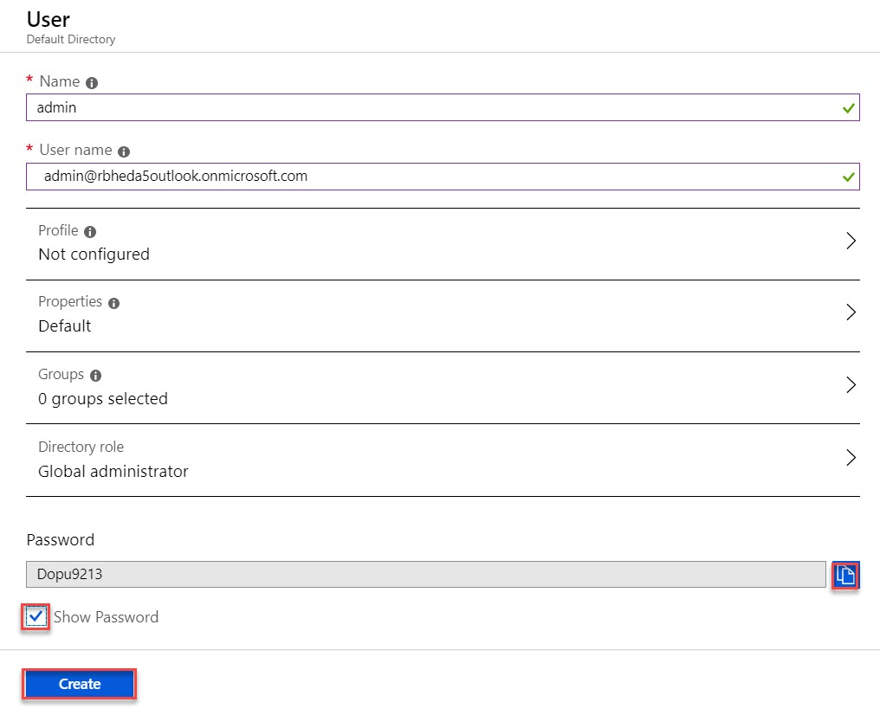

Under all Users, you can see Admin Member available.

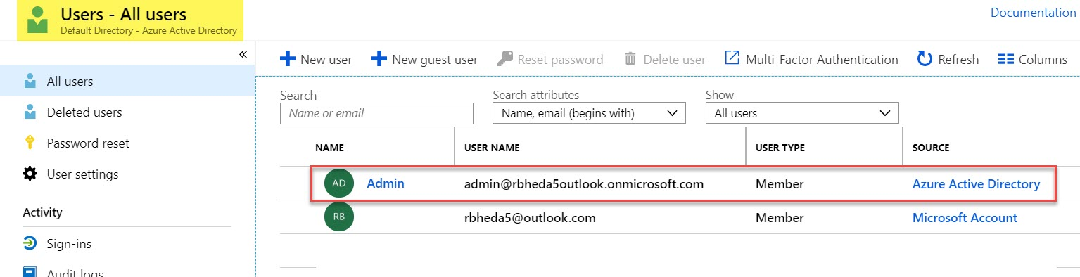

**Task 2: Create Management Group & Add Azure Subscription**

**Step 6:** Create Management Group

**All Services** -> Search for “**group**” -> Select **Management Groups**

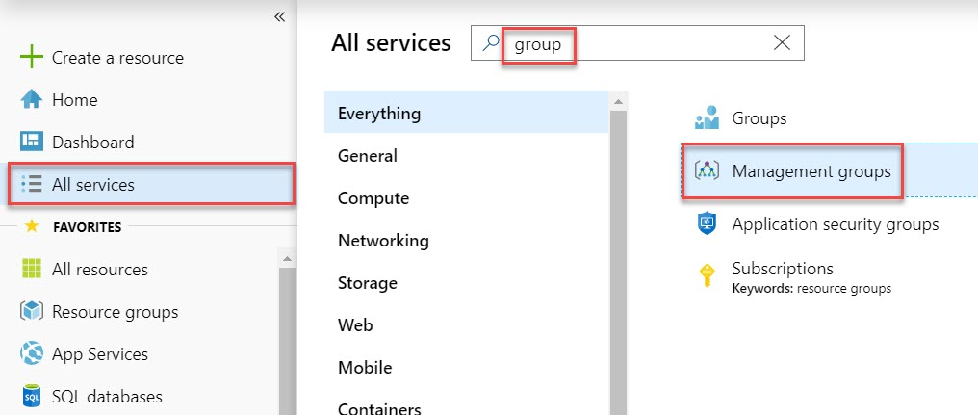

**Step 7:** Click on **Start using management groups**

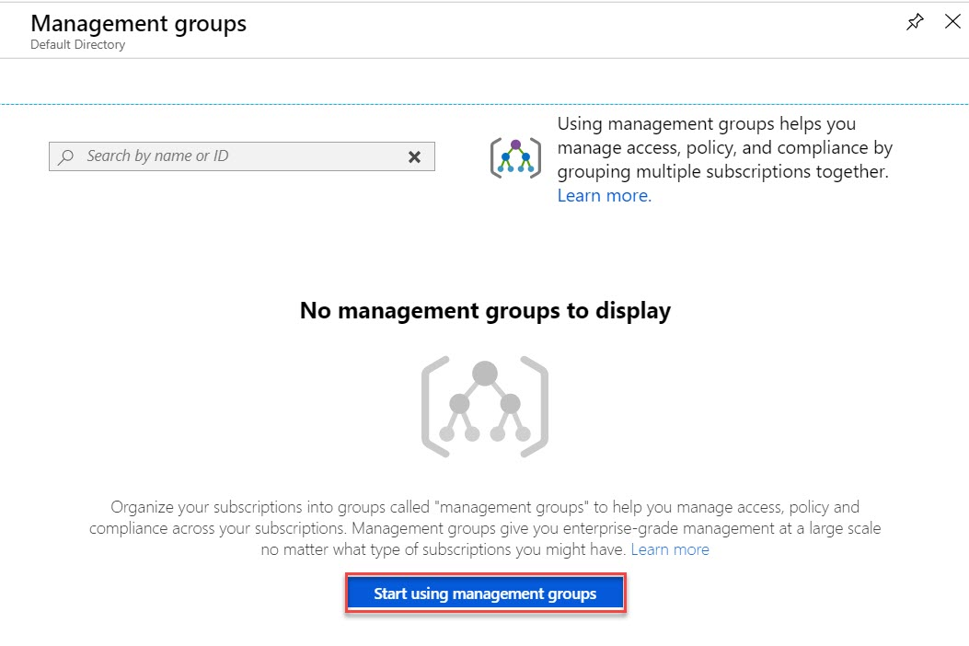

**Step 8:** Create New Management Group

**Create New**

Management Group ID: **ContosoMG**

Management group display name: **Azure Management Group1**

Click on **Save** button.

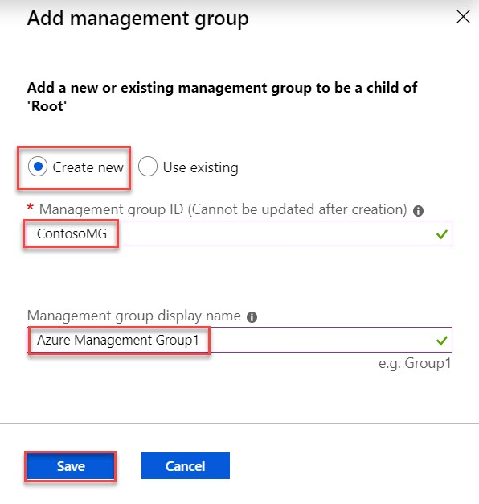

**Step 9:** After creation of Management Group, Click on that.

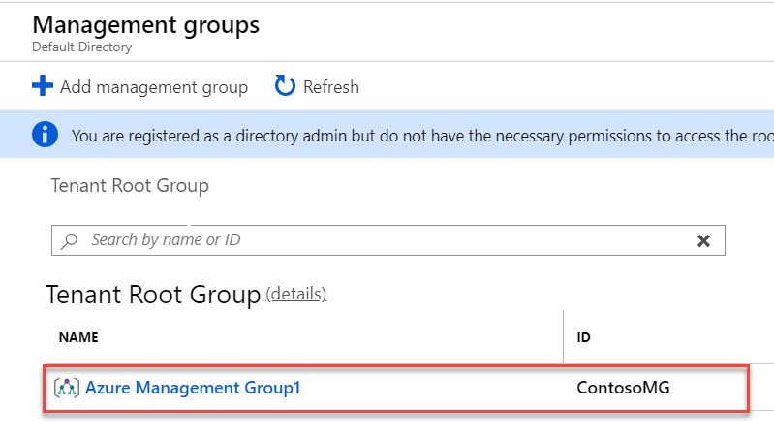

**Step 10:** Click on **details** of Management Group

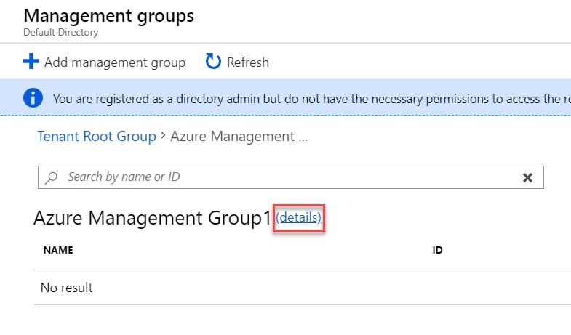

**Step 11:** Click on **+ Add Subscription**

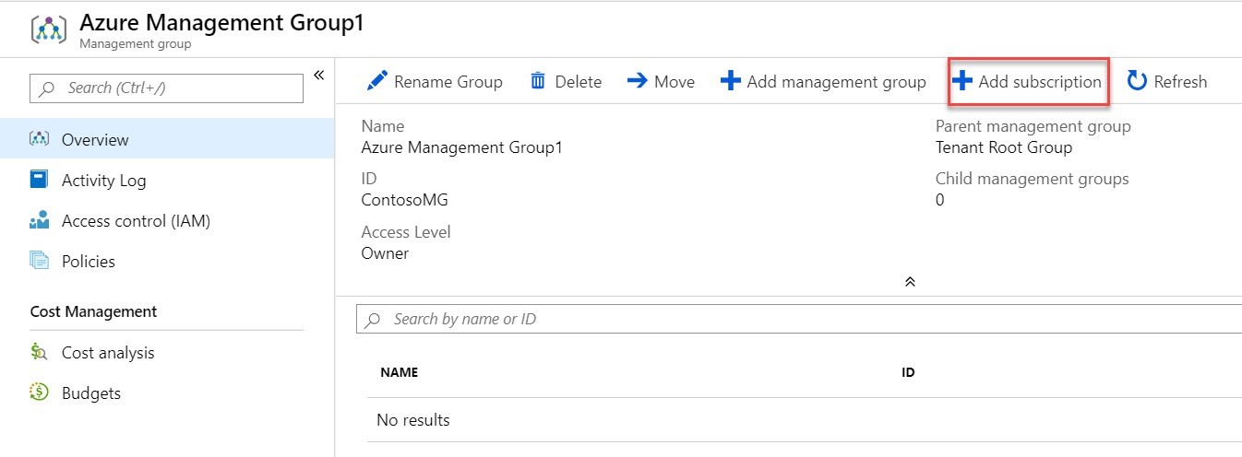

**Step 12:** From drop down menu select **Azure Subscription** Ex. Azure – DevTest

Click on Save button.

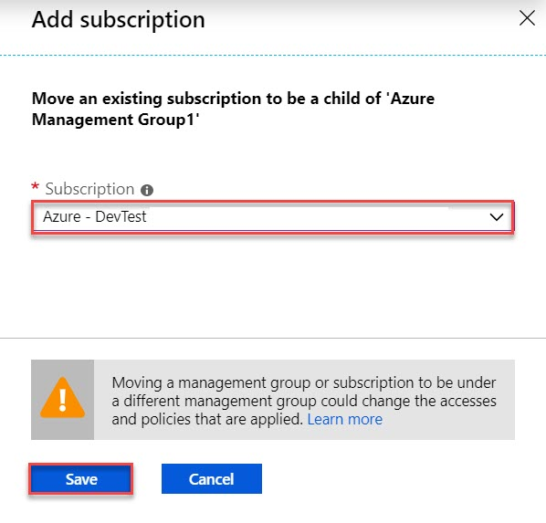

**Step 13:** Back to Management Group blade and once again Click on **details** option

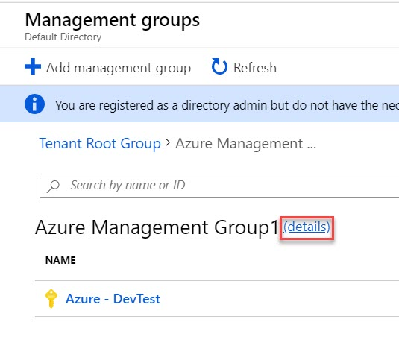

**Step 14:** Once again click on **+ Add Subscription**

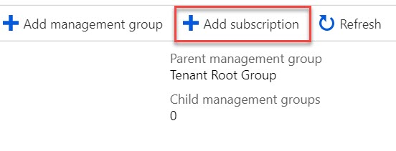

**Step 15:** Select another **Subscription** from drop down menu Ex. Azure – Production

Click on Save button.

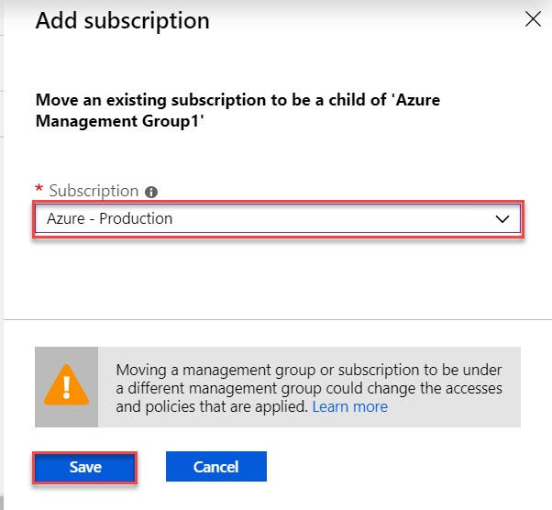

**Step 16:** Back to Management Group, you can see both the Subscription available.

Click on **details** option

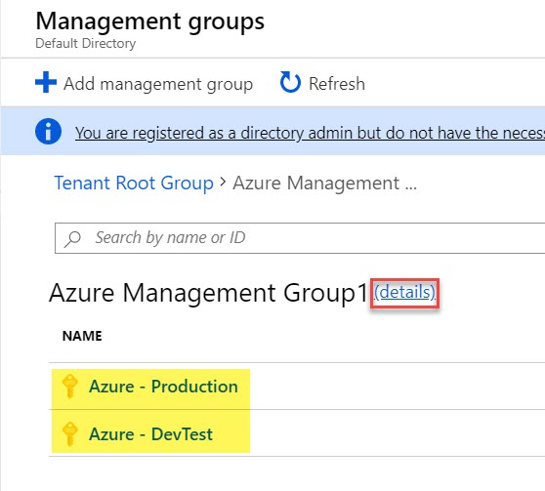

**Task 3: Configure Access Control (IAM) in Management Group**

**Step 17:** Select **Access Control (IAM)** option

Click on **+ Add** -> **Add role assignment**

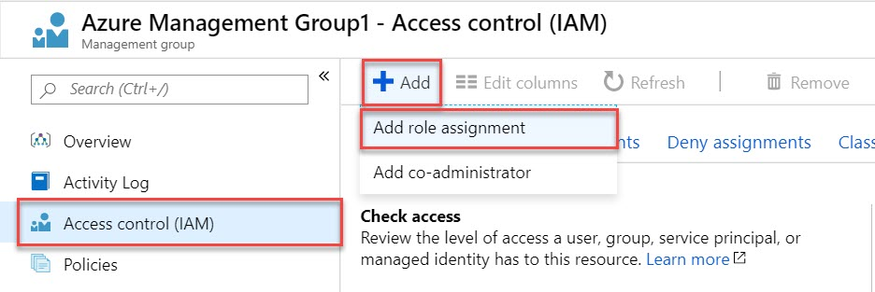

**Step 18:** Add Role Assignment

Role: **Owner**

Assign access to: **Azure AD user, group, or service principal**

Select: type **admin** or select admin address

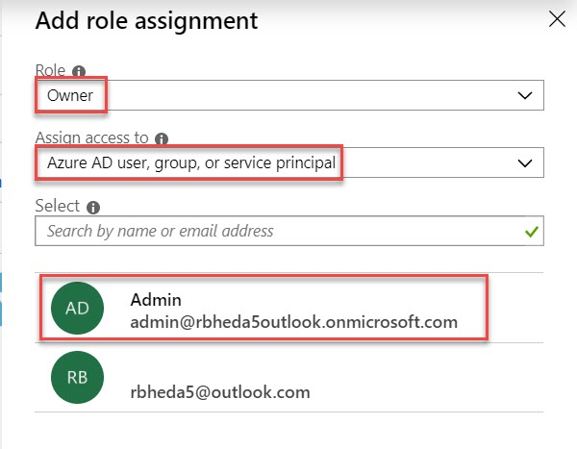

Selected Members: Admin will be there

Click on **Save** button.

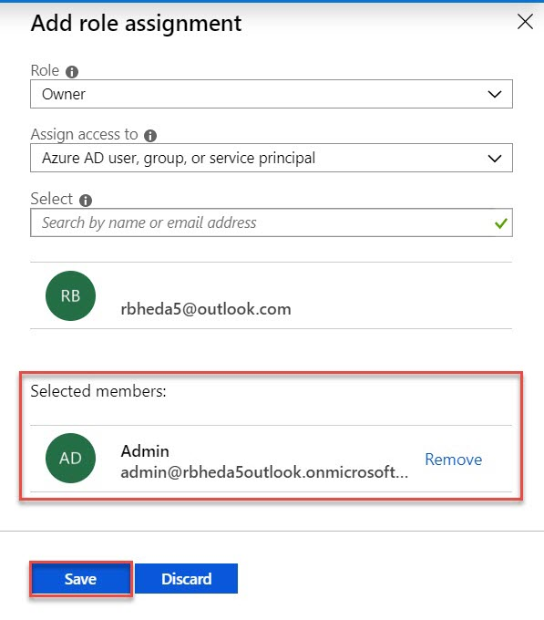

**Step 19:** To verify Navigate to Subscription

**All Services** -> Search for “**Subscription**” -> Click on **Subscriptions**

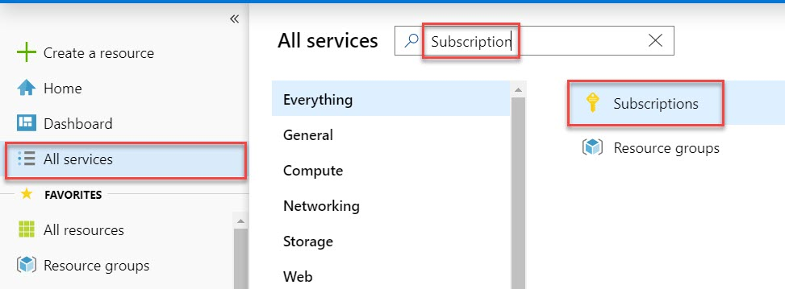

**Step 20:** Choose any Subscription

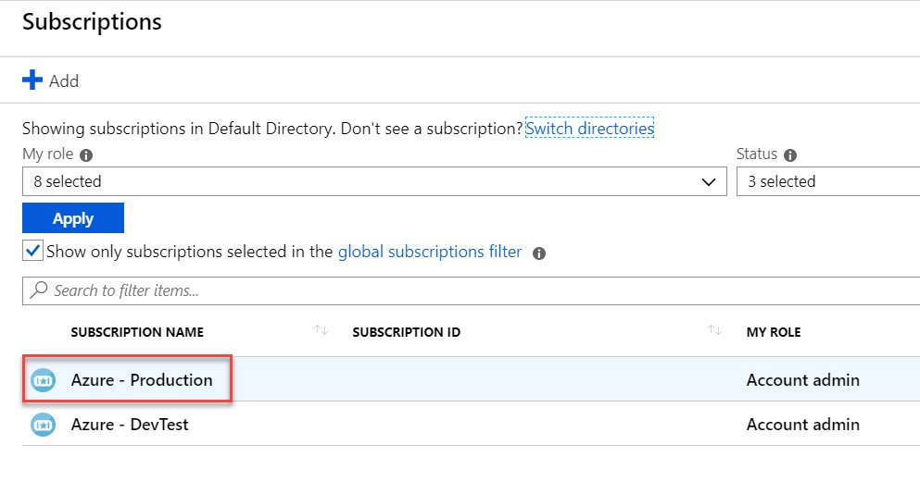

**Step 21:** **Access Control (IAM) -> Role Assignment**

You can see Admin available under that Subscription as Owner Role

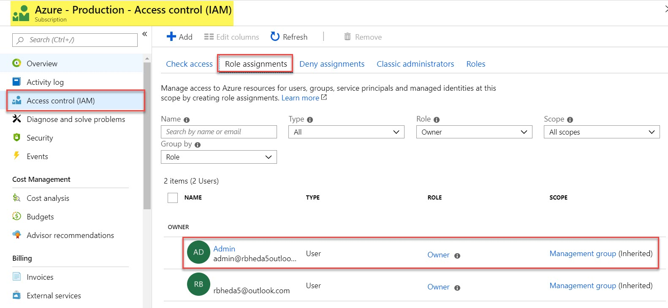

Testing with another Subscription

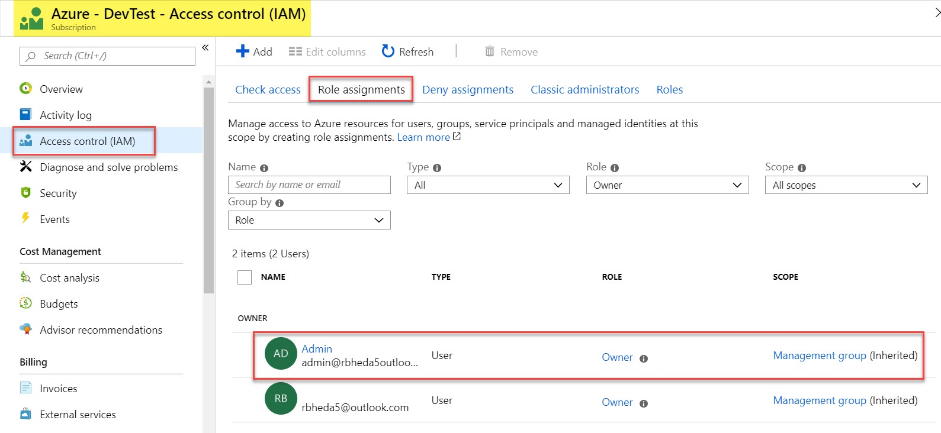

**Task 4: Configure Policy – Definitions & Assignment**

**Step 22:** Now try with Policies

Click on **Policies** under Management Groups

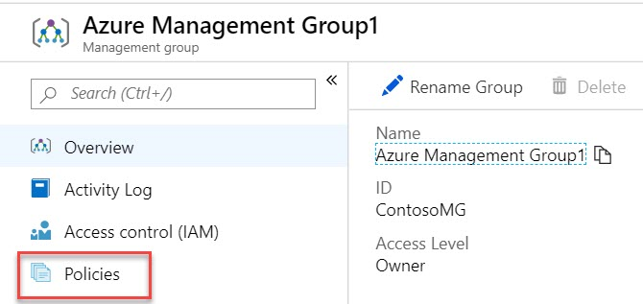

**Step 23:** First Select **Definitions**

Search for “**resource group**”

Select “**Allowed locations for resource group**”

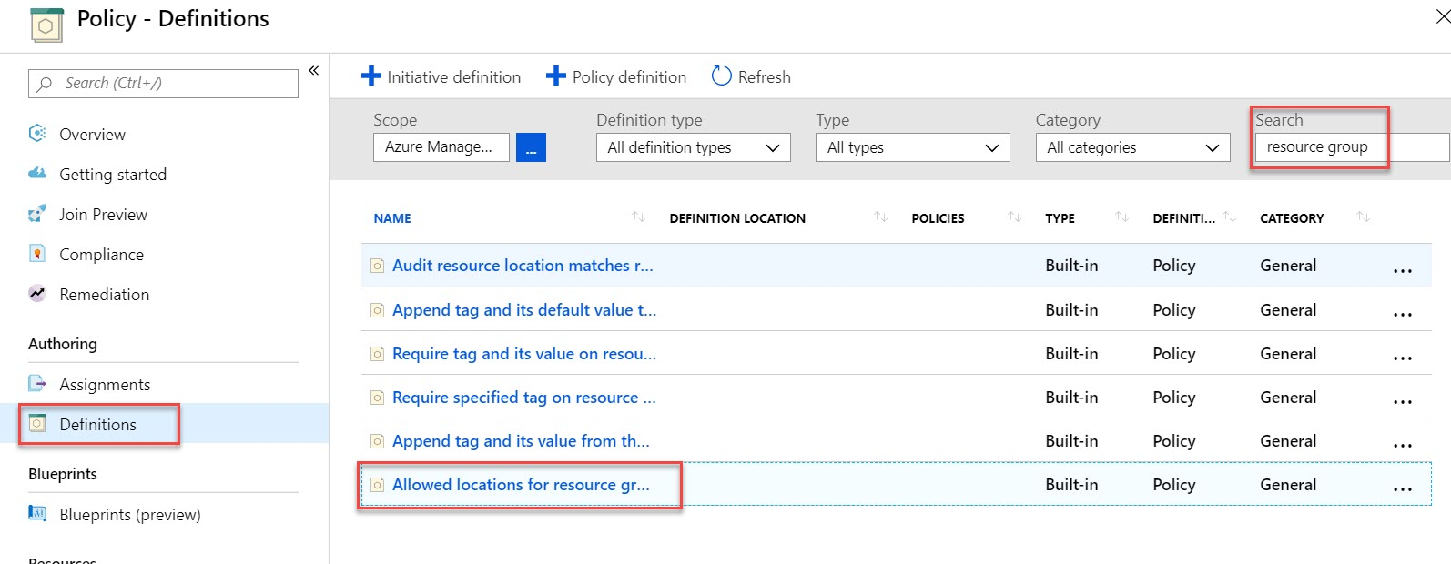

**Step 24:** Now **Assign** this policy by clicking on Assign option

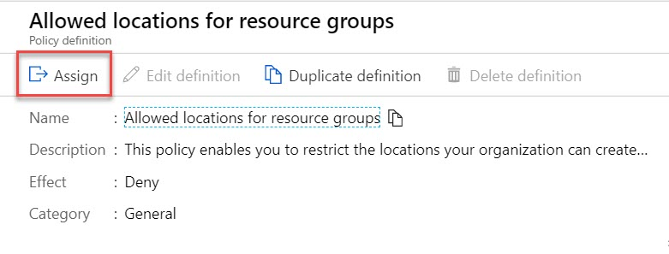

**Step 25:** First select **Scope**.

Click on **Browse** option

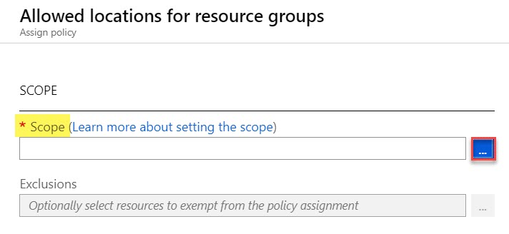

Select **Management Group** as a Scope.

Click on **Select** button

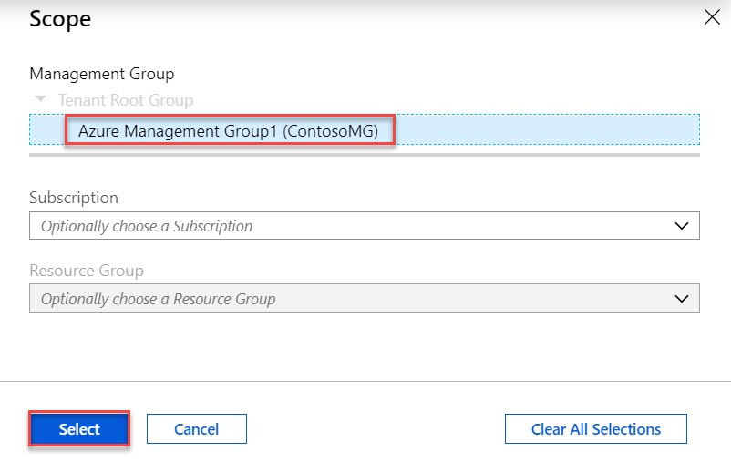

**Step 26:** Select **Allowed Location Ex. Southeast Asia**

Click on **Assign** button.

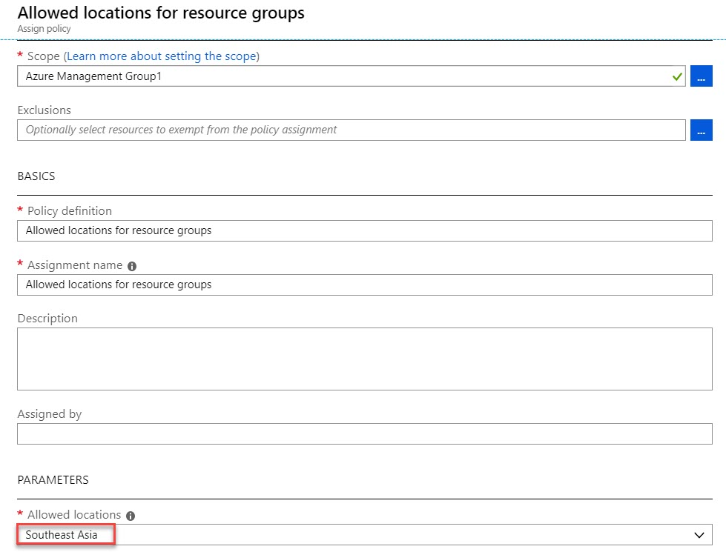



**Step 27:** Select **Assignments**

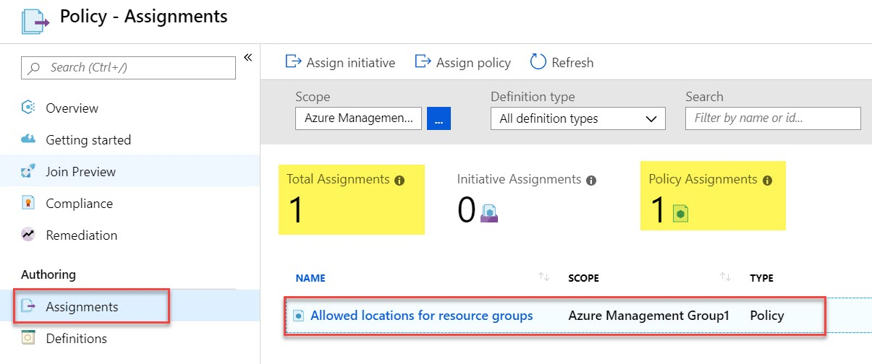

**Step 28:** Now create New Resource

Click on **Resource Groups -> + Add**

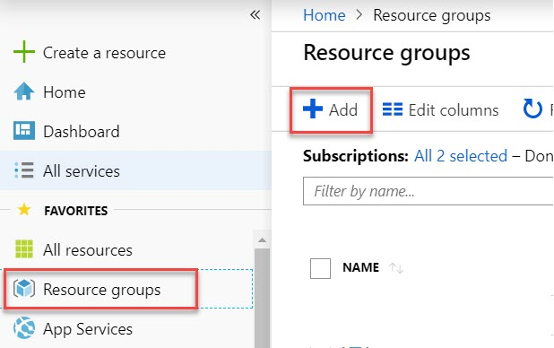

**Create New Resource Group**

Resource Group: **DemoRG**

Region: **Central US**

Click on Review **+ Create** button.

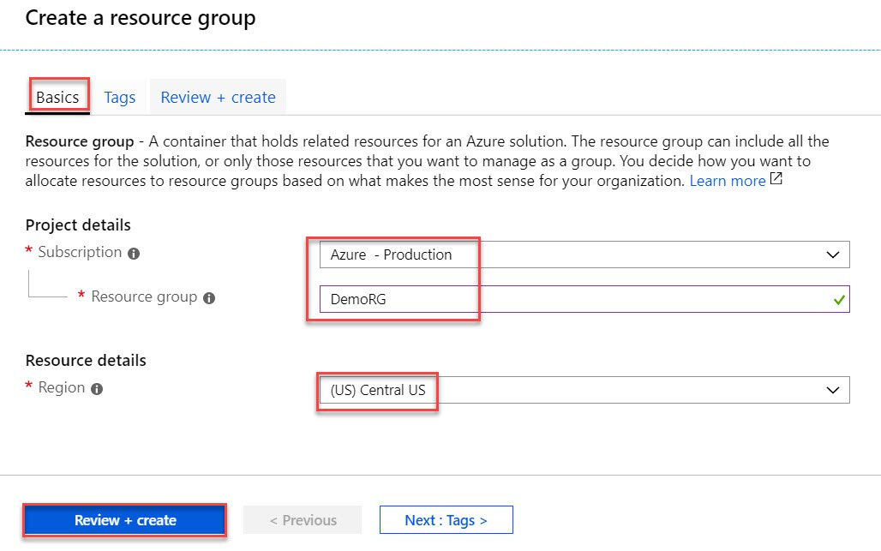

**Create** button.

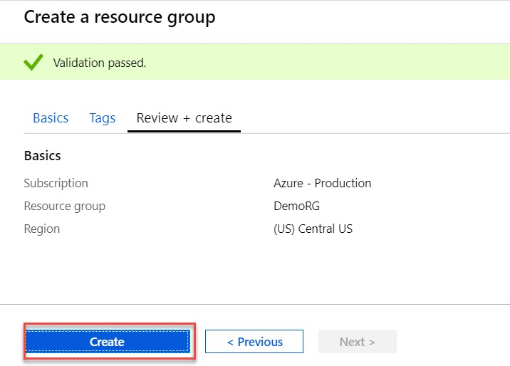

**Error: Disallowed by Policy.**

