**Create & Deploy Web App**

**Step 1:** Open **Microsoft Azure Portal**

[https://portal.azure.com](https://portal.azure.com/)

**Step 2:** Create Web App

**+ Create a resource -> Web -> Web App**

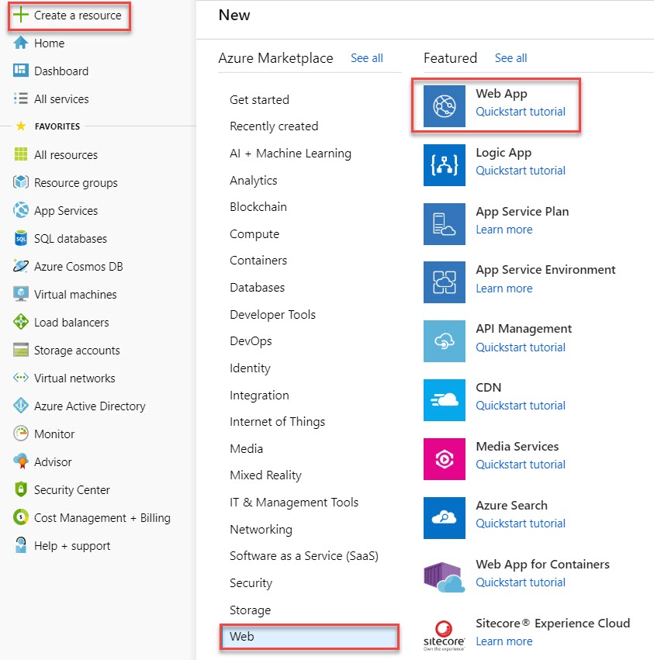

**Step 3:** Create Web App

Subscription: **Choose active Subscription**

Resource Group: **Create New** Ex. **WebAppDemoRG**

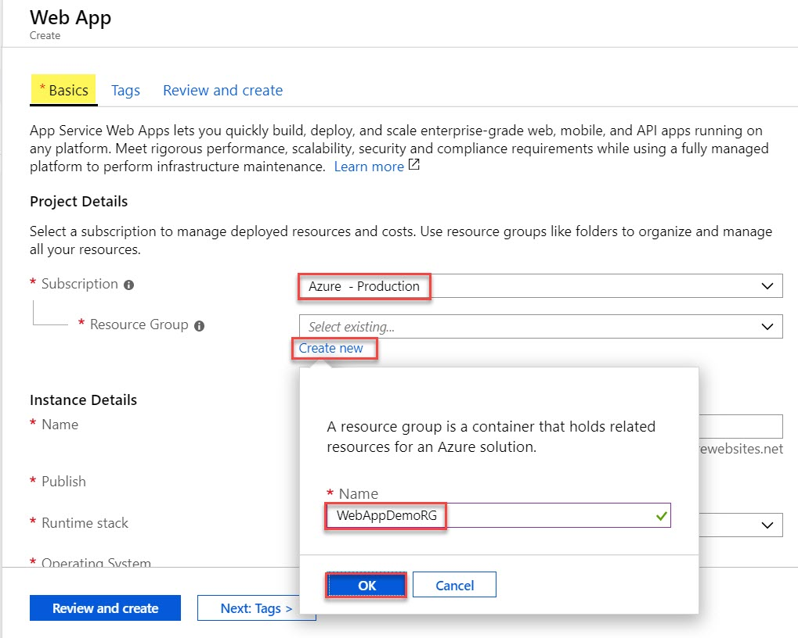

Name: **Enter Unique App Name**

Publish : **Code**

Runtime stack : **ASP.NET V4.7**

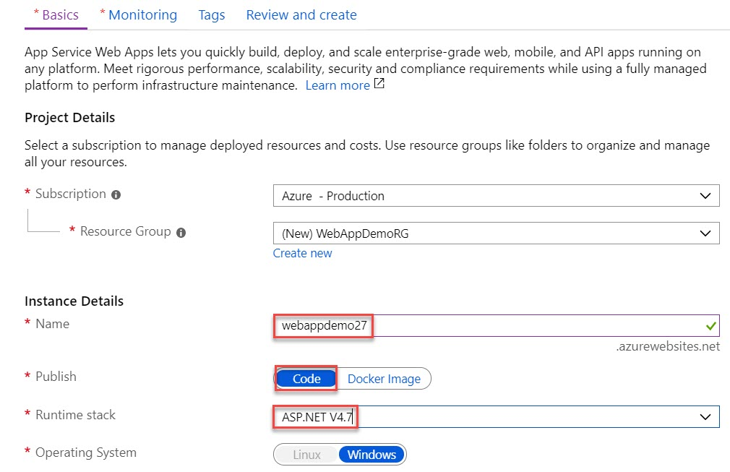

Region: **Choose Nearest Region**

Window Plan: Create New Ex. **webappdemoPlan**

Click on **OK** button.

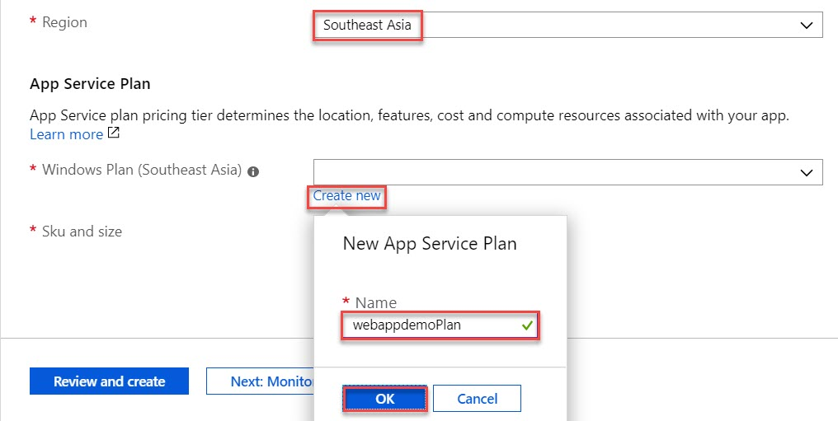

SKU and Size: **Standard S1**

(Note: This demo will continue with another demo that why selecting Standard S1. If you want to deploy normal web app you can select any pricing tier.)

Click on **Next: Monitoring >**

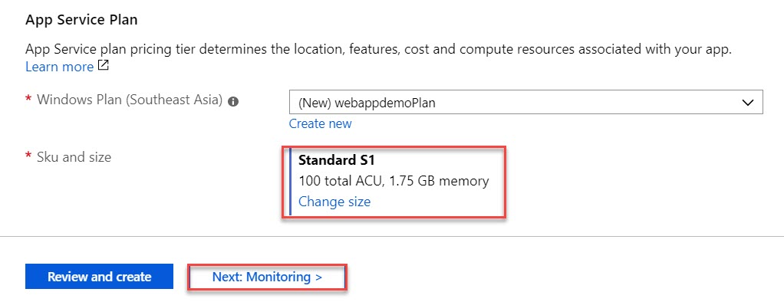

**Step 4:** **Monitoring** Tab

Application Insights: **No**

(Note: For this demo it’s not required but later on also can enable)

Click on **Review and Create** button.

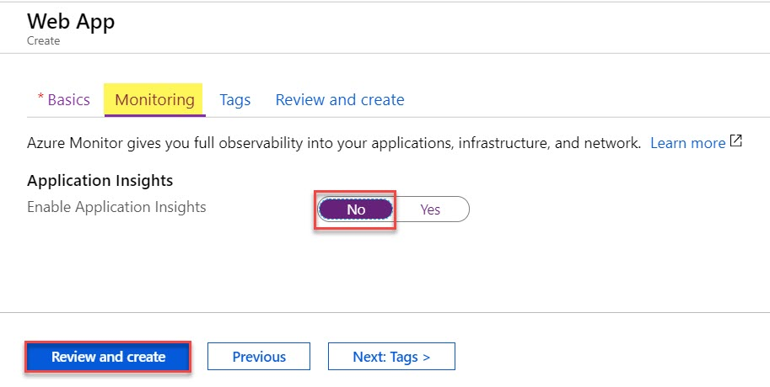

**Step 5:** Click on Create button.

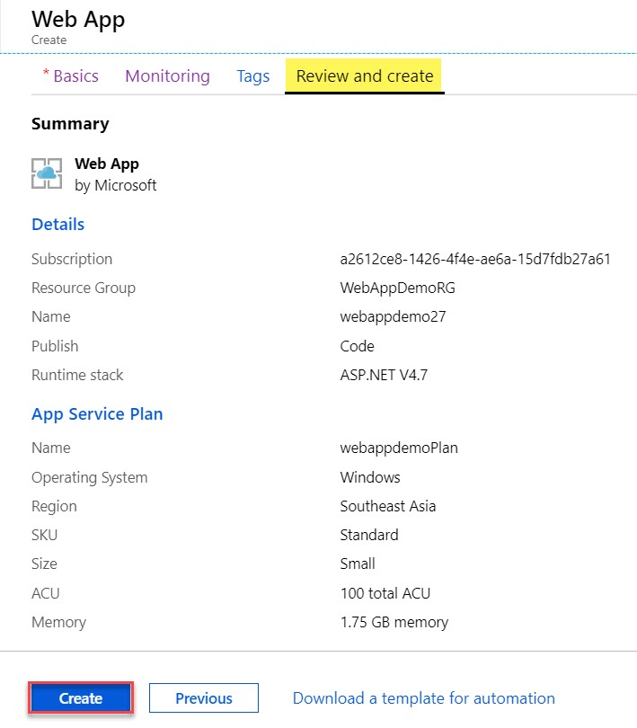

Wait for few seconds to deploy Web App.

Click on **Go to resource** button.

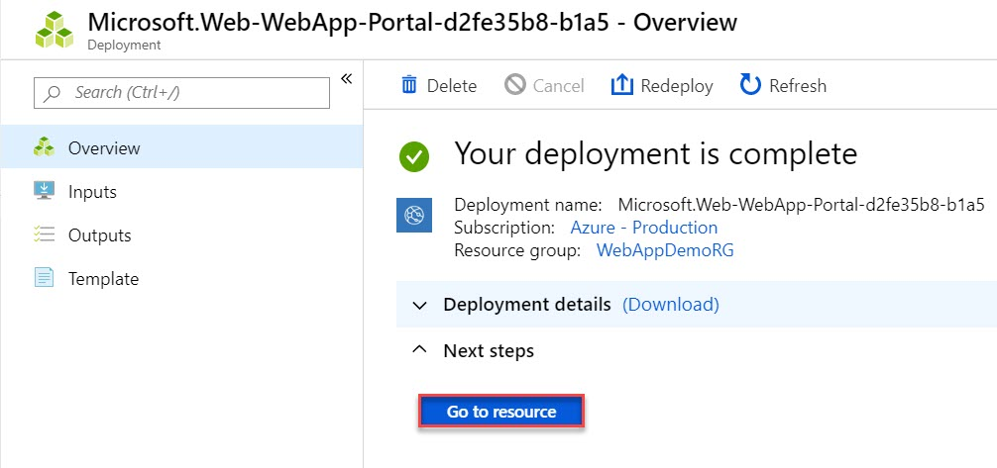

**Step 6:** Click on **Browse** option or Copy Web App URL

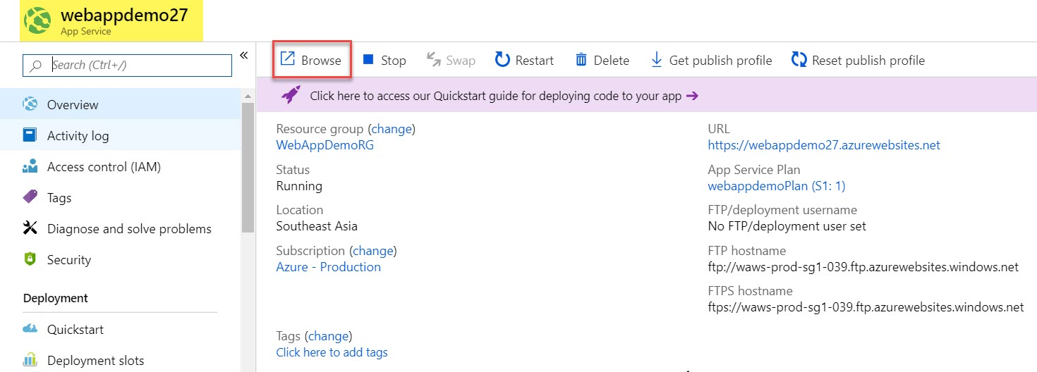

**Step 7:** Sample Page will run of Azure Web App.

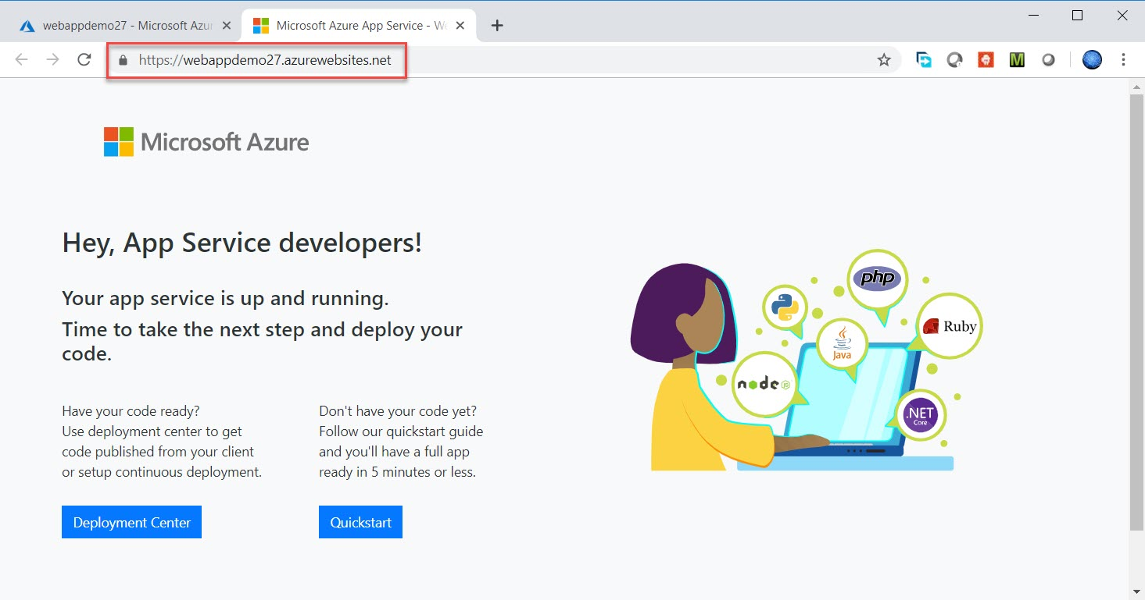

There is multiple way to upload content on Web App but in this document two methods are available.

**Step 8:** Open **Blank Notepad** and paste below code:

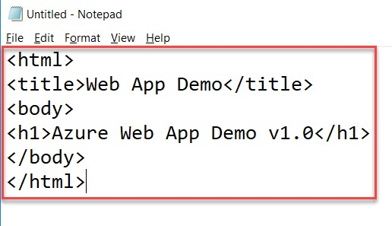

<html>

<title>Web App Demo</title>

<body>

<h1>Azure Web App Demo v1.0</h1>

</body>

</html>

**Step 9:** Now Save this page. **File** menu -> **Save As…**

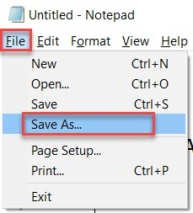

**Step 10:** Change location to **Desktop**

(Note: You can save on any location.)

File Name: **index.html**

Save as type: **All Files**

Click on **Save** button.

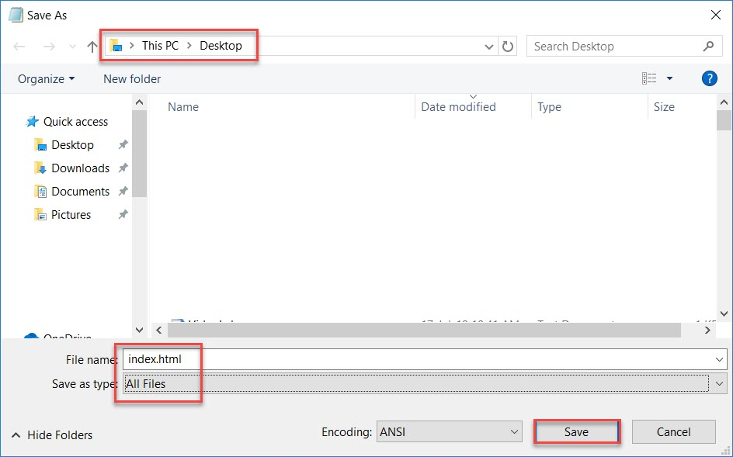

Note: index.html, default.html, etc are recognize as default document of Web App.

**Method 1: Upload Via FTP**

**Step 11:** Web App name reserved and Website is also ready so need to publish website on Microsoft Azure.

Click on **Get Publish profile** option

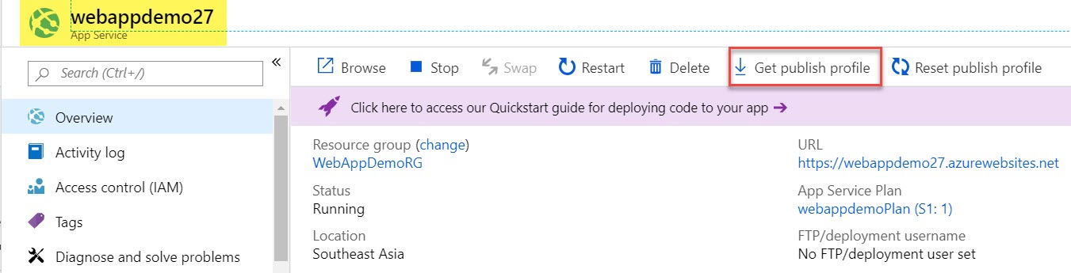

**Step 12:** File will download automatically. **Double Click on that or Open file**.



Select **Notepad** from list and click on **OK** button.

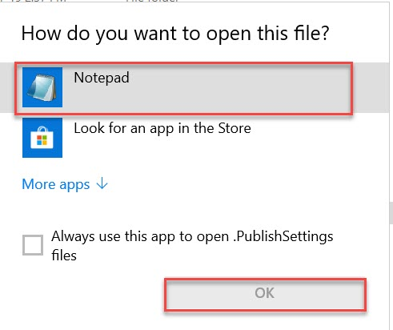

**Step 13:** We require FTP Credentials so collect **FTP Publish URL, Username, Password**

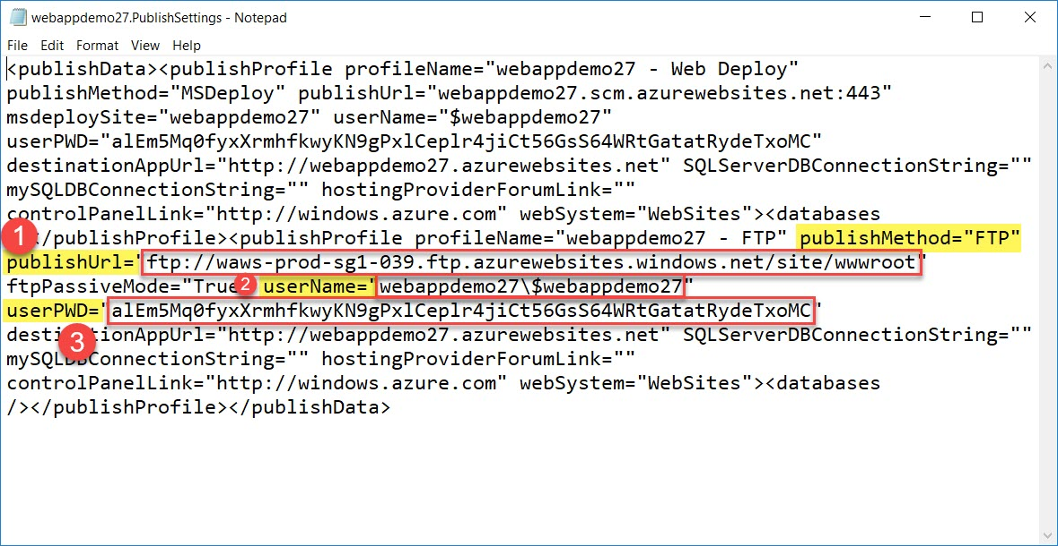

Open **This PC** or File **Explorer -> Copy-Paste FTP Publish URL** in File Explorer address and hit **Enter** key.

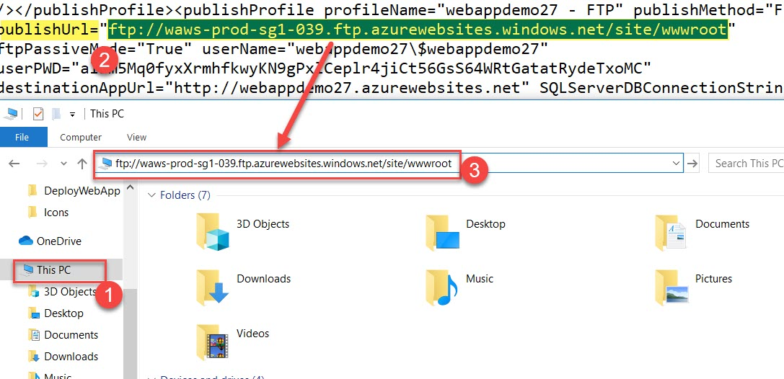

Now it will ask for **Username and Password** So Collect from .**PublishSettings** file. Click on **Log On** button.

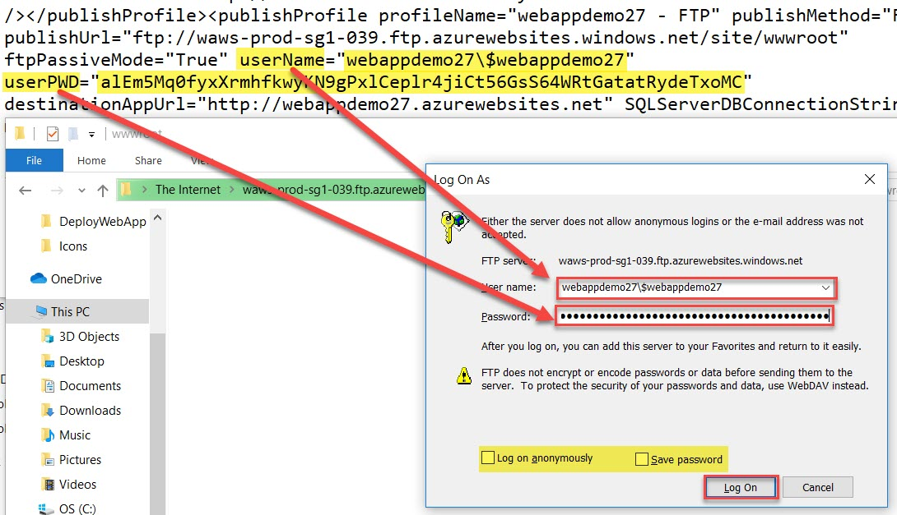

Enter credentials it will navigate to **wwwroot** folder and **hostingstart.html** (Default Page) will be there.

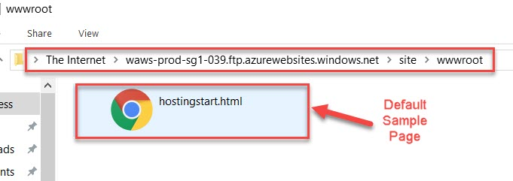

**Step 14:** Now copy local (available on Desktop) **index.html** and Paste into **wwwroot** folder.

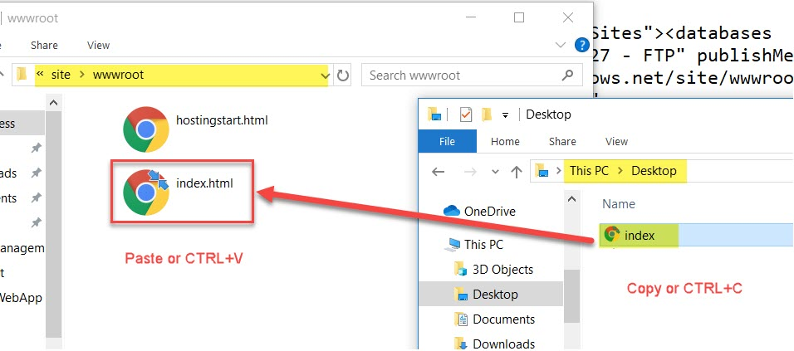

**Step 15:** Now navigate to Azure Portal and click on **Browse** option of Web App.

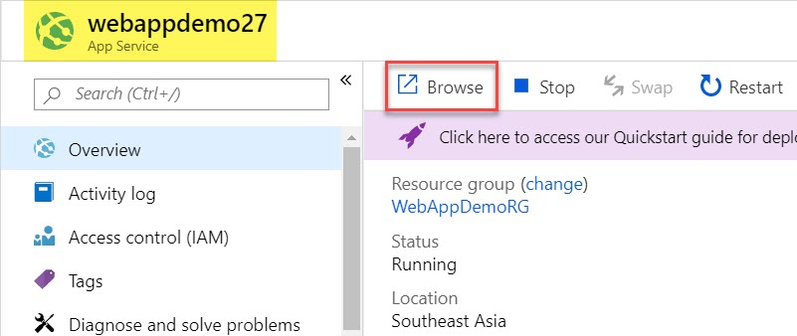

**Step 16:** Web App Content changed from Default to Custom (index.html).

