Tag! You’re It

Display RFID tags in Style: A User Manual

Delan Elliot | Juliana French | Roger Zhang

DataCOMM  SE12-323

**Getting Started**

To experience full functionality, you will need:

* a Skyetek RFID reader device
* the USB connector cable
* RFID tags to read.

Before running the program, you should connect the reader to your computer with the USB cable.

**Using the Program**

1. Start the program.

2. In the menu, click on “Connect/Disconnect” and select “Connect” to connect to the reader.

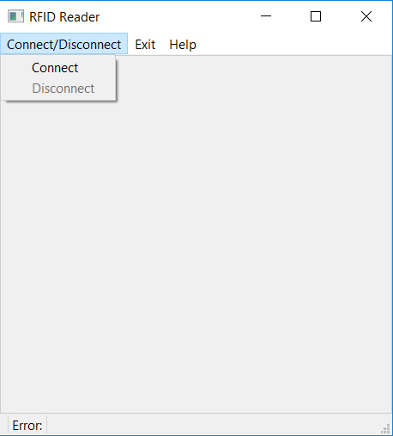

3. To read an RFID tag, place one (or a few) on or very near to the reader. Check the screen; the tag(s) within range of the reader should display.

<insert picture>

All tags that have

4. To disconnect, select “Disconnect” from the “Connect/Disconnect” menu.