Justin Valentine

Jason Ross

Dalton Ellis

Ken Aoyagi

ENGR114 Fall T/R

12/7/2019

**Balancing Car**

**Hardware Setup:**

Bill of Materials:

|  |  |  |  |  |
| --- | --- | --- | --- | --- |
| Part Name | Purpose | Item Name | URL | Price |
| Redboard | Microprocessor | Arduino Uno | <https://www.sparkfun.com/products/15123> | $20 |
| Arduino and  breadboard holder | Base for breadboard | Arduino and breadboard holder | <https://www.sparkfun.com/products/11235> | 3.95 |
| Motor driver | Controls voltage levels to motors | Dual TB6612FNG | <https://www.sparkfun.com/products/14450> | 5.45 |
| accelerometer | Sensing pitch level | MPU 92/65 | <https://www.banggood.com/buy/mpu-9265.html> | 12 |
| Hobby gearmotor | Moves vehicle | DG01D | <https://www.sparkfun.com/products/13302> | 4.95 |
| Wheels | Provide rotational inertia and minimal points of contact to board | Wheel | <https://www.sparkfun.com/products/13259> | 2.95 |
| Seesaw | Tilt car | Seesaw | HOMEMADE | N/A |
| Jumper wires | Facilitates flow of electrons with minimal resistance | Jumper wires | <https://www.sparkfun.com/products/11026> | 2.25 |
| Mini power switch | Turns off power | Mini power switch SPDT | <https://www.sparkfun.com/products/102> | 1.50 |

Hookup Guide:

See image below:

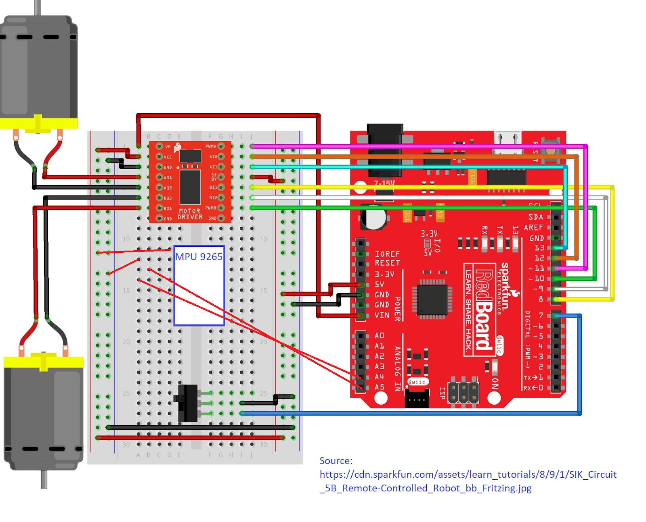

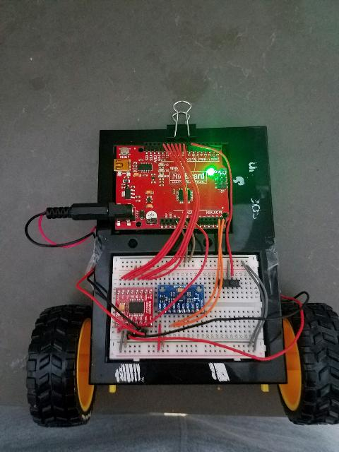

Hookup Guide:

|  |  |
| --- | --- |
| Redboard | Motor Driver |
| Digital 11 | PWMA |
| Digital 12 | A12 |
| Digital 13 | A11 |
| Digital 10 | PWMB |
| Digital 8 | B11 |
| VIN | VM |
| 5V | STBY |

|  |  |
| --- | --- |
| Left motor | Motor driver |
| Black wire | A02 |
| Red Wire | A01 |

|  |  |
| --- | --- |
| Right motor | Motor driver |
| Black wire | B02 |
| Red Wire | B01 |

|  |  |
| --- | --- |
| Accelerometer | Redboard |
| SCL | Analog A5 |
| SDA | Analog A4 |