Java Machine Test

1.addnewcustomer and display

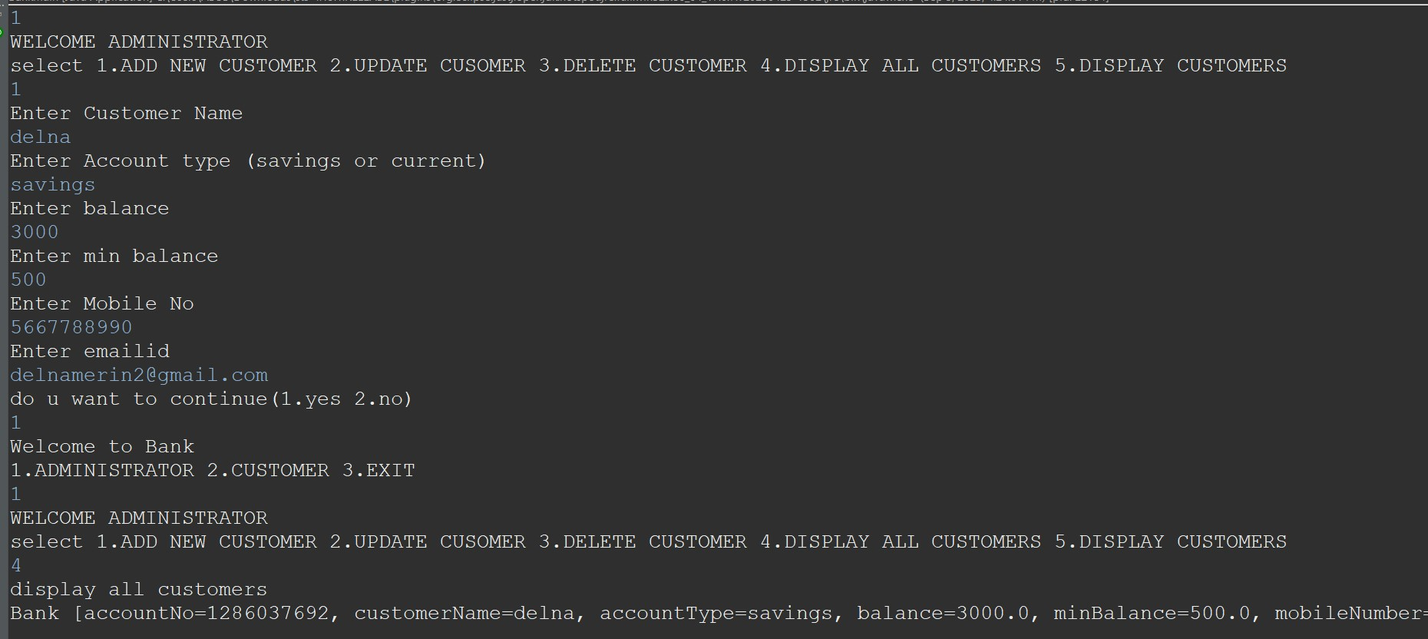

2.update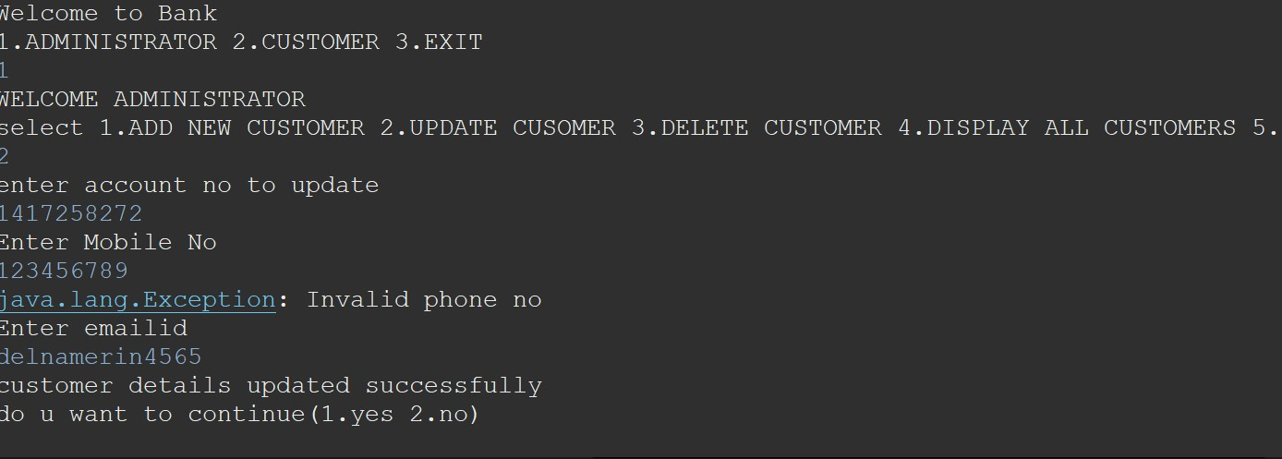

3.Display and delete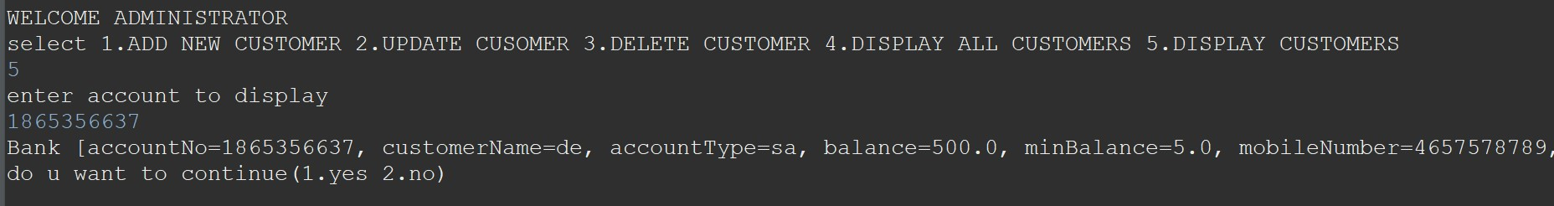

4.Transfer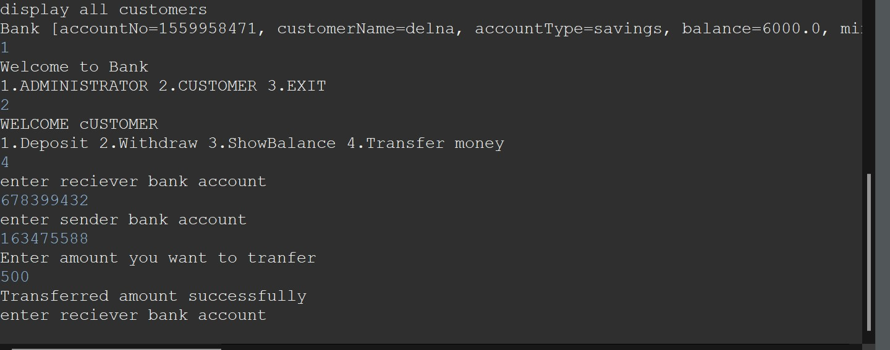

5.showbalance

6.withdraw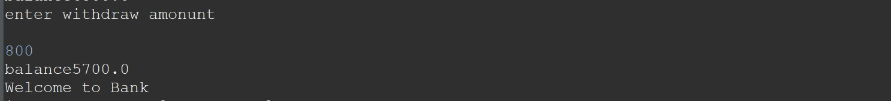

7.deposit

