Sudoku

By David Elner delner@umich.edu

# Installation

You may either install *Sudoku* or run it as a Standalone:

* **Install:** Double-click *“..\install\Sudoku.Install.msi”* and follow the on screen instructions.
* **Standalone:** Double-click *“..\install\Sudoku.exe”* and start playing.

# Usage

## Creating/Opening/Managing Puzzles

The *Puzzle Library* allows organization of all of your Sudoku puzzles!  
Go to “File🡪Puzzle Library” to open the *Puzzle Library* interface.  
  
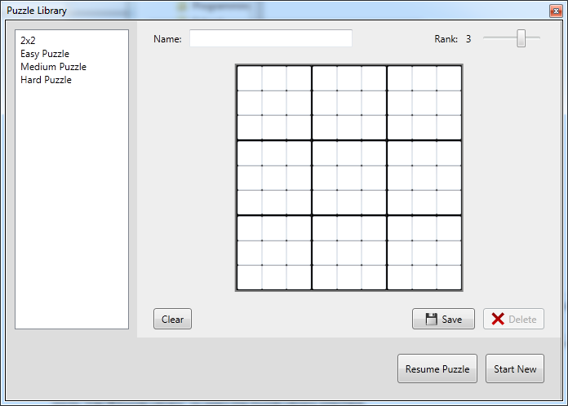

Figure : The Puzzle Library window

From this screen you can:

1. **Create a new Puzzle**:
   1. Select the puzzle rank (i.e. 3 = 9x9)
   2. Enter the name in the text box above.
   3. Place the given numbers on the grid.
   4. Click the Save button.
   5. If a puzzle already appears on the screen and you’d like to create one from scratch, click the Clear button.
2. **Edit a puzzle**:
   1. Select your puzzle from the left hand menu.
   2. Make any changes you wish.
   3. Press the Save button.
3. **Delete a puzzle**:
   1. Select your puzzle from the left hand menu.
   2. Press the Delete button.
4. **Start a puzzle**:
   1. Select your puzzle from the left hand menu.
   2. Press the Start New button.
5. **Resume a puzzle**:
   1. Select the puzzle which you’d like to resume.
      1. This requires having previously saved the puzzle via File🡪Save on the main window.
   2. Press the Resume Puzzle button.

## Gameplay Features

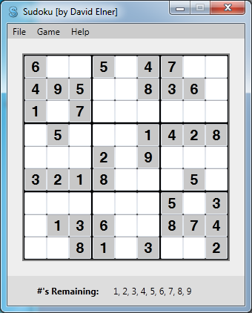

Figure : Main game screen

This version of Sudoku has a number of useful features, all of which are available under the *Game* menu.

These include:

1. **Show Possibilities on Hover**
   1. You may check/uncheck this option on the *Game* menu to enable this feature.
   2. When you hover over a cell, the possible values you may enter into that cell are listed below the puzzle.
2. **Show Errors**
   1. You may check/uncheck this option on the *Game* menu to enable this feature.
   2. If an error is made in the puzzle (i.e. the value for a cell does not match the value for the known solution), the number will appear highlighted in red.
3. **Remove Errors**
   1. Selecting this from the *Game* menu will clear all values from the puzzle that does not match the known solution.
4. **Solve**
   1. Selecting this from the *Game* menu will finish the puzzle with a pre-computed solution.