Structured Abstract

# Context

Healthcare industry rely heavilly to image recognition and image classification, many of disease diagnostic started from analysing image. On the other hand healthcare and medicine area require more accurate and reliable machine learning model than other industries.

# Objective

The purpose of the project is to develop a good model that can automatically give diagnose result related to skin cancer based on image classification. The problem itself use a large collection of multi-source dermatoscopic images of pigmented lesions as training dataset divided into seven classification.

# Method

Technical approach that implemented in this project are Convolutional Neural Network (CNN) which is one class type of deep learning. Four different CNN models were developed using different methods (pre-trained model, multi-input model and data augmentation).

# Result

From four models the highest result was the model that developed using pre-trained model and transfer learning, with 83% - 85% accuracy.

# Novelty

Although it was not the best model, CNN model with additional input other than the images input is the novel contribution to CNN and skin lesion image classification. Unfortunately, in this project the correlations between age, gender and lesion location were not strong enough that make additional input not effect so much to the model prediction.

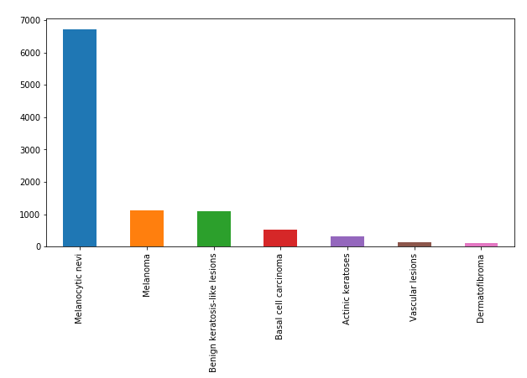

Figure 1 The extremely imbalance of the Dataset

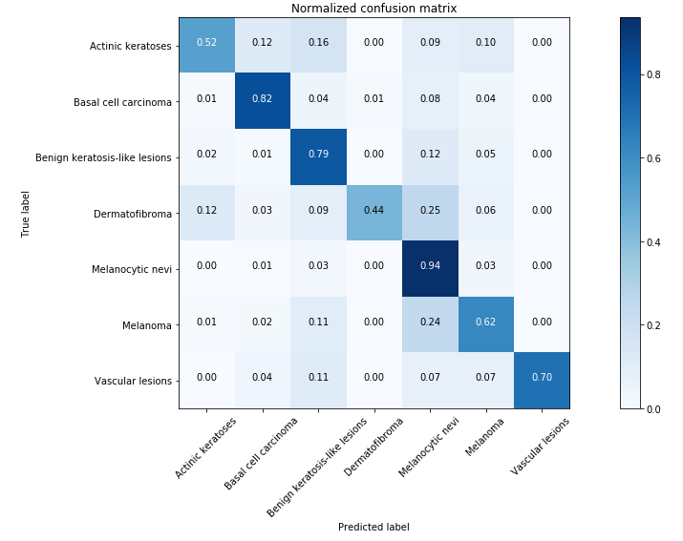

Figure 2 83% accuracy is not good enough especially in healthcare industry. Dermatofibroma and Melanoma have quite high missqualified result