Structured Abstract

# Context

Benchmarking the performance of cloud computing is never become an easy task, moreover if it is about super computer with many GPUs that working parallel. If the evaluation of the cloud is done carefully and give a good measurement, it can enable the organization to do optimisation.

# Objective

The purpose of this project is to evaluate the usage of 1024 GPUs that are used to render smart city terapixel image with expectation the usage duration of the cloud can be more optimised.

# Method

The evaluation mostly done using the guideline from “Scientific Benchmarking of Parallel Computing Systems” written by Torsten Hoefler. Specifically the 12 rules to report the performance evaluation results.

# Result

The project identify some pattern of the GPUs usage anomaly as well as the correlation between several GPUs performance variables (memory utilisation, CPU utilisation, temperature and power draw).

# Novelty

My novel contribution would be to use persistent database to store the data instead of in memory or csv file. It is different from my last datascience project that was used csv file, and for large data it was very convenient to use persistent database, moreover for reproducibilty it can increase the data preprocessing.

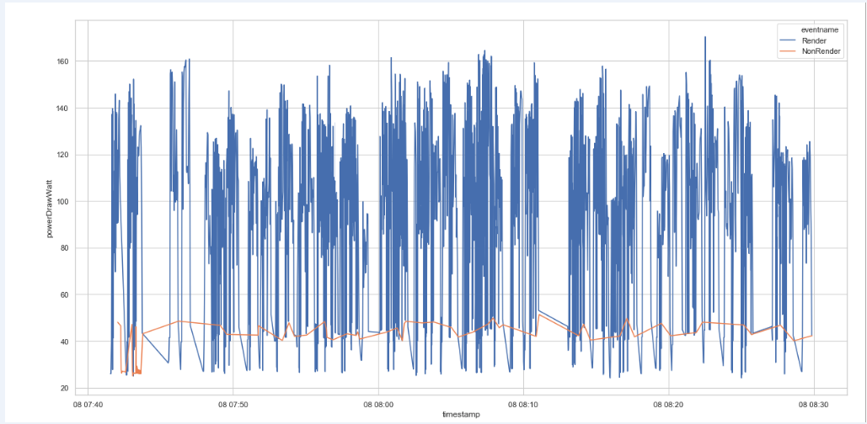

Figure 1 Power draw when render time and when non-render time

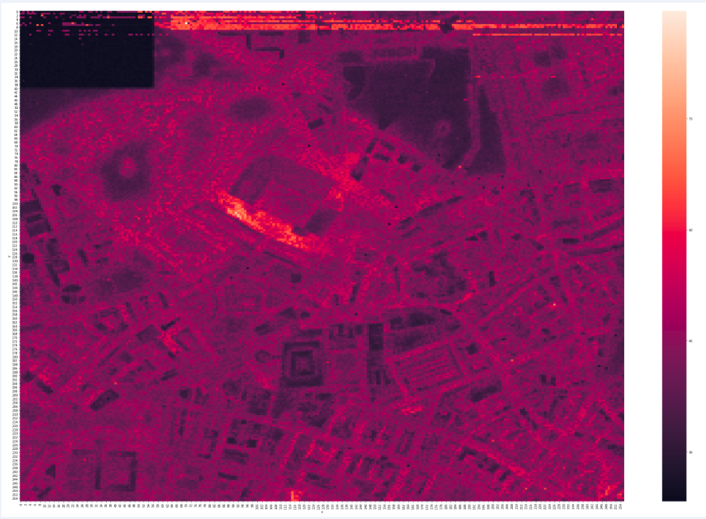

Figure 2 heatmap of time duration of the level 12 tiles image (256x256), can be seen some outliers and building trace