CDA Tool
Ver. 1.0

Table of Contents
Step 1: Request for TID (skip to step 2 if you already have a TID) 3
Step 2: Login using Stellantis Credentials 4
Step 3: Select your CAN-hardware device. 5
Step 4: Select your CANFD2 bus line. 6
Step 5: Select CVADAS from list. 8
Step 6: CVADAS identification successful 9
Step 7: SGW Unlocking / Authenticated Diagnostic Access Unlock 10
Step 8: ECU Identification 12
Step 9: On-Board Routines 14
Step 10: ECU Reset 15
Step 9: Read Diagnostic Trouble Codes. 16
Step 10: Avaliable Diagnostic Sessions 17
Step 11: PID Editor 18
Step 12: Reading bus-traffic and saving a can-log (.asc) 19

Step 1: Request for TID (skip to step 2 if you already have a TID)
To Request TID, please click link below to request a CAN
https://signup.fca-tools.com/
Please fill out as shown in example below:
- Select New User (if you do not have TID) or Reapply for Access if you want to add new access to existing TID (For example, ADA)
- Enter you contact information accordingly
- Business Justification: Test Engineer
- Stellantis Senior Mgmt Approver: Steven Stefanoski – Steven.Stefanoski@stellantis.com
- Access Type: ECU Supplier
- Release Engineer: Sam Tkac – Sam.Tkac@stellantis.com
- Authenticated Diagnostics: Yes.
- Do you have a FCA TID: Select No then you can contact Sam.Tkac@stellantis.com to get one.
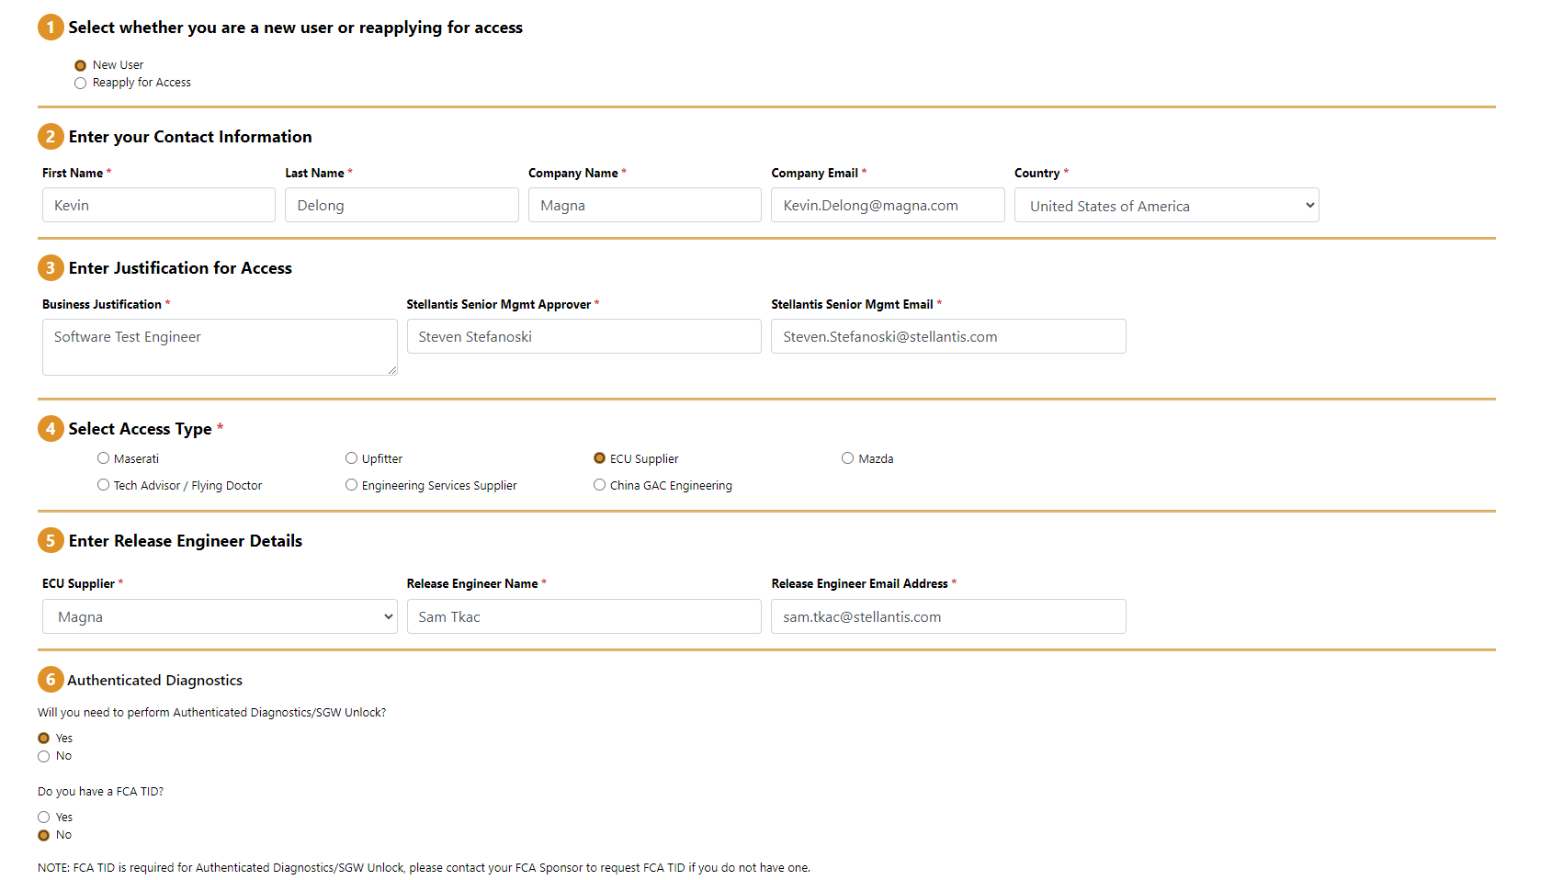

Wait for an email from support@dcctools.com with confirmation of your new TID and follow the steps that are provided for account verification. This will be the second request for stellantis credentials that you will need to login to CDA tool in Step 2.

Step 2: Login using Stellantis Credentials
- Login to Stellantis credentials for authenticated diagnostics access (ADA).
  - Logging with your Condro credentials will not have authenticated diagnostic access but tool can still be used for can-bus logging, read Diagnostic identifers and read diagnostic trouble codes.
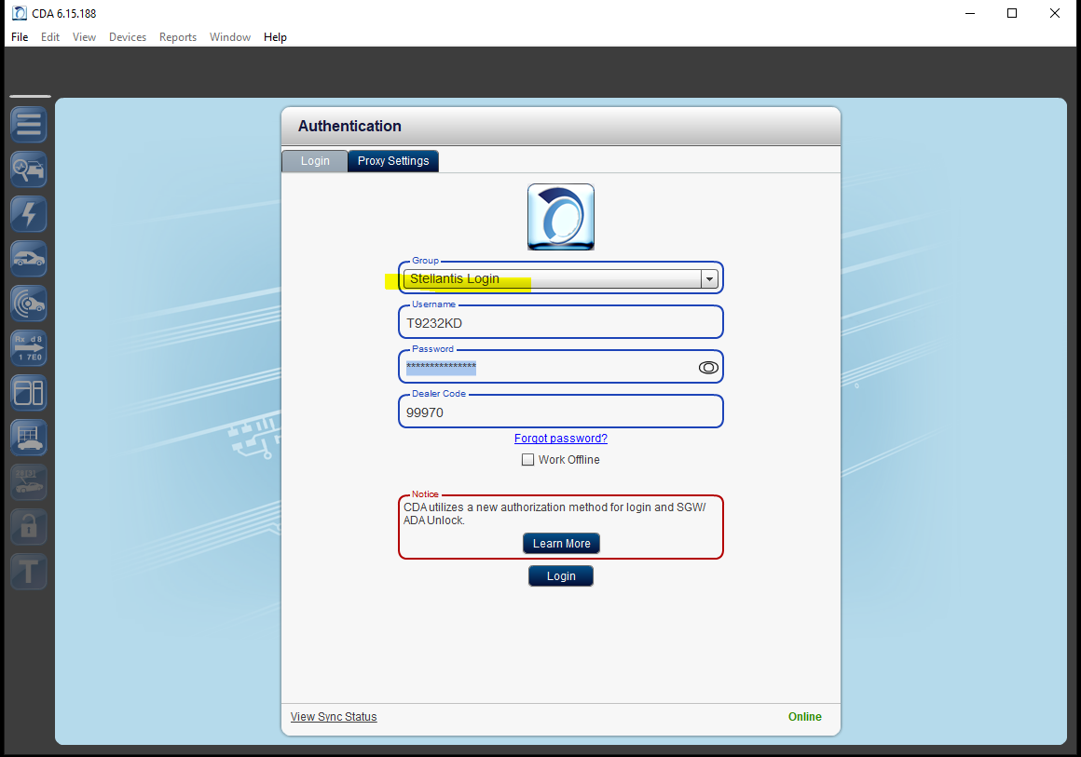

Step 3: Select your CAN-hardware device.
All vector hardware that is connected to your PC will show on screen below with status indicator. A green indicator means the device is avaliable to connect. A red indicator means the device is currently in use. If device is in use, close the corresponding software like Vector CANoe, Vflash or VTeststudio.
- Press the Benchtop mode if you are on bench without SGW module connected
- Press Vehicle Mode if you are in a vehicle with SGW module connected.
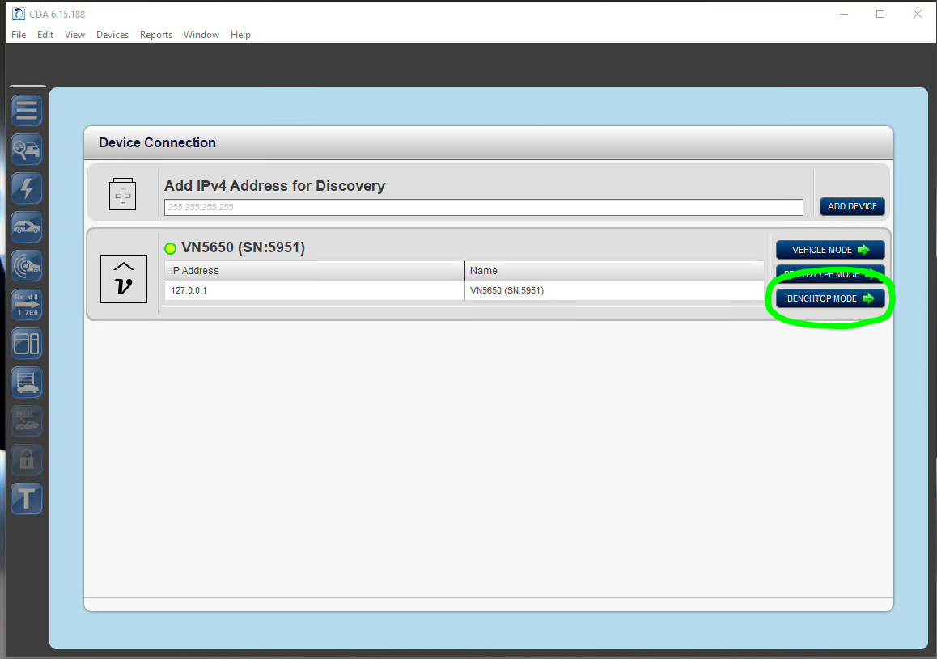

Step 4: Select your CANFD2 bus line.
- CDA tool will communicate on CAN-FD2 bus.
  - Select the CAN-database for CAN-FD2 that applies to the correct configuration (Atlantis-high)
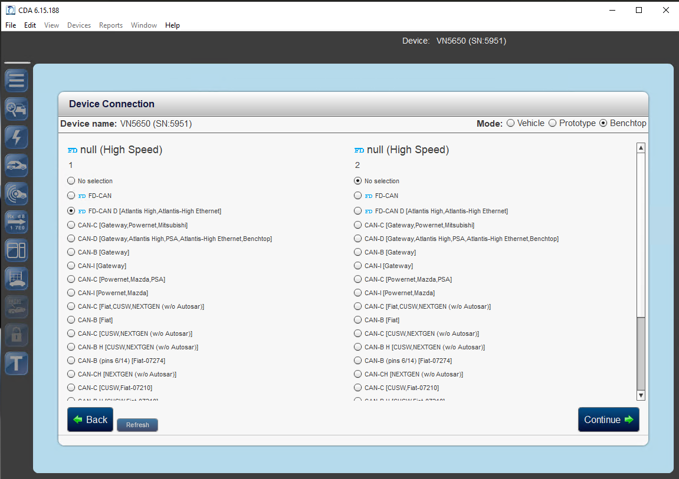

Step 5: Select CVADAS from list.
- To System/SW Testers only: If your list does not have ETM (Radio), you can request additional access (from step 1) to reapply for access and request to add “All ECUs” for Test as a business justification.
  - ETM access is for testing on a vehicle’s display, not a d3 for image quality tests.
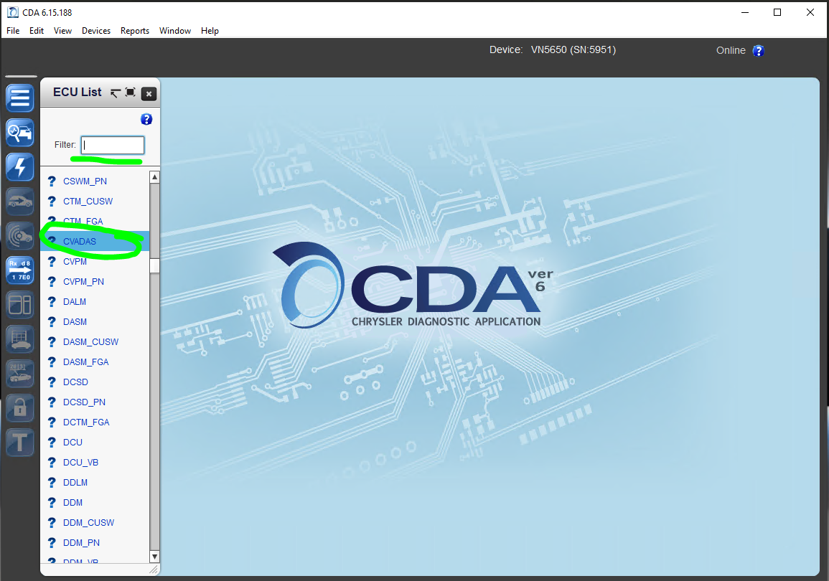

Step 6: CVADAS identification successful
If you see a error then you may have selected a wrong can-bus connection (ex. Powernet instead of Atlantis-high) or your can bus lines are not physically connected correctly on your CAN-device.
You can switch your CAN-lines on your physical device then press “Re-Identity ECU” or you can go to Devices > Change Configuration to select new can-bus configuration type.
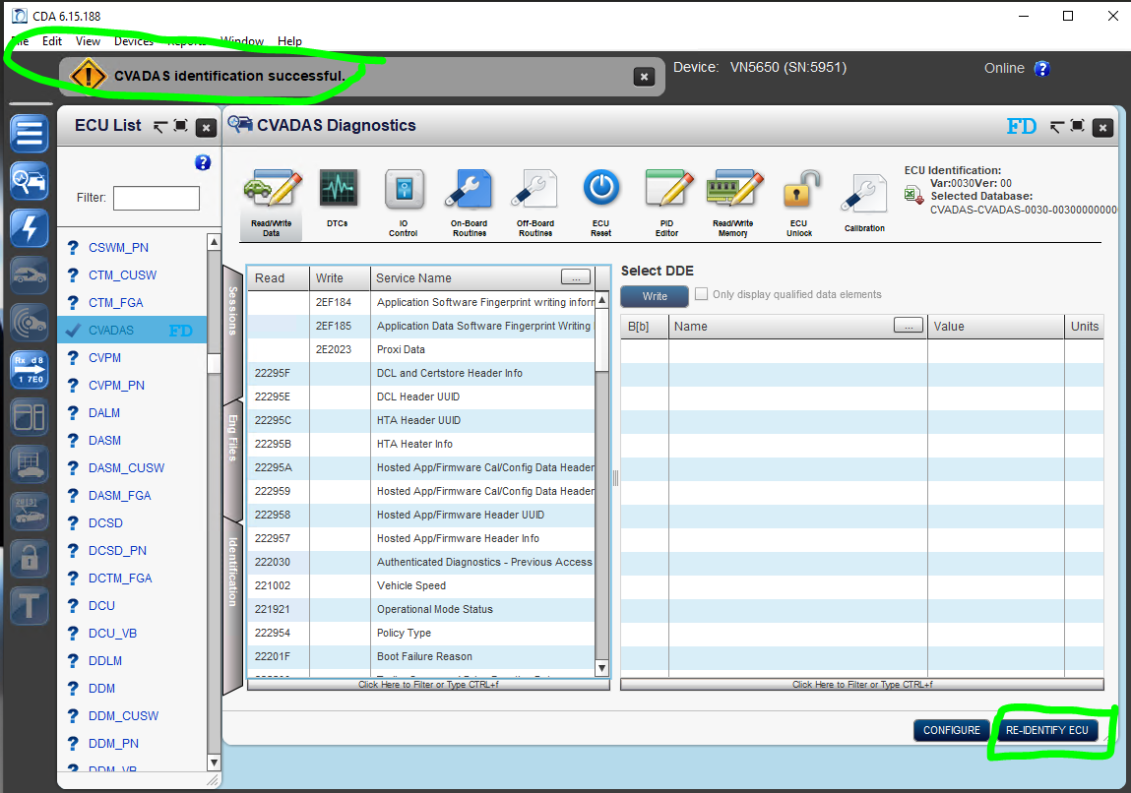

Step 7: SGW Unlocking / Authenticated Diagnostic Access Unlock
- Select Engineering Role and Press Unlock
- Security Seed and Key will be sent and proper response will be acknowledged.
When it is successful, you will see ADA Unlock Triggered then “Status and Unlock Role” will update accordingly.
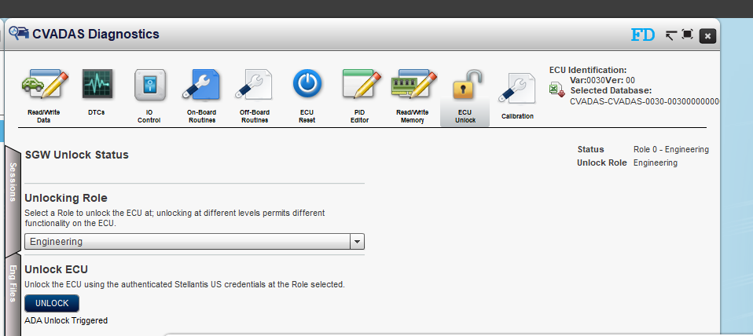

When it is not successful, You may see the following failures:
- Certificate failure:
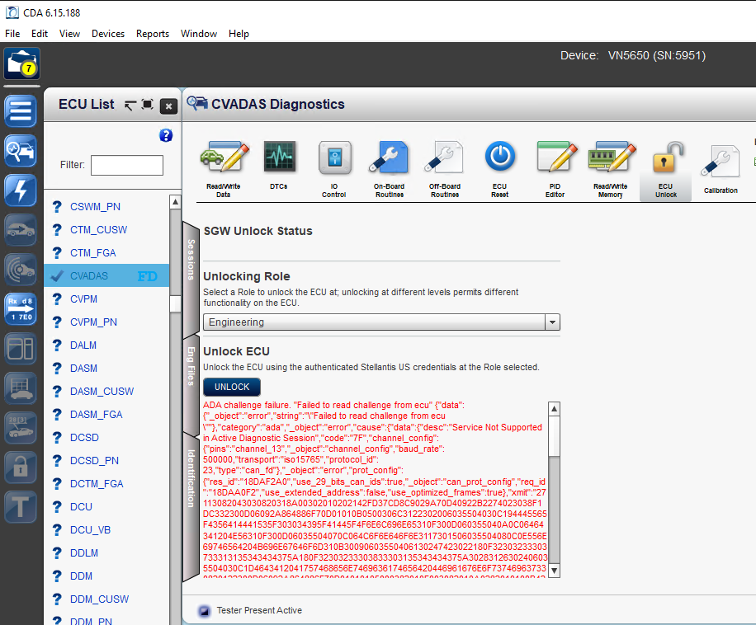
- To recover, is to flash new software that has proper certificate using lauterbach device.
- Part Number failure(s) – Make sure the proper part numbers are reading correct.
  - The tester can recovery by flashing a new EOL.bin to correct any part number failrues L2H4060_SW_part_number_matrix.xlsx
  - Policy Type (DID 2750) or ECU Serial Number (DID-F18C) are wrong!
    - ECU Serial Number
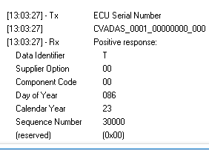
    - Policy Type: 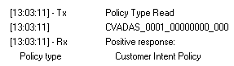

Step 8: ECU Identification
As CDA tool will include multiple revisions of the DBC and CDD versions. You can go to
Note: There is a glitch in the tool that the green check mark will not move to new selection. When you select a new Engineering file, you can verify the new file by selecting idendification tab or downloading the excel sheet to confirm the database version number.
Note: Use at your own risk – changing these files may alter the behavior of Diagnostic Identifiers (Reading part number) inforamation. Only change if expected to do so in troubleshooting negative responses (NRCs). 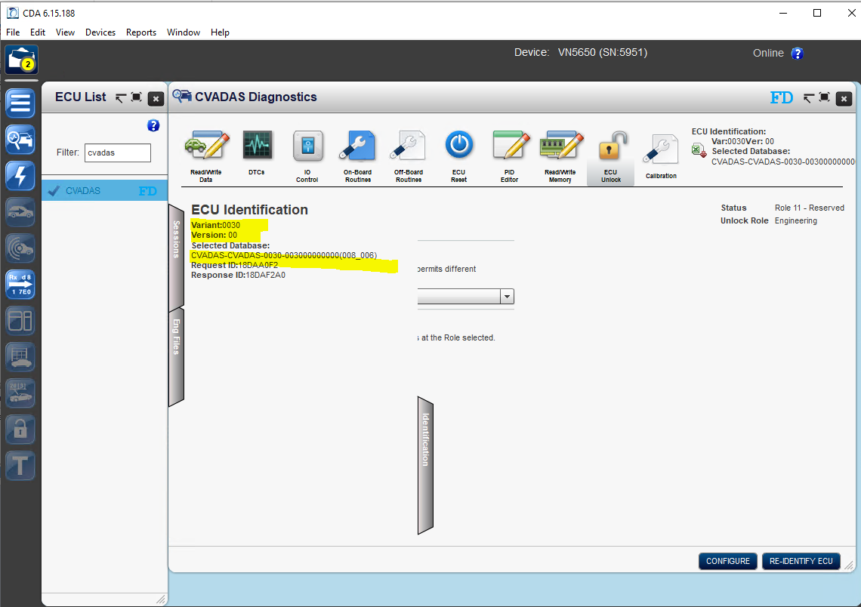
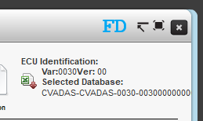
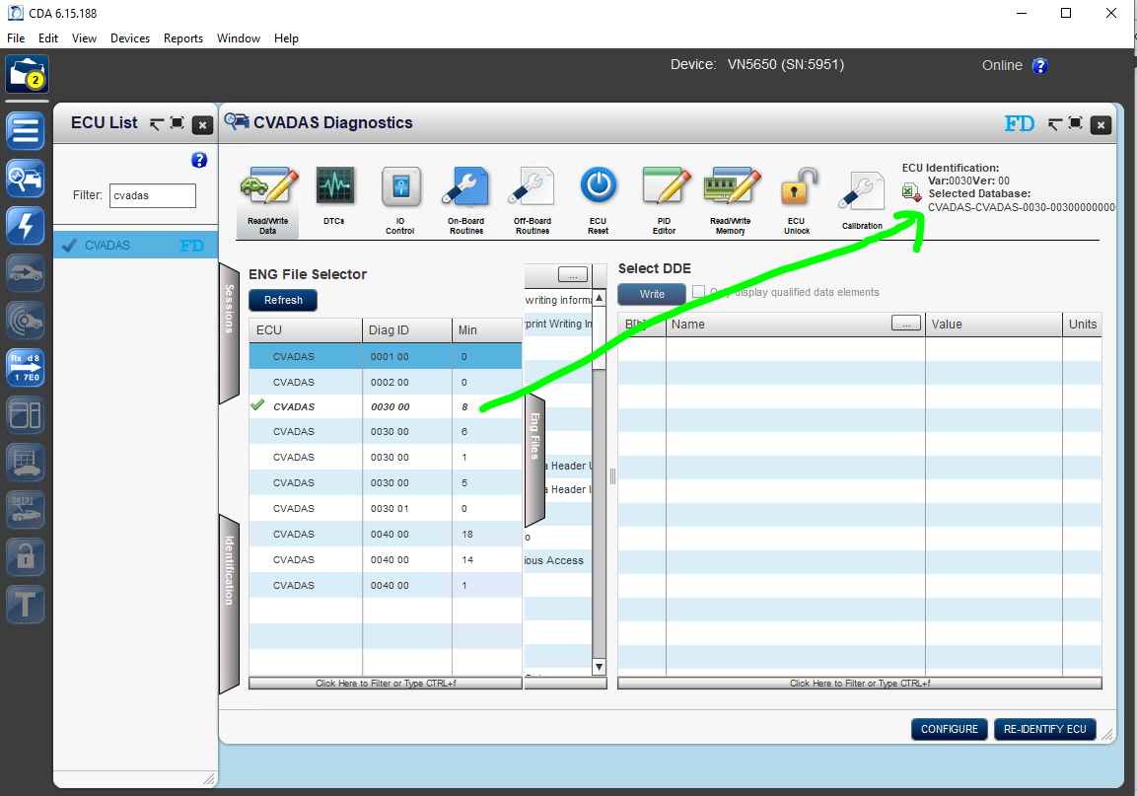

Step 9: On-Board Routines
A tester should be aware of these routines such as Camera EOL calibration, Plant Mode, Original VIN unlock, Failsafe Disable and Erase/flash using EFD file.
Use these routines are required to run specific tests -
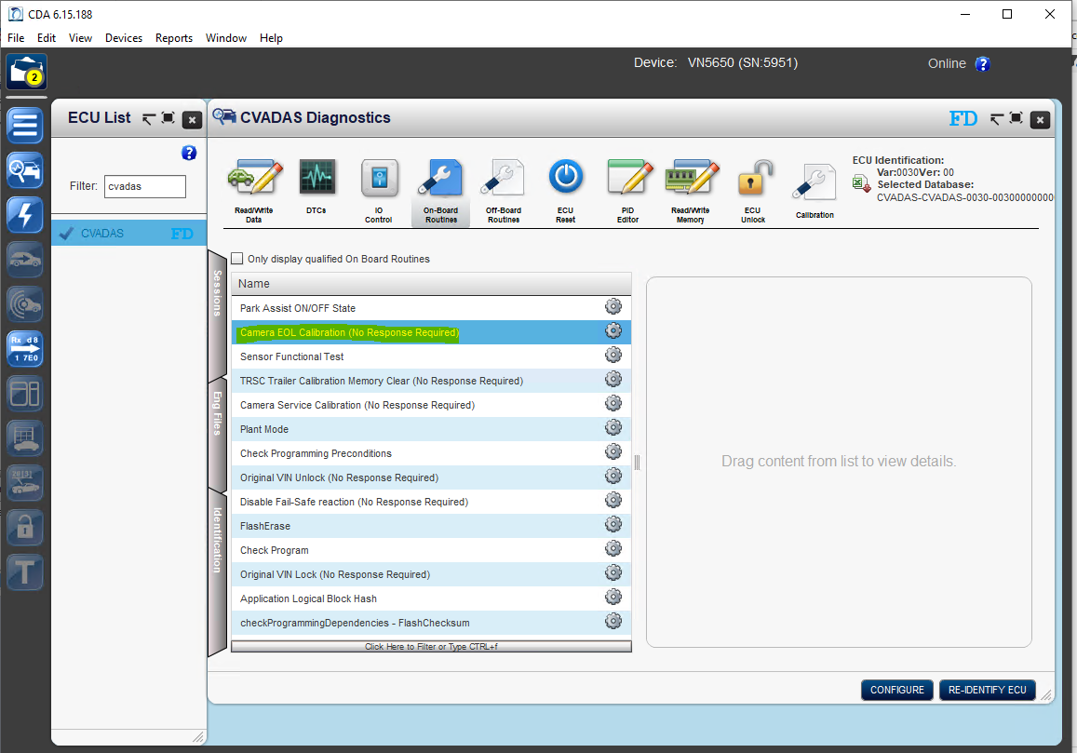

Step 10: ECU Reset
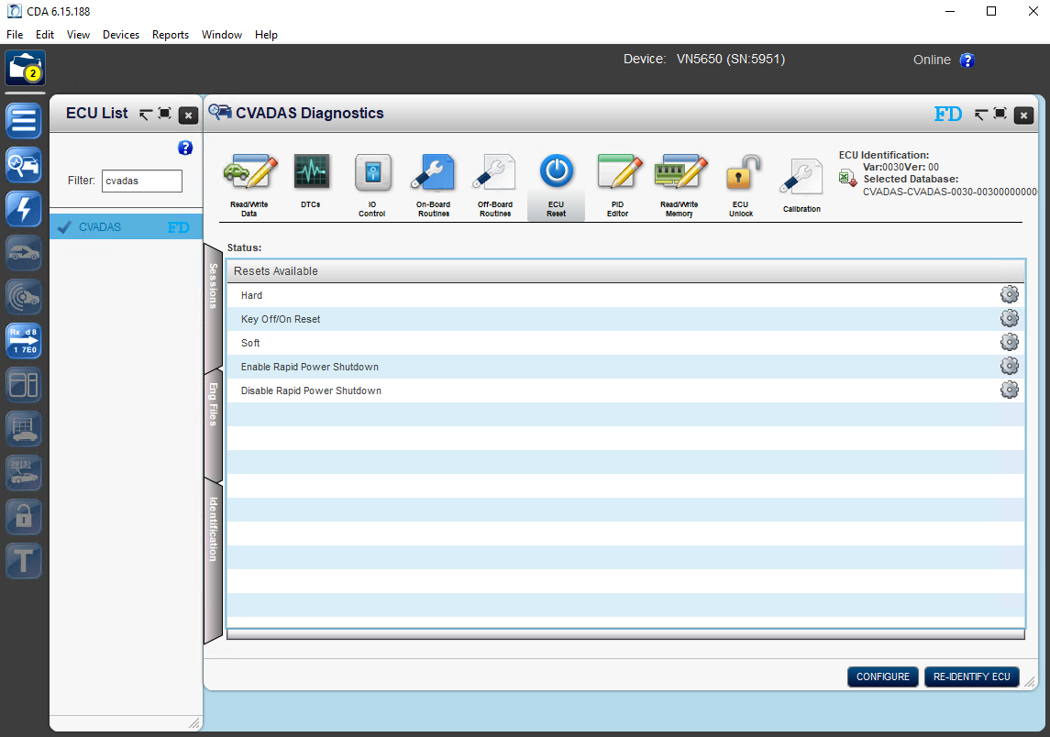

Step 9: Read Diagnostic Trouble Codes.
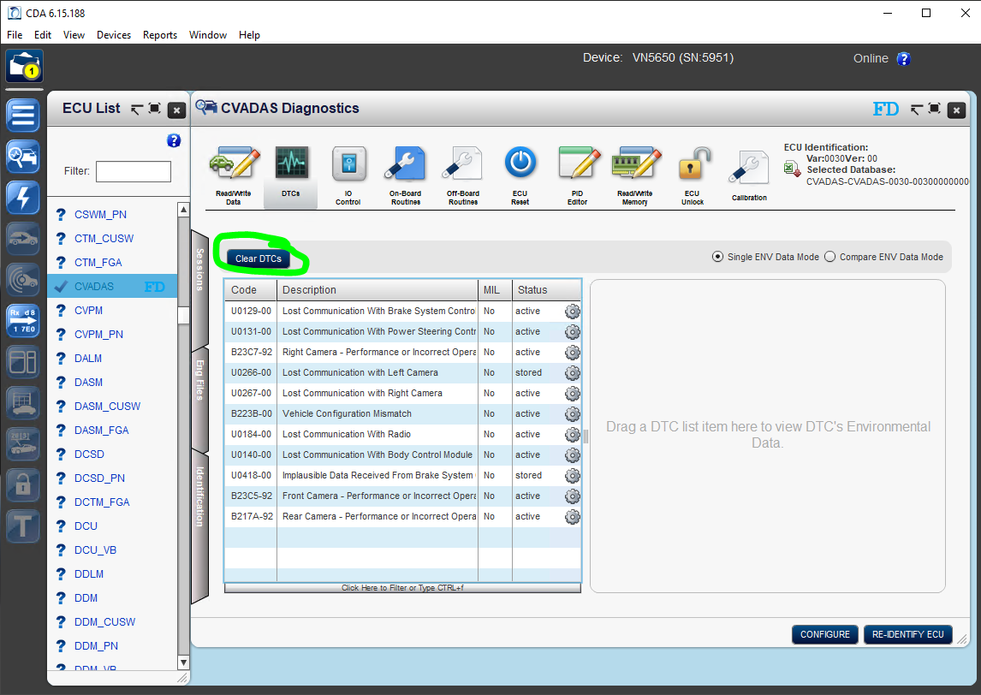

Step 10: Avaliable Diagnostic Sessions
- Default, programming and extended diagnostic session.
- User can start with or without Tester Present.
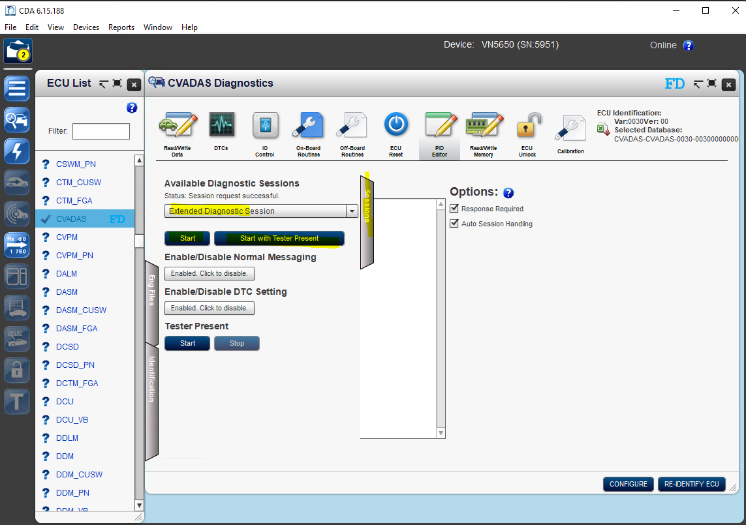

Step 11: PID Editor
You can send any diagnostic message to monitor response. This is commonly used as sending a proxy and reading current proxy on ECU.
Note: Use tab “Sessions” to enter in the required diagnostic session to send request.
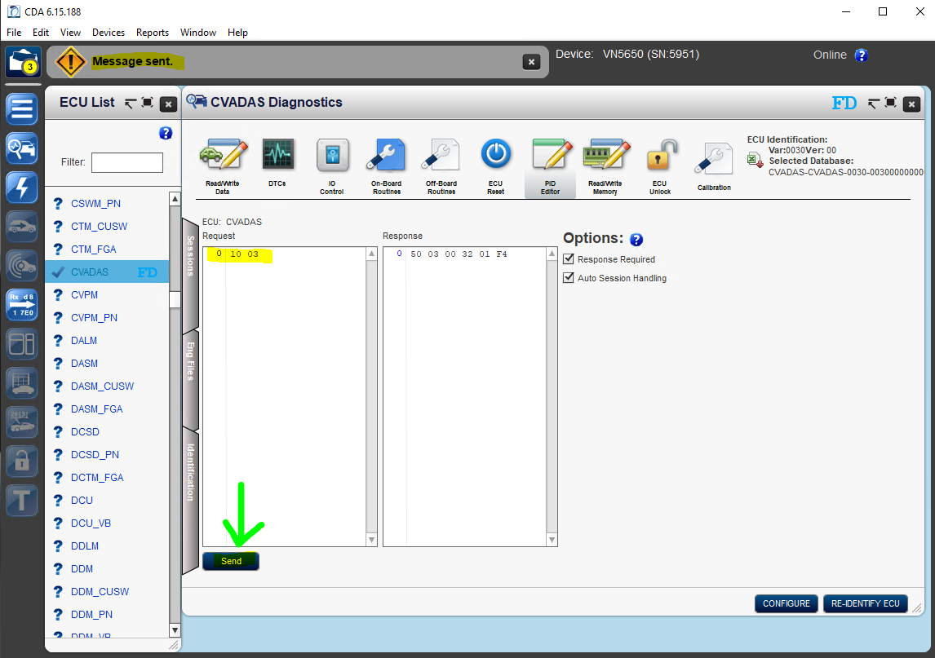

Step 12: Reading bus-traffic and saving a can-log (.asc)
