PROJECT REPORT

Adaptive human–robot scheduling for steel modular integrated construction
  - Factory production, human state and verified execution
English five-chapter report
P08 W5 | Local integration candidate v1.1.0
Source baseline: step-P07-r3
75c77ef9cf304b917ed87af002c169131f610fdd
The report documents the implemented simulation framework and its measured results. Owner operation is scheduled after document completion and is recorded separately. Appendix C records the subsequent W1 to W5 engineering candidate.

Contents
Abstract 3
1 Introduction 4
1.1 Production problem 4
1.2 Aim and research questions 4
1.3 Contributions 4
2 Related works 5
2.1 Collaboration and dynamic allocation 5
2.2 Fatigue, recovery and decision objectives 5
2.3 Rescheduling and bounded search 5
2.4 Position of the present study 5
3 Methodology 7
3.1 Production model and constraints 7
3.2 Collaboration modes and human state 8
3.3 Equipment, order and physical states 9
3.4 Execution feedback and independent validation 10
3.5 Adaptive controller and legal baseline 10
3.6 Dynamic catalogs and continuous sessions 11
3.7 Dual-view workbench and saved results 12
4 Experiments 13
4.1 Evidence design, versions and questions 13
4.2 Metrics and comparison rules 13
4.3 Normal production and closed-loop correctness 14
4.4 Collaboration, fatigue and the whole-module outcome 14
4.5 Equipment failure and legal recovery 17
4.6 Orders, cancellation and dynamic personnel 18
4.7 Strategy outcomes and computational effort 19
4.8 Failure history, performance and reproducibility 20
4.9 Scope and limitations 20
5 Conclusion 21
5.1 Answers to the research questions 21
5.2 Supported follow-up work 21
References 22
Appendix A. Evidence, reproduction and requirement locations 23
Appendix B. Contribution and AI assistance 24
Appendix C W1 to W5 engineering integration 25
C.1 Purpose and version of the evidence 25
C.2 What the staged work established 25
C.3 The integrated implementation and independent checks 26
C.4 Operating the candidate and returning to the original path 26
C.5 Interpretation and remaining acceptance 27

Abstract
Factory scheduling for complete steel volumetric modules in Modular Integrated Construction (MiC) requires coordination of fabrication, transport, workers, equipment and physical space while orders and resource states change. This project develops a simulation framework that connects a multi-resource production model, fatigue-dependent execution, verified online scheduling and an Isaac Sim workbench. Manual and sequential human-robot branches share a defined output, while commands, observations, dynamic catalogs and saved results retain explicit identities. Evaluation combines five fixed scenarios with an earliest-due-date baseline and an adaptive policy, four collaboration/fatigue mechanism cells, historical complete production and targeted physical execution witnesses. In the fixed comparisons, the adaptive policy produces no reduction in final receipt time; the largest exposure difference is approximately -0.001013 fatigue-hours in the urgent-order case. Sequential collaboration reduces branch labour by about 68% relative to manual processing, yet normal-condition final receipt is unchanged. Under high initial fatigue, the corresponding mechanism comparison advances receipt by 22.071 simulation hours. Waiting contributes 68.98% of model exposure in the normal baseline. These results show why local processing gains, modelled human exposure and final delivery require separate evaluation. Dynamic orders, personnel changes and saved-data reconstruction are demonstrated at the scopes recorded in Section 4. Sustained display performance, several operating extensions and owner operation remain open, and Project status lists them. The framework provides a traceable basis for studying these interactions, with measured negative results as well as working mechanisms.
Project status (as of this version). Implemented and checked: the production model, the manual and sequential branches, execution feedback and audit, bounded search with rule continuation, dynamic catalogs and saved-session reconstruction. Demonstrated at local scope: dynamic orders and personnel, cancellation cleanup, and the H/F/U/C witness cases. Open: owner continuous operation; sustained display performance (the 2 s source-age and 4 Hz goals are not met); industrial qualification; in-process cancellation and J3 recovery; the K01 native-driver root cause. Evaluation result: the fixed-scenario adaptive policy gives no delivery benefit; the collaboration/fatigue comparison in Section 4.4 is the substantive mechanism result.

1 Introduction

1.1 Production problem
Hong Kong’s Buildings Department describes Modular Integrated Construction (MiC) as a building method in which independent volumetric modules incorporating finishes, fixtures and fittings are made off site and brought to the building site for installation (Buildings Department, 2026). This study examines the factory production of complete steel MiC modules through modelled dispatch and external receipt. Site erection, inter-module connections and whole-building assembly are outside the simulation. Singapore’s prefabricated prefinished volumetric construction (PPVC) provides a related off-site production reference (BCA, n.d.). A faster fabrication operation may leave transport, assembly, quality and receipt obligations unchanged. Hong Kong MiC definition and Singapore PPVC reference.
The model studied here represents a complete steel MiC volumetric module served by named workers, a robot, production machines and a gantry crane. The resources interact through task precedence, skills, calendars, fixtures, material availability and spatial occupancy. A robot processing a frame can release a worker while continuing to hold the robot, fixture and work area until unloading. A worker waiting for another operation can still accumulate modelled fatigue. A completed module can remain in finished space until external receipt. The relevant scheduling state consequently extends beyond a list of unfinished tasks and free machines.
Changes during execution add a second difficulty. Equipment may fail while carrying a load; a person may depart while holding an assignment; an urgent order may enter after work has already started. A revised schedule must respect physical facts and accepted obligations while reconsidering future work. Predictive-reactive rescheduling offers an established way to connect plans with changing production conditions (Vieira et al., 2003). This project applies that principle to an explicitly checked simulation and records the distinction between a proposed plan, an adopted plan and an action that actually starts. Rescheduling framework.

1.2 Aim and research questions
The aim is to develop and evaluate an adaptive scheduling framework for steel MiC module manufacturing under changes in human, equipment and order state. Three questions organize the report:
1. Can the production model and simulation enforce the required resource, human-state and physical constraints while preserving a traceable feedback-to-execution chain?
2. Can the scheduling and session interfaces respond to order and personnel changes, retain committed work and reconstruct the resulting execution and display data?
3. In the evaluated cases, how do adaptive scheduling and collaboration modes affect delivery, human exposure, resource use and computational effort?
The evaluation uses the approved S18-SIM-A1 simulation abstraction. Processing and welding are timed symbolic operations, with geometric and execution predicates read from Isaac USD. The model provides a controlled setting for studying scheduling behaviour. Industrial welding qualification and measured physiological calibration are outside the established evidence.

1.3 Contributions
The work contributes an integrated, executable production model; a versioned interface linking observations, scheduling decisions and dynamic changes; and an evaluation that keeps execution validity, operating usability and performance outcomes separately inspectable. The empirical contribution is the comparison itself, including the absence of a meaningful fixed-scenario strategy advantage and the differing local and global effects of collaboration. The final software baseline is the published step-P07-r3; historical experiments retain their original source identities.

2 Related works

2.1 Collaboration and dynamic allocation
Collaboration mode and allocation policy describe different decisions. A mode specifies how a task is performed and which resources are held during its stages. Allocation selects an eligible resource or team for work that has become available. Park et al. (2025) address ergonomic fatigue together with sequential and simultaneous cooperation, so these concepts already belong to the scheduling literature. The present project selects sequential collaboration for its admitted frame operations and evaluates its consequences across the remaining production chain. Park et al..
Petzoldt et al. (2022) develop and evaluate dynamic human-robot task allocation, reporting adaptation to delays and cycle-time reductions where assembly provides sufficient parallelism. That dependence on process structure is directly relevant here: reallocating an operation cannot by itself guarantee an earlier final receipt when downstream requirements remain. It motivates reporting branch effort and module delivery together rather than using one as a proxy for the other. Petzoldt et al..

2.2 Fatigue, recovery and decision objectives
Human-state objectives require an explicit choice of measurement level and aggregation. Chand and Lu (2023) consider personalized fatigue, recovery and cycle time, including objectives focused on team or individual fatigue. The distinction motivates retaining both total exposure and the highest individual exposure in this project. Chand and Lu.
You et al. (2025) connect muscle-force estimation, a fatigue model and task allocation through a human digital twin. Ma et al. (2009) model effects of external load, workload history and individual differences, while identifying limits in dynamic experimental validation. These studies establish the relevance of state and history but also clarify a modelling choice here: the worker-level fatigue state is synthetic and interpretable, with declared accumulation and recovery rates. A reduction in its integral is a change in model exposure; interpreting it as a physiological benefit would require appropriate measurements and calibration. You et al., Ma et al..

2.3 Rescheduling and bounded search
Vieira et al. (2003) distinguish the production environment, the rescheduling strategy, the policy determining when to reschedule and the method used to change the schedule. This separation is useful for the implemented system. Its observed state defines the admissible problem, initial/periodic/event conditions trigger planning, and a bounded search proposes changes to uncommitted work. A legal dispatch rule supplies a continuation when no admissible new candidate is available.
Large neighbourhood search improves a candidate by destroying and repairing parts of a solution (Pisinger and Ropke, 2010). Here the removable part is a proposed future suffix. Completed execution and current resource ownership remain fixed. Candidate generation is therefore coupled to physical replay and independent verification. The use of this established search pattern is a design choice; the fixed-scenario evaluation in Section 4 determines whether its configured use improves outcomes. Pisinger and Ropke.

2.4 Position of the present study
The selected literature supports dynamic allocation, fatigue-aware decisions and reactive scheduling. The project brings those concerns into one steel MiC factory execution model with named crews, staged ownership, transport, stock, quality gates and receipt. Its particular research question is how these constraints interact in the implemented system and whether measured outcomes justify the additional scheduling effort. The comparison focuses on the design choices needed for these questions; the accompanying evidence index records source access and the scope of each citation. The production evidence ledger traces the choices for frame assembly, mechanical, electrical and plumbing work, fit-out and release gates to the available construction sources and distinguishes evidence from simulation assumptions.
Table 2-1. Roles of the selected sources in the argument. Source access and claim locations are also recorded in the accompanying evidence index.
Source group | Established idea | Use in this study
Hong Kong Buildings Department and BCA | MiC definition and related PPVC manufacturing context | Establish the complete volumetric module as the unit of study. Provide no project timing calibration
Park; Petzoldt | Collaboration stages; state-dependent task allocation | Separates mode selection, allocation and whole-chain outcome
Chand and Lu; You; Ma | Individual/team fatigue, recovery and state estimation | Motivates explicit human-state assumptions and multiple exposure summaries
Vieira; Pisinger and Ropke | Rescheduling policies; destroy-repair search | Structures the online controller, triggers and bounded future repair

3 Methodology

3.1 Production model and constraints
The model represents the manufacture of a complete steel MiC volumetric module, including structural fabrication, mechanical, electrical and plumbing work, finishes, quality release, packaging and dispatch preparation. A module has an order identifier, variant, revision, bill of materials, release time and due time. Core activities form a directed graph whose edges distinguish material dependencies, precedence, quality release and process-wait release. The selected SR-W1 configuration contains 37 core activities and 40 edges. These activities expand into 448 static operations across all alternative branches. An execution follows one admissible branch for each alternative work package; consequently, the static operation count is not a production completion target. Walking, empty travel and rest services generate additional commands when required. The production graph follows the module from fabrication and frame assembly through services and fit-out to quality release, dispatch preparation and modelled external receipt. The software record Product identifies one complete module instance. Bottom and top frames are components of that instance.
The production configuration imports Product, Person, Activity, Role and related records from domain/building.py. Its operation, device, command and execution-state records are defined in domain/production.py. This distinction also fixes the units: production time is measured in hours, distance in metres, mass in tonnes and travel speed in metres per second. Fatigue is dimensionless and cumulative exposure is measured in fatigue-hours. The earlier pipe-domain records use minutes and do not define the building production model.
A dispatch is identified by the configuration digest, run and epoch, module, activity, operation, attempt, unit and command identifiers. An operation can start only after its operation predecessors and any required completed-activity predecessors have been satisfied. For an activity with alternative modes, completion refers to the complete selected branch. It does not require both branches or permit a mixture of their units. Material inputs must have arrived, been identified and been released. Their reservations, transformation, consumption, scrap and return remain explicit. Component assembly also checks each component's physical input location. Completing a work unit does not itself create a quality PASS.
Four principal resource classes serve the production process. Named people perform preparation, welding, assembly, installation, testing and handling. Robot R1 performs the isolated robotic stage of the bottom- and top-frame work packages. CUT1 and the welding equipment perform their specified machining or welding operations, while TEST1 serves the modelled testing stages. Gantry crane CR1 moves components and frames with a named operator, rigger and signaller. Forklift, cart, fixture, support, route and location constraints remain part of the same model. R1 is encoded as a fixed device; its robotic role comes from its identifier and stage binding.
Resource ownership prevents incompatible simultaneous assignments. An operation checks the positions and qualifications of its bound people, equipment availability, route occupancy, load and size limits, material presence and destination capacity. Crane load checks use the current entity mass, installed material increments and rigging rather than only the nominal module mass. A source location remains occupied until the modelled move and landing complete. Finished-space occupancy also remains until an admissible external receiving operation completes.
The field, unit, consumer and verification mapping provides the detailed model specification. The complete process and resource-use graph is supported by the 37-activity table. The historical resource witnesses bind accepted starts to completions and their LIGHT_EXECUTOR or ISAAC_USD readback sources.

3.2 Collaboration modes and human state

Applicable modes and common output
Manual production, H, and sequential human-robot production, HR-seq, are alternatives for W-B and W-T, which produce the bottom and top frame components. Each alternative binds the same module and component revision, abstract joint set and output revision. The mode definitions are distinct and are committed at preparation. Other activities retain their applicable team, movement, waiting or gate modes; only the frame components carry an H/HR choice.
In H, a qualified welder performs a 0.5 h setup unit, four 0.5 h work units and a 0.5 h unloading unit. The baseline total is 3 h. The first five units have fatigue sensitivity coefficient κ=0.5; unloading has κ=0. In HR-seq, OP1 performs a 0.5 h setup, R1 performs a 1 h robotic unit without a continuously assigned human role, and OP1 performs 0.5 h unloading. Only setup has κ=0.5. Actual walking out of and back into J2 is additional to this 2 h processing baseline.
H holds WELD-J2 and FIX-J2; HR-seq holds R1 and FIX-J2. Ownership is assigned to the activity, attempt and revision and persists between units. Robot completion therefore does not release the robot or fixture while unloading is pending. Before robotic processing, people must have left J2 and no incoming walk may conflict with the stage. Human access requires the stopped-robot condition. Completion readbacks must match the branch and stage owners; the robotic stage also requires isolation evidence. Only completed unloading releases the held resources. The explicit phase and ownership table separates the process branch phase from the labour-accounting phase.
At a legal manual work-unit boundary, a crew change requires 0.1 h of HANDOVER involving both people and 0.1 h of RESTORE by the incoming person. The initial check covers the required 0.2 h path, including calendar and fatigue feasibility. The fixture stays held throughout. An interrupted or structurally cancelled attempt enters HOLD; it cannot switch mode or silently restart another branch.
The two branches share one output definition: a simulated frame component under the S18-SIM-A1 abstraction. Sharing it is what makes the H and HR branches comparable, and it bounds the claim: industrial weld qualification, weld quality, toolpath accuracy and safety certification are outside the abstraction (Appendix A).

Fatigue, recovery and duration
Let F_i(t) denote person i's fatigue, E_i(t) cumulative exposure and Δ a time interval in hours. For a non-recovery interval with activity rate a_i,
$$F_{i}(t+Δ)=F_{i}(t)+a_{i}Δ$$
$ΔE_{i}=\frac{Δ}{2}[F_{i}(t)+F_{i}(t+Δ)]$ (3-1)
For REST or OFF_SHIFT, recovery occurs at rate b_i until fatigue reaches zero. With u=min(Δ,F_i(t)/b_i),
$$F_{i}(t+Δ)=max(0,F_{i}(t)-b_{i}Δ)$$
$ΔE_{i}=\frac{u}{2}[F_{i}(t)+F_{i}(t+Δ)]$ (3-2)
Exposure already accumulated is retained. The 15-person parameter table records the actual input rates. Initial fatigue is 0.2, waiting accumulates at 0.02 h⁻¹ and recovery uses 0.2 h⁻¹. Work rates differ by person: W1 and W2 use 0.15 h⁻¹, whereas OP1 uses 0.04 h⁻¹. An unassigned person in a working window accumulates WAIT exposure unless explicitly resting. Robotic processing alone does not determine OP1's state.
An operation samples the maximum fatigue of its bound people at the unit start. For the applicable nominal duration d⁰_j and coefficient κ_j, the duration is
$f_{j}=max(\{0\}∪\{F_{i}(t_{j}):i∈C_{j}\}), d_{j}=d_{j}^{0}(1+κ_{j}f_{j})$ (3-3)
where C_j is the bound crew. The included zero defines f_j=0 for an empty crew, matching the executor's max(..., default=0). A robotic unit has no human role and κ_j=0, so its duration remains its nominal processing time. Travel duration includes route distance and speed, converted to hours, and the applicable setup, load and unload costs before the multiplier is applied. Adding crew members does not imply proportional acceleration. Verified partial execution and its remaining work are retained when a supported continuation is admitted.
Labour admission checks each bound person against the common cap of 0.8 using the sampled duration and that person's work rate. The implementation accepts only F_i+d_j a_i≤0.8+10⁻¹⁰ and a complete admissible calendar interval. Calendars repeat every 24 h with working windows [0,4) and [4.5,8.5); the intervening break and off-shift intervals recover explicitly. A REST service lasts at least 0.25 h. The rule planner can request it after an infeasible labour proposal or before idle waiting reaches the cap, and then rechecks the work. Rest does not create material, preparation or release facts.
The numerical consumers have distinct checks. The hour-domain adapter building_human.integrate uses the minute-domain human_state.evolve after explicit unit conversion. The S18 production executor integrates in hours directly; its interval integration rejects fatigue at or above 1, while labour admission, timely rest proposals and the independent audit enforce the 0.8 operating cap. Unknown emergency-hold duration remains explicit in the recorded trajectory.
The hand calculations and bounded witnesses check actual duration, integration and admission. With W1 at F=0.2, a 0.5 h unit at κ=0.5 takes 0.55 h and ends at F=0.2825 with exposure 0.1326875 fatigue-hours. With F=0.75, the corresponding predicted endpoint is 0.853125 and the executor rejects the start. OP1's lower work rate gives a different legal boundary. These are declared boundary-state witnesses, supplemented by historical continuous mode traces. Section 4.4 compares normal and high-initial-fatigue production cells and the common-window personnel results.

3.3 Equipment, order and physical states
Equipment failure and repair enter as observed world facts. Failure can interrupt an action while its resource ownership, attached load and verified progress remain active. Continuation requires repair and renewed admissibility; a recovery command refers to the interrupted action through its resume identity. This allows the audit to distinguish a resumed completion from a duplicate execution.
Orders become available through release or an applied registration transaction. Before the corresponding observation is delivered, the planner cannot use the order. Dynamic creation generates independent module, task and bill-of-material identities from an admitted template. Registration adds demand; material arrival, quality release, scene instantiation and capacity gates determine when work can proceed. Urgency and due time enter the declared ranking and objective, while the existing execution prefix stays fixed.
Cancellation removes eligible future demand but retains consumed materials, installed components, physical holds and any necessary cleanup. Section 4 distinguishes supported stock cancellation from the unresolved in-process J3 hold. READY denotes production and release conditions; receipt additionally requires permission and completed departure across the receiving boundary. Both times are reported because a finished module occupying space is still a production-system obligation.
Table 3-1. State transitions and the facts retained by the model.
Change | Reconsidered future work | Facts retained
Failure / repair | Device-dependent dispatch and legal continuation | Attached load, progress, resource owners and interrupted action identity
New / updated order | Eligible uncommitted work and priority | Started work, existing modules and accepted commitments
Cancellation | Cancelled demand and legal cleanup | Consumed stock, installed material, physical holds and historical cost
Departure / absence / return | Crew eligibility and safe reassignment | Person identity, fatigue/exposure history, carried loads and held work

3.4 Execution feedback and independent validation
The command-observation loop binds run, epoch, configuration, state revision and event prefix. The execution backend reports acceptance, start, completion or exception. For Isaac execution, the USD port supplies command-bound positions, transport predicates and applicable ownership, isolation and stopped-robot evidence. The next scheduling decision receives an explicitly delivered observation of these events. The driver checks the delivered identity, and an independent causal audit checks whether the information used was available at that point.
A historical normal chain, E19B-normal-isaac, provides an explicit example. CUT.U1 starts at 5.448048889 h and completes in EV-456 at 5.998153856 h, with its matching USD readback. Observation OBS-456 includes that completion. Decision line 188 then dispatches CUT.U2, whose STARTED receipt is EV-458 at the same simulation time. The original CPU and Isaac traces each contain 4,402 events and 2,072 decisions, complete 436 active static operations, and record external receipt at 272.350479737 h. Their process exits and audit results retain their original identities; compatibility evidence establishes the stated reuse scope.
Validation is layered. Model checks bind fields, units and consumers and include fixed hand calculations. Execution audits reconstruct task, physical and human-state constraints. Causal checks bind observations and decisions. Candidate checks replay a full nominal window. Session checks reconstruct catalogs, requests and terminal obligations. Display reconstruction consumes the same verified envelopes and full-plan references. Corrupt-readback and re-signed invalid-record controls exercise refusal behaviour at these interfaces.
The P02 model validation includes 86 specialized tests, six boundary-state cases and four independently specified corrupt-readback cases, with later limited repairs binding table fields, locators and the empty-crew duration case. The P06.3 reconstruction repair checks plan version, plan identity, visible anchors and complete plan-row coverage.

3.5 Adaptive controller and legal baseline
The online controller consumes delivered observations and their actual event prefix. Its candidate contains future dispatches, rest and time-advance decisions, including mode, crew and order choices. Search removes and repairs uncommitted suffixes. The physical prefix, active attempts, material reservations, carried loads and accepted work remain protected. A candidate must complete its declared nominal prediction window and pass execution and causal checks before entering the usable cache. Time-limited incomplete candidates do not enter that cache.
For the N/H/F/C fixed cases, the simulation candidate score is lexicographic: negative newly completed core-activity count, total cumulative exposure and maximum individual exposure. This short-window score rewards admissible progress before exposure; it is distinct from the evaluation's final delivery metric. U uses a four-component lexicographic catalog score: negative newly completed urgent activities; negative due-weighted progress summed across modules; total exposure; and maximum individual exposure. Due-weighted progress divides each module's newly completed activity count by max(0.01 h, due time minus prediction-prefix time). The 0.01 h floor keeps the denominator positive for due or overdue work. The configuration and objective are matched within each scenario pair. No pooled effect is computed across different objective families.
Search is triggered at initialization, periodic opportunities and relevant delivered changes. An existing cached action is checked again against current identity and admission conditions before dispatch. A catalog transaction can invalidate or require revalidation of affected uncommitted choices. A surviving cache entry counts as actual reuse only when the matching action really starts; its proof links the original candidate, current observation and STARTED receipt.
The baseline uses the same Session/OnlinePolicy execution and legal domain with joint search disabled. Its rule selects admissible work using the declared order priority and due-time logic, alongside the same resource and safety conditions. Both methods can request automatic rest and must obey the same physical constraints. If search provides no usable new plan, the adaptive controller can use a valid existing cache or the legal rule; where no action is legal it waits for an applicable event or boundary.
Algorithm 3-1. Online decision cycle, expressed at the implemented interface level.
Receive a delivered observation and verify its identity and event prefix.
Apply eligible catalog changes at the legal boundary; retain physical facts.
Update obligations; invalidate or revalidate affected uncommitted choices.
If a planning trigger is eligible and budget remains:
generate/repair future candidates from the observed state;
replay and independently verify the complete nominal window;
retain only fully checked candidates admitted before the deadline.
Select a checked new/cached action, or the legal rule continuation.
Recheck current identity, resource ownership and execution admission.
Dispatch or wait; record proposal, adoption, receipt and timing separately.
Repeat from newly delivered evidence until the declared session outcome.
For fixed P053 research, the total scheduling account is 900 s, the decision and search limits are 30 s and 25 s, and the nominal candidate horizon is 0.1 simulation hours. Ordinary search is eligible while the cumulative count is below four; change-triggered opportunities can use the account up to seven calls. All five selected adaptive runs record seven calls. The controller searches uncommitted work, and the legal rule supplies the continuation. The earlier 240 s preparation account belongs to a different, failed protocol and is retained in the failure history.
Timing is reported in wall-clock seconds and simulation time in hours. Search and verification sit inside the same decision cycle, so the reported wall time already contains them; they are not added again as separate costs. Deadlines are checked at cooperative checkpoints, so an individual call can return after the configured limit. Performance accounting therefore uses observed timings and recorded overruns.

3.6 Dynamic catalogs and continuous sessions
RunSpec binds the input configuration, source, templates, method and budget. ChangeRequest carries a run/epoch, request identifier, producer sequence, expected revisions, payload and validity interval. Immediate requests are resolved at a legal boundary; future requests are checked again when due. The same identifier and content retrieves the original receipt, while conflicting content is rejected. Submission, acceptance, waiting, application and business completion have distinct states.
The catalog retains the frozen initial configuration and appends versioned changes. New workers become eligible only after qualification, calendar, location and scene checks. Planned departure prevents new assignments before safe departure or handover; unexpected absence preserves affected physical obligations. Returning workers keep their identities and accumulated human-state history. Previously admitted execution commands remain bound to their admission version, while future planning uses the latest delivered applicable catalog.
A temporarily empty interactive queue remains open under its declared budget and clock policy. Time, calendars, fatigue, exposure and costs continue to be accounted for. Closing intake establishes a boundary for new orders while preserving already accepted future obligations. Normal completion requires successful draining and the corresponding final state. Orderly stop, blocked draining, time censoring and failure are recorded as distinct outcomes; saving a stopped session preserves its record, while completion requires a drained queue and a final state.

3.7 Dual-view workbench and saved results
The Windows workbench combines a PySide6/Qt host, a React/WebEngine Gantt view and an embedded native Isaac surface. Its approved horizontal layout gives the two drawing areas equal standing, with adjustable division, symmetric enlargement and restoration. The user configures and starts a session, previews actual parameters and confirms requests through typed forms. Source age, disconnected or unknown state and read-only terminals are visible; invalid or stale states prevent business writes.
The Gantt separates actual execution, commitments, forecasts, unplanned work and superseded plans. Operation/resource views, selection, filtering, time navigation, details and export operate on the delivered evidence. A versioned full plan is a forecast, not an execution ledger. The scene-domain projection and Gantt are bound through the same observation and prefix. Restoring the exact original colours and work numbering additionally requires the saved presentation cache; the event stream alone establishes the business rows.
The user guide supplies the actual bilingual controls and a continuous-operation checklist. Rest is scheduled automatically; the manual REST control is disabled in this version. User experience under new environments and the owner's own continuous operation are recorded separately from backend tests and historical screenshots.

4 Experiments

4.1 Evidence design, versions and questions
The fixed study uses N (normal), H (high initial fatigue), F (equipment failure), U (urgent order) and C (stock cancellation). Each has a legal EDD and adaptive CPU record. Four collaboration cells compare H and HR-seq at initial fatigue 0.2 and 0.6; the two HR cells reuse the N/H EDD runs. The study reports 12 distinct quantitative units; some runs support more than one comparison. Five physical-evidence questions are supported by a historical complete normal Isaac chain and targeted H/F/U/C witnesses. The 19 coverage cells describe evidence responsibilities, and several draw on the same run.
The paired N/H/F runs use P053-c1; U/C use P053-c2 with explicit repair and input identities. Comparisons are within a scenario and its matched input, constraints and window. The observation horizon is 720 h. Actual lifecycles and derived recovery tails are separate: after an eligible completed run, the verified rest-tail calculation permits common-window exposure comparison without claiming continued production. Dynamic P043 checkpoints have no such complete 720 h tail and retain their local observation windows.
The final distribution baseline is step-P07-r3 (commit 75c77ef9cf304b917ed87af002c169131f610fdd). Its publication evidence records source and isolated-wheel checks on Ubuntu and Windows, each with 1,276 test identities; each Ubuntu round has one recorded platform skip. Twelve-unit offline regeneration reproduces the published presentation tables and four figures. Those software and reproduction results establish artifact integrity; the research measurements below retain their original run identities and timing accounts.
Table 4-1. Evidence families and the conclusions they support.
Evidence family | Recorded scope | Main use
P053 fixed CPU, c1/c2 | Ten method rows, plus two manual-mode runs | Within-scenario outcome and mechanism comparison
Historical normal Isaac | Complete normal module and original exit | Complete physical execution/feedback witness
H/F/U/C Kit prefixes | Fresh local cases, common process exit and separate audits | Specific fatigue, failure, urgency and cleanup mechanisms
P043 dynamic CPU/Kit | Separate local checkpoints, 16 historical people each | Catalog, adoption and presence/availability accounting
P052 r14; r9; E21 | Real mechanism prefix; derived continuation; independent capacity | Approved split acceptance, with distinct original limits
P063 normal/dynamic/Kit | Complete CPU; stopped dynamic; stopped Kit | Installation, saving, reconstruction and full-plan consistency

4.2 Metrics and comparison rules
Delivery measures use actual receipt, alongside READY and the number of cancelled and uncancelled modules. Tardiness is max(0, receipt time minus due time); unfinished modules are censored at the observation end rather than given an imputed receipt time. C contains one cancelled module and one received module, so its shorter receipt is not a like-for-like two-module speed-up over N.
Human exposure is the integral of fatigue. The analysis retains total exposure, maximum individual exposure, peak fatigue, activity-specific exposure and actual lifetimes. Presence is the union of recorded present intervals. Availability is presence intersected with calendars, valid qualifications and eligible personnel states; idle time is a different quantity. Group aggregation is weighted by these recorded durations, with departed people retained in the historical population.
Physical resource accounting uses interval unions for device ownership, revision-sensitive occupancy and actual transport progress with root/resume deduplication. Walking is separate from transported distance; empty return is a subset of transport. Labour cost uses an explicitly declared rate and currency only where the original run specifies them. Missing rates, CPU time and peak memory remain unknown. Recovery milestones identify actual repair/resumed execution. The historical proposed '8 h catch-up' metric lacks a frozen reference trajectory and threshold, so no catch-up number is reported.

4.3 Normal production and closed-loop correctness
The normal historical CPU/Isaac pair completes the admitted static branch and reaches receipt, with the command/readback/observation chain described in Section 3.4. The final P063 normal CPU case independently demonstrates the current packaged path: 436 active static operations, one received module, no open obligations and COMPLETED. Its full record has 1,023 completed operations including services, 4,473 events and 2,149 projection packages. The 436 static operations appear as 1,023 command-level operations once services are counted.
The final P062 Kit session demonstrates a narrower path: a confirmed order update, catalog version 1, full-plan version 2, verified saving and actual native exit zero. It stops at 0.850075 h with one module unreceived and 29 obligations. Its 173 packages and 329 events support the recorded prefix, not complete production. The normal P063 CPU case, the historical complete Isaac chain and this final local Kit record therefore remain separate evidence rows.
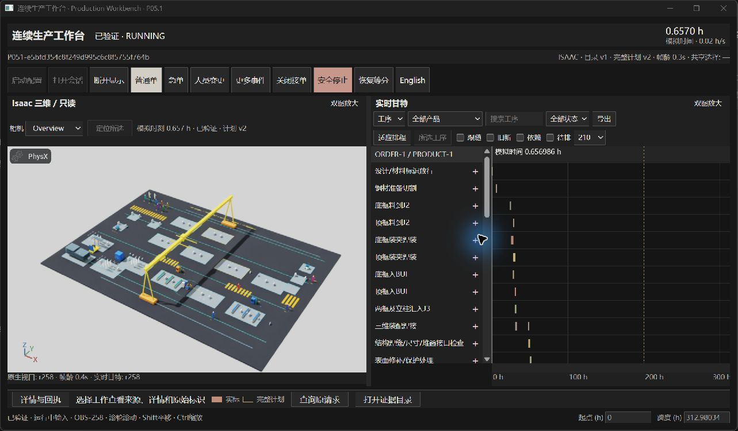
Figure 4-1. Archived real P05.1 workbench view, with native Isaac and Gantt visible together. The image is reused from its recorded live-r5 source; it is not a new P08 run or evidence that the final local Kit session completed all modules.

4.4 Collaboration, fatigue and the whole-module outcome
Sequential collaboration substantially reduces labour within the frame branches, while its effect on module receipt depends on the initial condition. With normal initial fatigue, branch person-hours fall from 12.755 to 4.036 and common-window total exposure falls by 3.48%, yet the final receipt remains 531.859 h. Under high initial fatigue, branch person-hours fall from 12.719 to 4.032, exposure falls by 4.61%, and final receipt advances from 553.930 to 531.859 h. The adaptive-policy comparisons appear in Section 4.7.
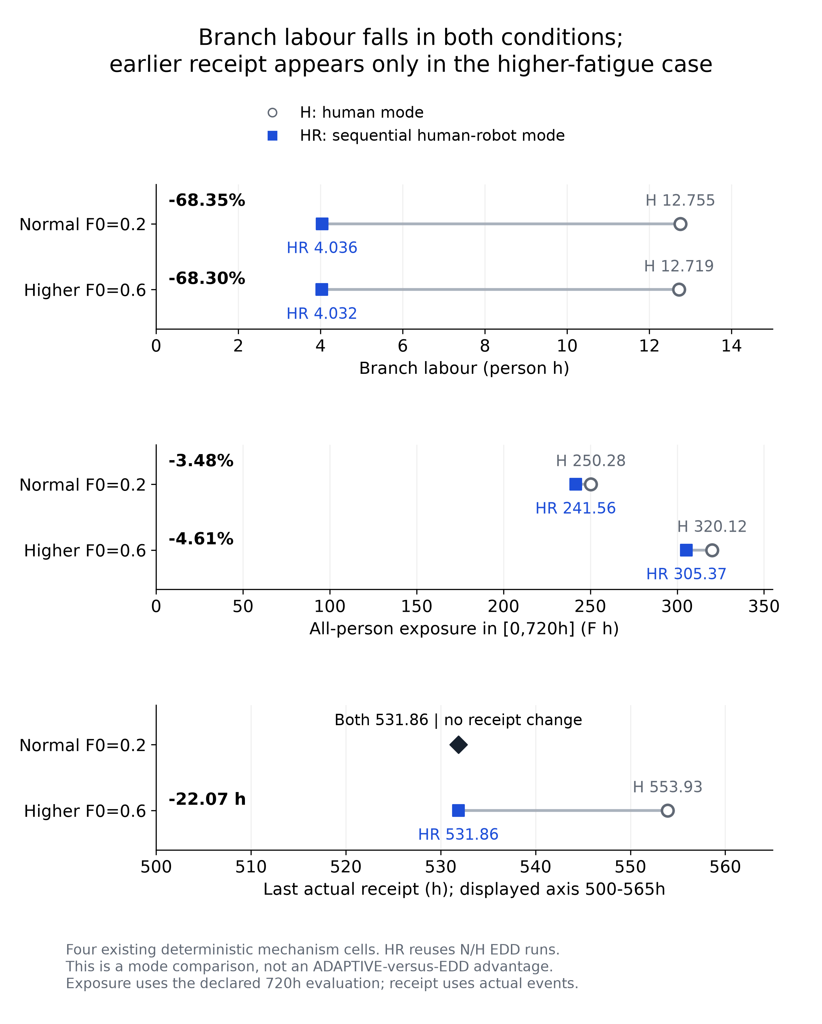
Figure 4-2. Manual versus sequential human-robot mechanism cells at normal and high initial fatigue. The comparison joins branch person-hours with whole-module receipt and common-window exposure. HR cells reuse the normal/high-fatigue EDD traces; they are not additional independent samples.
The normal-condition result shows that saving work within one branch is insufficient to advance final receipt in this configuration. Branch labour and common-window exposure decrease, while final receipt remains at 531.859 h. The comparison does not identify which constraints determine the unchanged receipt time.
Exposure depends strongly on the declared treatment of waiting. In the normal EDD actual lifecycle, WAIT occupies 91.06% of calendar-available person-hours and contributes 68.98% of cumulative exposure. Waiting accumulates at 0.02 fatigue units per hour, while explicit rest and off-shift intervals recover at 0.2 per hour. Thus exposure summarizes the full modelled state trajectory, not simply hours spent performing production work.
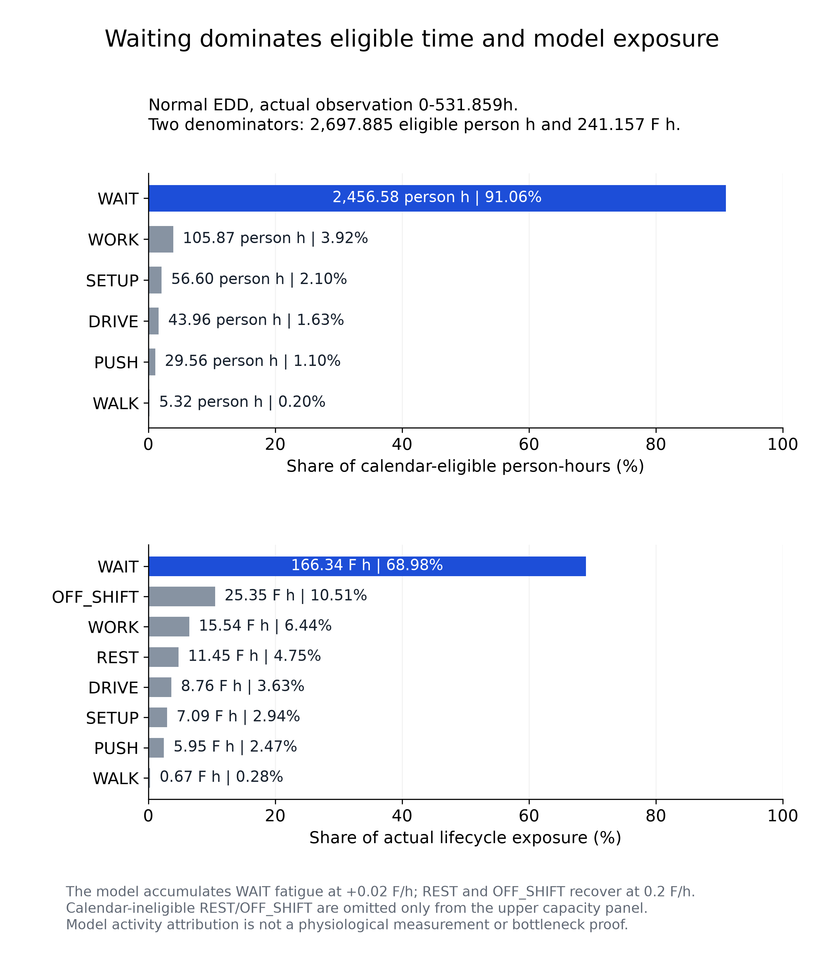
Figure 4-3. Time allocation and exposure composition use different denominators. Available person-hours describe the eligible calendar/state duration; exposure includes the model's actual accumulation and recovery trajectory. Percentages of time and exposure are not interchangeable.
Raising the initial fatigue of all 15 workers from 0.2 to 0.6 adds 63.806210 fatigue-hours to the N/H EDD common-window total. Of that difference, 99.02% accumulates during the first 24 h. The temporal concentration is more informative than reporting only a final integral: it locates when the initial-condition change enters the human-state record. It remains a result of the declared synthetic dynamics and configuration.
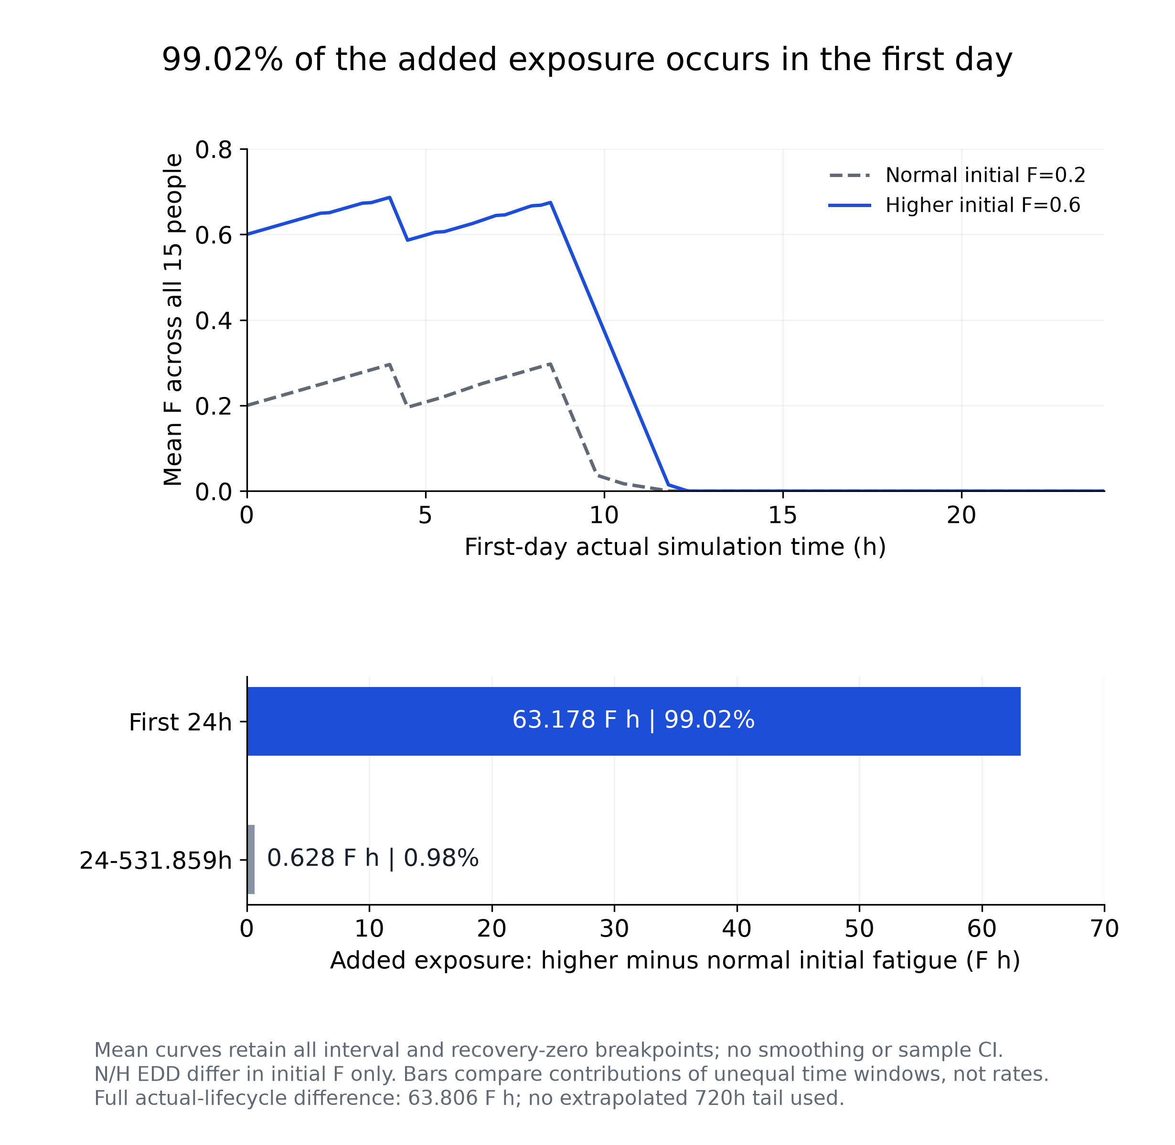
Figure 4-4. Normal and high initial-fatigue trajectories and the distribution of their exposure difference. Recovery-to-zero breakpoints are retained so the plotted curve area equals the corresponding exposure integral. The curves show the first 24 h, and the bars partition the exposure difference over the actual lifecycle ending at 531.859 h.

4.5 Equipment failure and legal recovery
The F physical witness provides a loaded-forklift recovery sequence. Failure EV-116 occurs at 0.6528425 h with attached load and in-transit position recorded from ISAAC_USD. Repair EV-118 follows at 0.9028425 h; completion EV-122 at 0.927675833 h identifies the resumed action. These milestones establish that the interrupted physical obligation is preserved across repair rather than silently replaced by a fresh unloaded action.
Table 4-2. F Kit witness milestones. This is a local mechanism prefix; fixed CPU module outcomes are reported separately.
Event | Simulation time (h) | Meaning
EV-116 | 0.652843 | Failure during loaded transport
EV-118 | 0.902843 | Observed repair
EV-122 | 0.927676 | Resumed completion with original-action linkage

In the fixed F CPU pair, both methods reach final receipt at 531.859 h and have the same common-window total exposure to the reported precision. Recovery stays within the legal domain: the interrupted obligation is preserved across repair, but delivery is unchanged. The separation is the finding: physical recovery and production performance are different outcomes.

4.6 Orders, cancellation and dynamic personnel
The fixed U protocol registers an order at 1 h and checks that urgency affects uncommitted scheduling only after the order is observed. The targeted Kit witness reaches its declared local goal at 26.490891 h. In the separate E20 r14 interactive chain, newly registered ordinary and urgent modules enter adopted plans promptly, but actual production starts later. The urgent module's first nonservice action occurs 24.378 h after registration; the two ordinary modules wait 52.971 h and 120.879 h. The first nonservice action can be transport and is not necessarily a processing start.
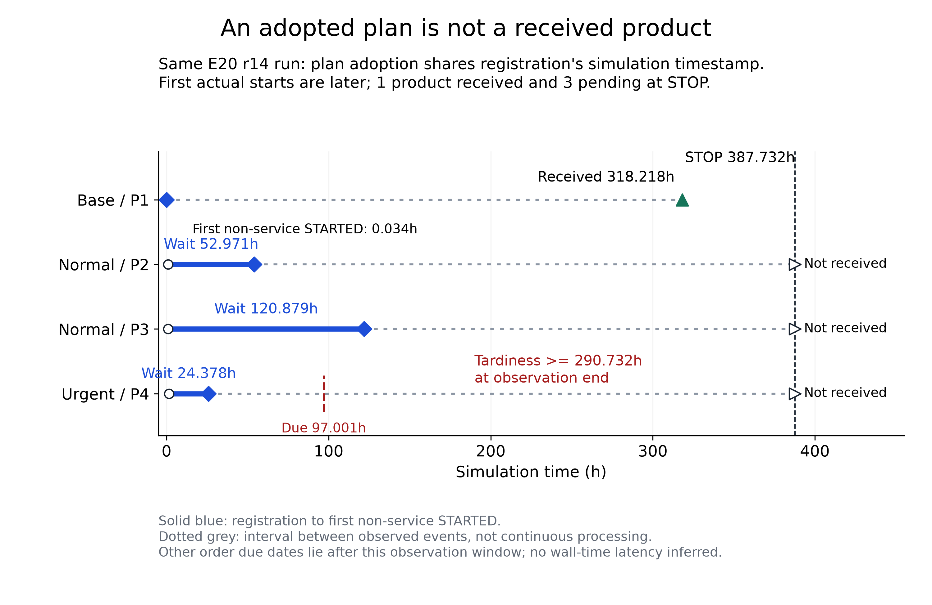
Figure 4-5. E20 r14 order milestones from the same run. Registration and adopted plans precede actual work. At observation end, 387.732463 h, only the original module is received. The urgent module is right-censored with a tardiness lower bound of 290.732 h; the other unfinished modules are not assigned invented receipt times.
E20 is accepted under the owner's recorded split-scope amendment: r14 supplies the real Kit mechanism prefix, r9 supplies separately identified offline-derived completion, and E21 supplies independent capacity evidence. The original same-Kit all-four-received result remains NOT_MET under the accepted split scope (Appendix A). The accepted stage outcome and the actual execution result are both preserved: the pieces are three separate records, not one continuous physical run.
The supported C stock-cancellation runs return 28 steel lots, totalling 3.318 t per run. Command-linked work, driving and walking consume 0.7473425 person-hours; transport totals 96.1 m, including 61.3 m of empty return, and walking adds 83.75 m separately. These are resources already used for the recorded cancellation/cleanup chain. No monetary disposal policy is supplied, so no price is inferred. Both methods receive the remaining module at 291.858973 h. Their original terminal classification remains WINDOW_CENSORED at 720 h, with remaining_products_complete=true. The earlier WIP cancellation failures and J3 hold remain unresolved.
Table 4-3. Cancellation resource account, per selected run. Components and subsets must not be added to their totals a second time.
Quantity | Value | Accounting meaning
Returned steel | 3.318 t | 28 returned lots
Command-linked labour | 0.7473425 person-h | WORK + DRIVE + WALK
Transport | 96.1 m | Includes 61.3 m empty return
Walking | 83.75 m | Separate from transported distance

The two P043 dynamic checkpoints each retain 16 historical people. Their presence/availability data compress into eight equal-value groups without discarding the 32 person identities. In the CPU case, W1 is present for only 0.259708 h, whereas the common 13-person group is present for 6.199011 h and available for 5.699011 h. In the Kit case, W1 is present for 0.541099 h; W3 has 6.480402 h presence and 5.449011 h availability. Applying the full checkpoint duration to every person would therefore distort utilization. These selected accounting cases have zero-valued arrival origins and do not quantify the effect of a newly arriving person's nonzero start time. Separate P043 worker evidence records arrival and order changes at nonzero times within its own local checkpoint.
The P061 adoption audit of the separate P043-CPU-FORMAL-R2 checkpoint binds 11 fully validated candidates to 17 actual cache-sourced starts and rejects 11 truncated candidate copies. Its contexts include observations after personnel and order catalog changes. Candidate reuse is real under changing state. The throughput question is answered in Section 4.7.

4.7 Strategy outcomes and computational effort
The fixed paired results show no final-receipt improvement from the configured adaptive policy. Across 45 paired metric entries, 43 are exactly zero, one differs only at floating-point scale and one is the U exposure difference of -0.001012944 fatigue-hours (-0.00041865%). In the tested configuration the adaptive policy gives no delivery benefit over the legal rule baseline.
Table 4-4. Fixed-case outcomes. Exposure is measured over the declared 720 h common window. Receipt time is identical between the two methods in every row. C includes one cancelled module.
Case | Received / released | Final receipt (h) | EDD total E | Adaptive total E
N | 2 / 2 | 531.858973 | 241.564111 | 241.564111
H | 2 / 2 | 531.858973 | 305.370320 | 305.370320
F | 2 / 2 | 531.858973 | 241.654235 | 241.654235
U | 2 / 2 | 531.875639 | 241.954559 | 241.953546
C | 1 / 2; 1 cancelled | 291.858973 | 232.976737 | 232.976737

For each method, all nine uncancelled received modules across the five scenarios are late, with tardiness between 123.859 h and 363.859 h. The zero on-time fraction is retained. Reporting the range describes severity without changing due dates or turning the cancellation case into a delivery improvement.
Table 4-5. Recorded computation and actual cache use. Wall time describes one original execution per method/case and is not a repeated-run benchmark.
Case | EDD wall (s) | Adaptive wall (s) | Recorded change | Cached / all STARTED
N | 603.92 | 640.04 | +5.98% | 24 / 2031 (1.18%)
H | 599.60 | 646.48 | +7.82% | 24 / 2036 (1.18%)
F | 357.80 | 384.37 | +7.43% | 21 / 2032 (1.03%)
U | 594.99 | 935.85 | +57.29% | 29 / 2043 (1.42%)
C | 134.84 | 137.79 | +2.19% | 24 / 1066 (2.25%)

The selected fixed runs record zero budget-overrun rows under the 900 s scheduling account; the largest selected adaptive account is 400.498 s in U, against a 935.854 s whole-run wall time. Cache-sourced actions account for 1.18% of starts in N and 1.03–2.25% across cases. Every adaptive run uses all seven permitted search calls, with a nominal candidate horizon of 0.1 simulation hours. The short prediction horizon and limited search allowance motivate a controlled comparison of longer horizons and additional search opportunities, measuring both final receipt and computational cost.

4.8 Failure history, performance and reproducibility
The evidence retains four original failed or censored preparation/production attempts: the initial normal EDD budget-limited run, two earlier cancellation attempts and the urgent-order preparation-budget failure. Later successful records are new identities. In-process cancellation and its J3 hold remain unresolved even though stock cancellation completes within its accepted scope. Auxiliary verification and presentation errors also remain recorded separately from production outcomes.
Reproduction uses the source package and its documented companion inputs; the core wheel alone does not contain the full desktop/Isaac runtime or all analysis assets. The final P063 reconstruction checks normal, dynamic and Kit archives with complete plan references. Their total displayed rows are 24,680 / 2,676 / 5,241, while FULL_PLAN rows are 1,023 / 2,046 / 2,046. The two counts measure different things: displayed rows and full-plan rows. P07's twelve quantitative units can be regenerated offline from the public inputs. The analysis draws only on these recorded runs.

4.9 Scope and limitations
The model covers factory production of a complete steel module. Site erection, inter-module connections and whole-building assembly are outside it, and both collaboration branches are evaluated under the approved S18-SIM-A1 abstraction, which does not cover industrial weld qualification, weld quality, toolpath accuracy or safety certification (Appendix A). Each case is a deterministic configuration comparison, so the tables describe these runs and support no population or significance inference. Modules unfinished at the observation end are censored there, with no imputed receipt time; exact values are reported in the tables. Timing values describe the recorded executions, including nested accounting and protocol differences.
Open items are listed in the Project status block: in-process cancellation and the J3 hold, the owner's continuous-operation session, sustained display performance and industrial qualification. The claims of this report therefore concern the tested configuration and the recorded runs, not general MiC practice or physiological effect.

5 Conclusion

5.1 Answers to the research questions
The project establishes a working simulation model linking complete steel MiC module manufacturing, heterogeneous resources, collaboration stages and human-state dynamics. Command identities, actual readbacks, delivered observations and independent audits support the claimed execution and feedback chain. Dynamic catalogs, bounded scheduling and shared session interfaces preserve physical obligations while changing future work. Saved results retain enough identity and plan information to reconstruct the recorded business and display state.
In the selected five-scenario pairs, adaptive scheduling provides no improvement in final receipt time and only a very small exposure difference in U, alongside higher recorded wall times. The fixed H/HR mechanism comparisons nevertheless show substantial branch labour reductions and, under high initial fatigue, an earlier final receipt. Both findings can hold because changing a collaboration mode and adding adaptive scheduling are different interventions.
The human-state results also show that total exposure must be interpreted through activity and time. Waiting accounts for much of the normal baseline's exposure, and most of the initial-fatigue difference develops in the first day. Dynamic presence and availability further change the denominator. These findings support reporting human trajectories, physical output and computation together when evaluating a scheduling framework.

5.2 Supported follow-up work
Further work should first test policy configurations that address the observed absence of a fixed-case advantage, including prediction horizon, search allocation and objective alignment with final delivery. Such comparisons should retain the present legal domain and report both the extra computational effort and any output gain. Physiological interpretation requires calibrated human data; industrial deployment requires the outstanding process and safety qualifications. The simulation results concern the factory stage and modelled receipt of steel MiC modules.
Engineering priorities follow the recorded operating gaps: source-age and throughput qualification, in-process cancellation/hold recovery, the manual-rest interface and the remaining native failure diagnosis. The owner's continuous-operation session remains pending for P08 and will provide usability evidence for the delivered guide and workbench.

References
BCA (n.d.). Prefabricated prefinished volumetric construction (PPVC). Building and Construction Authority, Singapore. Accessed 3 November 2026. Official page.
Buildings Department, Hong Kong (2026). Modular Integrated Construction. Last updated 30 January 2026. Official MiC definition.
Chand, S., and Lu, Y. (2023). Dual task scheduling strategy for personalized multi-objective optimization of cycle time and fatigue in human-robot collaboration. Manufacturing Letters, 35 (Supplement), 88-95. doi:10.1016/j.mfglet.2023.08.064.
Ma, L., Chablat, D., Bennis, F., and Zhang, W. (2009). A new simple dynamic muscle fatigue model and its validation. International Journal of Industrial Ergonomics, 39(1), 211-220. doi:10.1016/j.ergon.2008.04.004. Author manuscript archived in 2022; journal year retained as 2009.
Park, K.-T., Lim, C., and Lee, J.-Y. (2025). Production scheduling for human-robot collaborative assembly workstations under constraints of ergonomic fatigue and simultaneous cooperation. Journal of Manufacturing Systems, 83, 337-356. doi:10.1016/j.jmsy.2025.09.012.
Petzoldt, C., Niermann, D., Maack, E., Sontopski, M., Vur, B., and Freitag, M. (2022). Implementation and evaluation of dynamic task allocation for human-robot collaboration in assembly. Applied Sciences, 12(24), 12645. doi:10.3390/app122412645.
Pisinger, D., and Ropke, S. (2010). Large neighborhood search. In Handbook of Metaheuristics, second edition. Springer. doi:10.1007/978-1-4419-1665-5_13.
Vieira, G. E., Herrmann, J. W., and Lin, E. (2003). Rescheduling manufacturing systems: a framework of strategies, policies, and methods. Journal of Scheduling, 6, 39-62. doi:10.1023/A:1022235519958.
You, Y., Cai, B., Pham, D. T., Liu, Y., and Ji, Z. (2025). A human digital twin approach for fatigue-aware task planning in human-robot collaborative assembly. Computers & Industrial Engineering, 200, 110774. doi:10.1016/j.cie.2024.110774.

Appendix A. Evidence, reproduction and requirement locations
The companion docs/delivery/p08_evidence_index_r1.tsv binds requirement, claim and source identities to report sections, retaining technical scope and owner status. The key reusable entry points are the P02 model manifest, P053 coverage and evidence-reference tables, P052 acceptance amendment, P061 adoption validation, P062 limited-scope completion, P063 reproduction guide and reconstruction repair, P07 source registry and the published G07 verification record. Historical documentation is read with its dated scope and later resolution links.
Table A-1. Technical requirements and their report locations. Detailed source identities are in the evidence index.
Requirement | Method | Evaluation
T01 Dynamic multi-resource model | 3.1, 3.6 | 4.3, 4.6
T02 Collaboration modes | 3.2 | 4.4
T03 Human-state dynamics | 3.2 | 4.4, 4.6, 4.7
T04 Equipment failure | 3.3 | 4.5
T05 Urgency and cancellation | 3.3, 3.5 | 4.6
T06 Isaac production environment | 3.1, 3.4 | 4.3, 4.5
T07 Closed-loop disturbance response | 3.4 | 4.3, 4.5, 4.6
T08 Online scheduling | 3.5, 3.6 | 4.6, 4.7
T09 Efficiency and robustness | 3.4, 3.5 | 4.1-4.8
T10 Five-chapter report | Chapters 1-5 | Source/PDF consistency record

I01-I08 are addressed by the configuration, continuous change, state/receipt, common-contract, new-order, personnel, Gantt and dual-view mechanisms in Sections 3.6-3.7 and the corresponding evidence in Sections 4.3, 4.6 and 4.8. The operation guide maps their concrete controls to E01-E24. E12 has no completed owner record at this report version. E20 uses its explicit owner-approved split scope; the original all-received physical result remains unfulfilled.
For offline research reproduction, use the published P07 input manifest and the result/reproduction guide. For installed-package normal and dynamic runs and saved reconstruction, use the P063 guide with its final repair. For current user operation, use the P08 guide. The original P08 PDF was generated from report.md using build_report.py. This revised Word edition contains subsequent textual revisions; its accompanying PDF is exported from the revised document using Microsoft Word.
Status items. The industrial G2 status remains OPEN and industrial qualification remains NOT_ESTABLISHED; the original same-Kit all-four-received criterion is NOT_MET; E12 has no completed owner record at this report version; the owner's continuous-operation acceptance is pending. The study reports 12 distinct quantitative units and 19 coverage cells, and several cells draw on the same run; full identities are in the evidence index.
Software delivery and verification record. The workbench has approved limited low-frequency operation with visible scheduling waits. The original 2 s source-age goal is not met, sustained 4 Hz delivery is not established, and the steady-window and 10/s and 50/s request-rate qualifications are insufficient. The later shutdown repair closed K02 within its tested scope; the historical K01 root cause remains open. The Vite dependency high-severity finding and Chrome's same-page Mermaid rendering limitation remain disclosed with the release.

Appendix B. Contribution and AI assistance
The project author developed the research ideas and overall architectural direction and made selected detailed design decisions. The author also directed scope choices and reviewed project outcomes. AI was used in a supporting role for implementation assistance, evidence organization, analysis support and report drafting and revision. These roles reflect the author's declaration and recorded project decisions. The author will personally perform the continuous-operation acceptance after document completion; that activity has not yet occurred in this report version.

Appendix C W1 to W5 engineering integration

C.1 Purpose and version of the evidence
This appendix records engineering work after the reviewed research report. The five research chapters, original figures, numerical tables, equations, references and contribution statement are retained. W1 measured the waiting path, W2a made its state visible, W3 reduced replay preparation, and W5 integrates the selected repairs into a distributable candidate. Both W4 trials were rejected. The proposed application delivery is v1.1.0; the embedded Python library retains version 0.1.0. This is a local review candidate and has not been published or accepted through owner-operated E12.
The main engineering judgment is that replay preparation can be reduced while preserving the adopted plan and its proof. The original W3 result supports retaining that approach. W5 tests the integrated implementation and delivery paths; its functional checks do not provide a new four-pair performance estimate. Planning speed and the delivery-time comparison between ADAPTIVE and EDD are separate outcomes. The research finding of no final-receipt advantage in the five fixed scenario pairs remains unchanged.

C.2 What the staged work established
W1's recorded CPU initial-plan and replan build times were 84.065 s and 94.001 s. Three first verified archive projections took 18.599 s, 18.996 s and 18.814 s. These measurements identified substantial work in replay and independent verification. They are historical observations with their own process and input identities, rather than timing values for the W5 package.
W2a separates planning, waiting for independent verification, available and failed states. During replanning, the workbench retains the previous independently verified Gantt layer and labels its version and age alongside the candidate version. Actual observations and heartbeats retain separate meanings. A result can replace the displayed plan only when the task, run, epoch and checked plan reference agree. The repair also preserves an accepted business receipt when a plan reference fails, rejects late results after a new task begins, and freezes elapsed waiting time on failure.
STOP uses the existing control envelope. Request submission, durable acceptance, saving and the actual worker exit are shown separately. An UNKNOWN response allows querying the original STOP identity. Recovery of a missing envelope requires an explicit action and the original byte identity, without introducing a second accepted STOP. The five-second stale-write protection remains active. Historical W2a tests covered 128 Python/frontend checks; its three sets of 40 local Qt samples had p95 input, bridge and stage-presentation delays of 59.6 ms, 45.5 ms and 164.8 ms. Those numbers describe that W2a test, not new W5 latency qualification.
The selected W3 approach shares only structurally checked immutable configuration, state and event records. Event lists, operation and route dictionaries, business requests, catalog priorities and execution state remain private to the preview. A seed backend is reusable only for the same configuration object, run and epoch, and every dispatch decision still binds the current observation. Stable priorities are reused only while the configuration, priority inputs and requested order remain unchanged. Geometry preparation retains the original obstacle order and the original segment-intersection test, including support movement and collision rejection.
The earlier isolated W3 candidate completed four actual CPU AB/BA pairs, eight runs in total. Its paired median reduction was 17.331061% from change submission to APPLIED plus independently verified projection, and 26.501367% for net replay after subtracting execution and causal audits. All eight runs retained their original STOP, final save and zero worker exit. Two later review findings concerned per-call dependency isolation and insufficient evidence rejection. Their limited repair passed 20 targeted checks and one normal CPU chain. The four-pair numbers remain attached to the earlier measured candidate; the repaired and integrated versions have no replacement four-pair estimate.
W4's private structural-validation cache increased the fixed-boundary-to-save time from 35.900 s to 36.746 s and net replay from 18.697 s to 18.968 s. Its second trial reused geometry outside the exclusion set: two AB/BA pairs increased the save endpoint and net replay by paired medians of 2.770% and 3.660%. Both trials retained their failed retention decisions and were excluded from W5. Their equal plans and proofs do not establish a performance benefit.

C.3 The integrated implementation and independent checks
W5 replaces the experimental source-rewriting overlays with ordinary package modules. Each preview owns its seed, priority cache and geometry preparation. Context-local geometry is restored after nested calls or exceptions, and concurrent previews do not replace public planner functions. The execution and causal audits explicitly leave replay geometry scope and run through the original geometry path. No W4 cache is installed. The normal transaction, event, plan-adoption and STOP owners remain unchanged.
The fixed L1 v2 boundary is generation 1, revision 177, event count 177 and simulation time 0.36948611111111135 h. The integrated plan SHA-256 is 63b2ceacada7cc79d56b679b518576da1d3f3d0b29c8aa59d848abdee39a1733. The uncompressed proof SHA-256 is db4c69f5b88e2513c398d031afc65ae626c7f06513680faed22ed4d25bbaa4d7. Both exactly match the original fixed-boundary records. This is an equivalence check for that input, not a new field-speed result.
The exact candidate passed the unchanged scripts/check.py entry point: 1299 tests in the source round and 1299 tests in the isolated-wheel round. Ruff, locked dependencies, wheel/sdist building and dependency checks also passed. Eleven new ownership and fallback tests cover both concurrent exit orders, single/both exceptions, nesting, immutable record sharing, private mutable containers, the original full Python path and geometry-cache separation. Twelve evidence tests and two publication guards reject altered plans, proofs, STOP receipts, process identities, final saved state and invalid timing intervals, including under Python -O. The original independent verifier retained the same four negative-case reasons. The portable CPU/Qt chain displayed v1, retained v1 during a change, independently verified v2 and saved STOPPED/COMPLETE with worker exit 0. Its STOP was accepted once. Bilingual STOP recovery and read-only/fallback archive views also passed. Three sets of 40 candidate Qt fixture samples had p95 input, bridge and stage presentation delays of 62.2 ms, 77.1 ms and 293.8 ms. The recorded sandbox renderer failures were retained; the functioning Qt and EXE checks used the normal local process environment.
The reproducible source artifact starts from the published v1.0.1 tree and adds an explicit W2a/W5 path set. Unrelated uncommitted files and private test-fixture substitutions stay outside it. A migrated presentation contract retains the original v1.0.1 README and test bytes while binding the new bilingual README. The full source ZIP, exact delta, wheel, source distribution and Windows portable ZIP each have external hashes; the portable ZIP also carries a per-file manifest. Package identity, tested entry points and report identities are recorded in the candidate manifest.

C.4 Operating the candidate and returning to the original path
Extract the complete Windows package and start HRC-Workbench.exe beside its app directory. The package includes its own Python, Qt WebEngine, scheduling components and read-only archive. Start a single-product SR-W1 CPU session from Launch configuration. During initial planning the workbench shows a waiting state; during a change it keeps the previous verified plan until the new plan passes independent verification. Use Safe stop and wait for durable acceptance, completed saving and the actual worker exit before closing the workbench. A saved archive is opened read-only and cannot authorize new business writes.
Set P051_PREVIEW_REUSE=0 before launching to use the original full-copy, original geometry and unseeded Python preparation path. Set P051_WAIT_FEEDBACK=0 to hide the added waiting feedback. These controls leave original verification, write protection and STOP handling active. The published v1.0.1 package and tags remain available as the prior delivery; this candidate does not overwrite them.
Optional native 3D uses separately installed Isaac Sim and PowerShell 7. Use an ASCII-only results directory. The W5 native test is confined to a new local synthetic USD stage, SyntheticReceiver and a private test session. Its ORDER_UPDATE changes only simulation data; STOP ends and saves that local simulation. No physical factory equipment, PLC, robot controller or external order system is connected. SDK, driver and system settings are unchanged. The local simulation has a 900 s wall budget, with a separate shutdown reserve. An unproven launch boundary is skipped and reported rather than widened.

C.5 Interpretation and remaining acceptance
The local synthetic Kit chain passed with the same portable source identity: initial planning, independent verification, a single simulation-only ORDER_UPDATE, retention of v1 while v2 was pending, verified v2, original safe STOP, STOPPED/COMPLETE saving and confirmed native process exit 0. The installed Isaac Sim 6.1 runtime created a new private USD simulation. The launch retained the 900 s simulation wall budget and a separate two-hour test window with a 45-minute shutdown reserve. The saved v2 session reopened read-only and rendered 1,023 independently checked current intervals. This is one functional native run, with no paired Kit timing data or industrial speed qualification.
W5 concerns the waiting workflow, replay preparation and distributable integration. It supplies no new industrial speed claim, paired Kit speed estimate or physiological evidence. The original 2 s source-age target remains NOT_MET; sustained 4 Hz and the 10/s and 50/s request-rate qualifications remain unestablished or insufficient under their original definitions. E20 retains its accepted split scope and original all-four-received NOT_MET result. In-process cancellation and J3 HOLD, manual REST, historical K01 diagnosis and the recorded frontend advisory retain their previous status.
E12 remains OWNER_PENDING because the author has not performed the required continuous operation. P08 remains OVERALL_INCOMPLETE and P09 has not started. The owner can review the exact locally prepared candidate and decide whether to authorize publication. Preparation and automated verification do not substitute for that decision or for the author's operation record. The contribution and AI-assistance declaration in Appendix B also applies to this engineering update.

