Faces @ Pitt User Manual

**Product Overview**

Faces @ Pitt is a social network that allows users to connect, make friends, and interact with each other. The user can send messages, add friends, display messages and exclusively new messages, display friends, find any user, confirm or ignore pending friend requests, explore the social network through three degrees of separation, show statistics for top friends by messages received and sent, and drop the account if desired.

All the tasks are implemented and work as expected.

**Getting Started**

1. Registering

On starting the program, the user is presented with the following text:

“Choose: Login(1), Register(2), or Exit(-1)”

The user makes his or her choice by entering the appropriate number and pressing enter.

On selecting 2, the user can register an account.

The user is asked to input a name, email address, password, birthday, self description, and image url. Note that the email must be in valid @pitt.edu format and the birthday must be in date format.

You will be greeted with the text that you have been registered, and are now able to select the other functions!

1. Logging in

On starting the program, the user is presented with the following text:

“Choose: Login(1), Register(2), or Exit(-1)”

The user makes his or her choice by entering the appropriate number and pressing enter.

On selecting 1, the user can log in.

The user is asked to input the email and password, and then the user is logged in and able to select the other functions.

**Sample Run: Three Degrees of Separation**

This sample run walks through the three degrees of separation task.

First, log in to the website by entering 1 at the login screen, then enter the email address and password to pass to the main menu.

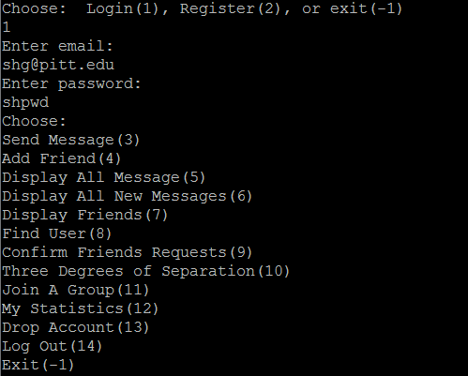

Next, select 10 to access the Degrees of Separation task. The user is presented with all the numbered users in the system and asked to select a user.

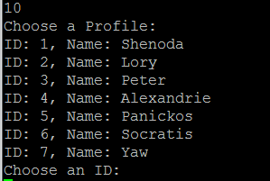

After selecting a user, the system finds the path between the current user and the selected user with up to three hops and displays the path or paths between them. The user is afterwards returned to the main menu.

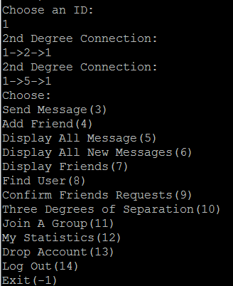

**Modes of Operation**

The user navigates the system by inputting text into the terminal. These commands are most often integer values, the semantics of which are specified by the system through output.

At the main screen: the command 1 leads to logging in, the command 2 leads to registering a new account, and the command -1 exits.

At the main menu: the command 3 leads to sending a message, the command 4 leads to sending a friend request, the command 5 displays all messages, the command 6 displays all new messages, the command 7 leads to displaying all friends, the command 8 leads to finding a user, the command 9 leads to confirming friend requests, the command 10 leads to the three degrees of separation task, the command 11 leads to joining a group, the command 12 leads to checking top friend statistics, the command 13 allows the user to drop the account, the command 14 logs out, and the command -1 exits the terminal as in the main screen.

**Changes to Phase 1**

-Specified evaluation modes

-Added foreign keys to the messages table

-Fixed naming conventions

-Changed all ID data types from varchar2 to number